SCIENCE FACTS

**Whatsapp group;**

# P.6 TERM ONE

**CLASSIFICATION OF ANIMALS**

QN. **What is classification**?

Classification is the grouping of organisms according to their characteristics.

##### Qn. What are living things?

Living things are things that have life.

##### Characteristics of living things

* Living things reproduce.
* Living things respond to stimuli.
* Living things respire.
* Living things feed.
* Living things grow.
* Living things excrete.
* Living things move / locomote.
* Groups of living things

Living things are grouped into major groups called **Kingdoms**.

##### Qn. Identify five groups/ Kingdoms of living things.

* Animal kingdom
* Plant kingdom
* Fungi kingdom
* Bacteria kingdom
* Protoctista kingdom
* ANIMALS KINGDOM
* Animals are classified according to their characteristics. Qn. **What is classification of animals**?

Classification of animals is the grouping of animals according to their characteristics.

##### Qn. Give one reason why animals are classified.

For identification

##### Qn. Give different factors considered when classifying animals.

* The way animals move.
* The way animals reproduce.
* The habitat of animals.

##### Groups of animals

Qn **Identify the two main groups of animals**.

* Vertebrates
* Invertebrates

##### A chart showing classification of animals

**Vertebrates**

-

**ANIMALS**

**Vertebrates Invertebrates**

Warm blooded

Cold blooded

Mammals

Birds

Amphibians

Fish

**VERTEBRATES**

##### Qn. What are vertebrates?

Reptiles

Vertebrates are animals with backbones.

##### Qn. Mention any five examples of vertebrates

* Human beings - elephants
* Rats - snake
* Goats - hedgehogs
* Sheep - spiny ant eater
* Cat - hen
* Dog - hare
* Characteristics of vertebrates
* Vertebrates have back bones.
* Vertebrates have endo skeleton.
* Vertebrates have waterproof skin.
* Vertebrates have a brain that is protected by the skull.
* Groups of vertebrates
* Vertebrates are grouped into main groups namely:-
* Warm blooded vertebrates (Homoiothermic)
* Cold blooded vertebrates ( Poikilothermic

##### Warm blooded vertebrates

**Warm blooded**

**Cold blooded**

Mammals

Birds

Reptiles Amphibians Fish

Qn. **What are warm blooded vertebrates**?

These are animals which maintain a constant body temperature.

##### Qn. State any four examples of warm-blooded animals.

* Human being - Bush baby
* Goat - spiny ant eater
* Elephant - Pika
* Chimpanzee

-

##### Groupsofwarm-blooded animals

* Mammals
* Birds

##### Cold blooded animals

Qn. **What are cold blooded vertebrates**?

These are vertebrates whose body temperature changes according to the surrounding.

##### Qn. Give any four examples of cold-blooded vertebrates.

* Snake - fish
* Frog - Newts
* Toad - Chameleon
* Crocodile - Gecko

##### Groups of cold-blooded vertebrates

* Reptiles
* Amphibians
* Fish

##### Classes or groups of vertebrates

* Mammals
* Birds
* Reptiles
* Amphibians

- Fish

##### MAMMALS

**Qn. What are mammals?**

Mammals are animals with mammary glands.

##### Qn. State any six examples of mammals

* Dog -Duckbilled platypus
* Monkey -Cow

-Spiny an eater - -Amadillo

* Elephant -Pika
* Whale -Rabbits

##### Specific characteristics of mammals

* They have mammary glands.
* They have fur on their bodies.
* They feed their young ones on milk produced by the mother’s mammary glands.
* Other characteristics of mammals
* Mammals undergo internal fertilization.
* Mammals have a four chambered heart.
* Mammals have two pairs of limbs.
* Mammals have well developed ear lobes with the pinna for trapping sound waves.
* Mammals are warm blooded.
* Mammals take care of their young ones.
* Groups of mammals
* Primates (Fingered mammals)
* Rodents (Gnawing mammals)
* Pouched mammals (Marsupials)
* Hoofed mammals (Ungulates)
* Flying mammals(chiroptera)
* Egg laying mammals (Monotremes)
* Sea mammals (Ceteceans)
* Insect eating mammals (Insectivores)
* Flesh eating mammals (Carnivores)
* Lagomorphs
* Edentate (toothless mammals)
  1. **PRIMATES (FINGERED MAMMALS)**

Qn. **What are primates**?

Primates are the most advanced groups of mammals.

##### Qn. Why are primates said to be the most advancedmammals?

Primates have awelldeveloped brain

##### Characteristics of primates

* Primates have well developed brain.
* Primates have five fingers on each hand and five toes on each foot.
* Primates have their font limbs for holding things and hind limbs of walking.
* All primates are omnivorous.
* Primates have a well developed set of teeth . Qn. **What are omnivorous animals?**

These are animals which feed on both flesh and vegetation.

##### Examples of primates

* Human beings - Monkey - Orangutans
* Baboons - Bush baby - Chimpanzee
* Apes - Gorilla - Gibbon

##### Diagrams showing some primates

* 1. **EGG LAYING MAMMALS (MONOTREMES)**

Qn. **What are monotremes**?

These are mammals that reproduce by laying eggs.

##### Note:

Monotremes are regarded as the most primitive group of mammals.

##### Qn. Why are monotremes regarded as the most primitive group of mammals?

* They have characteristics of mammals, reptiles and birds.

##### Qn. Why are monotremes grouped under mammals yet they reproduce by laying eggs?

* They have mammary glands.
* They feed their young ones on breast milk produced by the mammary glands.
* Characteristics of monotremes
* Monotremes reproduce by laying eggs.
* Examples of monotremes
* Duck billed platypus
* Spiny an eater (Echidna)
* 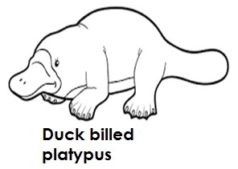Illustration showing monotremes

-

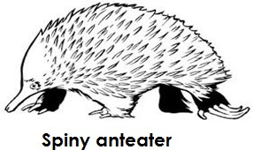

* 1. **FLYING MAMMALS (Chiroptera)**

Qn. **What are flying mammals?** These are mammals that fly. **Examples of flying mammals** Bats

##### Note

* Bats are the only mammals that can fly.

##### Characteristics of flying mammals

* They fly
* They have a fold skin attached to the fore limbs.
* Bats are active at night and rest during day time.

##### Qn. How are bats able to fly?

* They have a fold skin attached to their fore limbs that enable them to fly. Qn. **Why are bats regarded as mammals but not birds yet they can fly**?
* Bats have mammary glands while birds do not have mammary glands.
* Bats feed their young ones one breast milk while birds do not feed their young ones on breast milk.

##### Qn. What name is given to animals that become active at night and rest during day time?

Nocturnal animals.

##### Groups / types of bats

* Vampire bats (blood sucking bats)
* Insect eating bats
* Fruit eating bats

##### Blood sucking bats

These are bats which suck blood from other animals.

##### Note:

* Blood sucking bats suck blood from animals like cattle,pigs, buffalo, elephants etc.

##### Insect eating bats

These are bats that fed on insects.

##### Fruits eating bats

These are bats that fed on fruits from trees.

##### Qn. How are echoes important to bats?

* Echoes enable bats to locate their food.
* Echoes enable bats to dodge obstacles while moving.

##### Importance of bats in the environment

* Fruit eating bats help in seed dispersal.
* Insect eating bats help to feed on harmful insects in the environment.

##### A diagram showing a bat.

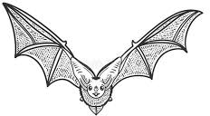

* 1. **POUCHED MAMMALS/MARSUPIALS.**

Qn. **What are marsupials**?

These are mammals with a pouch / pocket on their abdomen.

##### Qn. How is a punch important to pouched mammals?

* For carrying the young ones.
* For protecting the young ones.

##### Note:

The word **marsupial** means a pouch or bag.

##### Characteristics of pouched mammals

* They have a pouch.
* Their hind limbs are longer than the fore limbs.
* They have a long tail for balancing while hopping.
* They move by hopping

##### Examples of marsupials

* Kangaroo
* Koala bear
* Opossums
* Wallabies
* Wombats

##### Diagram showing a Kangaroo.

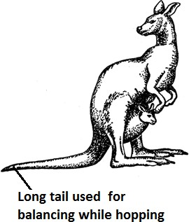

**FLESH EATING MAMMALS (CARNIVORES**)

##### Qn. What are carnivores?

These are mammals that feed on flesh.

##### Characteristics of carnivores

* They have well developed canines for tearing flesh.
* They have sharp claws forholding, killing and tearing flesh.
* They have soft pads under their feet to enable them run after their prey without making noise.
* They have a good speed.
* They have good sense of smell, sight and hearing

##### Groups of carnivores

* Cat family
* Dog family

##### Cat family

These are carnivores with features similar to those of a domestic cat.

##### Examples of carnivores in the cat family.

* cat - jaguar
* leopard - cheetah
* lion - puma
* tiger - panther

##### Dog family

These are carnivores with features similar to those of a domestic dog.

##### Note:

**Hyenas** and **jackals** are called scavenger mammals Qn. **What are scavenger mammals?**

These are carnivores which feed on abandoned flesh.

##### Importance of scavenger mammals

- They help to clean the environment by feeding on abandoned flesh/ carrion.

- Diagram show the skull of a carnivore

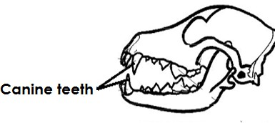

##### CETACEANS (SEA MAMMALS)

Qn. **What are cetaceans**?

These are mammals that live in seas.

##### Characteristics of sea mammals

* They live in seas.
* The have blubber (layer of fats) under their skin.

-

##### Qn.How is a blubber important to sea mammals?

* Blubber keeps the sea mammal warm in water.
* Blubber acts as a food store for sea mammals.

##### Examples of sea mammals

* Whale - Dugongs
* Dolphins - seals
* Porpoise
* Note
* The whale is the largest mammal.

##### Diagram showing some cetaceans

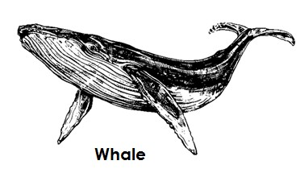

1. **UNGULATES (HOOFED MAMMALS)**

##### Qn.What are hoofed mammals?

* + These are animals which have hooves on their feet.

##### Characteristics of ungulates

* + They have hooves on their feet.
  + They are herbivores (feed on vegetation)

##### Groups of ungulates

* + Even toed ungulates
* Odd toed ungulates (a)**Even toed ungulates**

These are ungulates with even numbers of hooves on their feet.

##### Examples of even toed ungulates

* + cows - camel
  + goat - giraffe
  + pig - deer
  + sheep - antelope

##### Qn. Name the groups of even toed ungulates.

* + Ruminants
  + Non – ruminants

##### (i) Ruminants

Qn. **What are ruminants**?

* These are animals with four chambered stomachs and chew the cud. Qn. **What is cud**?
* Cud is the half digested food animals bring back from the rumen for further chewing. Qn. **What do we call the process of chewing cud?**

Rumination

##### Characteristics of ruminants

* + They chew cud
  + They have four chambered stomachs.

##### Qn. Name the four chambers of stomachs of a ruminant animal.

**-** Rumen (1st stomach)

* Reticulum (2nd stomach)
* Omasum (3rd stomach)
* Obamasum (true stomach) Examples of ruminants
* cattle - antelope
* zebra - sheep
* giraffe - camel

(i) **Non ruminants**

##### Qn. What are non ruminant animals?

These are animals which do not chew cud.

##### Characteristics of non ruminants

* They do not chew cud.
* They have one stomach.

##### Examples of non ruminants

* pigs - horse
* warthogs - rhinoceros
* donkey - hippopotamuses

##### Diagram showing hooves of even toed ungulates.

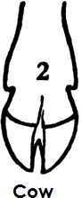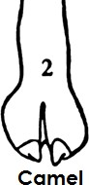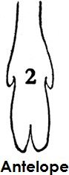

1. **Odd toed ungulates**

These are ungulates with odd number of hooves on their toes.

##### Examples of odd toed ungulates

* + Elephant - Rhinoceros
  + Horse - Zebra
  + Donkey

##### A diagram showing hooves of odd toed ungulates

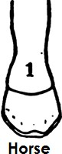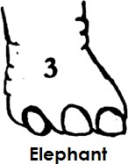

1. **INSECTIVORES**

##### Qn. What are insectivores?

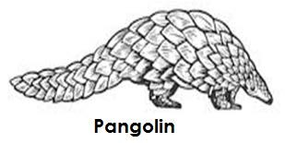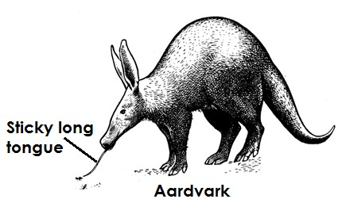

These are mammals that feed on insects.

##### Characteristics of insectivores

* They feed on insects.
* They are mainly nocturnal.
* They have a long sensitive snout.
* They have strong and sharp claws for digging up insects from the ground.

-

##### Examples of insectivores

* Porcupine
* Hedge hog
* Pangolin
* Elephant shrew
* Aardvark

##### Qn. How do the following animals protect themselves?

1. **Porcupine**
   * By piercing the enemy using spines.
2. **Hedge hog**
   * By curling / rolling itself into a ball like structure.

-

* + Diagram show insectivores

-

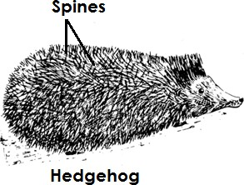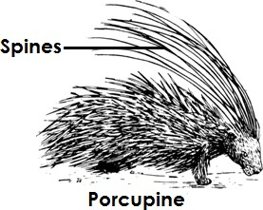

1. **RODENTS (GNAWING MAMMALS)**

Qn. **What are rodents**?

Are mammals with well developed incisors and chew rapidly.

##### Characteristics of rodents

* Rodents chew rapidly.
* Have well developed incisors for biting.
* They have sharp strong claws for digging up root crops.
* Most rodents make holes in the soil for protection and as habitat.
* They don’t have canine teeth.

##### Qn. State the disadvantages of rodents to crop farmers

* Rodents destroy farmer’s crops.
* Examples of rodents
* squirrels - guinea pig
* rats - porcupines
* mice - beavers
* mole rats

##### Diagram showing some rodents.

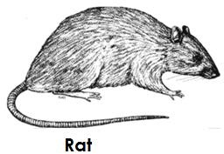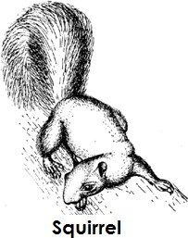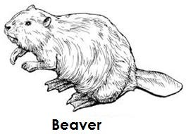

1. **LAGOMORPHS**

Qn. **What are lagomorphs**?

These are mammals with four sharp incisor teeth in their upper jaw.

##### Characteristics of lagomorphs

* They have four sharp incisors in their upper jaw.
* They have strong hind limbs that are longer than their forelimbs.
* They have long ears and short tails.

##### Examples of lagomorphs

* Rabbits
* Pikas
* Hares

##### Diagram showing some lagomorphs (Rabbit)

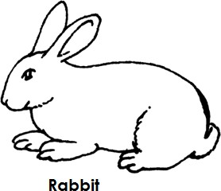

**Importance of mammals**

* Some mammals provide meat and milk.
* Some mammals are used for transport.
* Some mammals are used for ploughing.
* Some mammals provide security.
* Some mammals (scavenger mammals) clean the environment by feeding on abandoned flesh.
* Some mammal’s droppings are used to make manure.
* Some mammals provide hides and skins to people.
* The dung of some mammals can be used to produce biogas.

##### Disadvantages of mammals

* Some mammals are crop pests.
* Some mammals dirt the environment by disposing off their wastes.
* Carnivores feed on people and other animals.
* Some mammals make a lot of noise in the environment. Qn. **How do the following animals protect themselves**?

##### Dog

* By biting
* By barking

##### Cattle

* By goring

##### Zebra

* By running very fast

##### Cats

* By scratching using their strong claws

##### Goats

* By goring

**BIRDS**

Qn. **What are birds**?

Birds are animals with feathers on their bodies.

##### Note:

Birds are vertebrates that are said to have developed from reptiles.

##### Characteristics of birds

* They have bodies covered with feathers.
* They reproduce by laying eggs.
* Birds undergo internal fertilization.
* Their front limbs are modified into wings for flight.
* Birds have scales on their legs.
* Birds have streamlined bodies to overcome viscosity friction during flight.
* Birds are warm blooded vertebrates.
* Birds breathe through lungs.
* Birds have a nictitating membrane to protect their eyes when flying.

##### External parts of a bird.

**15 |** P a g e

##### FEATHERS

Qn. **How are feathers useful to birds**?

* Feathers cover and protect the body of a bird.
* Feathers enable birds to fly.
* Feathers keep the bird’s body warm.
* Feathers give the birds colour for identification.
* Feathers give the bird’s body shape.

##### Qn. How do feathers keep the birds body warm?

* Feathers prevent heat loss from the bird’s body. Qn. **How are feathers useful to people?**
* Feathers are used for decoration.
* Feathers are used for making pillows.
* Feathers are used for making cushions.
* Feathers are used for making dancing props.
* Feathers are used for making clothes.
* Feathers are used for cleaning certain parts of the body e.g ears.

##### Types of feathers

* Quill feathers / flight feathers
* Body feathers / covert feathers
* Filoplume feathers / hair feathers
* Down feathers

##### Quill feathers

* Quill feathers have a strong central part called **shaft** and the hallow portion at the end called **quill**.
* Quill feathers have a flat part called the vane and **space** called **barbs**. Qn. **Mention two body parts of a bird where quill feathers are found**.
* Wings
* Tail

##### Qn. How are quill feathers useful to a bird?

* Quill feathers are used for flying/flight.

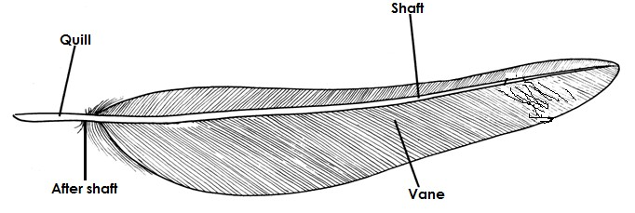**Structure of a quill feather**

**|** P a g e

**16**

##### Body / covert feathers

* They cover the body of a bird.

##### Qn. How are covert feathers useful to a bird?

* Covert feathers prevent heat loss from the body of a bird.
* Covert feathers give the bird’s body shape.

##### Diagram showing the structure of a covert feather

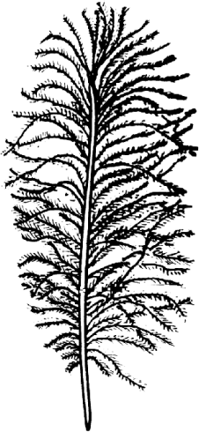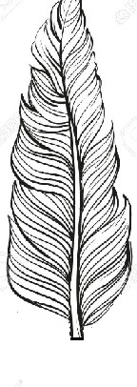

**DOWN FEATHERS**

* These are feathers a chick is hatched with. Qn. **How are down feathers useful to a bird?**
* Down feathers keep the bird’s body warm.

##### Structure of a down feather

**FILOPLUME FEATHERS / HAIR FEATHERS**

* Filoplume feathers are the smallest feathers found nearest the bird’s skin.
* 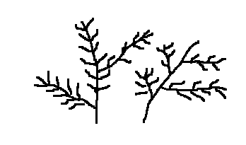Structure of a filoplume feather

##### Note

* Birds undergo biological process/change called **moulting /ecdysis.**

##### Qn. What is moulting as used in birds?

* Moulting is the process where birds shed their old feathers to replace them with new ones.

##### Note:

* Birds do not have sweat glands.
* Birds have a dry skin.

##### Qn. How do birds regulate their body temperature ?

* By panting

**REPRODUCTION IN BIRDS**

Qn. **How do birds reproduce**?

* By laying eggs

##### Qn. What type of fertilization do birds undergo?

* Internal fertilization

**A diagram showing the structure of an egg**

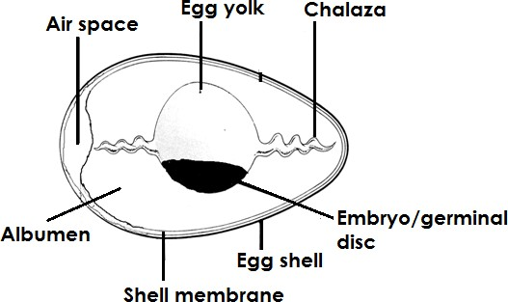

**Functions of each part of an egg.**

##### Egg shell

* + Protects the inner parts of an egg.
  + The egg shell is porous to allow free circulation of air/gaseous exchange.

##### Qn. How is the egg shell adapted to gaseous exchange?

* + It is porous to allow gaseous exchange.

##### Qn. Identify the mineral salts that harden the egg shell.

- Calcium.

* + Phosphorus.

##### Air space

* + Keeps and provides oxygen to the embryo.

##### Chalaza / twisted albumen

* + It holds the embryo and yolk in the central position.
  + It is a passage of oxygen from the air space to the embryo.

##### Egg yolk

* + It provides proteins and fats to the growing embryo.

##### Albumen

* + It provides water and proteins to the growing embryo.

##### Embryo / germinal disc

* + Develops into a youngone.

##### Shell membrane

* + Prevents the albumen from pouring.

##### FEEDING IN BIRDS

* + Birds use beaks to feed. Qn. **Why are birds fed?**
  + To grow well.
  + To keep the bird’s body healthy.
  + To enable birds lay many eggs.
  + To enable birds lay eggs with hard egg shell.
  + To enable birds grow fatter/put on weight.

**The alimentary canal of a bird**

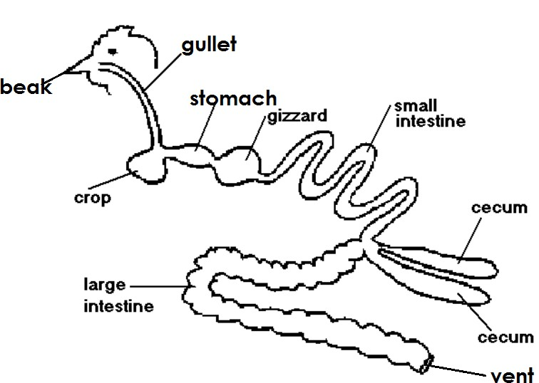

**Functions of each part.**

##### Beak

* + For picking food

##### Gullet

- Acts as a food passage to the crop.

##### Crop

* + Stores, softens and moistens food. (iv)**Gizzard**
  + The gizzard crushes food into small particles by the help of grit. (v)**Small intestines**
  + The small intestines absorb digested food.

##### Note:

* + Digestion of food ends in the small intestines.

##### (vi]Large intestines

* + Large intestines allow absorption of water to take place.

##### Caeca

* + It is where undigested food is stored for sometime before it is passed out as droppings.

##### Vent

It acts as a passage of droppings out of the bird’s body.

##### Qn. State the importance of the nostril to a bird .

* + For smelling.

##### CLASSIFICATION OF BIRDS

* + Birds are classified according to their characteristics. Qn. **How are birds classified?**
  + The type of beak they have.
  + The type of food they feed on.
  + Nature of their feet (claws)

##### Groups of birds

* + Birds of prey
  + Swimming birds
  + Flightless birds
  + Scavenger birds
  + Scratching birds
  + Climbing birds
  + Perching birds
  + Wading birds

##### BIRDS OF PREY

Qn. **What are birds of prey?**

* + These are birds which hunt and kill other animals for food.

##### Characteristics of birds of prey

- They have strong sharp and hooked beaks for tearing their prey.

* + They have strong sharp and curved talons or claws for holding, gripping and killing their prey.
  + They have a strong eye sight for locating their prey.
  + They only feed on flesh.

##### Examples of birds of prey include

* + Hawks - owls
  + Eagles - kites
  + Secretary birds

Qn. **What is a prey**?

* + A prey is a small animal hunted, killed and eaten by another animal.
  + Example of prey eaten by birds of prey
  + Chicks - snakes
  + Kittens - Geckoes
  + Lizards - Frogs
  + Rats - Ducklings

-

* + Diagram showing the beak and foot of a bird of prey

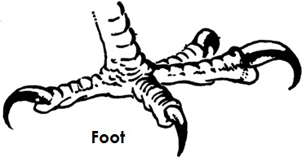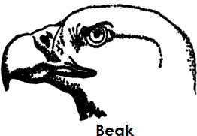

##### Qn. State any one danger of birds of prey

* + Birds of prey feed on chicks and kitten of people.
  + Note:
  + Birds of prey are also carnivorous groups of birds.

-

1. **SCAVENGER BIRDS**

Qn. **What are scavenger birds**?

* + Scavenger birds are birds which feed on flesh killed by other animals [abandoned flesh].
  + Examples of scavenger birds
  + Crow
  + Vulture

- Marabou stork

* + Note:
  + **A vulture** is both a scavenger and a bird of prey.

##### Characteristics of scavenger birds

* + Scavenger birds feed on rotten flesh.
  + Scavenger birds have sharp hooked beaks.
  + Scavenger birds have curved claws.
  + Diagram show the feet and beak of a scavenger bird

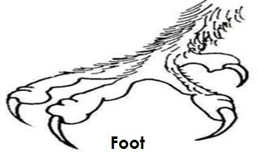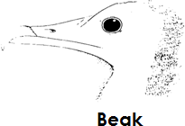

##### Qn. How are scavenger birds useful in the environment?

* + They keep the environment clean by feeding on the abandoned flesh.

1. **PERCHING BIRDS**

Qn. **What are perching birds?**

These are birds that perch on branches of trees.

##### Characteristics of perching birds

* Perching birds have three toes pointing forward and one toe pointing backward.
* Foot of a perching bird

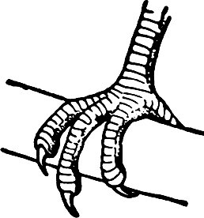

##### Groups of perching birds

* Insect eaters
* Seed eaters

- Nectar suckers

* Seed eaters
* These are perching birds that feed on seeds.
* Adaptation of seed eaters to their mode of feeding
* They have short strong conical beaks for breaking up seeds.

##### Examples of seed eaters

* Pigeons - finches
* Doves - weaver birds
* Diagram showing a head of a seed eater

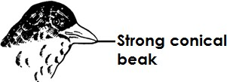-

-

-

-

-

-

-

* INSECT EATERS
* These are perching birds that feed on seeds.

##### Adaptation of seed eaters to their mode of feeding

* They have short narrow beaks for easy picking up of the insects from barks of trees.
* Examples of insect eaters
* Robin - swallow
* Sparrows - swift
* Cuckoo - swallows

-

* Diagram showing the beak of an insect eater

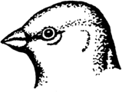-

-

-

-

-

-

-

##### Nectar suckers

* These are perching birds that fed on nectar.
* Adaptation of nectar suckers to their mode of feeding.
* They have long, slender and slightly curved beaks for sucking nectar from flowers.
* Examples of nectar suckers
* Sun bird

- Humming birds

* Diagram showing the beak of a sun bird.

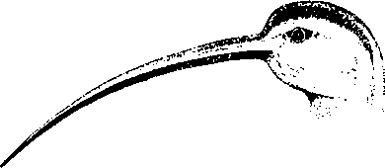

##### Qn. How are nectar suckers useful to crop farmers?

* They help to pollinate flowers while looking for nectar.
* Fruit eaters
* These are perching birds that feed on fruits.
* Adaptation of fruits eater to their mode of feeding.
* They have long stout beaks for collecting fruits.
* Examples of fruit eaters
* - Horn bill

-

* Qn.How are fruit eaters useful to people?
* They help in seed dispersal.
* Diagram showing a beak of a fruit eater

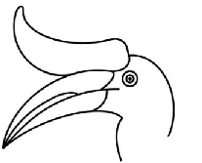-

-

-

-

-

-

-

-

1. **SCRATCHING BIRDS**
   * These are birds which scratch the ground while looking for food.
   * Characteristics / adaptation of scratching birds to their mode of feeding.
   * They have strong feet with thick toes and blunt claws.
   * They have strong, short and pointed beaks for picking up things from the ground. Qn. **What do scratching birds feed on?**
   * - seeds
   * - insects
   * - worms

##### Examples of scratching birds

* + - Chicken - Guinea fowl
  + - Turkey - Crested francolin.

-

-

-

* + Diagram showing the beak and feet of a scratching bird

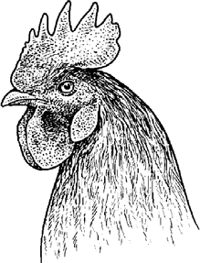-

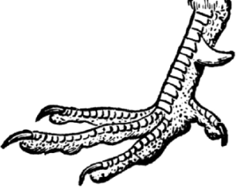-

-

-

-

-

-

-

-

-

* + 5. CLIMBING BIRDS
  + These are birds with two toes pointing backward and two toes pointing forward.
  + Adaptation or characteristics of climbing birds.
  + They have two toes pointing forward and two toes pointing backward.
  + They have strong pointed beaks for trapping food.
  + Examples of climbing birds
  + **-** Parrot
  + - Woodpecker

-

* + Diagram showing the beak and foot of parrot.

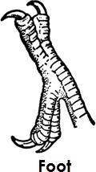-

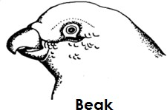-

-

-

-

-

-

-

-

-

* + Diagram showing the beak and foot of a wood pecker

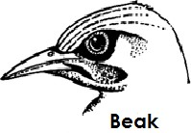-

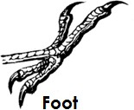-

-

-

-

-

-

-

-

-

1. **SWIMMING BIRDS.**

Swimming birds are birds with webs for swimming in water.

##### Adaptation / characteristics of swimming birds to living in water

* + They have webbed feet for swimming.
  + They have a spoon shaped beak for sieving food from water or mud.
  + They have a layer of fats to keep them warm in water.
  + They have a broad breast bone.

-

* + Examples of swimming birds
  + - Ducks - Penguins
  + - Pelicans - Coots
  + - Geese
  + - Swans
  + - Sea gulls
  + 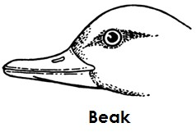Diagrams showing beak and foot of a swimming bird.

-

-

-

-

-

-

-

-

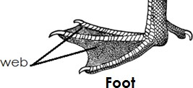

##### Qn .How are the webs important to a swimming bird?

* + For paddling in water
  + For swimming in water

-

##### WADING BIRDS

Qn. **What are wading birds**?

These are birds that walk through water or mud to find food.

##### Adaptation / characteristics of wading birds.

* They have long legs with half webbed toes that prevent them from sinking in water.
* They have long beaks for easy trapping of their food.
* Examples of wading birds
* - Heron - Crested crane
* - Ibis - Flamingo
* - Egret - Storks
* - King fisher

-

-

* Diagram showing a beak and foot of a wading bird

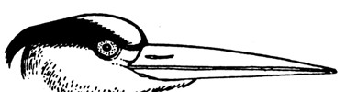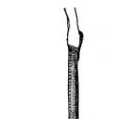

**26 |** P a g e

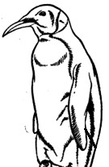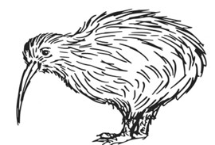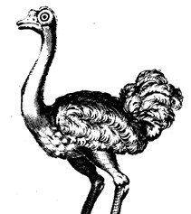

##### Qn. What do wading birds feed on?

* - Small fish
* - Frogs
* - Worms
* - Toads

-

* 8. FLIGHTLESS BIRDS. Qn. **What are flightless birds?**

These are birds which cannot fly but run very fast.

##### Qn. Why are flightless birds unable to fly?

* They have heavier bodies compared to their wings.
* They have a lot of bone marrow that make them heavier to fly.

##### Qn. How do flightless birds protect themselves yet they can’t fly?

* By running very fast.
* Examples of flightless birds
  + Ostrich
  + Kiwi
  + Emu
  + Penguin
  + Cassowary
  + Rhea

##### A diagram showing some flightless birds.

**27 |** P a g e

**Note**:

* - The ostrich is the biggest flightless bird.

-

* Adaptation of birds to flight
* Birds have streamlined bodies to overcome viscosity friction.
* Birds have hallow bones to reduce on their body weight.
* Bird’s front limbs are modified into wings for flight.
* Birds have no pinna to obstruct the flow of air while on flight.
* Birds have a nictitating membrane which protect their eyes against foreign bodies during flight.
* They have strong flight feathers on their wings and tail.

-

* Advantages of birds in the environment.
* Birds provide people with meat and eggs.
* Some birds can be sold to get money.
* Feathers from birds are used for decoration.
* Sun birds and humming birds help to pollinate crops.
* Droppings from birds are used as manure in the garden.
* Some birds provide security e.g parrot.
* Scavenger birds help to keep the environment clean.
* Disadvantages/ dangers of birds in the environment
* Some birds destroy crops.
* Some birds cause sound pollution.
* Some birds cause aeroplane accidents at the run ways.
* Feathers of birds keep vectors which may spread diseases to people.
* Some birds dirt the environment by disposing off their wastes.

-

* REPTILES
* Reptiles are animals which mostly move by crawling.
* Note:
* The word reptile comes from alatin word called reptalia meaning crawlers.

-

* Characteristics of reptiles
* All reptiles are cold blooded.
* Reptiles breathe through the lungs.
* Reptiles reproduce by laying eggs.
* Reptiles undergo internal fertilization.
* Reptiles have three chambered heart.

- Reptiles do not care for their young ones.

* Reptiles have their bodies covered with scales.
* Most reptiles have two limbs apart from snakes.

-

* Groups of reptiles

##### Reptiles are sub divided into main groups namely: -

* - Snakes
* - Lizards
* - Tortoises and turtles
* - Crocodiles and alligators

-

* SNAKES
* Snakes are reptiles with no limbs.
* Characteristics of snakes
* Snakes are limbless.
* Snakes move by slithering/gliding.
* Snakes have forked tongue which is used as sense organ for feeling and touch.
* Snakes undergo moulting.
* Snakes are carnivores.

##### Qn. How is a forked tongue important to a snake?

* It acts as a sense organ for touch or feeling. Qn. **What is moulting as used in snakes?**

Is the shedding of the old skin to be replaced by a new one.

##### Qn. How is moulting important to a snake?

* It helps the snake to grow or increase in size.

##### Qn. Why do snakes move while bringing the tongue out?

* To trap their prey
* For protection
* Groups of snakes
* Snakes are grouped into three namely: -
* - Poisonous/Venomous snakes.
* - Non poisonous/Non-venomous snakes.
* - Constrictors
* (i) Poisonous snakes
* These are snakes with poison glands and hallow fangs.
* Characteristics of poisonous snakes
* They have a pair of hallow teeth called fangs.
* They have poison glands.
* They produce venom.

Qn. How are the fangs important to a poisonous snake?

* For injecting poison or venom into the enemy.

- For injecting poison into the prey.

##### Qn. What scientific name is given to poison produced by poisonoussnakes?

* Venom

##### Qn. What is the function of venom from poisonous snakes?

* It is used to make serum used for treating snakes bites. Qn. **State the effect of snake poison/venom on blood.**
* Venom lowers the temperature of blood thus clotting it.
* Examples of poisonous snakes/venomous snakes.
* - A cobra
* - A puff adder
* - Black mamba
* - Gabon viper
* - Boom slang
* Diagram showing the head of a poisonous snake

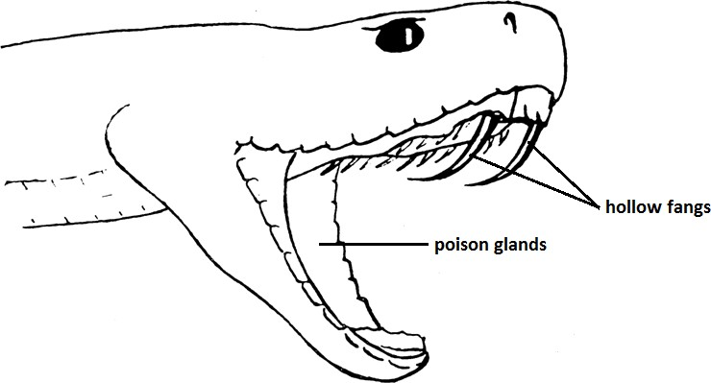

##### Qn. Why are the fangs of a poisonous snake hallow?

* To allow venom pass through easily.

##### Qn. Why are the fangs of a poisonous snake curved inside / in wards?

* To prevent the prey from escaping Qn. **State the first aid for snake bites.**
* Tie slightly above the bitten part.
* Use a black stone to suck venom from the body.

##### Qn. Why do we tie slightly above the bitten part when giving firstaid for snake bites?

* To prevent blood containing poison from flowing to the heart.
* 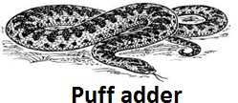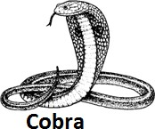Diagram showing some poisonous snakes

##### (ii) Non poisonous/Non-venomous snakes.

Qn. **What are non poisonous snakes?**

These are snakes without poison glands.

##### Characteristics of non poisonous snakes

* They have solid fangs.
* They do not have poisonous glands.
* They do not produce venom.
* They swallow their prey as a whole.
* They kill their prey by suffocating them to death.
* Examples of non poisonous snakes
* - Green snakes
* - Brown house snakes

##### Qn. Identify the examples of prey fed on by non-poisonous snakes.

- - Rats - Mice - Frogs

- - Newts - Salamander - Chicken

-

* (iii) Constrictors

##### Qn. What are constrictors?

* Constrictors are snakes which kill their prey by crushing and suffocating them to death.
* Characteristics of constrictors
* They have developed fangs.
* They kill their prey by crushing and suffocating them.
* They lick their prey making it slippery for easy swallowing.
* Examples of constrictors
* - Python
* - Anaconda
* - Boa
* Diagrams showing some constrictors

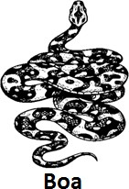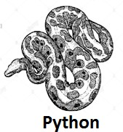-

-

##### LIZARDS

* Lizards have two pairs of limbs i.e. the front limbs and hind limbs.
* Characteristics of lizards
* They have a fleshy sticky tongue for trapping their prey.
* They have movable eyelids.
* They are cold blooded.
* They reproduce by laying eggs.
* They undergo internal fertilization

##### Examples of lizards

* - Gecko - monitor lizard
* - Chameleon - Agama lizards
* -Common lizards

##### Diagram showing some lizards

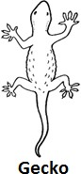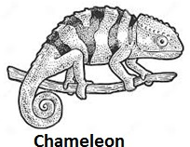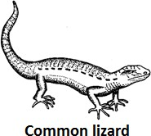

Qn. **Why does a chameleon changescolour / camouflage**?

* For protection
* For easy hunting of prey

##### Qn. How is a sticky long tongue important to a chameleon?

* For trapping prey

##### Qn. A part from a chameleon, mention four other organismsthat protect themselves by camouflaging?

* + Crocodile
  + Zebra
  + Octopus
  + Lizards
  + Geckoes

##### Qn. How are geckoes able to move upside down on ceilingswithout falling?

* They have suction pads under their feet.

##### Qn. How are geckoes and chameleons important in the environment?

* They help to feed on harmful insects.

-

* CROCODILES AND ALIGATORS
* Crocodiles and alligators are the largest among reptiles.
* Characteristics of crocodiles and alligators
* They are lethargic or very lazy.
* They have a long strong powerful tail for swimming and attacking their enemies.

- They have strong jaw bones for feeding on some aquatic animals.

* Diagram showing a crocodile

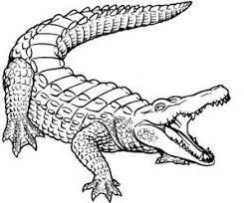

##### TORTOISES, TURTLES AND TERRAPINS

* These are reptiles enclosed in a complete hard shell made of bony plates for protection.
* Characteristics of tortoise and reptiles
* They do not have teeth but have sharp cutting edges used during feeding.
* They use lungs for breathing.
* They all reproduce by means of laying eggs.
* They hide under their shells for protection.

##### Qn. Name any one example of a vertebrate with a shell.

* + Tortoises
  + Turtles
  + Terrapins

##### Qn. How do tortoises protect themselves?

* By hiding in their hard shells
* Diagram showing tortoise, turtles and terrapins

-

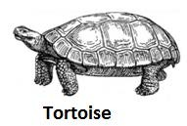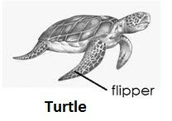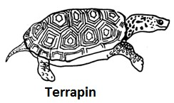

##### Feeding habits of tortoises and turtles

* Tortoises feed on vegetation.
* Turtles feed on small animals in water

##### Qn. How are tortoises and turtles adapted to their mode of feeding?

* They have sharp cutting edges
* Habitat for turtles, tortoise and terrapins
* Tortoises mostly live on land.

- Turtles stay in oceans and seas.

* Terrapins stay in fresh water.

-

##### Qn. How are terrapins and turtles adapted to life in water?

* They have flippers for swimming in water.
* Advantages of reptiles
* Some reptiles act as tourist attractions in the country.
* Some reptiles provide us with skins for making leather products.
* Some reptiles are sources of food to people.
* Some reptiles help to control insect vectors by feeding on them.

-

-

-

-

* AMPHIBIANS

Qn. **What are amphibians**?

* Amphibians are vertebrates that live on both land and in water.

##### Note:

* Amphibians spend their early stage of life in water and adult stage on land.

-

* Characteristics of amphibians
* They are cold blooded.
* They undergo external fertilization.
* They reproduce by laying eggs.
* They do not take care of their young ones.
* They live both on land and in water.
* Amphibians have webbed feet for easy swimming in water.
* They have backbones.
* Note:
* The young one of an amphibian is called **a tadpole.**
* Examples of amphibians

- - frog - salamander - toad

* - Newts - caecilians

##### Diagram showing some amphibians

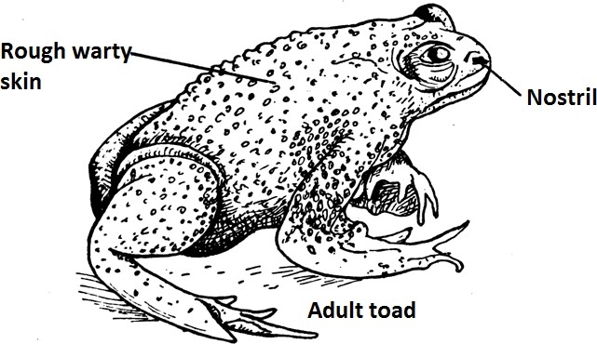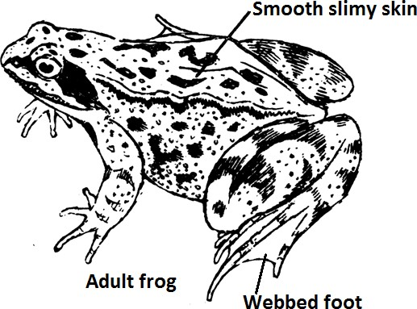

**Differences between a frog and a toad**

* A frog lays eggs in big masses(cluster) while a toad lays eggs in double ribbon like structure called **spawn.**
* A frog has no poison glands while a toad has poison glands.
* A frog hasafully webbed hind feet while a toad has a half webbed feet.
* A frog breathes through its moist skin in water and lungs on land while a toad breathes through lungs only.
* A frog commonly lives in water in the adult stage while a toad lives on land during the adult stage.
* A frog has a moist and smooth skin while a toad has a dry and rough skin.
* The tadpoles of a frog are brown while the tadpoles of a toad are black.
* Diagram showing eggs of a frog and a toad.

-

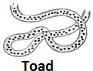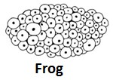

-

##### Breathing in amphibians

* A frog breathes through its moist skin and mouth cavity in water and lungs on land.
* A toad uses lungs and mouth cavity for breathing.
* A tadpole breathes through gills.
* Reproduction in amphibians
* Amphibians reproduce by laying eggs.
* The male amphibian mounts the female back.
* The female then lays eggs in water as the male sheds its sperms over them.
* This type of fertilization is called **external fertilization**

##### Qn. What is external fertilization?

Is the type of fertilization which takes place outside the body of a female animal.

##### Note:

* The eggs of amphibians are covered with a jelly like structure which has a bad smell.
* Importance of a jellylike substance to the eggs of an amphibian
* It protects the eggs from being eaten by predators.
* It makes the eggs difficult to pick.
* Diagram showing a tadpole

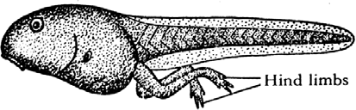-

-

-

-

* Feeding habits of amphibians
* Frogs and toads feed on worms and insects.

- Tadpoles feed on plants in water.

##### Qn. State the importance of a sticky tongue to an amphibian

* It helps an amphibian to catch the flying insects easily. Qn**. How do amphibians protect themselves?**
* A toad has poison glands which produce poison.
* A frog has a smooth and slippery skin which helps it to slide away from its enemies.
* The eyes of amphibians are found on top of the head to enable them see well in water.
* Adaptation of frogs to living in water
* Frogs have fully webbed hind feet to enable them swim in water easily.
* Frogs have a streamlined body to overcome viscosity friction in water. Qn. **How is a frog adapted to living on both land and in water?**
* A frog breathes through its moist skin while in water and lungs on land. Qn. **Give a reason why amphibians lay very many eggs**.
* To increase the chance of survival since some are preyed upon. [may be eaten by predators].
* Importance of amphibians
* They feed on some insect vectors.
* They are used in practical science lessons in schools.
* They are eaten as food in some parts of the world.
* FISH
* Fish are aquatic animals.
* Characteristics of fish
* They are cold blooded.
* They reproduce by laying eggs.
* They undergo external fertilization.
* They breathe through the gills.
* They have a streamlined body to overcome viscosity friction in water.
* The body of fish is covered with scales.
* Fish are vertebrates[have backbones].
* Note:
* The young one of a fish is called **a fry.**
* Diagram showing external parts of a fish

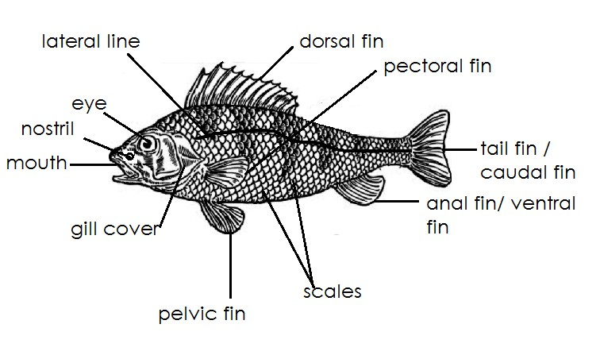-

-

-

-

-

-

-

-

-

-

-

-

##### Functions of each part of a fish

1. **Scales**

Covers and protect the body of a fish.

##### Gill cover/operculum.

Protect the gills from damage.

##### Nostril

For smelling For tasting food

##### Gills

For breathing

##### Mouth

Acts as a passage of food into the body of a fish. Acts as a passage of dissolved oxygen to the gills.

##### Lateralline

Detects sound waves in water.

##### Tail fin

It enables the fish to move forward (gives the fish forward movement). It protects the fish against enemies.

##### Dorsal fin

It protects the fish against enemies.

##### (xi) Anal fish / ventral fish

Controls the rolling and unsteady movement of fish in water.

##### Pectoral fin and pelvic fin

They enable the fish to move downwards and upwards in water. They help the fish to reduce speed and stop.

##### Note:

* + Pectoral fin and pelvic fin are called **paired fins.**

-

* + Types of fish
  + There are three types of fish namely: -
  + - Bony fish
  + - Cartilaginous fish
  + - Lung fish

##### Bony fish

These are fish with a bony skeleton and covered with overlapping scales.

##### Characteristics of bony fish

* + They are covered with overlapping scales.
  + They have swim bladder that keep them buoyant in water. Qn. **How is a swim bladder important to a bonny fish**?
  + It keeps the fish buoyant in water (keeps a fish afloat).
  + It controls the depth at which the fish swims in water.
  + Position of a swim bladder in the body of a fish.

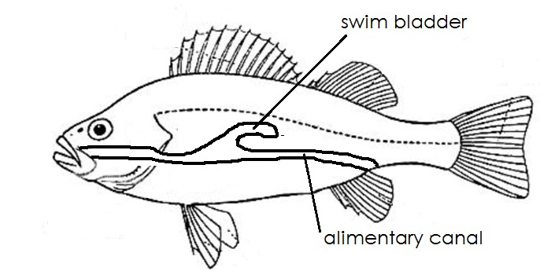-

-

-

-

-

-

-

-

-

-

-

* + Examples of bony fish
  + - Tilapia
  + - Nile perch
  + - Salmon
  + - herrings
  + - Vout fish
  + - pike

##### LUNG FISH

* + These are fish commonly found in dirty waters of pools, swamps and rivers.
  + Lung fish commonly hibernate during the dry season and continue living in wet season. Qn. **What is hibernation**?

Hibernation is a state when body activities are slowed down.

##### Examples of lung fish

* + - Common lung fish
    - Diponi
    - Epiceratodus

##### CARTILAGINOUS FISH

Cartilaginous fish are fish with soft tissue called cartilages

##### Characteristics of cartilaginous fish

* + They do not have gill covers instead they have gill slits.
  + They do not have a swim bladder.
  + They prevent sinking by constant swimming.
  + Examples of cartilaginous fish
  + - shark
  + - Dog fish
  + - Rays
  + - Skates

-

- Ways in which fish protect themselves

* + Fish use dorsal fins for protection.
  + Some fish have slippery body to protect themselves from enemies.
  + Fish have different shades of colour for hiding away from enemies.
  + Some fish have electric organs for shocking the enemy.
  + Some fish inject poison into their enemy.

-

* + Reproduction in fish

##### Qn. How do fish reproduce?

* + Fish reproduce by laying eggs.

##### Qn. What type of fertilization do fish undergo?

* + External fertilization

##### Qn. Where do fish lay their eggs?

* + They lay eggs in swallow water.

##### Qn. What name is given to the young one of a fish?

* + Fry or fingerling.

##### Qn. What name is given to the eggs of a fish?

* + Roe

-

##### Feeding in fish

* + Fish feed on aquatic plants.
  + Breathing in fish

Qn. **How do fish breathe**?

* + Fish breathe in dissolved oxygen using gills.

##### Qn. Why does fish die shortly after being removed from water?

* + Due to lack of dissolved oxygen.

##### Qn. By what process does fish take in dissolved oxygen?

By diffusion

##### Diagram showing the structure of gills

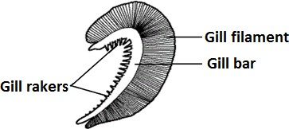

**Uses of each part of the gills**.

##### Gill rakers

Trap dirt and any solid particles that may damage the filament.

##### Qn. How are gill rakers adapted to their function?

* + They are comb like.

##### Gill bar

Holds the filament in position.

It prevents the gill rakersfrom interlocking with the gill filaments.

##### Filaments

* + It is where gaseous exchange takes place.

##### Qn. Identify one adaptation of the gill filaments to their function.

* + They are many in number.
  + They have thin walls.

##### Qn. Why are gill filaments many in number?

* + To increase the surface area for gaseous exchange to take place**.**
  + Adaptations of fish to living in water

##### Qn. How are fish adapted to living in water?

* + They have gills for breathing in water.
  + They have fins for swimming in water.
  + They have streamlined bodies that reduce viscosity friction in water.
  + Fish have a swim bladder that keep them buoyant in water.
  + They have a lateral line for detecting sound waves in water.
  + Some fish are slippery to escape easily from their enemies.

-

* + Advantages of fish
  + Fish are eaten as food.
  + Fish are source of income after sale.
  + Fish help to control malaria.
  + Fish bones are used in making poultry feeds.
  + Their bones are used to make glue.
  + Their skins are used to make surgical threads.

##### Qn. Which food value do we get from eating fish?

* + Proteins

##### Qn. How do fish help to control malaria?

* + Fish feed on the larva of mosquitoes which spread malaria.

##### Qn. What name is given to a glass container used to keep fish at home?

* + Aquarium

##### Qn. How does fish help to control kwashiorkor in children?

* + Fish provide proteins to children.

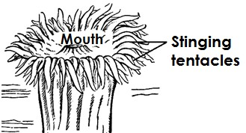

**41 |** P a g e

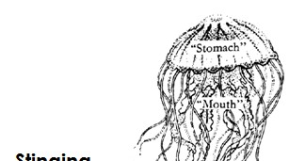

##### INVERTABRATES

Qn. **What are invertebrates?**

* + Invertebrates are animals with no back bones / spine /spinal column.

##### Characteristics of invertebrates

* + They do not have back bones /spine.
  + Most invertebrates have an exo skeleton

##### Groups of invertebrates

* + - Coelenterates
    - Echinoderms
    - Sponges
    - Molluscs.
    - Worms
    - Arthropods

##### COELENTERATES

These are stinging animals with only one opening.

##### Characteristics of coelenterates

* + They have one body opening which acts as both mouth and anus.
  + They have tentacles which act as sense organs for touch and smell.

##### Examples of coelenterates

-Jelly fish

* + - Sea anemones
    - Hydra
    - Corals

##### Diagram showing some coelenterates

**ECHINODERMS**

These are invertebrates which mostly live in seas.

##### Characteristics of echinoderms

* + They have spines.
  + They have unsegmented body.

##### Examples of echinoderms

* + - Star fish
    - Sea urchin
    - Sea cucumber

**Diagram showing some echinoderms**

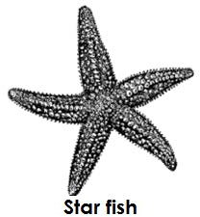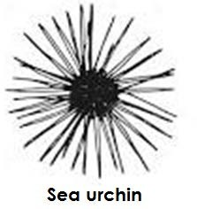

**SPONGES**

* + Sponges mostly live in fresh water of the sea.

##### Characteristics of sponges

* + Most of sponges have soft bodies.
  + Sponges do not move but remain attached to the floor of the sea.
  + Sponges breathe through the holes found on their skin.
  + Sponges feed through the holes found on their skin.

##### MOLLUSCS.

* + Molluscs are soft bodied and unsegmented invertebrates.

-

##### Characteristics of molluscs

- Most molluscs have shells for protection.

* + 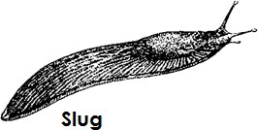Molluscs have soft bodies.
  + Molluscs have tentacles for detecting sound,smell and temperature.
  + Sea molluscs breathe through gills.
  + Land molluscs breathe through simple lungs.

##### Examples of molluscs

* + - Fresh water snail - Oyster
    - slug - squid
    - octopus - garden snail
    - curtle fish

##### Diagram showing different molluscs

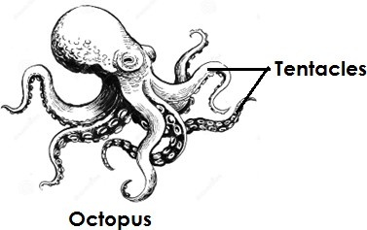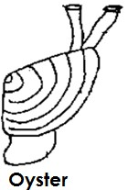

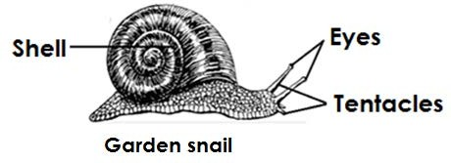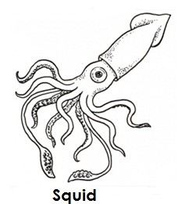

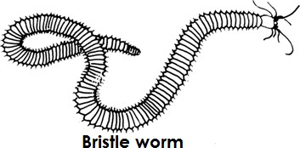**WORMS**

* + Worms are long thin and soft bodied invertebrates.

##### Characteristics of worms

* + Worms have soft bodies.
  + Worms breathe through their moist skin.

##### Groups of worms

* + Segmented worms (annelids)
  + Round worms (Nematodes)
  + Flat worms (Platy helminthes)

1. **Segmented worms**
   * These are worms whose bodies are divided into segments or rings.
   * They mostly live in moist places.

##### Examples of segmented worms

-Earth worms

-Leeches

-Bristle worms

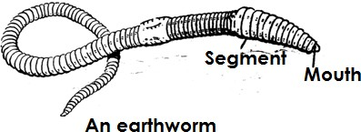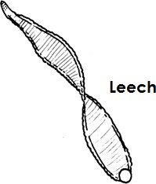**Diagrams showing segmented worms**

**Earth worms**

Earth worms mostly live in fresh waters and soil.

##### Note:

* + Earth worms are hermaphrodites i.e. they have both male and female reproductive organs.

##### Qn. How do earth worms breathe?

* + Through their moist skin. Qn. **How do earth worms move**?
  + By contraction of their body muscles.

##### Qn.How are earth worms important in the environment?

* + They help in aerating the soil. Qn.**How do earth worms aerate the soil**?
  + By digging holes/ tunnels in the soil. Qn.**How is soil aeration important**?
  + It enables air to enter into the soil.
  + It enables water to enter into the soil.

##### Qn. Why do earthworms come out of the soil after it has rained?

* + To get oxygen for breathing.

##### Qn. What happens when oil is poured on the body of an earth worm?

* + It dies.

##### Qn. Why does an earthworm die when oil is poured on its body?

* + Oil blocks the breathing organs of an earth worm.

##### Qn.What type of skeleton do earth worms posses?

* + Hydrostatic skeleton

##### FLAT WORMS

* + Are worms with flattened and segmented bodies.
  + Flats worms are parasites to animals.

-

##### Examples of flat worms

* + Liver flukes
  + Tape worms

##### Liver fluke

* + A liver fluke is a paper like worm.
  + It lives in the liver and damages it.
  + It enters the body through eating under/half cooked liver.

##### A diagram showing a liver fluke

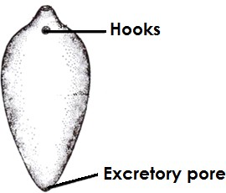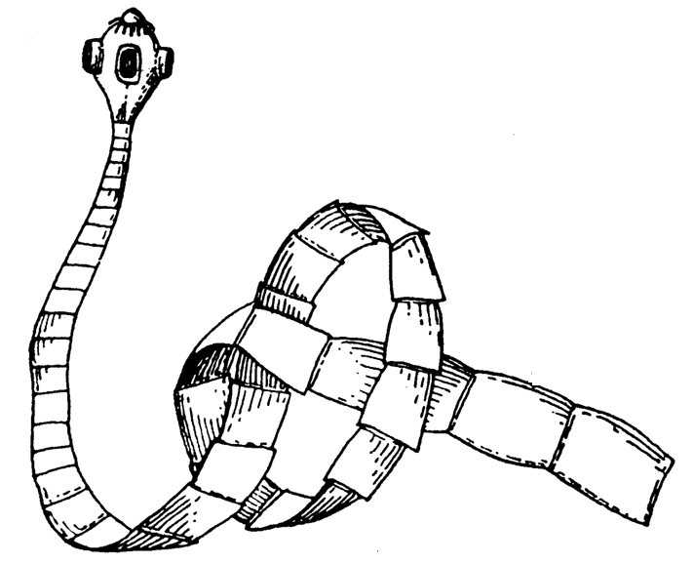

**Tape worm**

##### Qn. How do tape worms enter our bodies?

* + Through eating half cooked meat or pork. Qn. **Where do tape wormslive in our bodies**?
  + Small intestines

##### Qn. What do tape worms feed on?

* + Digested food

##### Qn. How do tape worms feed?

* + By diffusion

##### Qn. How are suckers and hookworms useful to a tape worm?

* + They attach the tape worm onto the walls of the small intestines. Qn. **How are segments useful to a tape worm**?
  + For storing eggs

##### Qn. What scientific name is given to the head of a tape worm?

* + Scolex

##### A diagram showing a tape worm

**46 |** P a g e

Qn. **State one way of controlling tapeworm infestation**.

* + Eating well cooked meat or pork.
  + Regular deworming.
  + Proper disposal of faeces.

##### Qn. State the effect of tape worms to an individual.

* + Tape worms feed on digested food and cause malnutrition.

##### ROUND WORMS

* + These are worms with cylindrical bodies.
  + They are parasites to animals and people.
  + Some live in water and others in soil.

##### Examples of round worms

* + hook worms - Eel worms
  + Pin worms - Filarial worms
  + guinea worms - whip worms
  + askaris - thread worms

##### Hook worms

* + Hook worms live in small intestines.
  + Hook worms feed by sucking blood.

##### Diagram showing hook worms.

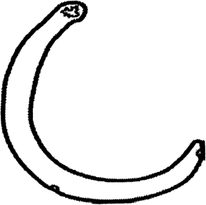

**Qn. How do hook worms enter our bodies?**

* + Through entering the skin of the bare feet.
  + Through entering the skin when one walks bare footed in wet/damp places.

##### Qn. What do hook worms feed on?

* + Blood

##### Qn. How are hook worms dangerous to humans?

* + They suck blood from the body and cause hook worm anaemia.

##### Ways of controlling hook worm infestations.

* + Byregular deworming
  + Proper disposal of faeces
  + Washing hands after visiting the latrines
  + Wear shoes / sandals when walking in wet dirty places.

##### Qn. State any two signs of hookworm infestations.

* + Abdominal pain
  + Fever
  + Faeces containing worms
  + Diarrhoea

##### ARTHROPODS

Qn. **What are arthropods**?

* + Arthropods are animals with jointed legs and segmented bodies.

##### Characteristics of arthropods

* + They have segmented bodies.
  + They have jointed legs.
  + They have an exo skeleton.
  + They undergo moulting in order to remove theirexo skeleton.

##### Qn. How is moulting important to arthropods?

* + It helps arthropods to grow and increase in size.

##### Groups of arthropods

* + Insects
  + Crustaceans
  + Myriapods
  + Arachnids

##### Myriapods

* + Myriapods are arthropods with many legs and segmented bodies.

##### Examples myriapods

* + Centipedes
  + Millipedes

##### Centipedes (Chilopoda)

- A centipede has a pair of jointed legs on each segment.

* + A centipede has a pair of antennae.
  + A centipede has poisonous claws used for protection.
  + Centipedes are carnivores.

##### A diagram showing a centipede.

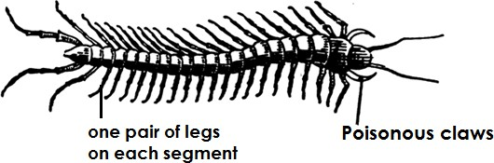

Qn. **How does a centipede protect itself**?

* + By injecting poison into the body of the enemy.
  + By stinging using their poisonous claws.

##### Qn. Name two examples of prey a centipede feeds on.

* + Worms
  + Insects

##### Millipede (diplopoda)

* + A millipede has two pairs of jointed legs on each segment.
  + A millipede protects itself by coiling.
  + Millipedes are herbivores.

##### A diagram showing a millipede

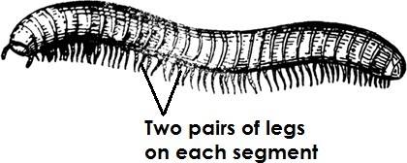

Qn. **How does a millipede protect itself?**

* + By coiling or curling

##### Qn. How are millipedes important in the environment?

g e

* + They aerate the soil by creating tunnels in the soil.
  + Their waste products make the soil fertile.
  + Their bodies when they die add fertility to the soil.

##### Qn. State three differences between millipedes and centipedes.

* + Millipedes are herbivorous while centipedes are carnivorous.
  + Millipedes have two pairs of legs on each segment while centipedes have one pair of legs on each segment.
  + Millipedes protect themselves by coiling while centipedes protect themselves by stinging. Qn. **Apart from coiling, how else do some millipede protect themselves**?
  + By producing bad smell.

##### CRUSTACEANS

Qn **What are crustaceans**?

* + These are arthropods with a hard crust exo skeleton.

##### Characteristics of crustaceans

* + They mainly live in fresh water.
  + They have a hard crusty exo skeleton.

##### Examples of crustaceans

* + - crab - shrimp
    - lobster - prawn
    - cyclop - wood louse
    - cray fish

##### Note:

* + Crabs and lobsters have pincers (sharp claws) for protection.

##### Diagram showing some crustaceans

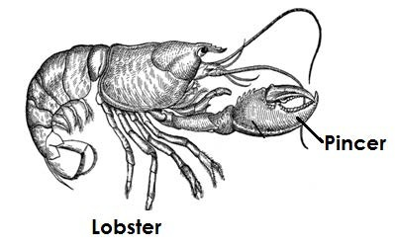

**50 |** P a

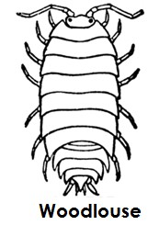

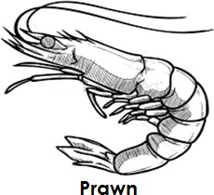 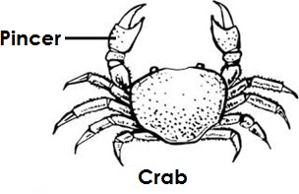

##### Feeding habits of crustaceans

* + Some feed on vegetation.
  + Some feed on insects and worms.
  + Some have filtering structures in the mouths which filter tiny plants and animals out of water.

##### Importance of crustaceans

* + Crabs and lobster are used as food.
  + They are sold for money.

##### ARACHNIDS

Qn. **What are arachnids**?

* + These are arthropods with two main body parts and four pairs of legs.

##### Characteristics of arachnids

* + They have four pairs of legs.
  + They have two main body parts i.e**cephalothorax**and**abdomen.**
  + They have no wings.
  + They have no antennae.
  + Arachnids breathe through lung books.

##### Examples of arachnids

* + - Ticks - scorpion
    - spider - mites

##### Spiders

* + A spider breathes through lung books.
  + A spider reproduces by laying eggs.

1. **|** P a g e
   * A spider has special organs called **spinneretes** at the end of the abdomen for spinning silk or making a web.

##### A diagram showing spider and its web.

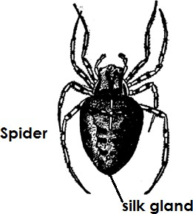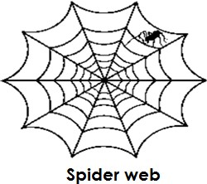

**Importance of a web to a spider**

* + It helps a spider to trap its food/prey.
  + It acts as a habitat for the spider.
  + It is used for protection.
  + Male spiders use a web for trapping the female during mating. Qn. **Why is a spider not regarded as an insect**?
  + A spider has two main body parts while an insect has three main body parts.
  + A spider breathes through lung books while an insect breathes through spiracles.
  + A spider has four pairs of legs while an insect has three pairs of legs.

##### Scorpion

* + A scorpion breathes through lung books.
  + A scorpion has a large tail with poisonous sting.
  + A scorpion reproduces by giving birth to live young ones.

-

##### A diagram showing a scorpion

1. **|** P a g e

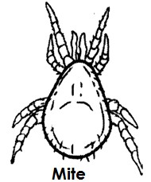

**53 |** P a g e

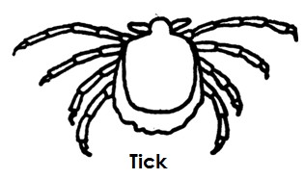

##### Qn. How is a scorpion different from other arachnids in the way it reproduces?

* + A scorpion reproduces by giving birth to live young ones while the other arachnids reproduce by laying eggs.

##### Qn. How does a scorpion protect itself?

* + By injecting poison into the body of an enemy.
  + By stinging using its poisonous claws.

##### TICKS AND MITES

* + Ticks and mites are parasites that feed on blood.
  + Ticks spread diseases to livestock animals.

##### Examples of tick borne diseases

* + East Coast fever
  + Red water
  + Heart water
  + Anaplasmosis

##### Note:

* + All the above diseases are caused by protozoa. Qn. **What is a parasite**?
  + A parasite is an organism which depends on another organism for its survival without killing it.

##### Qn. What name is given to the organism on which a parasite depends?

* + Host

##### Diagram showing a tick and a mite

**INSECTS**

* + These are arthropods with three main body parts and three pairs of legs.

##### Characteristics of insects

* + All insects have three main body parts.
  + All insects have three pairs of jointed legs.
  + Insects breathe through spiracles.
  + They have a pair of feelers called antennae.

##### Examples of insects

* + Housefly - grasshoppers - dragon flies
  + Cockroach - mosquitoes - wasps
  + Bees - tsetse flies - ants

##### Diagram showing the parts of an insect.

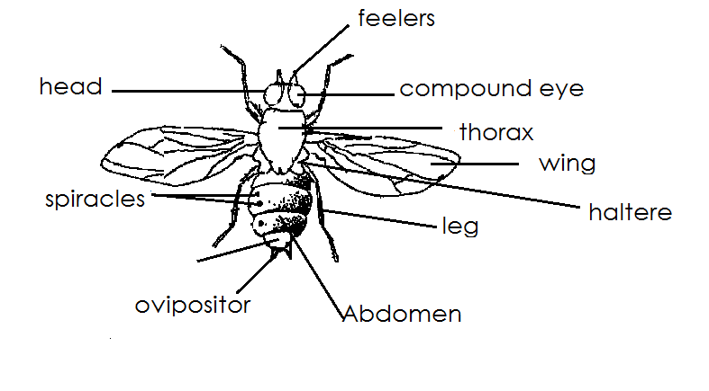Qn.

**Mention the three main body parts of an insect**.

* + - head
    - thorax
    - abdomen

##### Parts of an insect which are found on the head.

1. **compound eyes**
   * They are used for seeing

##### Antennae

* + For smelling and feeling
  + For detecting sound waves and temperature changes.

##### Proboscis

- For sucking blood and plant juice.

##### Mandibles

* + For biting and chewing
  + Parts of an insect found on the thorax

##### Wings

* + For flying

##### Halteres

* + For balancing the body of an insect during flight.

##### Legs

* + For movement

##### Parts of an insect found on the abdomen

1. **Spiracles**
   * For breathing

##### Ovipositor

* + For laying eggs

##### Stinger

* + For protection

##### Feeding habits of insects.

* + The feeding habits of insects depend on the mouth parts they have.
  + Some insects have **mandibles**while others have **proboscises.**

##### Qn. Name any four examples of insects with mandibles.

* + - Cockroaches - Crickets
    - Grasshoppers - Termites
    - Locusts - Beetles

##### Qn. Mention any four examples of insects with proboscises

* + - Houseflies - Tsetse flies
    - Mosquitoes - Moths
    - Bees - Butterflies

##### A diagram of a blood sucking mosquito (proboscis)

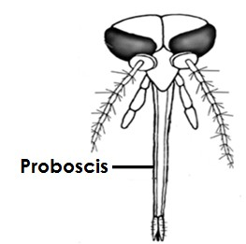

**Reproduction in insects**

##### Qn. How do insects reproduce?

* + By laying eggs

##### Qn. What name is given to the different stage of development the eggs of an insect undergoes?

* + Metamorphosis or life cycle.

##### Metamorphosis

* + Metamorphosis are the different stages of development an insect undergoes.

##### Types of metamorphosis

* + Complete life cycle
  + Incomplete life cycle

##### Complete life cycle/metamorphosis.

Qn. **What is a complete metamorphosis?**

* + This is where an insect undergoes all the four stages of development.

##### Stages of a completelifecycle/metamorphosis.

* + egg larva pupa adult

##### Examples of insects that undergo complete lifecycle

* + housefly - termites
  + mosquito - black flies
  + butterfly - black fly
  + bee
  + moths

##### A house fly

**A diagram showing the life cycle of a housefly**

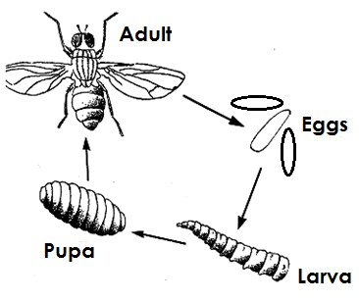

##### Note:

* + The larva of a housefly is called a **maggot.**
  + The adult stage of a housefly is called **imago.**

##### Qn. How are houseflies help to reduce the volume of faces in pit latrine?

* + The larvae of houseflies help to reduce the volume of faeces in pit latrines. Qn. **State any two dangers of a housefly**.
  + Houseflies spread diarrhoeal diseases.
  + Houseflies contaminate food.

##### Qn. How do houseflies able to spread diseases?

* + Through the hair on their bodies.
  + By the help of their hairy body.

##### Butterfly

**A diagram showing the life cycle of a butterfly**

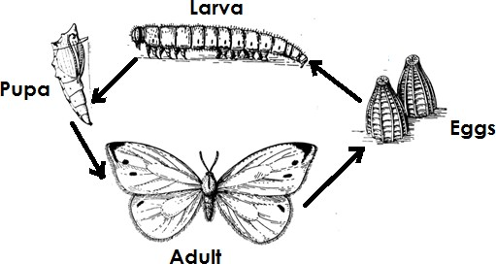

##### Note:

* + The larva stage of butterfly is called a **caterpillar.**

##### Qn. At what stage is a butterfly:-

1. **Useful to people**?
   * Adult stage

##### Dangerous to people

* + Larva stage

##### Qn. How is a larva stage of a butterfly dangerous to people?

* + It destroys people’s crops

##### Qn. How is the adult stage of a butterfly important to crop farmers?

* + It helps in pollination of farmer’s crops.

##### Qn. At what stage is a butterfly dormant?

* + Pupa

##### Mosquitoes

* + There are three types of mosquitoes namely:-
  + Culex mosquito
  + Anopheles mosquito
  + Aedes / tiger mosquito

##### Culex mosquitoes

* + Culex mosquitoes spread elephantiasis to people.
  + Elephantiasis is caused by **filarial worms**.

##### Characteristics of culex mosquitoes.

* + Culex mosquitoes fly during day and night.
  + The body of an adult mosquito lies horizontal or flat during rest.
  + They lay eggs in a raft.

##### Aedes / Tiger mosquito

* + It spreads yellow fever and dengue fever.
  + Yellow fever is caused by viruses.

##### Characteristics of aedes/tiger mosquitoes

* + They fly during day.
  + They lay single eggs.

##### A diagram showing the life cycle of tiger and culex mosquito.

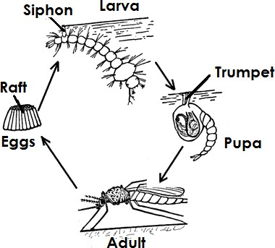

**Life cycle of an aedes / tiger mosquito**

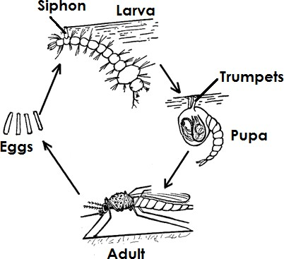

##### Note:

* + The larva of a culex and aedes mosquito lie at an angle to the surface of water.

##### Anopheles mosquito

* + The female anopheles mosquito spreads malaria.
  + Malaria is caused by **plasmodia germs.**

##### Qn. Why can’t a male anopheles mosquito spread malaria?

* + It does not suck blood but feeds on plant juices.

##### Qn. Why does a female anopheles mosquito suck blood?

* + To enable their eggs grow.

##### Characteristics of anopheles mosquitoes.

* + Anopheles mosquitoes lay eggs with an air float.
  + The larva of anopheles mosquito lies parallel to the surface of the water.
  + The adult anopheles mosquito rests at a floppy position.

##### Diagram showing the lifecycle of anopheles mosquito.

**59 |** P a g e

##### Qn. Name the structures the larva stage of a mosquito uses for breathing.

* Siphon

##### Qn. State the importance of an air float found on the eggs of a female anopheles mosquito.

* To enable the eggs float on water.

##### Qn. Name the breathing structure of the pupa stage of a mosquito.

* Trumpet

##### Breeding of mosquitoes

Qn. **Where do mosquitoes breed from**?

* Stagnant water/Still water.

##### Qn. Why do mosquitoes lay their eggs in stagnant water?

* To prevent eggs from being carried away.

##### Ways of controlling mosquitoes

* Draining stagnant water.
* Spraying using insecticides.
* Clearing tall grasses around the home.
* Pouring oil on stagnant water.
* Keeping fish in ponds to feed on mosquito larva.

##### Note:

* Keeping fish in ponds to feed on mosquito larva is a **biological method**of controlling mosquitoes.

##### Tsetse fly

* A tsetse fly feeds on blood. Qn. **How does a tsetse fly feed**?
* By sucking blood using a proboscis

##### Qn. Where do tsetse flies live or breed from?

- Tsetse flies live in bushy areas or forests.

##### The diagram showing the life cycle of a tsetsefly

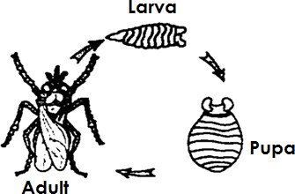

**Note**:

* The eggs of a tsetse fly hatch into larvae inside the abdomen of a female tsetse fly. Qn. **How does a tsetse fly reproduce**?
* By giving birth to a live larva.

##### Qn. State any two dangers of a tsetse fly.

* A tsetse fly spreads sleeping sickness to people.
* A tsetse fly spreads Nagana to animals.

##### Qn. What causes Nagana in animals and sleeping sickness in people?

* A germ called Trypanosome

##### Qn. State any two ways of controlling tsetse flies.

* By clearing bushes
* By setting up tsetse fly traps.

##### Incomplete life cycle

Qn. **What is incomplete metamorphosis**?

* This is where an insect undergoes only three stages of development.

##### Stages of incomplete life cycle

* Egg Nymph Adult

##### Examples of insects that undergo incomplete lifecycle

* Cockroaches - Dragon flies
* Grasshopper - Praying mantis
* Cricket
* Locusts

##### Cockroach

Qn. **Where do cockroaches breed from**?

* + In latrines
  + In septic tanks

- Cupboards

* + In sofa sets

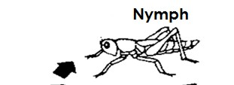

##### Qn. What do cockroaches feed on?

* + Leftover food

##### Qn. List any four diseases spread by cockroaches.

* + Diarrhoea
  + Typhoid
  + Dysentery
  + Polio
  + Cholera

##### Qn. Give any two ways of controlling cockroaches.

* + By spraying using insecticides.
  + By keeping cooked food covered.
  + By spraying breeding places for cockroaches.

##### The diagram showing the life cycle of a cockroach

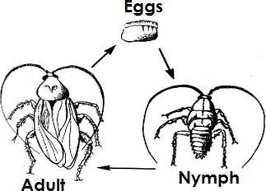

**Grasshoppers**

* + Grasshoppers feed on vegetation or leaves.

##### Qn. State one importance of grasshoppers to people.

* + Grasshoppers are eaten as food.
  + Grasshoppers are sold for money.

##### Qn. Identify any one danger of grasshoppers to crop farmers.

* + Grasshoppers destroy farmer’s crops.

Qn. **Where do grasshoppers lay their eggs?**

* + Soil

##### The diagram showing the life cycle of a grasshopper

**Advantages of insects**

* + Insects pollinate crops.
  + Some insects are eaten as food.
  + Some insects aerate the soil.
  + Bees provide honey and wax.
  + Maggots of houseflies help to reduce the volume of faeces in pit latrines.
  + Some insects are sold for money.

##### Disadvantages of insects.

* + Some insects spread germs that cause diseases.
  + Some insects destroy farmer’s crops.
  + Some insects sting animals and people.
  + Some insects are external parasites to farm animals.

##### SINGLE CELLED ANIMALS

Qn. **What are single celled animals**?

* + These are animals with only one cell.

##### Groups of single celled animals

* + Protoctista Monera

##### Protoctista Kingdom

Protoctista kingdom is divided into two groups viz: -

* + Protozoa
  + Algae

##### Protozoa

* + Most of the protozoa are germs that cause different diseases to people and animals.

##### Examples of protozoa

* + - Amoeba
    - Plasmodia
    - Trypanosomes
    - Paramecium

##### An amoeba

Qn. **Why is an amoeba called a single celled animal**?

* + It has only one cell

##### Qn. Where does an amoeba live?

* + In fresh water

##### Qn. How does an amoeba reproduce?

* + By the means of cell division or binary fission Qn. **How does an amoeba move**?
  + By the help of the pseudopodia or false legs. Qn. **How does an amoeba feed**?
  + By engulfing the food particles

##### The diagram showing an amoeba

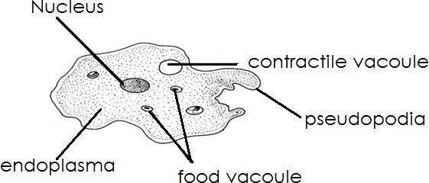

**A paramecium**

##### Qn. How does a paramecium move?

* + By the help of the cilia

##### The diagram showing a paramecium

**64 |** P a g e

##### An euglena

Qn. **How does an euglena move**?

* By the help of the flagellum

##### Note:

* Most euglena contain chlorophyll therefore they make their own food.

##### The diagram showing an euglena

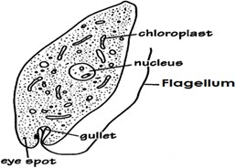

1. **Algae**

Qn. **Where do algae grow**?

* + Algae grow in water
  + Algae grow in damp places. Qn. **How do algae reproduce**?
  + By means of spores

##### Qn. State the two examples of algae

* + Spirogyra
  + Sea weeds
  + Fucus

##### Note:

* + Algae have chlorophyll and can make their own food.

##### The diagram showing a spirogyra

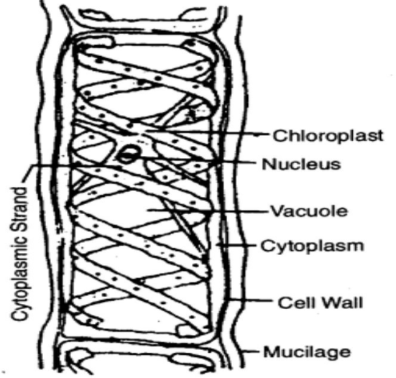

Qn. **How does a spirogyra move**?

* + By the means of fragmentation

##### Uses of algae

* + They are used as food
  + They add oxygen to water
  + They are used in making fertilizers.

##### THEME : MATTER AND ENERGY TOPIC : SOUND ENERGY

Qn. **Give the meaning of the term sound.**

* + Sound is the form of energy that enables us to hear.
  + OR
  + Sound is the form of energy produced by vibration of an object. Qn. **Why is sound called a form of energy**?
  + Sound enables us to do work.

##### Properties of sound

* + Sound can be reflected.
  + Sound moves in all directions.

##### Types of sound

* + Loud sound
  + Soft sound
  + High sound
  + Low sound

##### Production of sound

Qn. **How is sound produced?**

- By means of vibration.

Qn. **What is vibration**?

Vibration is the **to**and**fro** movement of an object.

##### Sources of sound

Qn. **What is a source of sound**?

* + A source of sound is anything that vibrates to produce sound.

##### Note:

* + Sources of sound are divided into two types viz.
  + Natural sources of sound.
  + Artificial sources of sound.

##### Natural sources of sound

* + These are materials that produce sound on their own.

##### Examples of natural sources of sound

* + Birds - A cat
  + Human beings - Storms
  + A cow - Insects
  + A dog - Water falls
  + A snake - Earth quakes

##### Qn. How do the following animals produce sound?

1. **Human beings**
   * By vibration of their vocal cords

##### Birds

* + By vibration of the rings of cartilage in their trachea.

##### Bees and mosquitoes

* + By moving/flapping their wings rapidly in air

##### Crickets and grasshoppers

* + By rubbing their hind legs against their vibrating wings

##### Artificial sources of sound

* + These are man made materials that produce sound.

##### Examples of artificial sources of sound

* + Drums - Phones
  + Xylophones - Guitars
  + Aeroplanes - Bottles
  + Cars - Horns
  + Guns- Bow harp
  + Whistles - Piano
  + Motorcycles

##### Musical instruments.

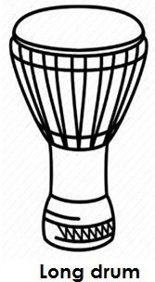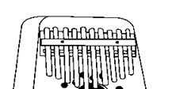

**68 |** P a g e

* + Musical instruments are tools played to produce musical sounds. Qn. **What is music**?
  + Music is an organized sound produced by regular vibration. Qn. **What is noise**?
  + Noise is disorganized sound produced by irregular vibration.

##### Qn. What is a musical instrument?

* + A musical instrument is a tool or device used for producing musical sound.

##### Group of musical instruments

* + Wind musical instruments.
  + String musical instruments.
  + Percussion musical instruments.

##### PERCUSSION MUSICAL INSTRUMENTS

Qn. **What are percussion musical instruments?**

* + These are instruments which produce sound by vibration when struck, hit or shook.

##### Examples of percussion musical instruments

* + Drum - Thumb piano
  + Xylophone - Brass band
  + Long drum - Rattles
  + Bells - Clappers / strikers
  + Shakers

##### Diagram showing some percussion instruments

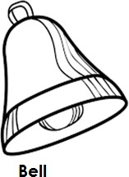 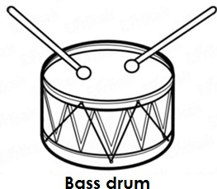

##### Qn. How some percussion musical instruments are played and produce sound?

1. **Drum**

##### Qn. How is a drum played?

* + By hitting it to vibrate.

##### Qn. How does a drum produce sound?

* + By vibration of its skin/membrane when hit.

##### Shakers

Qn. **How are shakers played?**

* + Shakers are played by striking/shaking. Qn. **How do shakers produce sound?**
  + By vibration when struck

##### Xylophone

Qn. **How is a xylophone played**?

* + A xylophone is played by hitting or beating

##### Qn. How does a xylophone produce sound?

* + By vibration when hit.

##### Bell

Qn. **How is a bell played**?

1. **|** P a g e
   * A bell is played by hitting.

##### Qn. How does a bell produce sound?

* + By vibration when it is hit.

##### STRING MUSICAL INSTRUMENTS.

**Qn. What are string musical instruments?**

* + These are musical instruments made of strings and produce sound by vibration when they are plucked or bowed.

##### Examples of string musical instruments

* + Bow harp - Guitar
  + Tube fiddle - Violin
  + Lyre

##### Diagram showing some string musical instruments

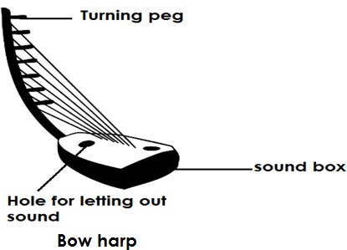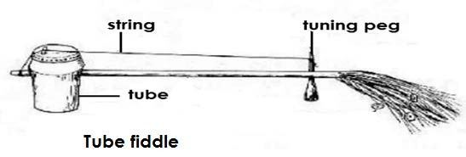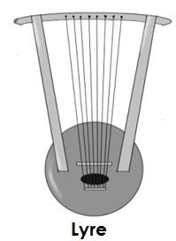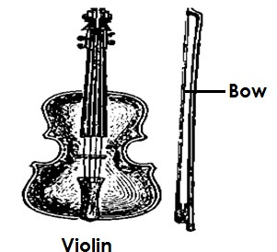

1. **|** P a g e

##### Note:

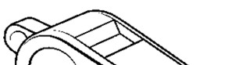

**71 |** P a g e

* + Strings of a bow harp have different length to produce different pitch of sound.

##### Qn. How can one change pitch of astring musical instrument?

* + By tightening or loosening the strings.

##### Qn. How can one increase the pitch of string instruments?

* + By tightening the strings

##### Qn. How can one lower the pitch of string musical instruments?

* + By loosening the strings

##### WIND MUSICAL INSTRUMENTS.

Qn. **What are wind musical instruments?**

* + These are instruments which produce sound by vibration of air blown inside them. Qn. **How are wind musical instruments played?**
  + By blowing air inside them.

##### Qn. How do wind musical instruments produce sound?

* + By vibration of air blown inside them.

##### Examples of wind musical instruments

* + Flute - Trumpet

A horn - Trombone

* + A whistle
  + A recorder
  + Empty bottles
  + Panpipes
  + Saxophone

##### Diagram showing some of the wind musical instrument

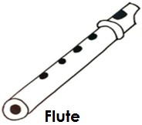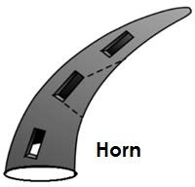

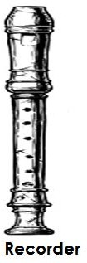 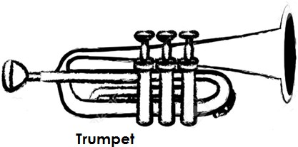

## Note:

* + Some wind musical instruments have holes numbered to produce different pitch of sound.

##### TRANSMISSION / MOVEMENT OF SOUND

Qn. **How does sound travel**?

* + By means of sound waves.

##### Note

* + Sound travels in all direction from the source.

##### Diagram showing that sound travels in all directions.

**72 |** P a g e

##### Note:

* For sound to travel,there must be a medium of sound transmission or matter Qn. **Why can’t sound travel through a vacuum?**

A vacuum has no matter that can transmit sound waves.

##### Speed of sound

* Sound travelsthrough different states of matter at different speed ie
* - Through solids at speed of 1500m/sec.
* - Through liquids at a speed of 1484m/sec.
* - Through gases at a speed of 330m/sec.

##### Qn. In which state of matter does sound travel fastest?

* In solids

##### Qn. Why does sound travel faster in solids?

* Solids have closely packed molecules which allow vibration to take place easily. Qn**. In which state of matter does sound travel lowest?**
* In gases

##### Qn. Why does sound travel slowest in gases?

* Gases have widely spread molecules.

##### An experiment to show that sound travels through solids

This experiment is done using two cups and a string as shown below.

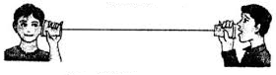

##### Qn. What does the above experiment prove about sound?

* It proves that sound travels through solids.

##### Factors that affect the speed of sound.

* + Altitude
  + Temperature
  + Heat
  + Wind

##### Qn. How does wind affect the speed of sound?

* Wind obstructs sound waves by blowing it to different directions.
* Wind carries sound waves further.

##### Qn. How does temperature affect the speed of wind?

* When temperature is low, sound waves travel along the ground and when it is high, sound waves rise.

##### Qn. Why are we able to hear clearly at night?

* There is low temperature at night which makes sound waves to move nearer to the ground.

##### Qn. How does altitude affect the speed of sound?

* Sound waves move easily along a lower altitude than going uphill. Qn. **Why are we unable to hear clearly on hills or mountains**?
* Hills and mountains are on a higher altitude.

##### Terms used in sound.

Qn. **Give the meaning of the following terms as used in sound**.

##### Pitch

Pitch is the highness or lowness of sound.

##### Volume

Volume is the loudness or softness of sound.

##### Frequency

Frequency is the number of vibration produced by an object per second.

##### Note:

Frequency is measured in units called **Hertz (Hz)**

##### Echo

An echo is a reflected sound.

##### Amplitude

Amplitude is the width of sound vibration.

##### PITCH

**Qn.What is pitch?**

* Pitch is the highness or lowness of sound.

##### Factors that affect pitch of sound

* Size of an object.
* Length of the string.
* Thickness of the string.
* Nature of the vibrating material.
* Tension of the string.
* Frequency.

##### Qn. How does the size of an object affect pitch of sound?

* The bigger the musical instrument, the lower the pitch of sound produced and the smaller the musical instrument, the higher the pitch of sound produced.
* Illustration showing how size of an object affects pitch of sound.

##### Comparing drums

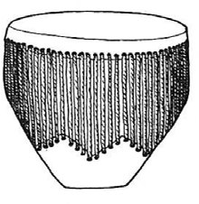 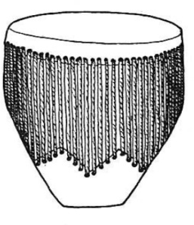 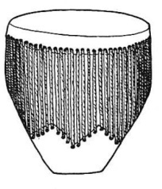

##### A B C

Qn. **Which drum produces sound of; high pitch?**

Drum marked C

##### Qn. Give a reason to support your answer.

- Drum C has a small vibrating surface or space.

(b) **Low pitch?**

Drum marked A

##### Qn. Give a reason to support your answer above.

Drum marked A has a big vibrating surface or space.

##### Comparing with different level of water. W X Y

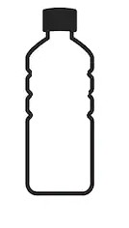

Qn. **Which of the bottles produce sound of:**

##### high pitch?

* + Bottle marked X produces high pitched sound.

##### Low pitch?

* + Bottle marked W produces low pitched sound.

##### Qn. Give a reason to support your answers above.

1. Bottle marked x has a small vibrating space.
2. Bottle marked W has a large vibrating space.

##### Qn. How does the thickness of the strings affect pitch of sound?

- The thicker the string, the lower the pitch of sound and the thinner the string, the higher the pitch of sound.

##### An illustration

**A**

##### B

Qn. **Which string produces sound of** :-

##### Lower pitch?

* + String marked A

##### Higher pitch?

* + String marked B

##### Qn. Give a reason to support your answers above.

1. String marked A has a large vibrating space.
2. String marked B has a small vibrating space.

##### Qn. How does the length of the string affect the pitch of sound produced?

- The shorter the string, the higher the pitch of sound and the longer the string, the lower the pitch of sound produced.

##### An illustration using a bow harp

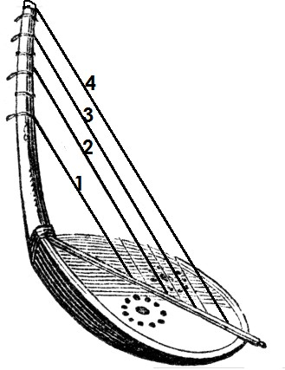

Qn. **Which string produces sound of**:-

##### Lower pitch?

* + String marked 4

##### Higher pitch

* + String marked 1

##### Qn. Give a reason to support your answers above.

1. String marked 4 has a large vibrating surface.
2. String marked 1 has a small vibrating surface.

##### Qn. How does frequency affect the pitch of sound produced?

* + The higher the frequency, the higher the pitch and the lower the frequency, the lower the pitch of sound produced.

##### An illustration

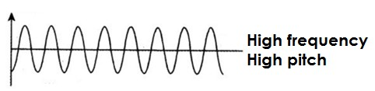

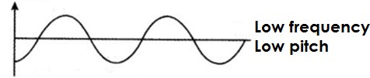

**Volume**

* + Volume is the loudness or softness of sound.

##### Qn. Name the factor that affects the volume of sound.

* + Amplitude

Qn. **What is amplitude**?

Amplitude is the width of the sound vibration.

##### Qn. How does amplitude affect the volume of sound?

* + 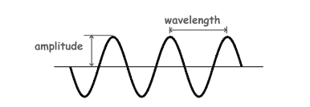The greater the amplitude, the louder the sound and the smaller the amplitude the softer the sound.

**Illustration showing amplitude**

##### Qn. In which units is soundmeasured?

* + Decibels

##### ECHO

**Qn. What is an echo?**

* + An echo is a reflected sound. Qn. **How is echo formed**?
  + Echo is formed when sound waves hit an obstacle or barrier.

##### Examples of obstacles that may form echo.

* + Mountain - Caves
  + Hills - Thick forests
  + Walls - Empty tall buildings
  + Valleys
  + Cliffs

##### An illustration showing formation of echo.

P a g e

**77 |**

##### Advantages of echoes

* + Echoes enable bats to locate food at night.
  + Echoes enable bats to dodge obstacles (to find their way)
  + Echoes enable sailors and seamen to determine the depth of the sea.
  + Echoes help pilots to avoid accidents.
  + Echoes help whales to dodge their enemies and obstacles in water.

##### Qn. Name the device sailors and seamen use to determine the depth of the sea.

* + Fathometer

##### Disadvantages of echoes

* + Echoes cause sound pollution.
  + Echoes cause accidents.
  + Echoes make sound hard to interpret.

##### Qn. How is echo controlled in disco halls and theatres?

* + By covering the inside walls with soft boards.
  + By covering the inside walls with thick curtains.

##### Qn. How do soft boards reduce or control echoes in the theatres or cinema halls?

* + Soft boards absorb sound waves.

##### STORING SOUND

Qn. **Write down the methods of storing sound.**

* + Recording method
  + Notation method

##### Recording method

This is the method of storing sound using electric devices.

##### Examples of devices used to store sound.

* + Memory cards
  + Compact discs (CDs)
  + Flash discs

- Digital video discs (DVDs)

**78 |** P a g e

* Video compact discs (VCDs)
* Cassette tapes
* Records
* Floppy discs
* MP3 and MP4
* Computer diskettes
* Cinefilm

##### Diagrams showing different devices used to record sound.

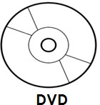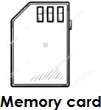

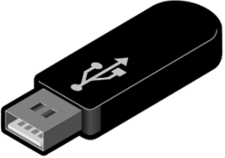**Cassette tape Flash disc**

##### Floppy disc Video tape

 

##### Notation method

* This is a method of storing sound by writing. Qn. **Write the types of notation**.
* Solfa notation
* Staff notation

##### Solfa notation

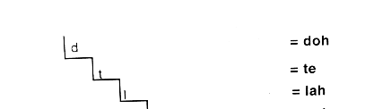This is a method of storing sound using letters called solfas

**IlluSSSTRATIONstration**

**79 |** P a g e

##### Staff notation

* + This is a method of storing sound using symbols.
  + 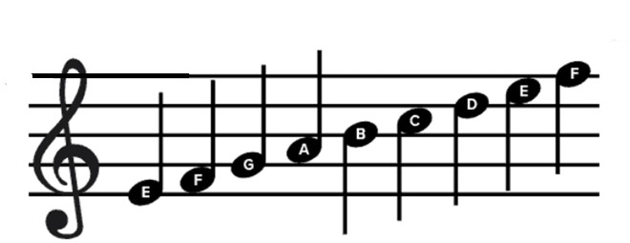An illustration

-

-

-

-

-

-

-

* + Reasons or importance of storing sound.
  + Stored sound is used for entertainment.
  + Stored sound is used as evidence in courts of law.
  + Stored sound is used as source of income.
  + Stored sound is used for remembrance or reference.
  + Sound is used for communication.

**REPRODUCTION**

**Qn. State different ways of reproduction sound**

* + Singing the solfas
  + Playing cassette tapes in cassette tape player.
  + Playing video tapes in a video deck.
  + Playing CDs in a CD player.
  + Playing DVDs in a DVD player.
  + Playing VCDS is a VCD player.
  + Playing memory cards on mobile phones.
  + Playing records in record players.
  + Playing cinefilms using a problem.
  + Using a piano and a keyboard to reproduce sound stored by notation.
  + Playing flash discs using computer and music systems.

##### Qn. Name different devices used to reproduce stored sound.

* + Computer monitors
  + Compact disc players
  + DVD players
  + VCD players
  + MP3 players
  + Radio cassette players
  + MP4 players
  + Mobile phones
  + Film projectors
  + Gramophones
  + Video decks

##### Diagrams showing some devises used to reproduce sound.



1. 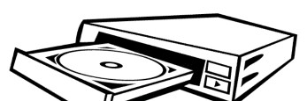DVD player film projector

**80 |** P a g e

1. Turn table Mobile phone



##### THE HUMAN EAR

The human ear is sense organ used for hearing.

##### Qn. A part from hearing , how else is the human ear useful?

* For body balance

##### Qn. Which part of the human skeleton protects the ear?

* Skull
* Structure of the human ear

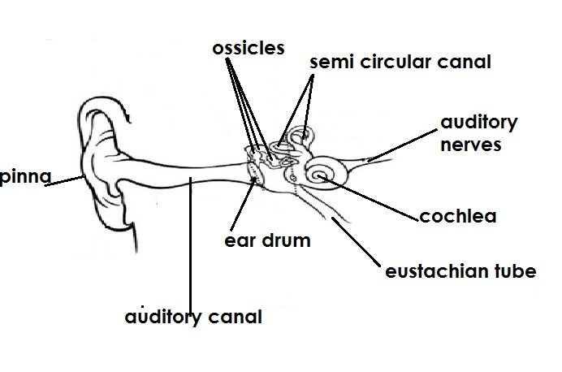-

-

-

-

-

-

-

-

-

-

-

* Region of the human ear

1. The outer ear
2. The middle ear
3. The inner ear

##### Qn. Name the parts that make up the outer ear.

* + Pinna
  + Auditory canal

##### Qn. Identify the parts that make up the middle ear.

* + Ear drum
  + The ossicles
  + Eustachian tube

##### Qn. Mention the parts that make up the inner ear.

* + Cochlea
  + Semi- circular canal
  + Auditory nerves

##### Qn. State the function of each of the following parts of the human ear.

1. Pinna
   * Collects sound waves from the environment.
   * Directs sound waves into the auditory canal.

##### Qn. How is the pinna adapted to collecting sound waves?

* + The pinna is folded to increase the surface area for collecting sound waves.

##### Auditory canal

* + Directs sound waves to the middle ear.
  + Acts as a passage of sound waves to the middle ear.
  + Note:
  + The auditory canal contains hair and wax which traps dust and other foreign bodies in the ear.

##### Ear drum

* + Changes sound waves into sound vibrations.
  + Vibrated according to the pattern of sound waves it receives. Qn. **How is the ear drum adapted to its functions**?
  + It is made up of a thin soft membrane which is very sensitive to sound waves.

##### Ossicles

* + They amplify sound vibrations.
  + Transmit sound vibrations from the ear drum to the inner ear.
  + Note
  + The ossicles are the three small bones found in the middle ear. I.e. Hammer, Anvil , stirrup mallers , …… and stapes (HAS/MIS)
  + The stirrup / stapes is the smallest bone in the human body.

##### Eustachian tube

* + Balances / equalizes the air pressure between the middle ear and the atmosphere.

##### Sem – circular canal

* + Helps in body balance.

##### Cochlea

* + Changes/ converts sound vibrated into nerve impulses / signals. Qn. **How is the cochlea adopted to its function**?
  + Contains fluids called Endolymph and perilymph which convert sound vibration into nerve impulses.
  + Note
  + The cochlea is sais to be the centre of hearing.

##### Auditory nerves

Transmits sound impulses to the brain for interpretation.

##### Qn. Name the parts of the human ear which are not connected to the hearing process.

* + Semi – circular canal
  + Eustachian tube

##### Qn. Disorder of the human ear

1. Partial deafness
2. Sensory deafness
3. Permanent deafness Qn. **What is deafness?**

Deafness is the inability to hear properly.

##### Types of deafness

1. This is the type of deafness where a person is unable to hear properly.

##### Causes of deafness

* + Having too much wax in the ear.
  + Correction of partial deafness
  + By removing too much wax from the ear.

##### Sensory deafness

This is a type of deafness / condition where a person cannot differentiate between

sound.

##### Causes of sensory deafness

* Old age
* Damage caused on the ear drum.
* Disease or injury on the auditor nerve.
* Serious fracture of the skull.
* Living / working in noisy places for along time. Qn. **How to control sensory deafness?**
* Feeding on a balances diet to keep healthy.
* Avoid travelling in vehicles which are in dangerous mechanical condition (DMC’S)
* Avoid staying in noisy places for a long time.
* Treat any infection of the ear as early as possible.

##### Permanent deafness

This is the irreversible inability to hear.

##### Causes of permanent deafness

* + Through inheritance.
  + Diseases like German measles.
  + Damage of the ear drum after piercing it with a very sharp objects.
  + Note
  + Permanent deafness cannot be corrected.
  + Diseases of the human ear
  + Otalgia
  + Otitis media
  + Ways of caring for the human ear
  + Clean the ears with clean water and soap daily.
  + Avoid pushing sharp piercing instruments in the ear.
  + A void playing games which may damage the ear.
  + Use ear buds while cleaning the ear.
  + Feed on food that make up a balance diet.
  + Carry out regular physical exercises.
  + State the importance of wax / cerumen in the ear
  + Traps dust in the ear.

##### Qn. State the danger of having too much wax/ cervmen in the ear.

* + Leads to partial deafeness

##### Qn. State the danger of cleaning the ear using sharp piercing objects

- Causes damage to the ear drum

* + Comparing the human ear with other hearing organs of other animals

1. Fish use of the lateral line for detecting sound waves.
2. Insects use the antennae/ feelers for detecting sound waves.
3. Snakes use the basal skin for detecting sound waves.
4. Amphibians (frogs , toad etc) use the tympanum/ tympanic membrane/ ear drum for detecting sound waves.

(vi) Birds use fine feather / tiny hair found at the entrance of the ear canal to defect sound waves.

**TOPICS 3**

**THE CIRCULATORY SYSTEM**

##### Qn. What is the circulatory system?

The circulatory system is the body’s transport system through which , oxygen and other materials are supplied to all body parts.

**Or** The circulatory system is the system made up of organs and tissue which help in the transportation of substance in the body.

##### Qn. Write down the components of the circulatory system.

* The heart
* Blood
* Blood vessels

1. **THE HEART**

The heart is the main organ of the human body which pumps blood to all body parts.

* + The heart is found / located in the **chest cavity**.
  + The heart is protected by part of the skeleton called **Rib cage / Ribs.**
  + The heart is made up of strong muscles called **Cardic muscles.**
  + The heart is made up of four chambers ie the two upper chambers and two lower chambers.
  + The upper chambers are called Atria (auricles)and the lower chambers are ventricles.
  + Heat beat

Qn. **What is heart beat**?

Heart beat is the alternate contraction and relaxation of the heart muscles.

##### Qn. State factors /conditions that may increase heart beat.

* + Shock
  + Fear
  + Too much excitement
  + Fatigue
  + After performing a vigorous exercise
  + Note
  + The number of heart beats per minute is regarded or pulse rate.
  + The heartbeat of an adult person under normal condition is about 72 times per minute. Qn. **Why does the heart beat faster after performing a vigorous exercise/ activity**?
  + To supply more food and oxygen to the body muscles.

##### Qn. Which instrument do doctors use to listen to the heart beat/ blood flow?

* + Stethoscope

##### Qn. Name the instrument used to measure blood pressure.

* + Sphygmomanometer

**STRUCTURE OF THE HUMAN HEART**

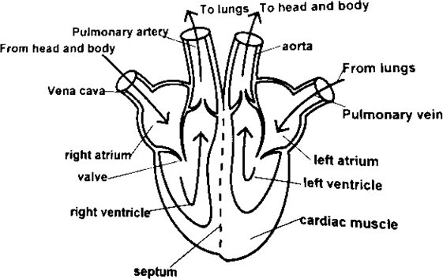-

**Functions of each part of the heart.**

1. **Vena cava**
   * Transports deoxygenated blood from all body parts to the heart.

##### Right atrium

* + Receives deoxygenated blood from the vena cava.

##### Right ventricle

* + Pumps deoxygenated blood to the lungs through the pulmonary artery.

##### Pulmonary artery

* + Transports deoxygenated blood from the heart to the lungs. Qn. **Why is deoxygenated blood sent to the lungs**?
  + To drop carbon dioxide and pick oxygen.
  + To be oxygenated.

##### Pulmonary vein

Transports oxygenated blood from the lungs to the heart.

##### Left atrium

* + Receives oxygenated blood from the pulmonary vein.

##### Aorta

* + Transports oxygenated blood from heart to all body parts.

##### Septum

* + Prevents deoxygenated blood from mixing with oxygenated blood.

##### Valves

* + The valves prevent the backflow of blood in the heart.

##### Qn. Why is the left side of the hear thicker that the right side?

* + The left side pumps blood of high pressure to longer distance than the right side. **BLOOD CIRUCULATION**

##### Qn. What is blood circulation?

Blood circulation is the continuous movement of blood around the body.

##### Qn. Write down the types of blood circulation.

- Pulmonary circulation

* + Systemic circulation

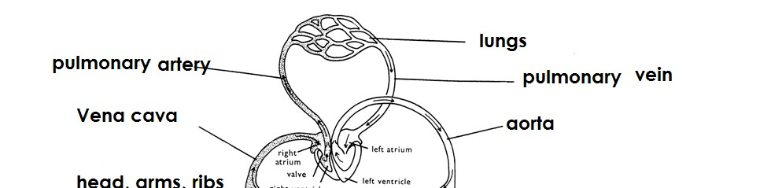

##### Qn. What is pulmonary circulation?

* + Pulmonary circulation is the circulation of blood to and from the lungs. Qn. **What is systemic circulation**?

Systemic circulation is the circulation of blood from the heart to the all parts of the body.

##### DIAGRAM SHOWING BLOOD CIRCULATION

1. **BLOOD**

##### Qn. What is blood?

* + Blood is a red liquid that flows around the body. Qn. **Write down the types of blood.**

1. Oxygenated blood.
2. Deoxygenated blood

##### Oxygenated blood

- This is the type of blood rich in oxygen.

**Note**

Oxygenated blood id bright red in colour.

##### Deoxygenated blood

This is the type of blood rich in carbon dioxide (type of blood without oxygen)

**Note**

Deoxygenated blood is dark red in colour.

##### Qn. Write down the components/ parts of blood.

1. Red blood cell (Erythrocytes)
2. White blood cells (Leucocytes)
3. Platelets (Thrombocytes)
4. Plasma
5. **Red blood cells (ERYTHROCTTES)**
   * These are disc shaped cells with no nucleus. Qn. **How are red blood cells useful in the body?**
   * Red blood cells transport oxygen around the body.

##### Qn. Where in the body are red blood cells made/ manufactured?

- Red bon marrows of short bones

##### Qn. How are red blood cells adapted to their function?

* + They contain haemoglobin

##### Qn. How is haemoglobin important?

* + Haemoglobin transports oxygen around the body.
  + Note:
  + Haemoglobin is red pigment found in red blood cells.
  + Haemoglobin is made from a minerals salt called iron.

##### Qn. What is formed when oxygen combines with haemoglobin?

* + Oxyhaemoglobin
  + Diagram showing a red blood cell

##### Qn. State the characteristics of red blood cells.

* + They are disc shaped.
  + They have no nucleus.
  + They carry oxygen around the body.
  + They contain haemoglobin.
  + Note
  + Red blood cells are affected by malaria disease which is caused by plasmodia.
  + Red blood cells are destroyed in the liver / spleen. Qn. **Why are red blood cells destroyed in the liver**?
  + To make up like pigments

-

##### WHITE BLOOD CELLS (LEUCOCYCLES)

* + These are colourless blood cells with a nucleus.

##### Qn. State the function of white blood cells in the body.

* + White blood cells fight against disease causing germ.
  + Or
  + White blood cells defend the body against disease causing germs.

##### Qn. How do white blood cells defend the body against disease causing germ?

* + By engulfing disease causing germs.
  + By producing antibodies against disease causing germs. Qn. **How are white blood cells adapted to their function**?
  + White blood cells produce antibodies that fight against disease causing germs.
  + White blood cells have an irregular shape to enable them engulf disease causing germs. Qn. **What are antibodies**?
  + Antibodies are chemicals produced by white blood cells to defend the body against diseases.

##### Qn. Where are white blood cells manufactured in the body?

* + In bone marrow of long bones.
  + In the spleen.
  + In the lymph nodes.

##### C:\Users\babra\AppData\Local\Microsoft\Windows\INetCache\Content.Word\Img-1595504151446.pngDIAGRAM SHOWING THE STUCTURE OF A WHITE BLOOD CELL

**Characteristics of white blood cells.**

* + White blood cells have a nucleus.
  + White blood cells are irregular shaped.
  + White blood cells defend the body against diseases.

-

* + Note:
  + White blood cells are fewer in number that red blood cells.
  + Too many white blood cells can lead to leukaemia (blood cancer)
  + White blood cells are destroyed or attacked by the HIV germs that causes AIDS.
  + Differences between white blood cells and red blood cells.
  + White blood cells defend the body against disease while red blood cells transport oxygen around the body.
  + White blood cells have a nucleus while red blood cells do not have a nucleus.
  + White blood cells have an irregular shape while red blood cells are disc shaped.

##### Qn. State the functional difference between white blood cells and red blood cells.

* + White blood cells defend the body against diseases while red blood cells transport oxygen around the body.

##### Qn. State any two structural difference between the white blood cells and red blood cells.

* + White blood cells have nucleus while red blood cells don’t have nucleus.
  + White blood cells have an irregular shape while red blood cells have disc shape.

-

* + PLATELETS (THROMBOCYTES)
  + Platelets are the smallest component of blood in the body. Qn. **Where are platelets made in the body**?
  + In the red bone marrow.

##### Qn. State the function of platelets.

* + Platelets help in blood clotting. Qn. **What is blood clotting**?
  + Blood clotting in the thickening of blood at the site of an injury.
  + OR
  + Blood clotting is the formation of a solid lump of blood at the site of an injury (wound or cut)

##### Qn. How do platelets help to prevent bleeding?

- By clotting blood in wounds or cuts in case of an injury.

* + Note:
  + Lack of enough platelets in the body may result in excessive bleeding in case of a cut or wound.
  + DIAGRMA SHOWING THE STUCTURE OF PLATELETS

-

-

-

* + PLASMA
  + Plasma is the liquid part of blood.
  + Plasma is pale in colour and watery.

-

* + Functions of plasma
  + Plasma transports carbon dioxide from all body part to the lungs.
  + Plasma transports digested food to all body parts.
  + Plasma transports hormones from the glands where they are made to where they are needed in the body.
  + Plasma transports antibodies to the site of infection.
  + Plasma distributes heat produced in the liver to all body parts.
  + Components of blood plasma
    - Digested food
    - Carbon dioxide
    - Hormones
    - Blood proteins
    - Water

-Mineral salts.

* + General function of blood in the body.
  + Blood defends the body against diseases.
  + Blood transports oxygen around the body.
  + Blood regulates body temperature.
  + Blood transports digested food to all body parts.
  + Blood transports antibodies to the site of infection.
  + Blood helps in clotting to control excessive bleeding.
  + Blood transports carbon dioxide from all body parts to the lungs.
  + Blood transports nitrogenous wastes from the liver to the kidney.
  + Blood transports hormones around the body.
  + Blood distributes heat from the liver to all body parts.
  + BLOOD GROUPS
  + Blood groups is a method of classifying blood according to whether antigen A or B are present in the red blood cells.

Qn. **What is an antigen**?

* + An antigen is a substance that stimulates production of antibodies.
  + Classification of blood groups
  + Blood group A (has antigen A only)
  + Blood group B ( has antigen B only)

- Blood group AB (has both antigens A and B)

* + Blood group O ( has neither antigens)

##### Note:

* + Blood groups were discovered by an Austrian Scientist called **Karl Landsteiner**.
  + When a person gets a serious accident, he or she loses a lot of blood and blood has to be given to him or her to replace the lost blood through blood **transfusion**.

-

* + Blood transfusion

##### Qn. What is blood transfusion?

Blood transfusion is the transfer of screened blood from one person to another as long as blood groups agree.

##### Qn. Why should blood be screened before transfusion?

* + To know where there are HIV germs that cause AIDS.
  + To know if it is free from blood diseases. Qn. **What is a blood bank?**
  + A blood bank is a place where supplies of blood for transfusion are kept or stored.
  + Note:
  + A person who donates /gives blood is called **a blood donor.**
  + A person who receives blood is called a **blood recipient**
  + A person who donates blood to any person of any blood group is called a **universal donor.**
  + A person who received blood from a person of any blood group is called a **universal recipient**.

##### SUMMRY OF BLOOD GROUPS

|  |  |  |
| --- | --- | --- |
| Blood group | Donor group | Recipient |
| A | A and AB | A and O |
| B | B and AB | B and O |
| AB | AB | AB, A, B , O |
| O | AB, A , B , O | O only |

**Note**:

* + A person of blood group A can give blood to a person of blood group A and AB but receives blood from a person of blood group A and O only.
  + A person of blood group B can give blood to a person of blood B and AB but receives from a person of blood group B and O only.
  + A person of blood group AB can give blood to a person of AB only but receives blood from a person of any blood group. Therefore he or she is called a **Universal recipient.**
  + A person of blood group O can give blood to a person of any blood but receive blood from a person of blood group O only. Therefore, she / he is called a **Universal donor.**

##### Qn. Give any two conditions in which one may require blood transfusion.

* + When a person in anaemic.
  + When a person gets a severe accident and loses a lot of blood.
  + Ways of increasing the volume of blood in the body.
  + Feeding on a balanced diet.
  + Taking plenty of fluids.
  + Talking iron tablets.
  + Feeding on food rich in iron.
  + Through blood transfusion.

##### Qn. Why should adolescent girls be given food rich in iron?

* + To replace lost blood during process of menstruation.

-

* + BLOOD VESSSELS

##### Qn. What are blood vessels?

Blood vessels are tubes through which blood flows.

##### Types of blood vessels

* + Veins
  + Arteries
  + Capillaries

##### VEINS

Veins are blood vessels that carry towards the heart. Qn. **Which types of blood is carried by most veins?**

* + Deoxygenated blood

##### Note:

* + Most veins carry deoxygenated blood except the pulmonary vein which carries oxygenated blood from the lungs to the heart.
  + Characteristics of veins
  + Veins have thin walls.
  + Veins have a wider lumen.
  + Veins have valves.

##### Qn. State the function of valves found in veins.

* + Valves prevent the back flow of blood. Qn. **Why do veins have thin walls**?
  + Veins carry blood of low pressure.

##### Qn. Name the largest / main vein in the body.

* + Vena cava
  + Diagram showing a vein

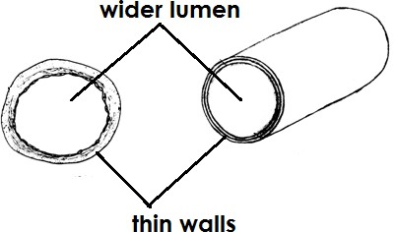

**Diagram showing position of valves**

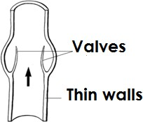

1. **ARTERIES**
   * Arteries are blood vessels that carry blood away from the heart**. Qn. Which type of blood is carried out by most arteries?**
   * Oxygenated blood

**Note**

* + Most arteries carry oxygenated blood except the pulmonary artery which carries deoxygenated blood.

-

* + Characteristics of arteries
  + Arteries have thick walls.
  + Arteries have narrow lumen.
  + Arteries do not have valves.

##### Qn. Why do arteries have thick walls?

* + Arteries carry blood of high pressure.

##### Qn. How is the backflow of blood prevented in arteries?

* + By the high pressure of blood moving through the narrow lumen. Qn. **Name the largest/main artery in the body**.
  + Aorta

**DIAGRAM SHOWING ARTERY**

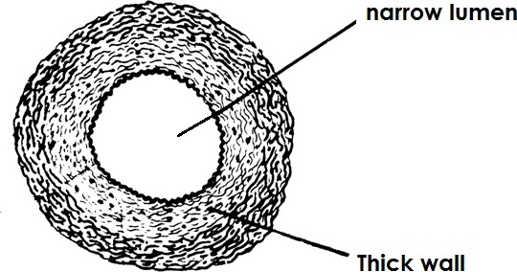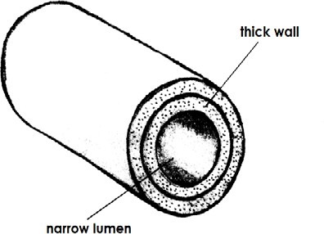

Qn. **State the functional difference between arteries and veins**.

* + Arteries carry blood away from the heart while veins carry blood towards the heart. Qn. **Give the structural differences between arteries and veins**.
  + Arteries have narrow lumen while veins have a wider lumen.
  + Arteries have thick walls while veins have thin walls.
  + Arteries lack valves while veins have valves.

1. **CAPILLARIES**
   * Capillaries are the smallest vessels in the body. Qn. **State the functions of capillaries in the body.**
   * Capillaries allow exchange of materials in the body.
   * Characteristics of capillaries
   * Connect veins to arteries.

##### Qn. Write down different examples of materials exchanged by capillaries.

- Oxygen

* + Digested food.
  + Carbon dioxide
  + Water

-

-

-

-

-

-

* + Diagram showing blood capillaries

-

-

-

-

-

-

-

-

-

-

-

-

-

* + 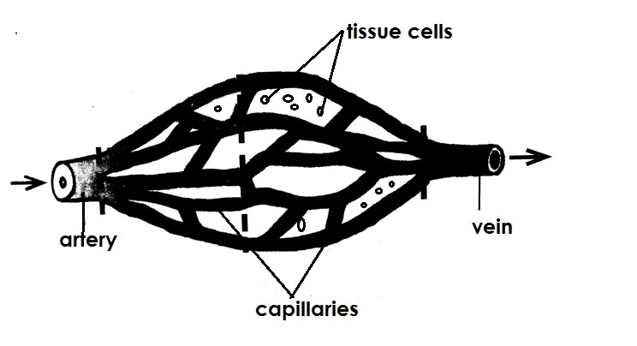Disorder of the circulatory system
  + Poor blood clotting
  + Heart attack
  + Artheroma (buildup of a fatty substance in artery)
  + Angina

-

* + Diseases of the circulatory system

##### Diseases that affect the heart

* + Heart attack
  + Heart failure
  + Coronary thrombosis
  + Hypertension (High blood pressure)
  + Heart attack
  + It is caused due to smoking

##### Qn. How does smoking cause heart attack?

* + The poisonous drugs contained in tobacco smoke damages the cardiac cells.
  + Coronary Thrombosis
  + This is a heart disease caused due to blockage of the coronary arteries which supply the heart with blood rich in oxygen and digested food.
  + 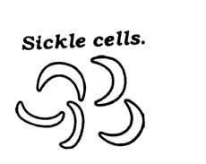Heart failure
  + Heart failure is a condition when the heart fails to pump blood properly.
  + Hypertension
  + It is a heart disease caused due to high accumulation of fats on the walls of arteries making the narrow.

##### Qn. How can high blood pressure be controlled?

* + Taking less fatty foods.
  + Avoid smoking
  + Avoid taking alcohol
  + Carry out regular physical exercise.
  + Checking blood pressure regularly.

##### Diseases that affect the blood.

* + Malaria
  + Anaemia
  + Sickle cell anaemia
  + Blood cancer (Leukaemia)
  + AIDS

-

* + Malaria
  + Malaria is a blood disease caused by plasmodia germs.
  + The plasmodia germs are spread through the bites of female anopheles mosquito. Qn. **How does malaria affect blood**?
  + Plasmodia germs destroy red blood cells which carry blood around the body.

-

* + Anaemia
  + Anaemia is a blood disease caused due to lack of enough iron in the body. Qn. **How does anaemia affect blood**?
  + Anaemiamakes them unable to carry oxygen. Qn. **How can anaemia be controlled**?
  + Taking iron tablets.
  + Eating food rich in iron.
  + Through blood transfusion.

-

-

-

* + Sickle cell anaemia
  + Sickle cell anaemia is a blood disease caused when one red blood cells become sickle celled. (having a sickle cell)

Qn. How doe sickle cell anaemia affect blood?

* + It deforms the red blood cells making them unable to carry oxygen around the body.
  + Diagram showing effects of sickle cell anaemia on red blood cells

-

-

-

-

* + The child grows slowly.
  + A person passes out dark coloured urine.
  + A person has yellowish eyes.
  + Fingers, arms and fingers swell.
  + Note:
  + Sickle cell anaemia is genetic / hereditary inherited disease of the circulatory system.
  + Haemophilia
  + Is a condition in which ones blood is unable to clot in case of an injury. Qn. **How is haemphilia caused**?
  + Haemophilla is caused when there are few platelets in the body.
  + Note:
  + Haemophila is a genetic/hereditary disease of the circulator system. Qn. **How can haemophilia be controlled**?
  + By giving the patient vitamin K.

##### Qn. How is vitamin K useful to a person suffering from haemophilia?

* + The drag contains a substance which helps in blood clotting.

-

* + Leukaemia (blood cancer)
  + Is a condition in which a person has a large number of immature white blood cells.
  + These immature white blood cells prevent the production of normal blood cells by the bone marrows.
  + Note:
  + Leukaemia is incurable.

-

* + AIDS
  + AIDS is a blood disease caused by HIV.

##### Qn. How AIDS does affect the circulator system?

* + HIV destroys the white blood cells.

##### Qn. Write the following in full.

1. **AIDS** - Acquired Immune Deficiency Syndrome.
   * **Acquired** - means got from.
   * **Immune** - means protected against
   * **Deficiency** - means lack of
   * **Syndrome** - means signs and symptoms

-

1. **HIV** - Human Immunodeficiency Virus

##### Note

* + AIDS does not kill its victims instead they die due to opportunistic infections.
  + (Secondary infection)
  + Examples of opportunistic infection that affects AIDS victims.
  + Pneumonia

- Tuberculosis

* + Diarrhoea

##### Ways through which AIDS spreads.

* + Through having unprotected sexual intercourse with an infected person.
  + Through sharing sharp skin piercing instruments.
  + From the infected mother to the unborn baby in the womb during pregnancy.
  + From the infected mother to the baby during birth.
  + From the infected mother to the baby during breastfeeding.
  + Through circumcision using unsterilized instruments.
  + Ways through which AIDS cannot spread
  + Shaking hands.
  + Sharing a desk
  + Swimming together
  + Through insect bites
  + Sharing cups, plates and spoons
  + Sharing a seat
  + Through hugging
  + Through sharing food
  + Through sharing cups

##### Body fluids which may contain HIV germ

* + Semen
  + Virginal fluids
  + Breast milk
  + Blood

##### Traditional practices that may lead to the spread of HIV /AIDS

* + Tribal circumcision using unsterilized instruments.
  + Tribal tattooing
  + Female genital mutilation.

##### Social practice that may lead to the spread of HIV/AIDS

* + Ear and nose piercing using unsterilized instruments.
  + Extraction of false teeth using unsterilized instruments.
  + Jigger extraction using unsterilized instruments.
  + People at high risk of getting AIDS
  + Prostitutes
  + Bar maids / bar attendants
  + Rapists
  + Long distance travelers e.g. truck drivers
  + The youth

##### Qn. Why are the youth more vulnerable to contracting HIV/AIDS?

* + The youth are more sexually active.

##### Qn. Why are girls most attacked /affected by AIDS than boys of the same age group?

* + Girls are easily convinced to engage in sex unlike boys.
  + Girls like luxury than boys.

-

* + Signs and symptoms of AIDS

##### Qn. What is a sign of a disease?

Is an effect or a health problem that can be seen by others.

##### Qn. What is a symptom of a disease?

Is an effect of a disease that can be felt by only the sick person.

##### Sign of AIDS

* + Loss of body weigh
  + Chronic cough
  + Skin rash all over the body
  + Sores in the mouth (oral thrush)
  + Chronic diarrhoea

-

* + Symptoms of AIDS
  + Persistent fever
  + General body weakness
  + Mental disturbance
  + Loss of appetite

##### Qn. Write down any four diseases that shouldn’t be confused with AIDS

* + Pneumonia
  + Tuberculosis
  + Measles
  + Cancer
  + Typhoid

##### Qn. How can one confirm his / her HIV status?

* + By having a blood test for HIV.

##### Qn. Who is an HIV positive?

* + An HIV positive person is one who has HIV germ in the body. Qn. **Who is an HIV negative**?
  + Is a person who does not have HIV germ in the blood.

##### Qn. What is the difference between on HIV positive and a person with AIDS.

* + An HIV positive is a person who has got HIV germs in the body but not shown sign while a person with AIDS is the one who has started showing the signs and symptoms.
  + EFFECTS OF HIVS /AIDS

##### To an individual

* + It destroys the body immunity.
  + AIDS leads to death.
  + AIDS causes depression, fear, hopelessness.
  + AIDS makes a person lose income.
  + AIDS causes worries.
  + AIDS affects the brain that leads to mental confusion.

##### To the family.

* + It leads to poverty.

- AIDS leads to loss of family members.

* + Some children in the family may be infected with HIV/AIDS.
  + Children become orphans when parents die. (c **To the community**
  + AIDS leads to loss skilled manager.
  + AIDS leads to shortage of the productive population.
  + AIDS leads to childhood families.
  + AIDS leads to increased numbers of orphans in the community.
  + AIDS leads to depopulation.
  + Ways of controlling and preventing the spread of HIV/AIDS
  + Abstaining from sex until marriage.
  + Be faithful to one sexual partner.
  + Use of condoms when having sex.
  + A void extra martial sex.
  + A void sharing sharp skin piercing instruments.
  + A void traditional practice that may lead to spread of HIV /AIDS.
  + Pregnant women should go for antennal care visits to test for HIV /AIDS. Qn. **Write ABC in full as used in the prevention and control of HIV/AIDS.**
  + Abstaining from sex.
  + Be faithful to your sexual partner.
  + Condom use.

##### Qn. Give ways in which an HIV/AIDS mother can protect her unborn baby from getting HIV /AIDS?

* + Through taking ARVs.
  + Delivering from hospitals.
  + Through PMTCT services.
  + By proper feeding.
  + Going for antenatal care services. Qn. **Write the following in full.**

1. PMTCT - Prevention of Mother to Child Transmission.
2. ARVs - Anti retroviral.

##### Qn. How are ARVs useful to HIV/AIDS patients?

* + ARVs prevent the HIV germs from multiplying.
  + Reduce the effect of the disease to the body.

##### Qn. Why is it easier to control the spread of HIV/AIDS than controlling the spread of malaria?

* + It is easy to abstain from sex than to prevent mosquito bites.
  + CARE FOR AIDS PATIENTS
  + Feeding the patient on a balanced diet.
  + Giving the patient ARVs.
  + Taking the AIDS patients to the hospital.
  + Offering counselling services to AIDS victims or patients.
  + Encouraging the AIDS patients to take ARVs.

-

- Reason for counselling HIV/AIDS

* + Counselling helps to create awareness among HIVS/AIDS victims.
  + Counselling prevents the HIV/AIDS patients from spreading the disease.
  + Counselling enables the HIV /AIDS victims to live positively with the diseases.
  + Counselling prevents the HIV/AIDS victim from feeling neglected.
  + Counselling helps the HIV/AIDS victims to have hope.
  + Organisations that offer counselling services to the HIV/AIDS victims.
  + TASO (the AIDS Support Organisation**)**
  + AIC (AIDS Information Centre)
  + ACP (AIDS Control Programme)
  + SYFA (Safe Guard Youth from Aids)
  + ROLES PLAYED BY TASO
  + TASO provides ARVs to AIDS victims.
  + TASO provides maternal assistance to AIDS victims.
  + TASO provides counselling services to AIDS victims.
  + TASO provides relief items to AIDS victims.

##### Qn. Why is AIDS most common in women than men?

* + Women are more sexually active than men.

-

* + PIASCY
  + PIASCY stands for Presidential Initiative on AIDS.
  + Strategy for Communication to Youth.
  + Examples of PIASCY messages
  + Say No to sex.
  + Say No to bad touches.
  + Resist peer pressure.
  + AIDS kills.
  + Virginity is healthy.
  + Avoid gifts from strangers.
  + Avoid lifts from strangers.
  + AIDS has no cure.

##### Qn. How do PIASCY messages help to control the spread of HIV/AIDS?

* + PIASCY messages help children to abstain from sex.
  + PIASCY message enable children to know how HIV/AIDS is transmitted.

-

* + TOPICS FOUR
  + ALCOHOL, SMOKING AND DRUGS IN SOCIETY Alcohol

Qn. What is alcohol?

Alcohol is a chemical substance which make people drug when taken.

##### Qn. Write down the two types of alcohol.

* + Ethanol or Ethyl
  + Methanol or Methyl
  + Methanol alcohol

- Methanol alcohol is the most poisonous type of alcohol that cause death if it is drunk.

* + Note:
  + Methanol also causes blindness in case it comes into contact with eyes.

-

* + Ethanol alcohol
  + This is the commonest type of alcohol which is contained in most alcoholic drink. Qn. **Write down the common examples of alcoholic drinks.**
  + Beer - wines
  + Malwa - Whiskey
  + Tonto - Gins
  + Waragi - Kwete

##### Qn. Mention the different reasons or excuses people give for drinking alcohol.

* + To pass time
  + To forget problems for a while.
  + To celebrate victory / success.
  + To fit in peer groups of alcoholics.
  + To quench thirst.
  + To socialize with others.
  + To feel confident at doing certain things.
  + Some drink to improve on their mental performance.
  + The young drink to show that they are mature.
  + Methods of making alcohol.

Qn. Write down the two methods used to make alcohol.

* + Fermentation method.
  + Distillation method.

-

##### Fermentation method

Qn. **What is fermentation**? Fermentation is the process of making alcohol where sugars from plants juices added to water are turned into alcohol by the help of yeast.

##### Note:

* + The sugar found in millet,maize, banana, sorghum, wheat, barley can be used. Qn. **Name the fungus used in fermentation process of making alcohol.**
  + Yeast

##### Qn. State the role or importance of yeast in fermentation process of making alcohol.

* + Yeast produces zymase enzyme which speeds up rate of fermentation.

##### Qn. Write down examples of alcoholic drinks brewed using fermentation method.

* + - Tonto - Pineapple wine - Kwete
    - Malwa - Maramba- Kwete

##### Distillation

Qn. **What is distillation method?**

Distillation is the process of obtaining alcohol by the process of evaporation and condensation of liquids containing alcohol.

##### Qn. Write down the two main physical process involved in distillationmethod of making alcohol.

- Evaporation

* Condensation

##### The diagram showing distillation method of making alcohol.

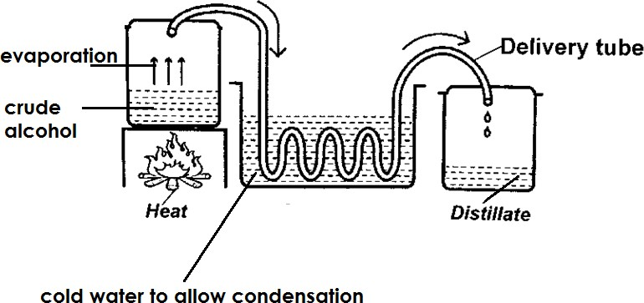

**Note**:

* Heat helps to evaporate crude alcohol.
* The delivery acts as a passage of the alcohol vapour.
* Cold water helps to condense the alcohol vapour.

##### Qn. Why is the delivery tube passed through cold water?

* To allow condensation of the alcohol vapour.

##### Qn. Why is the delivery tube coiled in the container with cold water?

* To increase the surface area for condensation to take place.

##### Qn. Why are the most delivery tubes in the distillation method made of copper?

* Copper does not rust easily.

##### Qn. What scientific name is given to the fine liquid collected after distillation?

* Distillate

##### Qn. Write down the examples of alcohol drinks obtained through distillation.

* Waragi - Gins
* Whiskey - Spirits -Vodka

##### Qn. Write down body organs damaged by alcohol.

* Brain
* Liver
* Pancreas
* Stomach

##### Qn. Name the body organ mostly affected by excessive drinkingof alcohol.

* The liver
* Uses of alcohol in society
* Alcohol is used to sterilize medical instruments.
* Alcohol is source of income to people.
* Alcohol is used in cleaning wounds.
* Alcohol is used to mix paints and dyes.
* Alcohol is used in some types of thermometers.
* Alcohol is mixed in petrol to make gasohol.
* Alcohol is used to clean the area of skin where an injection is to be taken.

- Alcoholism and Alcoholics

Qn. **What is alcoholism**?

* Alcoholism is a condition which results from prolonged use of alcohol. Qn. **Who is an alcoholic?**
* An alcoholic is a person who depends on an alcohol for his / her normal body functioning. Qn. **Write down the different factors that can lead to alcoholism.**
* Stress
* Peer pressure
* Seductive adverts
* Family backgrounds
* Sad news
* Happiness
* Success
* Excitement
* Frustration.

-

* Effects of alcoholism

##### To an individual

* + Alcoholism leads to self neglect.
  + Alcoholism leads to brain damage.
  + Alcoholism leads to damage of the liver.
  + Alcoholism leads to stomach ulcers.
  + Alcoholism leads to damage of the pancreas.
  + Alcoholism leads to loss of appetite.
  + Alcoholism leads to loss of jobs.
  + Alcoholism leads to poverty.
  + Alcoholism may lead to death.

##### To the family

* + Alcoholism leads to child abuse.
  + Alcoholism leads to poverty in the family.
  + Alcoholism leads to spouse abuse.
  + Alcoholism leads to family neglect.
  + Alcoholism leads to domestic violence.
  + Children in the family may learn to drink alcohol when they are still young.
  + Children of alcoholics may lack love and parental care.

##### To the family

* + Alcoholism leads to road accidents.
  + Alcoholism leads to poor job performance.
  + Alcoholism leads to increased crime rates.
  + Alcoholism leads to poor performance at school.

-

* + Laws related to drinking alcohol in Uganda.

##### Qn. State any four laws governing the drinking of alcohol in Uganda.

* + Persons below 18 years are not allowed to drink alcohol.
  + Do not drink and drive.

- Home distilled alcohol is not allowed to be transported.

* + Home distillation of alcohol is not allowed.
  + Alcohol should not be sold in shops.
  + Ways of controlling alcoholism
  + A void bad peer groups.
  + Never believe in advertisements that praise alcohol.
  + Join groups whose members are not alcoholics.
  + Read more about dangers of alcohol.
  + Teach people about the danger of alcohol.
  + Get activities to occupy you during free time.
  + Join good social groups like football clubs, net ball clubs.

-

* + SMOKING

##### Qn. What is smoking?

* + Smoking in the frequent inhaling of tobacco smoke.

-

* + Ways through which people smoke
  + Through burning pipes.
  + Through burning cigarettes.
  + By chewing leaves.
  + By sniffing tobacco powder.

-

-

* + Types of smoking

##### Qn. Write down the two types of smoking.

* + Active smoking
  + Passive smoking

##### Active smoking

Qn. **What is active smoking?**

* + Active smoking is the inhaling of tobacco smoke directly from a burning cigarette. Qn. **Who is an active smoker**?
  + An active smoker is a person who inhales smoke directly from a burning cigarette.

##### Passive smoking

Qn. **What is passive smoking?**

* + Passive smoking is the inhaling of air containing tobacco smoke from an active smoker. Qn. **Write down the poisonous substance contained in tobacco smoke**.
  + Nicotine
  + Tar

##### Qn. Mention the poisonous gas contained in tobacco smoke.

* + Carbon monoxide

##### Qn. How do the following poisonous substances affect as smoke.

1. **Nicotine**
   * Nicotine causes addiction
   * Nicotine narrows the blood vessels to the heart.

##### Tar

* + Tar causes lung cancer

##### Qn. State the effect or danger of carbon monoxide to a smoker.

* + Carbon monoxide reduces the intake of oxygen in blood.

-

* + Factors that lead people to smoking.
  + Peer pressure
  + Desire to relax
  + Desire to warm up
  + Pride
  + Poor home atmosphere

##### Qn. State the different reasons or excuses some people give for smoking.

* + Some people smoke to pass time.
  + Some people smoke to feel confident.
  + Some people smoke to feel warm.
  + Some people smoke to look sophiscated.
  + Some people smoke to concentrate on what they are doing.
  + Some people smoke to socialize with others.

-

* + Harmful effects of smoking

##### To an individual

* + Smoking leads to lung cancer.
  + Smoking cause bronchitis.
  + Smoking cause emphysema.
  + Smoking worsen tuberculosis and asthma.
  + Smoking increases the risks of heart attack.
  + Smoke stains teeth.
  + Smoking cause a bad smell in the mouth.
  + Smoking worsens ulcers in the stomach.
  + Smoking reduces appetite.

##### Effects of smoking to a pregnant mother

* + Smoking leads to miscarriage.
  + Smoking leads to still birth.
  + Smoking leads to premature birth.
  + Smoking leads to birth of underweight babies.

##### Effects of smoking to the family.

* + Family members become passive smokers.
  + Smoking leads to poverty.
  + Smoking may lead to fire outbreak.
  + Young children may learn to smoke when they are still young.
  + Smoking may lead to family neglect.

##### Effects of smoking to the community

* + Smoking caused air pollution.
  + Smoking leads to passive smoking.
  + Smoking leads to fire outbreak.

- Smoking may lead to poor job performance.

##### Qn. Write down any three diseases caused by smoking.

* + Lung cancer
  + Bronchitis
  + Emphysema

##### Qn. Mention any four diseases worsened by smoking.

* + Tuberculosis
  + Asthma
  + Pneumonia
  + Heart attack
  + Whooping cough
  + Diphtheria

##### Qn. Mention the body organs damaged due to smoking.

* + Lungs
  + Heart

##### Note:

* + The lungs are the organs which are greatly damaged by smoking.
  + Ways of safeguarding against smoking
  + A void bad peer groups of smokers.
  + Keep busy during free time.
  + Never allow any body to convince to start smoking.
  + Read more about the dangers of smoking.
  + Teach friends about the dangers of smoking.
  + Never believe in advertisement that praise smoking.
  + Join good social groups e.g. football clubs, church choir.
  + Report all friends who smoke to elders.
  + Take advice from elders about smoking serious.

-

##### DRUGS

Qn. **What is a drug**?

A drug is a chemical substance which when introduced into body, affects the body’s functioning.

##### Groups of drugs

* + Essential drugs
  + Drugs of dependency or Narcotics

(a) **Essential drugs**

##### Qn. What are essential drugs?

Essential drugs are drugs which meet people’s health needs.

##### Groups 0r classes of essential drugs

* Pain killers
* Curative drugs
* Preventive drugs
* Contraceptives

##### Pain killers

- Pain killers are drug used to reduce body pain.

##### Examples of pain killers

* + Paracetamol
  + Ibrufen
  + Indocid
  + Diclofenac

##### Curative drugs

* + Curative drugs are drugs which cure diseases.
  + Examples of curative drugs
  + Coatem - Fansidar
  + Quinine - Chloroquine

##### Preventive drugs

* + Preventive drugs are drugs used to prevent diseases.
  + Examples of preventive drugs
  + Vaccines

##### Contraceptives

Contraceptives are drugs used in family planning to space children or avoid unwanted pregnancies.

##### Examples of contraceptives

* + Birth control pills
  + Spermicides
  + Characteristics of essential drugs
  + They meet people’s health needs.
  + Essential drugs are safe and effective if used correctly.
  + Essential drugs are affordable.
  + Essential drugs are readily available.
  + Essential drugs should be accessible.
  + Essential drugs should have valve for money. Qn. **Give any two uses of essential drugs.**
  + Essential drugs reduce pain.
  + Essential drugs prevent diseases.
  + Essential drugs control unwanted pregnancies.
  + Essential drugs cure diseases.

##### Qn. State any two ways in which drugs are introduced in the body.

* + By swallowing e.g. Tablets.
  + By injections e.g. injectables.
  + By drinking e.g. syrups
  + By smearing e.g. Ointments

-

* + Types of essential drugs
  + Traditional drugs
  + Laboratory manufactured drugs or modern drugs

##### Traditional drugs

Qn. **What are traditional drugs?**

These are drugs obtained from plants and animals and are mainly used in their raw form.

##### Examples of traditional essential drugs

* Black jack
* Mululuza
* Aloe vera
* Bombo

##### Qn. State the characteristics of traditional drugs

* They are mostly used in their raw form.
* Their effect on human health is not well known.
* Their qualify and purity changes.
* They are not well packaged.

##### Laboratory manufactures drugs.

Qn. **What are laboratory made drugs**?

These are drugs manufactured in factories under well controlled conditions.

##### Qn. Write down the different examples of laboratory manufactureddrugs.

* Coatem
* Panadol
* Septrin
* Ibrufen
* Chloroquine
* Quinine
* Fansider

##### Qn. State the characteristics of laboratory made drugs.

* They are well packaged.
* Their effect on human health is well known.
* Their quality is the same for every amount.
* They are labelled to show name and date of manufacture etc.
* Their strength, purity and stability is known.
* They are carefully made and tested.
* Drug prescription

##### Qn. What is drug prescription?

Drug prescription is the written information given by a health worker on how to use the drug.

##### Information found on drug prescription

* Name of the drug
* Dosage
* Time of taking the drug
* The disease it cures

##### Qn. Write down the factors a health worker should consider before prescribing a drug for a patient.

* Age of the patient.
* Weight of the patient.

- Medical history of the patient.

* Sex of the patient.
* Severity of the disease affecting the patient. Qn. **State the importance of drug prescription.**
* Drug prescription prevents people from taking overdose.
* Drug prescription prevents patient from taking under dose.
* Drug prescription prevent drug misuse. Qn. **What is under dose**?

An under dose is the taking of less drugs than the recommended amount by the health worker.

##### Qn. State the effects of under dose.

* Under dose makes the germs stronger and resistant to a certain drug. Qn. **What is an over dose**?

An over dose is the taking of more drugs than the recommended amount by the health worker.

##### Qn. State the dangers or effects of an over dose.

* Over dose cause body poisoning.
* Over dose can lead to death.
* 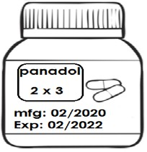Use the information about drug prescription below to answer the questions below.

##### How many tablets is the patient supposed to take in a day?

* + 6 tablets

##### How many times in a day will the patient take the drug?

* + 3 times

##### After how long is the patient supposed to take the drug?

24 = 8 hours 3

##### What is the name of the drug given to the patient?

* + Panadol

##### Why is the patient not advised to take the drug in March 2022?

* + They drug will have expired.

##### Qn. Give the danger of taking expired drugs.

* + Expired drugs cause body poisoning.
  + Expired drugs do not cure the disease.
  + Expired drugs may lead to death.

##### Proper storage of drugs

Qn. **State the conditions under which drugs should be stored**.

* + Drugs should be stored in well stored sealed containers.
  + Drugs should be stored out of reach of children.

- Drugs should be stored in dry cool place.

* + Drugs should be kept away from sunlight, dirt and moisture. Qn. **Why should drugs be kept in well sealed containers**?
  + To prevent drug contamination.

##### Qn. Why should drugs be kept away from children’s reach?

* + To prevent drug poisoning.
  + To prevent drug misuse.
  + To prevent children from taking over dose.

##### Qn. Give a reason why drugs should be kept in a cool dry place.

* + Prevent drugs from losing their curative value.
  + To prevent drugs from getting spoilt.

##### Qn. State the dangers of poor storage of drugs.

* + Drugs can be contaminated.
  + Drugs can lose their curative value.
  + Drugs can become poisonous and lead to death.
  + Drugs can be misused.
  + Drugs can get spoilt easily.

##### Qn. Mention the different places recommended for people to buy drugs.

* + Hospitals
  + Clinics
  + Dispensaries
  + Pharmacies
  + Drug shops
  + Note:
  + Never buy drugs from shops, markets, hawkers.

##### Qn. State the danger of buying drugs from local shops, markets and hawkers.

* + Drugs from shop may be poorly prescribed.
  + Drugs from shops may be contaminated due to poor storage.
  + Drugs from shops may be fake.
  + Drugs from shops may be expired.
  + The patient may buy wrong drugs for the diseases.
  + DRUG MISUSE

##### Drug abuse

Qn. **What is drug abuse?**

Drug abuse is the use of a drug in a way that is harmful to the body. Qn. **Mention the different examples of commonly abused drugs.**

* + Marijuana / cannabis
  + Heroin
  + Cocaine
  + Alcohol
  + Tobacco
  + Shisha
  + Aviation fuel
  + Petrol
  + Opium

- Miraa

* + Caffeine

##### Qn. Give different reasons why people abuse drugs.

* + To fits in peer groups of drugs abusers.
  + To keep awake at night.
  + To boost their mental performance.
  + To concentrate on what they are doing.
  + To get sleep.
  + To celebrate victory.
  + To pass time.
  + To be confident at doing certain things.
  + To forget their problem for a while.
  + To acts as mature if they are young.

##### Qn. Give the factors that can lead to drug abuse.

* + Bad peer influence.
  + Poor family background.
  + Emotional stress.
  + Seductive advertisements on televisions and radios.
  + Boredom
  + Frustration
  + Desire to stay awake
  + Desire to be strong and bold
  + Effects of drug abuse

##### To an individual

* + Drug abuse can lead to brain damage.
  + Drug abuse can lead to damage of the liver.
  + Drugs abuse can lead to damage of the pancreas.
  + Drug abuse can lead to self neglect.
  + Drug abuse can lead to death of an individual.
  + Drug abuse can lead to job neglect and dismissal.
  + Drug abuse can lead to loss of school education.
  + Drugs abuse can lead insomnia.
  + Drug abuse can lead to intensive sleepiness.

##### To the family

* + Drug abuse leads to poverty in the family.
  + Drug abuse leads to child abuse.
  + Drug abuse leads to spouse abuse.
  + Drug abuse leads to family separation.
  + Drug abuse leads to delinquent children. Qn. **Who is a delinquent child?**

A delinquent child is a child who commits crimes that are punishable by law.

##### To the community

* + Drug abuse leads to high crime rates.
  + Drug abuse leads to accidents.
  + Drug abuse leads to poor job performance.

- Drug abuse can lead to death of important people in the community.

* + Drug abuse can lead to the spread HIV/AIDS.

**DRUG MISUSE**

Qn. **What is drug misuse**?

Drug misuse is the use of a drug against the doctor’s prescription.

##### Ways how people misuse drugs

* + Through sharing drugs with another patient.
  + Through taking overdose.
  + Through taking underdose of the drug.
  + Through taking drugs that do not cure the disease. Qn. **Why do some people misuse drugs**?
  + Poverty
  + Ignorance
  + Inaccessibility of drugs

-

* + Narcotics or drugs of dependency Qn. **What are narcotics?**

Narcotics drugs are drugs that cause addition due to prolonged use.

##### Qn. What is drug dependency?

Drugs dependency is a condition in which one’s body becomes addicted to a certain drug.

##### Note:

* + A person who depends on drugs for his / her normal body functioning is called a **drug addict or drug dependant.**
  + Examples of drugs of dependency
  + Alcohol - Heroin
  + Tobacco - Shisha
  + Marijuana - Aviation fuel
  + Opium - Petrol
  + Cocaine - Caffeine

# PRIMARY SIX SCIENCE LESSON NOTES

TERM2

##### Topics 5 : CLASSIFICATION OF PLANTS

**Qn. What is classification as used in plants?**

* + Classification is the grouping of plants according to their particular characteristics**.**
  + Groups of plants
  + There are two groups of plants namely: -
  + **-** Flowering plants
  + - Non flowering plants

##### A chart showing classification of plants.

**PLANTS**

Flowering plants Non flowering plants

bearing

Monocotyledonous Dicotyledonous spore bearing

plants plants plant

Seed

plants

##### Liverworts Horse tails Ferns mosses

**pine cypress fir cedar**

##### podo

**Characteristics of plants**

* + Plants make their own food.
  + Plants breathe through stomata.
  + Plants are multicellular organisms.
  + Plants contain chlorophyll. Qn. **What is chlorophyll**?

Chlorophyll is a green colouring matter (pigment) found in plants.

##### Difference between plants and animals.

* + Plants have chlorophyll while animals do not have chlorophyll.
  + Plants make their own food while animals do not make their own food.
  + Similarities between plants and animals.
  + Both are multicellular organisms.
  + Bothe reproduce.
  + Both breathe.
  + Both respond to stimuli.
  + Both move.

##### Qn. How do plants benefit from animals?

* + Both get carbon dioxide from animals.
  + Animal provide manure to plants.
  + Animals help in seed dispersal.
  + Plants get care from animals.

##### Qn. How do animals benefit from plants?

* + Animals get food from plants.
  + Animals get oxygen from plants.
  + Animals get herbal medicine from plants.
  + Animals get shelter from plants.

##### Qn. State any four importance of plants in the environment.

* + Plants are source of food to animals.
  + Plants provide herbal medicine to animals.
  + Plants are source of fire wood and charcoal.
  + Plants provide timber.
  + Plants provide poles for building houses.
  + Plants purify air.
  + Plants help in formation of rainfall.

-

* + NON-FLOWERING PLANNING

##### Qn. What are non-flowering plants?

* + Non flowering plants are plants that do not bear flowers.
  + Groups of non-flowering plants
  + Spore producing plants
  + Conifers

-

##### Spore producing plants

**Qn. What are spore producing plants?**

These are non-flowering plants which reproduce by means of spores.

Qn. **What is a spore**?

* A spore is a single cell that can develop into a new plant if conditions are favourable.
* Note:
* Spore are protected in structures called **spore cases or sporangium**. **Examples of spore bearing non flowering plants.**
  + Liverworts - Ferns
  + Mosses - Horse tails

##### Ferns

* Ferns grow in shady places.
* Ferns reproduce by means of spores.
* Ferns are the most advanced groups of spore producing plants.
* Ferns are green therefore they make their own food.

##### Qn. Why are ferns regarded as the most advanced among the spore producing plants?

* Ferns have proper leaves, stems and roots.
* A diagram showing a fern.

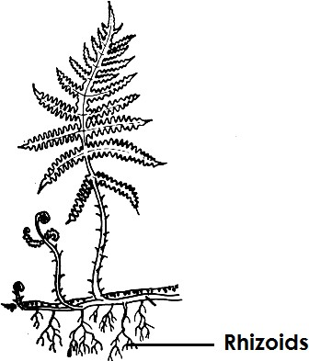

##### Mosses

* + Mosses grow on house roofs, verandah, tree trunks, logs and soil in the damp and shady places.
  + Mosses contain chlorophyll therefore they make their own food.
  + Mosses reproduce by means of spores.
  + A diagram showing a moss plant

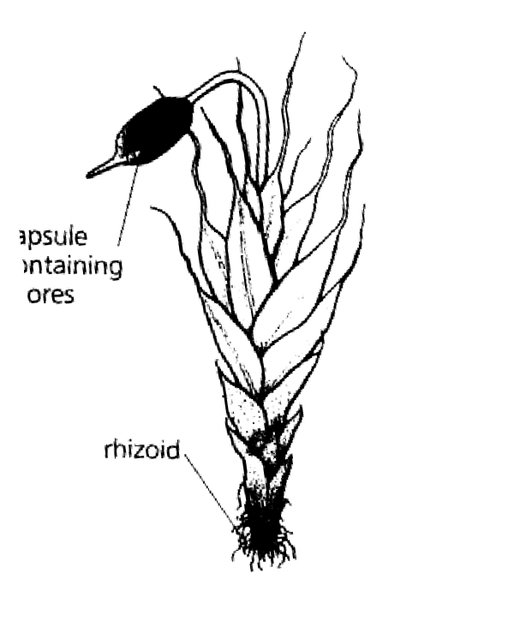

##### Liverworts

* + Liverworts grow in moist places.
  + Liverworts contains chlorophyll therefore they make their own food.
  + Liverworts reproduce by means of spores.
  + 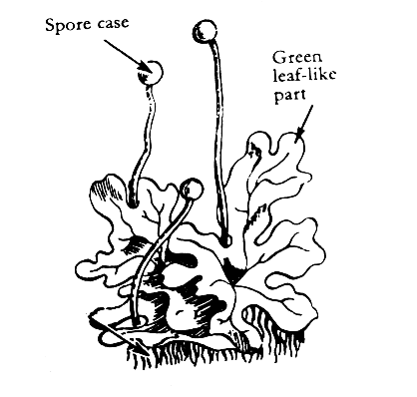Diagram showing a liverwort.

##### Coniferous plants

Qn. **What are conifers**?

* + Conifers are plants that reproduce by means of seeds found in cones.

##### Qn. Name the structure in which seeds are produced in coniferous plants.

* + Cones

##### Qn. Why are coniferous plants regarded as non-flowering plants yet they reproduce seeds?

* + They do not bear flowers
  + 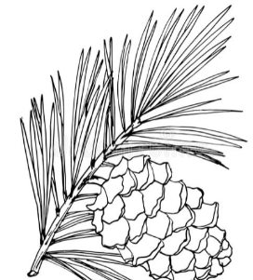A diagram showing cones

**115 |** P a g e

##### Qn. What name is given to male and female cones of a conifer?

* Male – staminate
* Female- Ovulate.

##### Examples of conifers

* + fir - cycads
  + cypress - cedar
  + podo - pines
  + Ginkgo - spruce
  + Eucalyptus

##### Economics importance of conifers

* Conifers provide soft wood timber used for making papers, matchsticks, ceiling boards
* Other importance of conifers
* Some conifers provide people with herbal medicine.
* Some conifers provide people with shade.
* Some conifers are planted to act as live fences.
* Some conifers are planted to act as wind breaks.
* FLOWERING PLANTS

##### Qn. What are flowering plant?

Flowering plants are plants that bear flowers.

##### Qn. How do flowering plants reproduce?

* By means of seeds

##### Groups of flowering plants

* Monocotyledonous plants
* Dicotyledonous plants

-

* Examples of dicotyledonous plants

-Beans

-Soya beans

-Cow peas

-Groundnuts

-Mangoes

-Avocado

-Bambara etc.

##### Note:

* Most dicots are legumes.
* Characteristics of dicotyledonous plants
* Dicotyledonous bear seeds with two cotyledons.
* Dicotyledonous undergo epigeal germination.
* Dicotyledonous have a network leaf venation.
* Dicotyledonous have tap root system.

##### Monocotyledonous plants

Qn. **What are monocots**?

* + These are plants that bear seeds with one cotyledon.

##### Examples of monocotyledonous plants

* + Maize
  + Wheat
  + Sorghum
  + Rice
  + Barley
  + Rye
  + Oats
  + Millet

Qn. **Note**:

* + Most of the monocots are cereals Qn. **What is a cereal crop**?

A cereal crop is a crop that bears small seeds called grains.

Characteristics of monocotyledonous plants.

* + They bear seeds with one cotyledon.
  + Monocots undergo hypogeal germination.
  + Monocots have a parallel leaf venation.
  + Monocots have fibrous root system.

##### STRUCTURE OF A FLOWERING PLANT

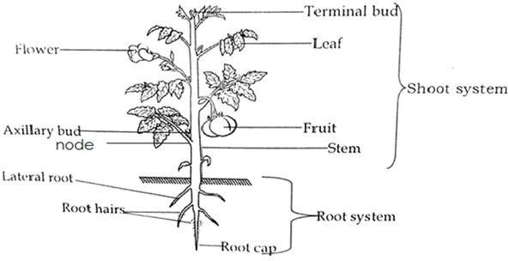

* + System of flowering plant
  + Shoot system
  + Root system
  + Root system
  + Root system is the part of a plant that grows underground.

##### Types of root system.

* + There are two types of root system namely: -

- - Tap root system

* + - Fibrous root system

##### Tap root system

* + Tap root system is a root system that grows directly from the radicle.
  + Structure of a tap root system

-

-

-

-

-

-

-

-

-

-

-

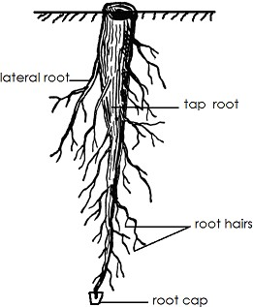

-

* + Functions of the parts

##### Main tap root

* + Holds the plant firmly in the soil.

##### Lateral roots

* + Give support to the plant in the soil.

##### Root hairs

* + Absorb water and mineral salt from the soil.

##### Root cap

* + The root cap protects the growing root tip from damage.

##### Note:

* + Root hairs absorb water and minerals salts from the soil by a process called **Osmosis.**

##### Qn. What is osmosis?

* + Osmosis is the movement of water molecules from a region of low salt concentration to a region of high salt concentration through a semi permeable membrane.

##### Qn. How is osmosis useful to plants?

* + Osmosis helps plants to absorb water and minerals salts from the soil.

##### Qn. By what process does water move from the roots up to the leaves of a plant?

* + Capillary attraction /capillarity

##### Qn. By which process is dissolved food substances able to more from the leaves to the roots?

* + Translocation
  + Examples of plants with tap system
  + Beans - coffee
  + Soya beans - Avocado
  + Ground nuts
  + Cow peas
  + Mangoes
  + Jackfruits

1. **Fibrous root system** 
   * Fibrous root system is the system of a plant that grows from one point at the base of the stem.
   * Diagram showing fibrous roots

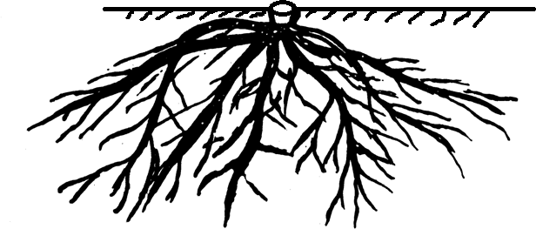-

-

-

-

-

-

-

-

* + Examples of plants with fibrous root system.

**-** maize - sorghum

* rice - millet
* wheat - rye
* barley - oats

##### Types of roots

* + Tap roots - prop roots
  + Fibrous roots - stilt roots
  + Adventitious - breathing roots
  + Storage - clasping roots
  + Buttress roots

##### Buttress roots

Buttress roots are roots that enlarge at the base of a plant.

##### Note:

* + Buttress root give extra support to the plant.
  + 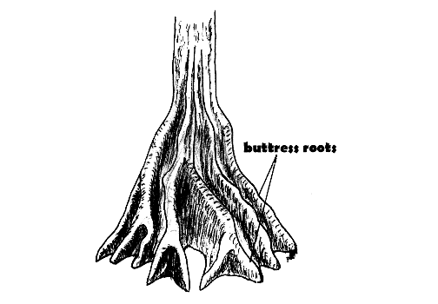Diagram showing buttress roots

-

-

-

-

-

* + Examples of plants with buttress roots
  + - Mahogany - Jack fruit
  + - Ficus tree - silk cotton
  + - Mvule - celtis

##### Stilt roots

* + Stilt roots re roots that grow from the lateral branches on different branches.
  + They give extra support to the plant.
  + They are found on plants which grow in swamps.

- Note:

Stilt roots are common in mangrove (Rhizophora)

* + 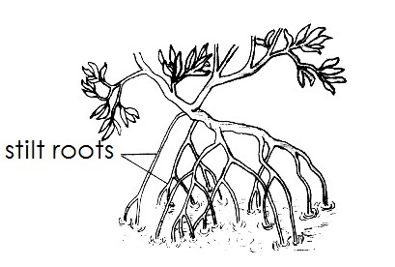Diagram showing stilt roots

(iiI) **Clasping roots**

* + Clasping roots are commonly found in climbing plants.
  + Clasping roots enable the plant to climb by growing round and clasping for support.
  + Diagram showing clasping roots.

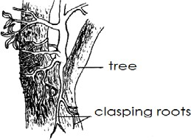

##### Breathing roots

* + Breathing roots are roots which grow upwards from soil and act as breathing organs.
  + Breathing roots are common in plants in water logged areas.
  + Breathing roots are common in black mangrove (Avicenna)
  + Diagram showing breathing roots

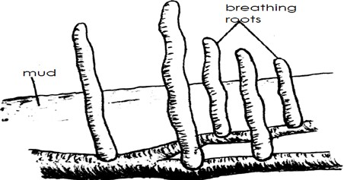

##### Prop roots

* + Prop roots are roots that grow from the nodes of a stem.
  + Note:
  + Prop roots mainly grow during the flowering stage in order to give extra support. Qn. **State the main function of prop rots**.
  + Prop roots give extra support to a plant.
  + Examples of plants with prop roots
  + Maize - Sugarcane
  + Sorghum - Rice
  + Wheat - Barley
  + Note:
  + Prop roots are common with monocots.

##### Diagram showing the prop roots.

-

-

-

-

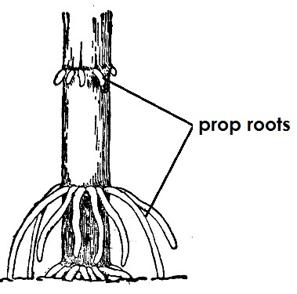-

-

-

-

-

-

-

-

-

-

-

-

##### Adventitious roots

* + Adventitious roots are roots that grow from any other part of a plant other than the radicle.
  + Adventitious roots are common with stem tubers bulbs, rhizomes, corms.

##### Storage roots

* + Storage roots are roots that store food.
  + Note:
  + The food mainly stored by storage roots is called starch.
  + Most storage roots are root tubers. Qn. **What are root tubers**?
  + Root system are plants that store their food in the swollen underground roots.
  + Examples of plants root tubers
  + Cassava
  + Carrots
  + Turnips
  + Sweet potatoes
  + Note
  + Root tubers are swollen because they store food (starch)

##### Structure of a carrot

**121 |** P a g e

**Qn. What type of root system does a carrot have?**

* + Tap root system
  + Function of roots to plants
  + Roots hold a plant firmly in the soil.
  + Roots absorb water and mineral salts from the soil.
  + Some roots store food for the plant.
  + Some roots help a plant to breathe.

##### Importance of roots to people / animals

* + Some roots are source of food.
  + Some roots are used as herbal medicine.
  + Some roots are sold to get money.
  + Some roots are source of firewood.
  + Roots of legumes have root nodule which store nitrogen fixing bacteria that add nitrogen into soil.

##### An experiment to illustrate osmosis

Qn. **Study the experiment below and use it to answer the questions that follow.**

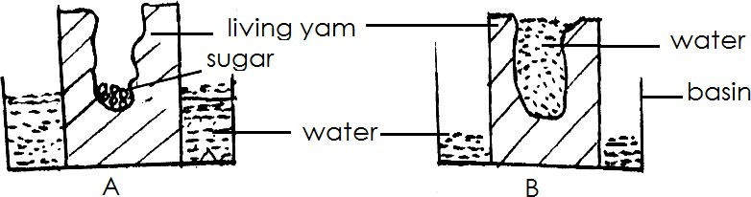

##### Qn. What is the experiment above about?

* + Osmosis

##### Qn. What does the peeled potato act as?

* + Semi permeable membrane

##### Qn. Why is sugar placed in the hole dug in the potato?

* + To pull water from the basin

##### Qn. What doe sugar act as in the experiment above?

* + Sugar acts as an area of high salt concentration.

##### Qn. Why did the water level increase as shown in diagram B?

1. **|** P a g e
   * Sugar pulled water from the basin.
   * Water molecules moved from a region of low salt concentration to the region of high salt concentration.

-

-

* + SHOOT SYSTEM

##### Qn. What is a shoot system?

* + The shoot system is the system of a flowering plant that grows above the guard.
  + Parts that make up the shoot system of a plant.
  + Flower - Node
  + Leaves - Internodes
  + Stems - Axillary bed
  + Branches - Terminal bud
  + Fruits

##### STEMS

* + A stem is the main long part of a plant from which leaves and flowers grow.

-

* + Parts of the stem

##### Node

* + A node is a part of the stem where the leaf is fixed.

##### Internodes

* + Internodes is the distance between two nodes.
  + 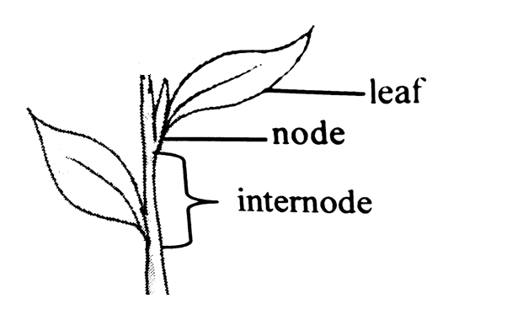Diagram showing the node and internodes

-

-

-

-

-

-

-

-

##### Terminal bud

* + Terminal bud is the growing tip of a plant.

##### Axillary bud

* + An axillary is the bud that can develop into a fruit, flower branch etc.
  + An axillary bud is located at the part a plant called **axil.**
  + Diagram showing the axillary bud and axil.

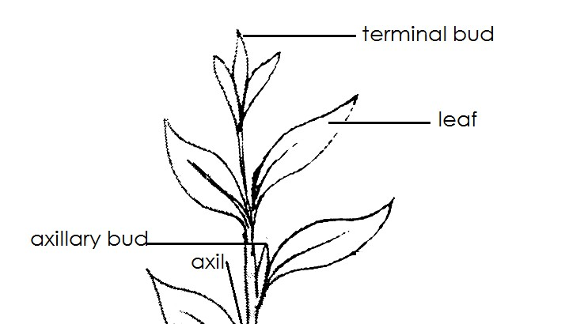-

-

-

-

-

-

-

-

1. **|** P a g e

-

-

-

-

* Uses of stems to plants
* Some stems store food for the plant.
* Some stems make food for the plant.
* Some stems hold the flower and fruits in the upright position.
* Stems hold flower for easy pollination.
* Some stem help in transpiration.
* Stem hold leaves in position for easy trapping of sunlight.
* Uses of stems to people
* Some stems are eaten as food.
* Some stems provide herbal medicine.
* Some stems provide us with timbers.
* Some are source of wood fuel.
* Types of stems
* Upright / erect stem
* Underground stem
* Climbing stem.
* Creeping stem
* Upright stems
* An upright stem is a stem that grow vertically or straight in space.
* Examples of plants with upright stems
* Beans - oranges
* Mangoes - Apples
* Maize - Guava
* Soya beans - Avocado
* Jackfruit
* Creeping stems
* Creeping stems are stems that grow along the ground.

-

* Examples of plants with creeping stems.
* Sweet potatoes
* Watermelon
* Pumpkin
* Straw berry
* Morning glory
* Note:
* Creeping stems are unable to climb because they bear fruits that are heavy.
* Climbing stems
* Climbing stems are stems that are weak and cannot support themselves upright. Qn. **Why do some plants climb others?**
* To get support.
* To get enough sun light.
* Method used by climbing plants to climb others.
* By clasping / twining.
* By using tendrils.
* By using hooks.

##### Uses of tendrils

* + A tendril is the thin coiling stem that develops from the lateral bud.
  + A tendril helps a plant to attach itself for the support.
  + Diagram showing a tendril.

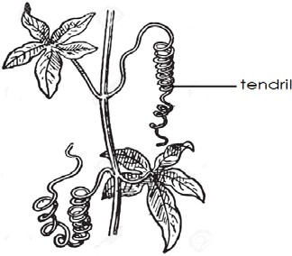-

-

-

-

-

-

-

-

-

* + Examples of plants that use tendrils to climb others.
  + Passion fruits
  + Beans
  + Peas
  + Cucumber

##### Use of hook

* + Hooks are downward pointing structures which prevent the climbing plant from slipping off the other plants.

##### Diagram to illustrate

**Examples of plants that used hooks to climb others.**

* + Rose flowers
  + Thorn apple

##### Clasping / twining

* + Plants twine or clap their weak stems around to get support.

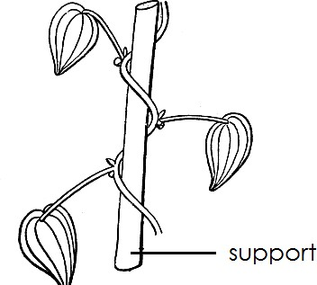

##### Examples of plants that climb others by twining.

* + Morning glory
  + Some beans
  + Tomatoes
  + White yams
  + Underground stems
  + Underground stems are stems that store food.
  + Underground stem can also be called storage stems.
  + Groups of underground stems
  + Bulbs
  + Rhizomes
  + Corns
  + Stem tubers

##### Stem tubers

Qn. **What are stem tubers?**

* + Stem tubers are plants that store their food in swollen underground stems.
  + Characteristics of stem tubers
  + Stem tubers store the food in the swollen underground stems.
  + Stem tubers have eyes.
  + Examples of stem tubers
  + Irish potatoes
  + White yams

-

-

-

-

-

-

-

* + Diagram showing an Irish potato

-

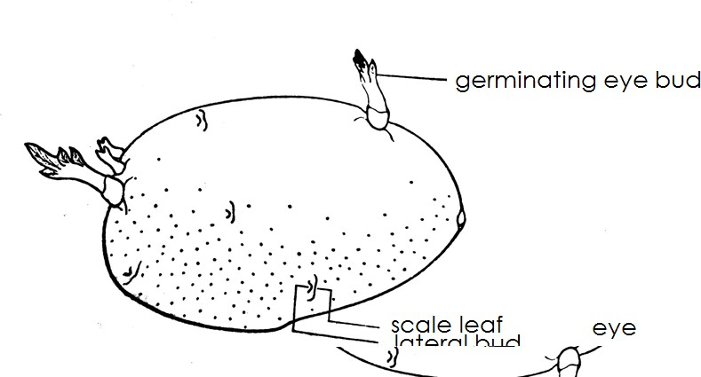

##### Qn. Give the functions of the following parts of an Irish potato.

1. **Axillary potato**
   * It develops into the shoot system.

##### Scale leaf

* + Protect the axillary bud
  + Note:

- The axillary bud and the scale leaf make up the eye.

##### Qn. How are stem tubers propagated?

* + By planting stem tubers.

##### Bulbs

Qn. **What are bulbs?**

* + Bulbs are swollen underground stems with fleshy leaves.

-

* + Characteristics of bulbs
  + Bulbs store food in their fleshy leaves.
  + Bulbs have small stems and lateral bud.
  + Bulbs have adventitious roots.
  + Examples of bulbs
  + Onions
  + Garlic
  + Spider lily

##### Qn. How are bulbs propagated?

* + By planting bulbs
  + By planting seeds

-

-

-

-

-

-

-

-

* + 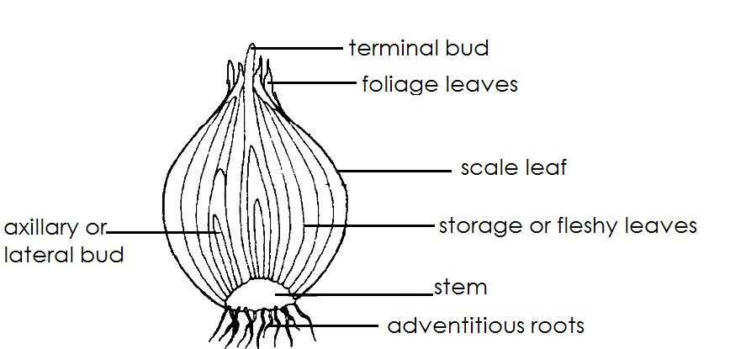A diagram showing a bulb (onion)

-

-

-

-

-

-

-

-

-

-

-

* + Function of each part of a bulb

##### Foliage leaves

* + Foliage leaves make food for the bulb.

##### Fleshy or storage leaves

* + They store food for the bulb.

##### Scale leaves

- Protect the inner parts of an onion.

##### Lateral bud

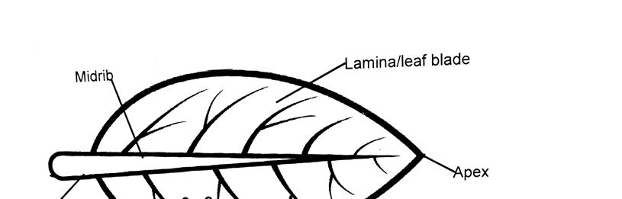

* + It grows into a new plant.

##### Stems

* + It holds the storage leaves.

##### Adventitious roots

* + They absorb water and mineral salts from the soil.

##### Rhizomes

Qn. **What are rhizomes**?

* + Rhizomes are horizontal underground stems that store food.
  + Examples of rhizomes
  + - Ginger - Cana lily
  + - Turmeric - Zoyzia

##### Qn. How are rhizomes propagated?

* + By planting rhizomes

##### A diagram showing a rhizome

1. **Corms**

Qn. **What is a corm**?

* + A corm is a vertical swollen underground stem that stores food.
  + Examples of corns
  + Cocoyam
  + Crocus
  + Gladiolus
  + A diagram showing a corm

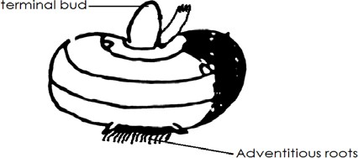

##### Qn. How are corms propagated?

* + By planting corms

##### LEAVES

**A diagram showing a leaf**

e



##### Functions of each part of a leaf.

1. **Leaf stalk**
   * It holds the leaf on the branch or stem.
   * Supplies water from the stem to the leaf.

##### Mid rib

* + It transports water and mineral salts from the stalk to the leaf.

##### Veins

* + Veins supply minerals salts and water to all parts of the leaf.
  + Veins transport manufactured food from all parts of the leaf to the midrib.

##### Lamina / leaf blade

* + It is where photosynthesis take place.
  + The lamina helps in respiration.

##### Stomata

* + They are used for breathing
  + Stomata help in transpiration

##### Uses of leaves to plants

* + Leaves make food for the plant.
  + Some leaves store food for the plant.
  + Leaves help in transpiration process.
  + Leaves enables plants to breathe.
  + Some leaves are used for propagation.

##### Uses of leaves to people

* + Some leaves are eaten as food.
  + Some leaves are source of herbal medicine.
  + Some leaves are used for mulching.
  + Some leaves are used for decoration.
  + Some leaves are source of income.
  + Some leaves are used to make craft.
  + Leaf venation

##### Qn. What is leaf venation?

* + Leaf venation is the arrangement of veins in a leaf.
  + Types of leaf venation
  + Parallel leaf venation
  + Network leaf venation

##### Parallel leaf venation

* + Parallel leaf venation is the type of venation where veins run from the stalk to the apex without crossing each other.
  + Diagram showing parallel leaf venation

##### Examples of plants with parallel leaf venation.

* + Brain
  + Sorghum
  + Rice
  + Sugarcanes
  + Wheat
  + Barley
  + Rye
  + Oats
  + Note:
  + Parallel leaf venation is common in monocots.

##### Network leaf venation

* + Network leaf venation is a type of venation where veins make something like a net in a leaf.
  + A diagram showing network venation

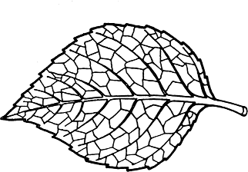-

-

-

-

-

-

* + Examples of plants with network leaf venation
  + Beans - Avocado
  + Peas - Jackfruits
  + Soya beans
  + Groundnuts
  + Coffee
  + Types of leaves
  + Simple leaves
  + Compound leaves

##### Simple leaves

Qn. **What is a simple leaf**?

* + A simple leaf is a type of leaf with on leaflet on the leaf stalk.

##### Types of simple leaves

* + Simple entire leaf
  + Simple lobed
  + Simple serrated leaf
  + Simple divided entire
  + Simple palmate
  + Monocotyledonous leaf

**130 |** P a g e

* Diagram showing different simple leaves

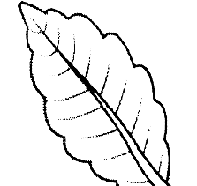

**iv)**

**Simple lobed leaf**

**131 |** P a g e

-

##### Illustrations

* 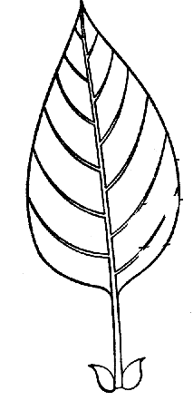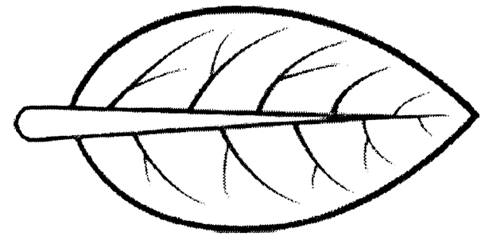Simple entire leaf

**Examples of plants with simple entire leaves.**

* Mangoes
* Jackfruit
* Avocado
* Oranges

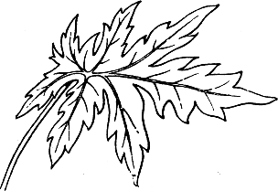**Simple palmate leaf**

**Examples of plants with simple palmate leaves**

* Pawpaw
* Castor oil

##### C:\Users\isma\AppData\Local\Microsoft\Windows\Temporary Internet Files\Content.Word\Img-1599219941038.pngSimple serrated leaf

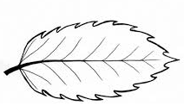

**Examples of plants with simple serrated leaves**

* Black jack
* 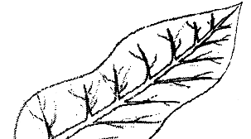Tick berry plant

##### Examples of plants with simple lobed leaves

-

-

* Simple divided entire leaf

##### Examples of plants with simple divided entire leaves.

* Passion fruit

##### Monocotyledonous leaf (simple lanceolate)

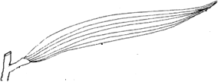

**Examples of plants with a monocotyledonous leaf.**

* + Maize
  + Sorghum
  + Millet
  + Rice
  + Wheat
  + Sugarcane

##### Compound leaves.

**Qn. What are compound leaves?**

* + Compound leaves are leaves with many leaflets on a leaf stalk.

##### Qn. Give examples of plants with compound leaves.

* + Cassava
  + Jacaranda
  + Beans

- Soya beans

* + 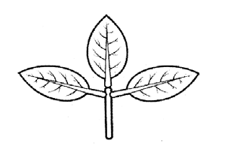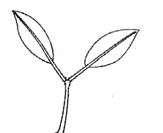Ground nuts
  + Acacia trees

##### Qn. Mention the type / examples of compound leaves.

* + Compound trifoliate leaf.
  + Compound bi-foliate leaf.
  + Compound pinnate leaf.
  + Compound bi-pinnate leaf.
  + Compound digitate.
  + Diagram showing different compound leaves

|  |  |
| --- | --- |
| - | - Examples of plants with such a leaf |
| - Compound bipinnate | - Jacaranda  -  -  -  -  -  -  -  - |
| - Compound pinnate leaf | - Acacia tree  -  -  -  -  -  - |
| - Compound digitate | - cassava  -  -  -  -  -  -  - |
| - Compound trifoliate leaf | * Beans * Soya beans |
|  | - peas |
|  | - |
|  | - |
|  | - |
|  | - |
|  | - |
| - Compound bifoliate | -  - |
|  | - |
|  | - |

|  |  |
| --- | --- |
|  | -  - Bryophyllum  -  -  -  -  - |

-

* + Important process that take place in a leaf.
  + **-** Photosynthesis
  + - Transpiration
  + - Breathing
  + Photosynthesis
  + Photosynthesis is the process by which plants make their own food.

##### Qn. What name is given to the food made by plants during photosynthesis?

* + Starch
  + Note:
  + Photo mean **light**
  + Synthesis means building up / making / manufacturing.

-

* + Raw materials for photosynthesis Qn. **What is a raw material**?
  + A raw material is a basic material for making a product.
  + Product made during photosynthesis
  + - Starch
  + - Oxygen

##### Qn. Mention the bi product of photosynthesis.

* + Oxygen

##### Qn. Mention the raw materials for photosynthesis.

* + Carbon dioxide
  + Water

##### Conditions for photosynthesis.

-Sunlight

-Chlorophyll.

##### Requirements necessary for photosynthesis.

* + Chlorophyll
  + Sun light
  + Carbon dioxide
  + Water

##### Qn. How is chlorophyll useful during photosynthesis?

* + Chlorophyll traps / absorbs sun light energy from the sun. Qn. **How is water useful during photosynthesis**?
  + Water combines with carbon dioxide to form starch.
  + Note:
  + Water is absorbed from the soil by the help of root hairs.

##### Qn. State the function of sunlight during the process of photosynthesis.

* + Sunlight splits water into hydrogen and oxygen.

##### Note:

* + Photosynthesis takes place during day.
  + Photosynthesis cannot take place at night.

##### Qn. Give a reason why photosynthesis cannot take place at night?

* + There is no sun light at night.

##### Qn. Why is photosynthesis able to take place during day time?

* + There is sunlight during day time.
  + Summary of photosynthesis and its products
  + Water + carbon dioxide chlorophyll starch + oxygen

Sun light

##### Qn. How are plant leaves adapted to the process photosynthesis?

* + Plant leaves have their walls to allow carbon dioxide diffuse through.
  + Plant leaves have chlorophyll that help to trap sunlight.
  + Leaves have a broad shape to increase the surface area for absorbing sunlight.

##### Note

* + Photosynthesis is a chemical change in plants.

-

* + Testing for starch in a leaf
  + Pluck a leaf from a plant.
  + Boil the leaf in water.
  + Boil the leaf in methylated spirit.
  + Wash the leaf in cold water and pour iodine solution on the leaf.
  + **Observation** The leaf turns dark blue or blue black.
  + Questions

##### Why is the leaf boiled in water?

* + To kill the cells in a leaf.

##### Give the reason of boiling the leaf in methylated spirit.

* + To remove chlorophyll.

##### Qn. Why is the leaf washed before pouring iodine solution?

* + To remove methylated spirit.

##### Qn. Name the chemical used to test for starch in aleaf.

* + Iodine solution

-

* + TRANSPIRATION

##### Qn. What is transpiration?

* + Transpiration is the process by which plants lose water in the form of water vapour to the atmosphere through the stomata**.**

##### Qn. How is transpiration important to plants?

* + Transpiration cools the plant.

- Transpiration enables plants to absorb water and mineral salts from thesoil.

##### Qn. State the importance of transpiration to the environment.

* + Transpiration help in rain formation.
  + An experiment to show transpiration.

1. Get a transparent polythene paper.
2. Look for a plant well placed in sunlight.
3. Tie a polythene paper on one of the branches.
4. Leave it there for some time.

##### A diagram showing transpiration in plants

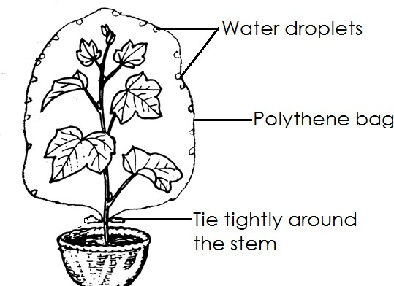

**Observation**

* + Water droplets will be formed on the sides of the polythene paper.
  + Conclusion

##### Qn. Why are water droplets formed inside the polythene paper?

* + Due to condensation

##### Qn. State the function of the polythene paper in the experiment above?

* + Trap water droplets
  + Factors that affects the rate of transpiration in plants.
  + Temperature
  + Wind
  + Size of the leaf
  + Humidity
  + Light intensity
  + Number of stomata in a leaf

##### Questions

1. **How does temperature affect the rate of the transpiration**?
   * The higher the temperature the higher the rate of transpiration and the lower the temperature the lower the rate of transpiration.

##### Why do plants lose a lot of water on hot days than on cold days?

* + On hot days the temperature is high leading to high rate of temperature while on cold days, the temperature is very low leading to low rate of transpiration.
  + Humidity

##### What is humidity?

Humidity is the amount of water vapour in the atmosphere

##### Qn, How does humidity affect the rate of transpiration

The higher the humidity the lower the rate of transpiration and the lower the humidity the higher the rate of transpiration,

##### Why does low temperature take place on high humidity?

* + When there is high humidity, there is a lot of water vapour is in the atmosphere, leading to low transpiration.

Wind

##### How does wind affect the rate of transpiration?

* + When there is a lot of wind there is high rate of transpiration and when there is less wind there is low rate of transpiration.

##### Why does the rate of transpiration increase when there is a lot of wind?

* + Wind blows away water vapour from the leaves leading to high rate of transpiration.

-

* + Light

##### How does light intensity affect the rate of transpiration?

* + When there is a lot of sunlight in the atmosphere high rate of transpiration will take place.

##### Why does the rate of transpiration increase when there is high sunlight in the atmosphere?

* + When sunlight is too much, stomata are opened leading to high rate of transpiration.

-

* + Number of stomata

##### Qn. How does the number of stomata affect the rate of transpiration?

* + The greater the number of stomata the higher the rate of transpiration.
  + Size of the leaf

##### Qn. How does size of the leaf affect the rate of transpiration?

* + The larger the leaf the higher the rate of transpiration and the smaller the leaf the lower rate of the transpiration.

-

* + Factors that increase the rate of transpiration
  + High light intensity
  + Low humidity
  + High number of stomata
  + Large size of the leaf
  + High temperature
  + Wind
  + Factors that lower the rate of transpiration
  + High humidity
  + Low temperature
  + Small size of the leaf
  + Low light intensity

- Few stomata in a leaf

* + Ways through which plants reduce the rate of transpiration.
  + Some plants shed their leaves during the dry season.
  + Some plants reduce the size of their leaves to thorns.
  + Some plants put a layer of wax on their leaves to cover the stomata.
  + Some plants fold their leaves during the dry seasons.
  + Some plants grow very small leaves to reduce the rate of transpiration.

-

* + Questions

##### How do cactus plants reduce the rate of transpiration?

* + By reducing the size of their leaves to thorns

##### Diagram showing a cactus plant

1. **Give a reason why some plants shed their leaves during the dry season.**
   * To reduce the rate of transpiration

##### What are deciduous plants?

* + These are plants which shed their leaves during the dry season.

##### State any four examples of deciduous plants

* Mvule trees - Willow trees
* Oak trees - Ficus trees
* Sycamore trees
* Fig trees

##### FLOWERS

Qn. **What is a flower**?

* + A flower is a reproduce part of a plant.

##### Qn. Why is a flower regarded a reproductive part of a plant?

* + A flower produces seeds that develop into young plants.
  + A flower contains gametes or reproductive cell.

##### Qn. What is the main function of the flower to a plant?

* + For reproduction
  + To produce seeds and fruits

-

##### Structure of a flower

-

-

-

**138 |** P a g e

-

-

-

-

-

-

-

-

- Functions of each of part o f a flower

##### Petals

* + Petals protects the inner parts of a flower.
  + Petals attract pollinating agents.

##### Qn. What name is given to a group of petals?

* + Corolla

##### Qn. How are petals adapted to attracting pollinating agents?

* + They are brightly coloured

##### Sepal

* + Sepals protect the flower during the bud stage.
  + Sepals make food for the flower.

##### Qn. What name is given to a group of sepal?

* + Calyx

##### flower stalk

* + It holds the flower in an upright position.
  + It supplies water to the flower.

##### Qn. What does a flower stalk develop into after fertilization?

* + Fruit stalk

##### Stigma

* + It is receives pollen grains

##### Anthers

* + They produce and store pollen grains.

##### Style

* + Holds the stigma in upright position.

##### Filament

* + Holds the anthers in an upright position.

##### Receptacle

* + Receptacle protects the ovary and ovules.
  + Receptacle protects the nectaries.

##### Qn. What is the importance of nectaries?

* + They produce and store nectar
  + Main parts of a flower
  + Stamen
  + Pistil

##### What is the pistil?

* + A pistil is a female part of a flower.

- Parts of the pistil

* + Stigma
  + Style
  + Ovary
  + Ovules

##### Diagram of a pistil

**Stamen**

##### Qn. What is a stamen?

* + A stamen is a male of a flower.
  + Parts of a stamen
  + Anther
  + Filament

##### Diagram showing a stamen

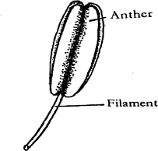

**Uses of flower to people**

* + Flowers are used for decoration.
  + Flowers are used to show love.
  + Flowers are source of income.
  + Some flowers are used to make perfumes.
  + Some flowers are eaten as food.
  + Some flowers are used for making dyes.
  + Some flowers are used for making insecticides.
  + POLLINATION

##### Qn. What is pollination?

* + Pollination is the transfer of pollen grains from the anthers to the stigma.
  + Importance of pollination

##### Qn. How is pollination important?

* + Pollination enables fertilization to take place in plants.
  + Pollination enables high yield in farmer’s harvest.

- Types of pollination

* + Self pollination
  + Cross pollination
  + Self pollination

##### Qn. What is self pollination?

* + Self pollination is the transfer of pollen grains from anthers to the stigma of the same flower.
  + 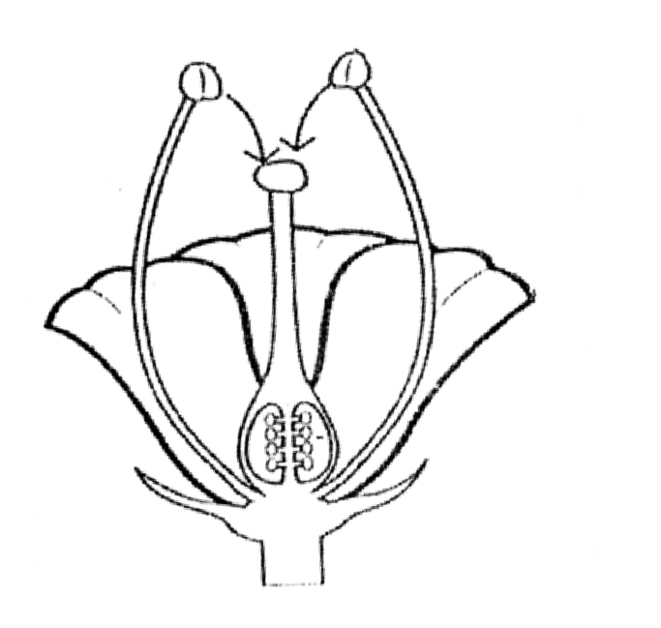A diagram showing self pollination.

##### Characteristics of self pollination /Adaptation of some flowers to self pollination.

* + The stamen is longer than the pistil.
  + The anthers and stigma mature at the same time.
  + The flowers remain closed until self pollination has taken place.
  + The flowers are hermaphrodites(have both male and female organs)
  + Examples of plants that have self pollination
  + Groundnuts
  + Tomatoes
  + Apples

##### Qn. How are tomatoes adapted to self pollination?

* + The pistil and stamen mature at the same time.

-

* + Cross pollination

##### Qn. What is cross pollination?

Cross pollination is the transfer of pollen grains from the anthers to the stigma of another flower but of the same kind.

##### A diagram showing cross pollination

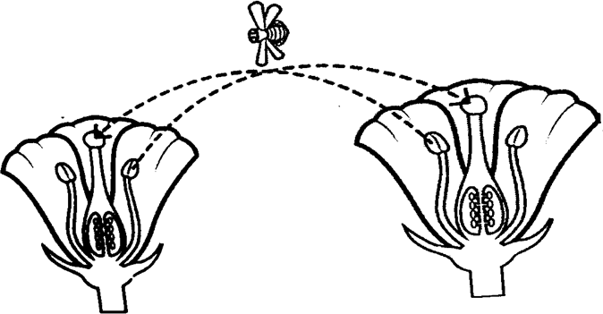

**Characteristics of cross pollination (Adaptation of some flowers to cross pollination)**

* + The pistil is longer than stamen.
  + Both the male and female flowers may occur on the same plant but mature at difficult times.
  + The male and female flowers grown on separate plants.
  + Pollen grains cannot germinate on the stigma of the same flower.
  + Examples of plants that undergo cross pollination
  + - maize
  + - pawpaw
  + - coconut
  + 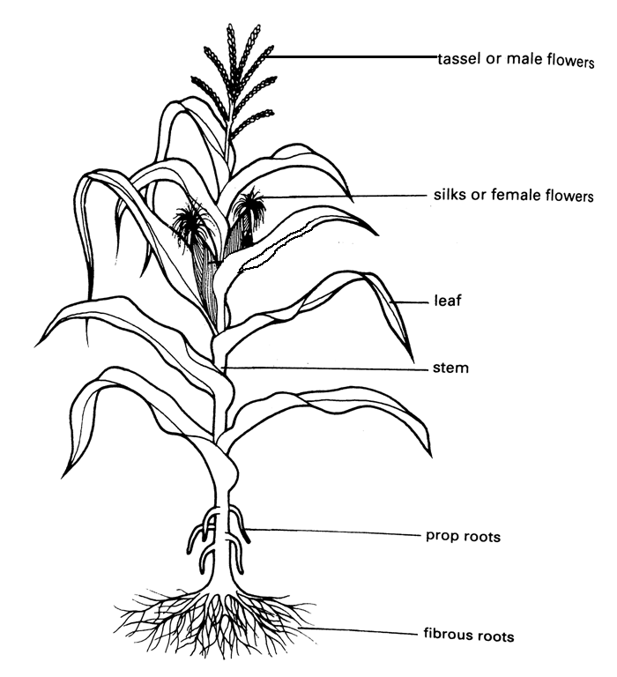A diagram showing maize plant

Questions

##### Write down the adaptation of pawpaw plants to cross pollination.

* + The male and female flowers grow on separate plant**.**

##### How does a maize plant avoid self pollination?

* + The male and female flowers mature at different times.

##### How does a pawpaw plant avoid self pollination?

* + The male and female flowers grow on separate plants.
  + Agents of pollination

##### Qn. What is an agent of pollination?

* + An agent of pollination is a factor or thing that help in transfer of pollen grains from the anthers to the stigma.
  + Examples of agents of pollination
  + - Insects
  + - Animals
  + - Birds
  + - Wind
  + - Water

##### Qn. How are some animals adapted to pollinating flowers?

* + Some animals have hair on their bodies that helps to carry pollen grains from the anthers to the stigmas of anther flower.
  + Note:
  + Human being mainly pollinate vanilla.

##### Qn. How do some birds help to pollinate flowers?

* + Some birds rub their bodies on the anthers and stigma as they collect nectar.
  + Examples of birds that pollinate flowers.
  + - Sunbirds
  + - Humming birds

##### Qn. How are sun birds adapted to pollination?

* + Sunbird have a long slender and slightly curved beaks. Qn. **How are insects adapted to carrying out pollination**?
  + Insects have a hairy body on which pollen grains get attached.
  + Note:
  + Insects visit flowers to collect nectar.
  + Characteristics of insect pollinated flowers
  + Insect pollinated flowers produce scent (good smell)
  + Insect pollinated flowers have brightly coloured petals.
  + Insect pollinated flowers are large and easily seen.
  + Insect pollinated flowers produce a lot of nectar.
  + Insect pollinated flowers produce less pollen grains.
  + Insect pollinated flowers produce heavy and sticky pollen grains.

-

* + Examples of insects that pollinate flowers
  + Bees
  + Butterflies
  + Moth
  + Beetles
  + Note:
  + Moths pollinate flowers at night.

##### Qn. How is a moth able to pollinate flowers at night?

* + By the help of the scent produced by some flowers at night.
  + Characteristics of wind pollinated flowers
  + They produce a lot of pollen grains.
  + Wind pollinated flowers have dull coloured petals.
  + Wind pollinated flowers do not produce nectar.
  + Wind pollinated flowers produce light pollen grains.
  + Wind pollinated flowers do not produce scent.
  + Wind pollinated flowers have a long feathery stigma to increase chances of pollination. Qn. **Why do wind pollinated flowers produce a lot of pollen grains**?
  + To increase the chance of pollination since most of it may fall on wrong parts of a plant. Qn. **Why do wind pollinated flowers produce light pollen grains**?
  + To easily be blown by wind.
  + Examples of plants pollinated by wind
  + Maize - Barley
  + Millet - Rice
  + Sorghum
  + Wheat

Difference between wind pollinated flowers and insect pollinated flowers.

* + 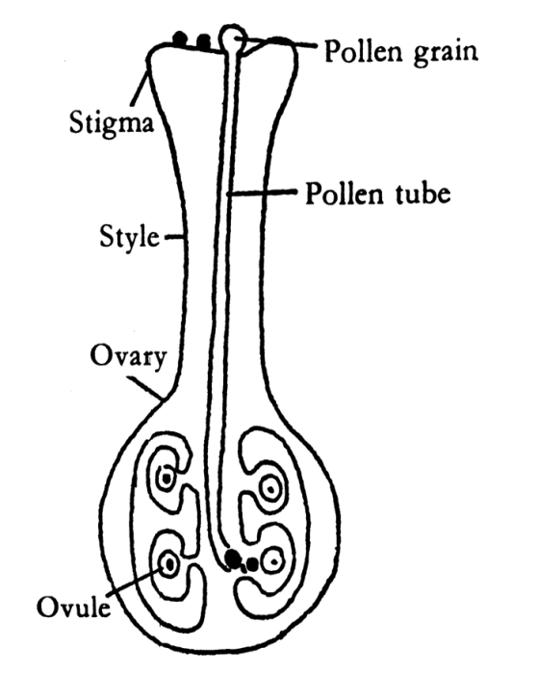Wind pollinated flowers produce light pollen grains while insect pollinated flowers produce heavy and sticky pollen grains.
  + Wind pollinated flowers have dull coloured petal while insect pollinated flowers have brightly coloured petals.
  + Wind pollinated flowers do not produce nectar while insect pollinated flowers produce nectar.
  + Wind pollinated flowers produce a lot of pollen grains while insect pollinated flowers produce less pollen grains.
  + Wind pollinated flowers have small petals which are not easily seen while insect pollinated flowers have large petals which are easily seen.

##### Qn. How is water adapted to pollinating some flowers?

* + When water droplets fall on the anthers, the pollen grain may float and come into contact of another flower leading to pollination.

-

* + Examples of plants pollinated by water
  + Water lily
  + Cauliflower

-

* + FERTILIZATION IN PLANTS

##### Qn. What is fertilization?

* + Fertilization is the union of a male and female gametes to form a zygote.

##### Qn. What is a gamete?

* + A gamete is a reproductive cell.

##### Qn. Where is a flower does fertilization take place?

* + In the ovary
  + Note
  + The male gametes in plants are called pollen grains and the female gametes are called ovules.

##### Qn. How does fertilization occur in plants?

* + After pollination has taken place, a pollen tube in formed through the style and pollen grain will travel down to the ovary to join with ovules.
  + Diagram showing fertilization in a flower

-

-

-

-

-

-

-

-

-

-

-

-

-

-

-

* + Questions

##### (a) What do the following develop into the after fertilization?

1. **Ovary fruit**

##### Ovules seeds

1. **Flower staik fruit stalk**

##### Qn. What happens to the pollen grains when they reach the stigma?

- A pollen tube is formed

##### Besides the ovary, which other part of a flower can develop into a fruit?

* + Receptacle
  + SEEDS

##### Qn. What is a seed?

* + A seed is fertilized ovule.

##### Qn. How are seeds important to plants?

* + Seeds help plant to multiply in number.

-

* + Types / groups / classes of seeds
  + Dicotyledonous seeds
  + Monocotyledonous seeds

##### Dicotyledonous seeds

**Qn. What are dicotyledonous seeds?**

* + Dicotyledonous seeds are seeds with two cotyledons.
  + Characteristics of dicotyledonous seeds
  + Dicotyledonous seeds tap root system.
  + Dicotyledonous seeds have two cotyledons.
  + Dicotyledonous seeds undergo epigeal germination.

##### Examples of Dicotyledonous seeds

* + Beans
  + Soya beans
  + Cowpeas
  + peas

##### A diagram of Dicotyledonous seed (bean seed)

* + External parts of a bean seed

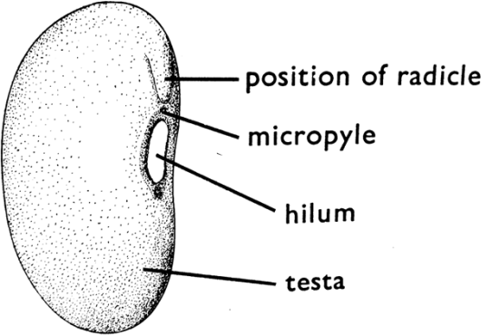

##### Internal parts of a bean seed

1. **|** P a g e

##### Functions of the parts of a bean seed

1. **Micropyle**
   * The micropyle lets in water and air into the bean seed.

##### Hilum

* + Hilum is a scar that attaches the bean seed to the pod.

##### Cotyledon

* + Cotyledon stores and supplies food to the embryo.

##### Testa / seed coat

* + Testa protect the inner parts of the seed.

##### Radicle

* + The radicle develops into the root system.

##### Plumule

* + The plumule develops into the shoot system.
  + Note:
  + The plumule and the radicle make up the **embryo**.
  + Monocotyledonous seeds

##### Qn. What are monocotyledonous seed?

* + Monocotyledonous seeds are seed with one cotyledon**.**
  + Characteristics of monocotyledonous seeds
  + Monocotyledonous seeds have one cotyledon.
  + Monocotyledonous seeds undergo hypogeal germination.
  + Monocotyledonous seeds have fibrous root system.
  + Examples of monocotyledonous seeds
  + Maize
  + Barley
  + Wheat
  + Rice
  + Sorghum
  + Structure of a maize grain

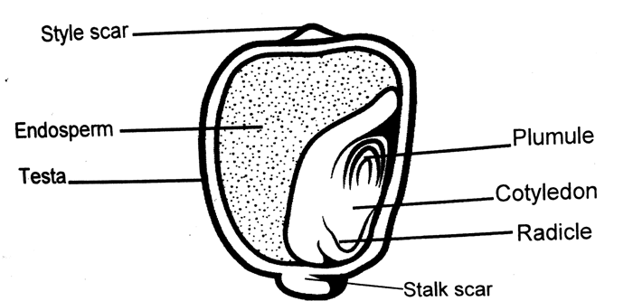-

-

-

-

-

-

-

1. **|** P a g e

-

-

- Functions of the parts of a maize grain.

##### Testa

* + Testa protects the inner parts of a maize grain.

##### Plumule

* + Plumule develops into shoot system

##### Radicle

* + The radicle develops into root system.

##### Endosperm

* + The endosperm stores food for the embryo.

##### Cotyledon

* + Cotyledon supplies food to the embryo.

##### Stalk power

* + Stalk power attaches the maize grain to the cob.

##### Style scar

* + Style scar is where the style of a flower is attached.
  + Note:
  + The plumule and radicle make up embryo.
  + Questions

##### Why is a maize grain called a fruit.

1. **Name the two scars of a maize fruit.**
   * Style scar
   * Stalk scar

##### Give two differences between a maize grain and a bean seed.

* + Maize grain has two scars while a bean seed has a one scar.
  + A maize grain stores food in the endosperm while a bean seed stores food in the cotyledon.

-

* + GERMINATION

##### Qn. What is germination?

Germination is the development of a seed embryo into a seedling.

##### Qn. What is a seedling?

* + A seedling is a young plant.
  + Steps of germination
  + The seed first absorbs water from the soil to soften the testa.
  + The seed swells.
  + The radicle grows and root hairs develop.
  + The radicle pushes the testa and comes out of the soil.
  + The plumule grows and pushes itself of the soil.
  + Note:
  + The radicle comes out first to absorb water and mineral salts from the soil in order for the plumule to grow.
  + Types of germination
  + Epigeal germination
  + Hypogeal germination
  + Epigeal germination

##### Qn. What is epigeal germination?

* + Epigeal germination is the type of germination where the cotyledon grows above the ground.
  + Examples of plants that undergo epigeal germination
  + Beans
  + Soya beans
  + Cowpeas
  + Peas
  + Groundnuts
  + Stages of germination in dicotyledonous seeds

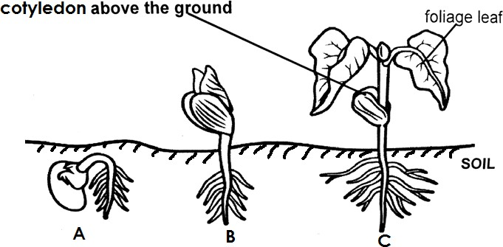

##### Questions

1. **How are the cotyledons useful to the seedling of stage B?**
   * The cotyledons make food for the plant.

##### State the function of foliage leaves at stage C?

* + Foliage leaves make food for the seedling

##### Why are the cotyledon no longer useful to the seedling at stage C?

* + At stage C the seedling has developed foliage leaves that make food.

##### Hypogeal germination

Qn. **What is hypogeal germination?**

* + Hypogeal germination is the type of germination where the cotyledon remains under the ground.
  + Examples of plants that undergo hypogeal germination.
  + Maize
  + Sorghum
  + Wheat
  + Barley
  + Millet
  + Oats

-

-

* + Stages of germination of a monocot seed

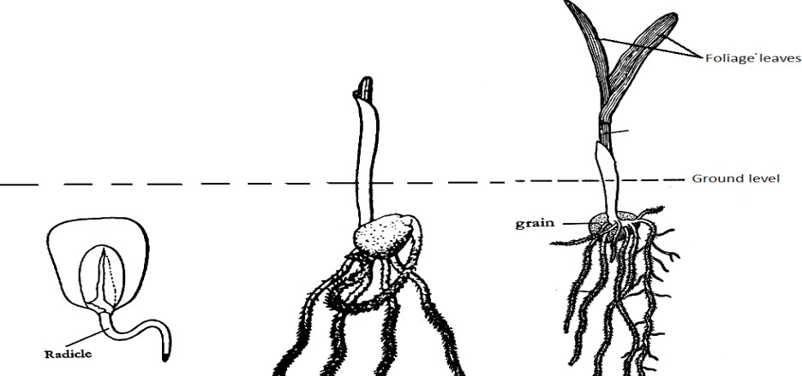-

##### Questions

1. **Which part of a seed comes out first during germination?**
   * Radicle

##### Why does the radicle come out first during germination?

* + To absorb water and mineral salts from soil.
  + Condition necessary for germination
  + Warmth
  + Oxygen
  + Moisture (water)

##### Importance of each condition

1. Warmth (moisture)
   * Water softens the testa for the radicle to come out.
   * Water dissolves food nutrients within the seed.

##### Warmth (optimum temperature)

* + For metabolism

1. Oxygen
   * For oxygen
   * Oxygen oxidises food to produce energy used by the embryo during germination.
   * Experiment to find out conditions necessary for germination.

- ARGAZZHN AAAAAA

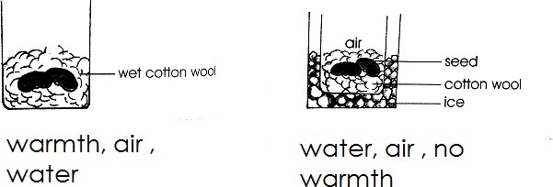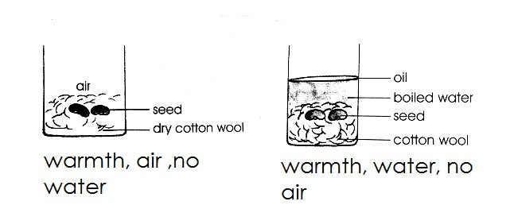

##### Questions

1. **Why didn’t the seeds in the test A germinate?**
   * Seeds in test tube A didn’t germinate because there isn’t moisture.

##### Why will the seeds fail to germinate in test tube B?

* + Seeds in test B will fail to germinate because oxygen supply was cut off.

##### Give a reason why seeds in test C will germinate.

* + Seeds in test tube C will germinate because all the conditions are present.

##### Why will seeds in test tube D fail to germinate?

* + Seeds in test tube D will fail to germinate because there is no warmth.

-

* + Seeds viability and seed dormancy.
  + Seed viability

##### Qn. What is seed viability?

* + Seed viability is the ability of seeds to germinate under fovourable conditions.
  + Qualities of a good viable seed
  + A good viable seed should be mature.
  + A good viable seed should be dry.
  + A good viable seed should be heathy.
  + A good viable seed should not be broken.
  + Seed dormancy

##### Qn. What is seed dormancy?

* + Seed dormancy is the inability of a seed to germinate.

##### Factors that can lead to seed dormancy

* + Planting diseased seeds.
  + Planting premature seeds.
  + Planting broken seeds.
  + Too much heat in the soil.
  + Dumpness of seeds during storage.
  + Lack of necessary conditions.
  + Ways of protecting seeds from dormancy
  + Dusting seeds.
  + Proper drying of seeds before storage.
  + Keeping seeds in dry place.
  + Putting rat guards in granaries.

##### Tropism

Qn. **What is tropism?**

* + Tropism is a plant growth response towards stimuli. Qn. **What is stimulus?**
  + A stimulus is achange in the environment to which a plant is sensitive to.
  + Types of tropism
  + Phototropism
  + Geotropism
  + Thigmotropism (Haptotropism)
  + Chemotropism
  + Hydrotropism

##### Phototropism

* + Phototropism is the growth movement of a plant shoot towards sunlight.

##### Note:

* + The part of the plant that responds to sunlight is the shoot system.

##### Diagram showing phototropism.

1. **|** P a g e

##### Hydrotropism

* + Hydrotropism is the growth movement of plant roots towards the source of water.
  + Note:
  + The part of the plant that responds to water is the root system.
  + Diagram showing Hydrotropism

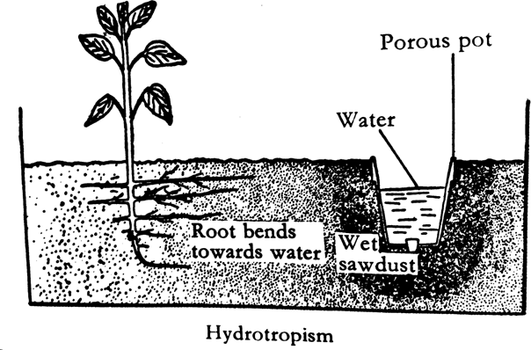

##### Geotropism

* + Geotropism is the growth movement of plant roots towards the directions of force of gravity.
  + Note:
  + The part of a plant that responds to force of gravity is root system.

##### Chemotropism

* + Chemotropism is the growth movement of plants parts towards a source of chemicals. Qn. **Give an example of chemotropism in plants**.
  + Movement of pollen tubes from the stigma through the style towards the ovary.

##### Thigmotropism

* + Thigmotropism is the growth movement of certain parts of some plants in response to the stimuli of touch.
  + Note:
  + Thigmotropism is common in climbing plants.

##### Qn. How is Thigmotropism important to climbing plants?

* + Thigmotropism enables climbing plants to twine on other plants.
  + Summary of tropism

|  |  |
| --- | --- |
| - Tropism | - Stimulus |
| - Phototropism | - sunlight |
| - Geotropism | - Force of gravity |

1. **|** P a g e

|  |  |
| --- | --- |
| - Hydrotropism | - Water and moisture |
| - Thigmotropism/ Haptotropism | - Touch |
| - Chemotropism | - Chemicals |

-

* + Fruits

Qn. **What is a fruit**?

* + A fruit is a developed ovary.
  + Characteristics of fruits
  + Fruits have two scars.
  + Fruits have no micropyle.
  + Fruits have the ovary to protect the seeds.
  + Fruits have a pericarp which forms external parts.
  + Difference between a fruit and a seed.
  + A fruits has two scars while a seed has one scar.
  + A fruit has no micropyle while a seed has a micropyle.
  + A fruit has a pericarp that forms the external parts while a seed has a testa that forms the external parts.
  + A fruit has a pedicel as its stalk while a seed has a funicle as its stalk.
  + Similarities between a fruit and a seed
  + Both have scars.
  + Both have stalks.
  + Both contain food substances.
  + Both have outer coating forming external parts.

-

##### Importance of fruits to plants

* + Fruits help in seed dispersal.
  + Fruits protect the seeds.

-

* + Importance of fruits to people
  + Fruits are eaten as food.
  + Fruits are source of income.
  + Some fruits are source of herbal medicine.

-

* + Groups / classification of fruits
  + Juicy fruits / succulent fruits
  + Dry fruits

-

##### Chart showing groups of fruits

* + Fruits

-

-

Succulent fruits (juicy fruits Dry fruits

Dehiscent fruits Indehiscent fruits

-

**152 |** P a g e

(splitting fruits) (Non splitting)

Berries Drupes Pomes

##### Succulent fruits (juicy fruits)

Qn. **What are succulent fruits?**

* + Succulent fruits are fruits with a lot of juice inside them.
  + Note:
  + A pericarp consists of three layers i.e. epicarp, mesocarp, endocarp.
  + The epicarp is a thin outer most layer.
  + The mesocarp is the juicy or fleshy layer.
  + The endocarp is the hard layer that encloses the seed in case of drupes.
  + Groups of succulent / juicy fruits
  + Berries
  + Drupes
  + Pomes
  + Compound fruits

##### Drupes

Qn. **What are drupes**?

* + Drupes are fruits with one seed inside their pericarps.
  + Examples of drupes
  + Avocado
  + Coconut
  + Oil palm fruit
  + Peach
  + 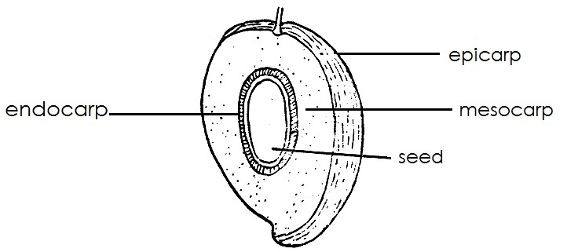Diagram showing a drupe (mango)

##### Berries

Qn. **What re berries**?

* + Berries are fruits with many seeds insides their pericarp.
  + Examples of berries
  + Tomatoes
  + Oranges
  + Passion fruits
  + Pawpaw
  + Lemon
  + Watermelon
  + Strawberries
  + Jackfruit
  + A diagram showing a berry fruit

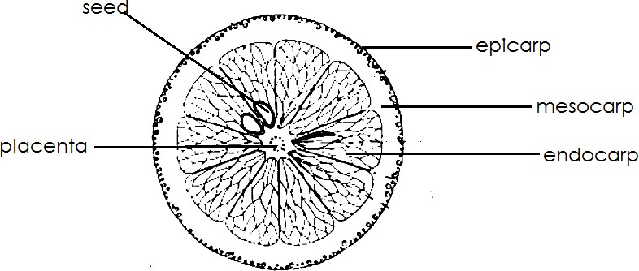

##### Pomes

Qn. **What are pomes**?

* + Pomes are fruits that develop from a swollen receptacle.
  + Example of a pome
  + Apple
  + Diagram of a pome

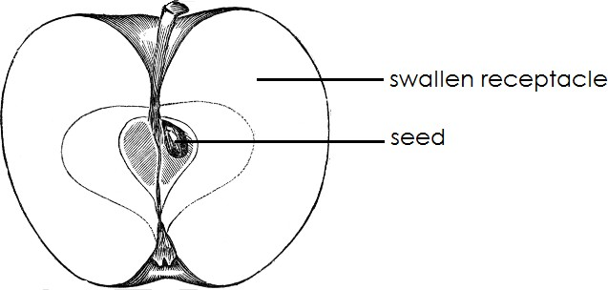

##### Compound / multiple fruits.

Qn. **What is multiple fruit?**

* + This is a fruit formed from many flower on a stalk.
  + Examples of compound fruit
  + Pineapple
  + Straw berry
  + Dry fruits

##### Qn. What are dry fruits?

* + Dry fruits are fruits whose pericarp is dry and woody.
  + Groups of dry fruits
  + Dehiscent fruits (splitting fruits)
  + Indehiscent fruits ( Non splitting fruits)

##### Dehiscent fruits

Qn. **What are dehiscent fruits?**

* + Dehiscent fruits are fruits with pods which split to disperse the seeds.
  + Examples of dehiscent fruits

- Beans

* + Peas
  + Castor oil
  + 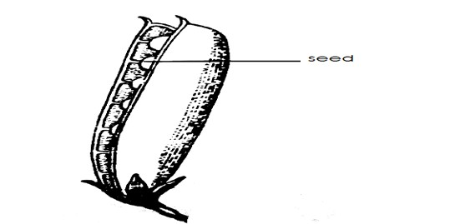Diagram showing dehiscent fruits

##### Indehiscent fruits

* + Indehiscent fruits are fruits that do not split to disperse the seeds.
  + Examples of indehiscent fruits
  + Maize fruit
  + Sunflower
  + Black jack
  + Tridax

##### Note

* + Fruits that develop from many flowers on the same stalk are called compound fruit e.g. jack fruit.

-

##### Seed and fruits dispersal

Qn. **What is seed dispersal?**

* + Seed dispersal is the scattering of seeds from a parent plant over a wide area.
  + Importance of seed dispersal
  + Seed dispersal enables plant to colonise new areas.
  + Seed dispersal prevents overcrowding of plants in an area.
  + Seed dispersal reduces competition for plant nutrients.
  + Seed dispersal reduces on competition for sunlight.
  + Seed dispersal increases survival for plant species.
  + Seed dispersal reduces on spread of diseases among plants.

##### Disadvantage of seeddispersal in the environment.

* + Leads to spread of weeds.
  + Agents of seed dispersal

##### Qn. What is an agent of seed dispersal?

* + An agent of seed dispersal in anything that helps in scattering of seeds from a mother plant over a new area.
  + Agent of seed dispersal
  + Water

- Wind

* + Animals
  + Types of seed dispersal / mechanisms of seed dispersal.
  + Animal dispersal
  + Wind dispersal
  + Water dispersal
  + Explosive mechanism

##### Animal dispersal

**Characteristics / adaptations of seeds / fruits dispersal by animals.**

* + Some seeds have hooks to attach to the animals body.
  + Some fruits have sticky hair.
  + Some seeds have tough testa which prevents them from being digested after being eaten by animals.
  + Most of the fruits eaten by animals are sweet and juicy.
  + Many of the fruits eaten by animals have brightly coloured epicarp when they are ripe.
  + Examples of seeds and fruits dispersed by animals
  + Jack fruit - Water melon
  + Mangoes - lemons
  + Oranges - Pineapples
  + Apples - Paw paws
  + Passion fruit - Black jack
  + 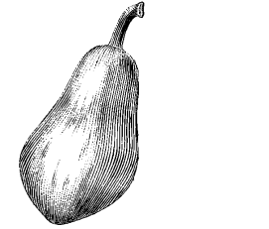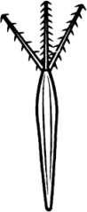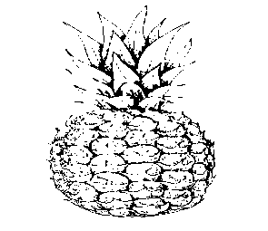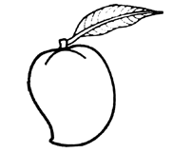Guava -Avocado

|  |  |  |
| --- | --- | --- |
| -  -  -  -  -  - | - | - |
| - Mango | - tomato | - pineapple |
| -  -  -  -  -  -  - | - | - |
| - Black jack | - Paw paw | - |

##### Qn. How is a black jack adapted to its mode of dispersal?

* + It has hooks that attach on the animal’s body

##### Wind dispersal

**Characteristics /adaptations of seed dispersed by wind.**

* + Some have wing like structures e.g. jacaranda
  + They are small and light.
  + Some have tiny thread like or feather structures.
  + Some seeds have parachute like structures e.g.tridax
  + Some seeds have a layer of tough hair e.g. cotton seed

|  |  |
| --- | --- |
| -  -  -  -  -  -  - | - |
| - Jacaranda | - Dandelion |
| -  -  -  -  -  -  -  -  - | -  -  - |
| - Calotropis | - cotton |
| -  -  -  -  -  -  -  - | -  -  -  -  -  -  -  -  - |
| - Tridax | - |

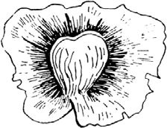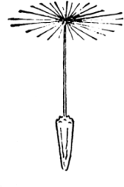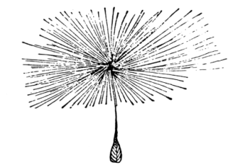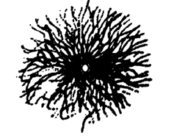

##### Water dispersal

* + Seeds dispersed by water have a lot of air space that enables them to float on water.
  + Characteristics /adaptations of seeds dispersed by water
  + They are light and this enable them to float on water.
  + They have air spaces which help them to float.
  + Example of seeds dispersed by water
  + Coconut
  + Water lily

-

##### Diagram showing coconut

a g e

**157 |** P

##### Self dispersal/ explosive mechanism

* Explosion is the bursting of fruits pods with a loud noise.
* Explosive mechanism is the type of dispersal where the fruits ripens, dries up and splits with force to disperse seeds.

##### Examples of fruits / seeds that undergo explosive mechanism

* Beans - Mahogany
* Peas - Cassava
* Castor oil
* Soya beans

-

-

-

-

* A diagram showing self dispersal

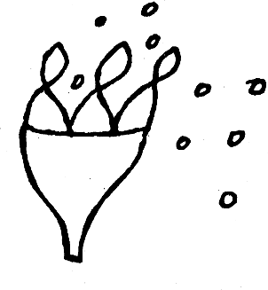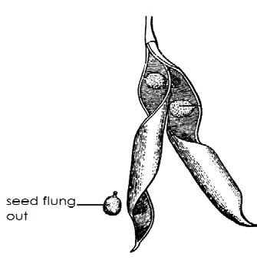-

castor oil

-

* Bean

-

-

-

-

-

-

-

-

* PLANT PROPAGATION

##### Qn. What is plant propagation?

* Plant propagation is a method of making plants to multiply.
* Method of plant propagation
* Seed propagation
* Vegetative propagation

-

* Seed propagation
* Seed propagation is a method of propagation where seeds are used to obtain new plants.
* Examples of plants propagated by means of seeds
* Carrots - Wheat
* Maize - Peas
* Barley - Tomatoes
* Sorghum - Cow peas
* Oats - Groundnuts
* Beans
* Soya beans

- Methods of planting seeds

* Row planting
* Broad casting

##### What is broadcasting?

* + Broadcasting is a method of planting where seeds are scattered in a well prepared garden.
  + Examples of seeds planted using broadcasting
  + Simsim - millet
  + - Rice - wheat

-

##### Advantages of broadcasting

* + Broadcasting saves time.
  + Broadcasting require less labour.
  + Many seeds are planted at a time.

##### Disadvantages of broadcasting

* + Broadcasting makes weeding difficult.
  + Broadcasting encourages overcrowding of crops.
  + Broadcasting leads to easy spread to diseases.
  + Broadcasting makes harvesting difficult.
  + Broadcasting requires large piece of land.
  + Broadcasting makes thinning difficult.
  + Many seeds are used.
  + Row planting

##### Qn. What is row planting?

* + Row planting method is a method of planting where seeds are planted in rows or lines.
  + Examples of seeds / plants planted using row planting
  + Cabbage - Passion fruits
  + Maize - Soya beans
  + Beans - Pineapples
  + Carrot - Bananas
  + Watermelon - Tomatoes
  + Oranges - Mangoes

##### Illustration of row planting

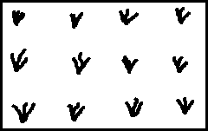

**Advantages of row planting**

* + Row planting makes weeding easy.
  + Row planting makes harvesting easy.

- Few seeds are used.

* + Row planting prevents overcrowding of plants.
  + Row planting makes spraying easy.

##### Disadvantages of row planting

* + Row planting is time consuming.
  + Row planting requires large human labour.
  + Row planting is tiring.

-

* + Vegetative propagation

##### Qn. What is vegetative propagation?

* + Vegetative propagation is a sexual reproduction in which another part of a plant other than seeds in used to grow a new plant.

##### Qn. What is a sexual reproduction?

* + A sexual reproduction is a form of reproduction where reproductive cells are not used.
  + Form s of a sexual reproduction
  + Spore formation in fungi.
  + Budding in yeast.
  + Vegetative propagation in plants.
  + Cell division / binary fission in bacteria.

-

* + Methods of vegetative reproduction
  + Natural vegetative propagation.
  + Artificial vegetative propagation.

##### Natural vegetative propagation

**Methods of natural vegetative propagation.**

* + Use of corms
  + Use of bulbs
  + Use of rhizomes
  + Use of leaves
  + Use of suckers
  + Use of stem tubers

##### Use of corms

A corm is a vertical swollen underground stem the stores food.

##### Examples of plants propagated by means of corms.

* + Coco yams
  + Gladiolus
  + Crocus

##### Use of rhizomes

* A rhizomes is a horizontal underground stem that store food.
* Examples of plants propagated from rhizomes
* Ginger
* Turmeric
* Cannalily
* Zoyzia

##### Use of leaves

* + Some leaves develop adventitious roots on their margin if favourable conditions are found.
  + Examples of plants propagated from leaves.
  + Bryophyllum
  + Cactus

-

* + Illustration (bryophyllum)

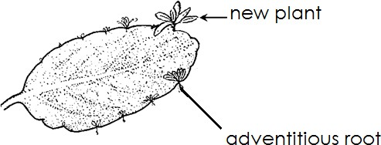

##### Propagation from suckers

* + A sucker is a lateral branch from the terminal bud that develop from the base of a parent plant.
  + Examples of plants propagated by planting suckers.
  + Bananas - Aloevera
  + Pineapples
  + Sisal

##### Diagram showing a pineapple sucker

**161 |** P a g e

Qn. **Besides using suckers, how else can pineapple be propagated**?

* + By planting the crown
  + A diagram showing a banana plant with its sucker.

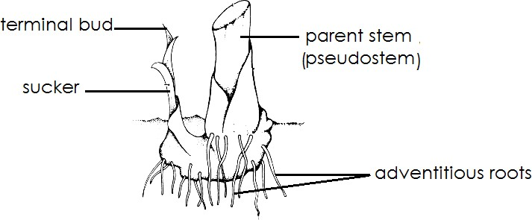

##### Qn. Give a reason why leaves are cut off from a banana plant before planting.

* + To reduce water loss from the plant.

##### Qn. Why are the adventitious roots removed from a banana sucker before planting?

* + To avoid nematodes from spreading incase they existed in parent plant.

-

##### Use of stem tubers

* + Stem tubers are crops that store their food in the swollen underground stem.
  + Examples of plants propagated using stem tubers
  + Irish potatoes
  + White yams

##### Artificial vegetative propagation

* + Artificial vegetative propagation is method where a farmer use stems to obtain new plants.
  + Forms of artificial vegetative propagation
  + Stem cutting
  + Grafting
  + Layering
  + Macrotting
  + Budding

##### Propagation from stem cuttings

* + Stem are cut into short pieces with two or three nodes and axillary buds to grow.
  + Examples of plants propagated by means of stem cuttings
  + Sugar canes
  + Cassava
  + Sweet potatoes
  + Rose flowers

-

-

* + Diagram showing stem cutting (cassava stem cutting)

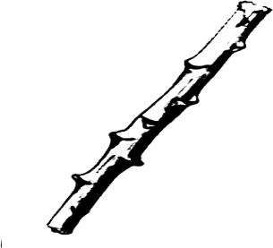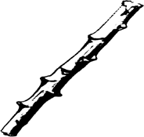-

-

-

-

-

-

##### Propagation by grafting

* + In this method, a shoot with a bud of one plant in joined to another plants with a waterproof binding tape.

##### Note

The bud which is used is called a**scion**and the plant to which the bud is joined is called

**stock.**

**Diagram showing grafting**

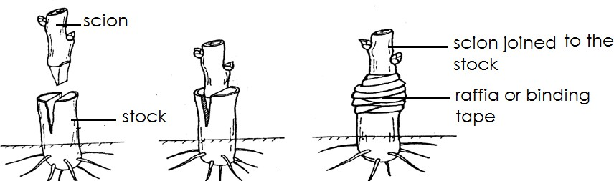

##### Examples of plants propagated by grafting

* + Oranges
  + Lemon
  + Cocoa
  + Avocado
  + Mangoes

##### Propagation by layering

* + In this method a branch from a parent plant is bent into the soil and a slit is made at one of the nodes and covered in soil.
  + After some times, adventitious roots grow from the part covered in the soil.
  + It is then cut off from the parent plant to become independent.
  + A diagram showing propagation of layering.

-

-

-

-

-

-

##### Examples of plants propagated by layering

* + Roses

##### (ii) Propagation by marcotting

- In this method, one healthy branch of a plant is used.

- A cut is made on that branch carefully to remove the bark.

* Fertile soil is put in a piece of sack and placed around the part of the branch where the bark has been removed.
* 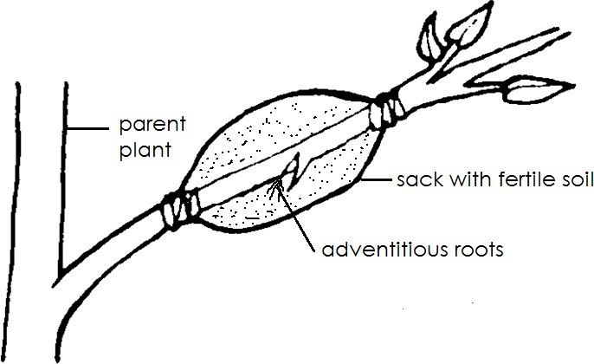A diagram showing marcotting

##### Propagation from budding

* + In this method, a bud of one plant is made to grow on another plant.
  + The plant used should be of the same kind.
  + A diagram showing budding.

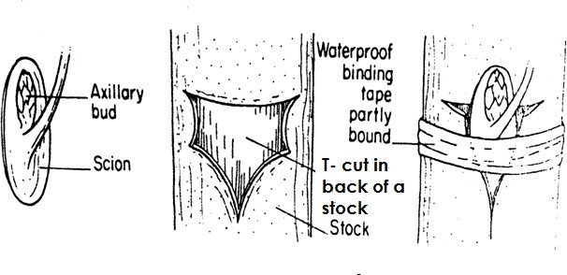-

-

-

-

-

-

-

-

-

-

* + Examples of plants propagated by budding
  + Oranges
  + Lemons
  + Apples
  + Tangerine
  + Advantages of vegetative propagation
  + Only one plant is needed to produce the off spring.
  + The new plant gets food from the parent plant.
  + Growth of the new plant is rapid.
  + No pollinating agent is needed.
  + It enables plants to maintain their genetic characteristics.
  + Disadvantages of vegetative propagation
  + Colonisation of new areas will not happen.
  + The disease can be transmitted from the parent plant to offspring.
  + Many plants may be destroyed by disaster e.g. fire
  + No new varieties are produced in the plants.

##### Topics 6 ANIMALHUSBANDRY

Qn. **What is animal husbandry**?

* + Animal husbandry is the keeping of livestock. Qn. **What is livestock**?
  + Live stock are farm animals.
  + Examples of live stock
  + Cattle
  + Goats
  + Sheep
  + Pigs
  + Rabbits
  + Cattle keeping

##### Qn. What is cattle keeping?

* + Cattle keeping is the rearing of cattle.

##### Examples of cattle

* + Cows - Calves
  + Bulls - Oxen
  + Bullocks
  + Heifers
  + Terms used in cattle keeping

##### Qn. Give the meaning of each of the following terms as used in cattle keeping

* + A calf is a young one of cow.
  + Abull is mature male cattle.
  + A cow is mature female cattle.
  + A heifer is a young female cow which has not yet given birth.
  + A bullock is young male cattle.
  + Oxen are castrated bulls reared for doing work.
  + Steers are castrated bulls reared for meat production.

##### Importance of keeping cattle (Reason why people keep cattle)

* + For milk
  + For meat production
  + Cow dung is used as manure.
  + Cow dung is used for production of biogas.
  + Cattle provide hides for making leather products.
  + Oxen provide energy resources for ploughing and transport.
  + Hooves and horns are used to make buttons, glue and necklaces.
  + Keeping cattle is source of employment.
  + Keeping cattle is a source of income.

##### External features of a cow.

-

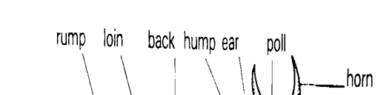 -

**165 |** P a g e

-

-

-

-

-

-

-

-

-

-

-

-

-

- Functions of some parts of a cow

(i) **Eyes**

- For seeing

##### Ears

* + For hearing
  + For body balance
  + For beating insects around the head.

##### Muzzle

* + The muzzle is the protruding part of the nose.
  + Note:
  + The muzzle is cold and moist when the cow is health and warm when the cow is sick.

##### Hooves

* + Hooves protect the feet from external damage.

##### Udder

* + The udder stores milk produced by mammary glands.

##### Teats

* + The teats let out milk from the udder.

##### Switch

* + The switch helps to chase away insect from animals.

##### Horns

* + For protection

-

* + Breeds of cattle

##### Qn. What is a breed of cattle?

* + A breed of cattle is a family of cattle with specific characteristics.

##### Qn. How is breed of cattle determined?

* + Size of an animal.
  + Production rate of the cattle.
  + Ability of resist diseases.
  + Colour of animals.
  + Body shape / body conformation of cattle.

-

* + There are three main breeds of cattle namely;
  + Local breed of cattle.
  + Exotic breeds of cattle.
  + Hybrids / cross breed.
  + Local breeds or indigenous breeds
  + Local breeds are breeds that have been kept in Uganda for a long time.
  + Note:
  + Local breeds of cattle can also be called**indigenous breeds Examples of local breeds of cattle**
  + Zebu cattle
  + Ankole cattle
  + Nsoga cattle
  + Nganda cattle
  + Nsagala cattle
  + Boran cattle
  + Small East African Zebu

##### Characteristics of local breeds of cattle.

* + Local breeds produce less quantity of meat and milk.
  + Local breedsrequire less attention and care.
  + Local breeds can survive on poor pasture.
  + Local breeds can with stand harsh weather conditions.
  + Local breeds grow and mature slowly.
  + Local breeds have few reproductive problems.
  + Local breeds are more resistant to diseases.

-

* + Advantages of keeping local breeds of cattle
  + Local breeds need less care and attention.
  + Local breeds have few reproductive problems.
  + Local breeds can survive on poor pasture.
  + Local breeds are resistant to disease.
  + Local breeds can withstand harsh weather condition.

-

* + Disadvantage of keeping local breeds of cattle
  + Local breeds produce less quantities of meat.
  + Local breeds are small in size.
  + Local breeds produce less milk.
  + Local breeds grow and mature slowly.

##### Qn. How can the quality of local breeds be improved upon?

* + By crossbreeding
  + By upgrading /selective breeding
  + By proper feeding
  + Exotic breeds of cattle
  + Exotic breeds are breeds that were imported to Uganda from outside countries.

- Examples of exotic breeds of cattle

* + Santa gertrudis - Hereford
  + Jersey cattle - Brown Swiss
  + Friesian cattle - Ayrshire
  + Aberdeen angus - American brahman
  + Charolais - Jamaicanhope
  + Sahiwal - Red poll
  + Characteristics of exotic breeds of cattle
  + Exotic breeds produce high quantity of meat and milk.
  + Exotic breeds have many reproductive problems.
  + Exotic breeds have a lot of care and attention.
  + Exotic breeds cannot withstand harsh weather conditions.
  + Exotic breeds cannot survive on poor pasture.
  + Exotic breeds are easily attacked by diseases.
  + Advantages of keeping exotic breeds of cattle.
  + Exotic breeds produce high quantity of milk.
  + Exotic breeds grow and mature faster.
  + They are easy to market.
  + Disadvantages of keeping exotic breeds
  + Exotic breeds are easily attacked by diseases.
  + Exotic breeds have a lot of reproductive problems.
  + Exotic breed need a lot of care and attention.
  + Exotic breed cannot withstand harsh weather condition.
  + Exotic breed are expensive to maintain.

##### Cross breeds

**Qn**. **What is a cross breed**?

* + Cross breed is a breed of cattle obtained by mating an exotic breed together with a local breed.
  + Note:
  + A cross breed is can also be called a **hybrid. TYPES OF CATTLE**

##### Qn. What is a type of cattle?

* + A type of cattle is a class of cattle kept for a specific purpose.
  + There are four types of cattle namely:-
  + Dairy cattle
  + Dual purpose cattle
  + Beef cattle
  + Draught cattle

##### DAIRY CATTLE

**Qn**. **What are dairy cattle**?

* + Dairy cattle are types of cattle kept for milk.
  + Characteristics of dairy cattle.
  + Dairy cattle have triangular body shapes.
  + Dairy cattle have a higher rate of milk production.
  + Their hind quarters are wide and they have big udders.

- Dairy cattle have small heads and neck.

* + Dairy cattle have four medium teats.
  + Dairy cattle have plenty of space between their hind legs.

##### Body shape of a dairy cattle.

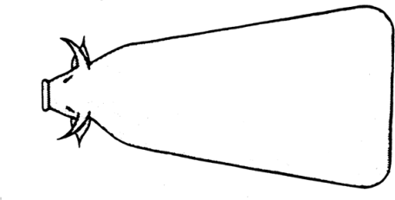-

-

-

-

-

-

##### Examples of milk breeds/ dairy breeds of cattle.

* + Friesian
  + Guernsey
  + Jersey
  + Ayrshire
  + Jamaican hope
  + Note
  + Friesians are the best milk producers.
  + Beef cattle

##### Qn. What are beef cattle?

* + Beef cattle are cattle kept for meat or beef production.
  + Characteristics of beef cattle
  + Beef cattle produce high quantity of meat.
  + Beef cattle have rectangular block shapes.
  + Beef cattle have short legs.
  + Beef cattle have broad long backs.

##### Body shape of breed cattle

-

-

-

-

**Examples of breeds of cattle**

* + Aberdeen angus - Charolasis
  + Galloway - American Brahman
  + Hereford - Santa gertrudis
  + American beef master

##### Dual purpose cattle

**Qn. What are dual purpose cattle**?

* + Dual purpose cattle are cattle kept for both beef and milk production.
  + Example of dual purpose cattle
  + Red poll
  + Sahiwal
  + Milking short horn

- Zebu cattle

* + Ankole cattle
  + Small East African Zebu

##### Draught cattle / work type cattle

* + Draught cattle are cattle kept for labour.

##### Examples of work done by draught cattle

* + Pulling cats
  + Ploughing gardens
  + Examples of work cattle
  + Oxen

##### Breeding in cattle

**Qn. What is breeding?**

* + Breeding is the maintaining of inherited characteristics among cattle.
  + Examples of inherited characteristics in cattle
  + Colour of the animal.
  + Production rate of the animal.
  + Growth rate of the animal.
  + Ability to live longer.
  + Type of the animal.
  + Milking ability of the animal.
  + Size of the animal.
  + Resistance to diseases.
  + Types of breeding
  + Cross breeding
  + Inbreeding
  + Line breeding
  + Up grading
  + Out breeding
  + Cross breeding
  + Cross breeding is the mating of unrelated breeds of cattle.
  + Note:
  + The product got after cross breeding **is a hybrid / cross breed.**
  + Advantages of cross breeding
  + Cross breeding helps to improve the quality of local breeds.
  + The offspring may grow fast and healthy.
  + The offspring may have better performance thanthat of the parents.
  + Disadvantages of crossbreeding
  + Animals might lose some characteristics.
  + Inbreeding
  + In breeding is mating of very closely related animals like brothers and sisters, fathers and daughters.
  + Importance of inbreeding
  + In breeding is used by expert breeders to maintain and strengthen good characteristic among animals.

- Disadvantages of inbreeding

* + 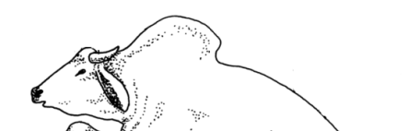Inbreeding may lead to production of poor quality animals if not done properly.
  + The offspring produced may be of low resistance to diseases.
  + The offspring may grow slowly.
  + Out breeding
  + Out breeding is the mating of same animals but from different flocks.

##### Qn. How is out breeding important?

* + Out breeding helps to restore qualities in cattle that may be disappearing from the flock.
  + Up grading
  + Up grading is the mating of a poor breeds with the animal of a superior quality.

##### Line breeding

* + Line breeding is the mating of closely related animals like cousins.

##### Reproduction in cattle

**Qn. What is reproduction**?

* + Reproduction is a process by which organisms multiply in number by giving rise to young ones.
  + Note
  + Cattle undergo sexual reproduction.

##### Qn. What is sexual reproduction?

* + Sexual reproduction is the type of reproduction that involves reproductive cells.

##### Qn. How do cattle reproduce?

* + By giving birth to live young ones.

##### Qn. How is reproductive important in cattle.

* + It helps cattle to increase in number.

##### Heat period in cattle (Oestrus) Qn. What is heat period?

* + Heat period is the time a cow is ready to mate with a bull.
  + Signs of heat period in cattle
  + The cow stands still when being mounted.
  + The vulva swells and turns red.
  + Loss of appetite to graze.
  + The cow urinates frequently.
  + The cow makes a lot of noise.
  + The cow mounts other cattle.
  + Service / insemination as used in cattle.

##### Qn. What is insemination?

* + Insemination is the act of depositing sperms inside a cow’s vagina.
  + Types of insemination
  + Artificial insemination
  + Natural insemination
  + Natural insemination
  + Natural insemination is the type of insemination where a bull deposits sperms inside a cow’s vagina during mating.

-

* + Diagram showing natural insemination

-

-

-

-

-

-

-

-

* + Methods of natural insemination

##### Hand mating

* + Hand mating is a method of mating where a bull is kept separately from cows and it is brought when the cow is on heat.

##### Pasture mating

* + Pasture mating is a method where a bull is kept together with cows.
  + Advantages of natural insemination
  + It is cheap to manage.
  + Both male and female animals are not denied desire for sex.
  + Natural insemination does not bother a farmer to look for a trained inseminator.
  + It is easy for a bull to detect the cow on heat.
  + Disadvantages of natural insemination
  + Natural insemination encourages inbreeding.
  + It may be expensive to transport a bull if not around.
  + Small cows may be injured by big bulls.
  + Natural insemination leads to easy spread of venereal diseases.
  + Artificial insemination
  + Artificial insemination is the act of depositing sperms into cow’svagina using a syringe.

##### Diagram showing artificial insemination.

-

-

* + Advantages of artificial insemination.
  + Artificial insemination controls inbreeding in cattle.
  + Artificial insemination controls easy spread of venereal diseases.
  + Artificial insemination prevents injuries on small cows by heavy bulls.
  + A farmer can only keep cows instead of rearing bulls.
  + Semen from dead bulls can be used to inseminate all cows.
  + Semen can easily be transported.
  + Artificial insemination enables a farmer to use semen from good breeds of cattle.
  + Disadvantages of artificial insemination
  + It is expensive to maintain proper storage of sperms.
  + It requires a trained and experienced person to carry it out.

- It may be very difficult for a farmer to identify a cow on heat.

* + Animals are denied their natural feeling of having sex.
  + 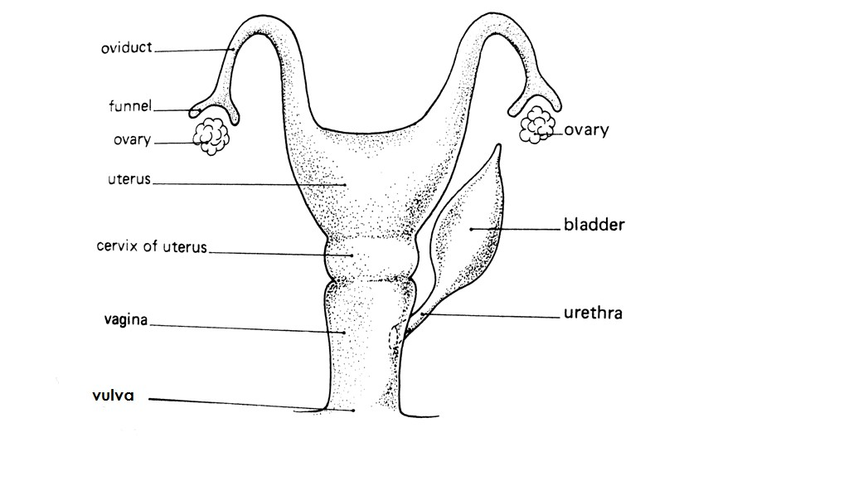The reproductive system of a cow.

-

-

-

-

-

-

-

-

-

-

-

-

##### Functions of the parts of the reproductive system of a cow.

1. **Vulva**
   * The vulva receives the penis and guides it to the vagina.

##### Vagina

* + It where semen is deposited.
  + It acts as a birth canal during delivering.

##### Ovary

* + It produces the female reproductive cells ova.
  + It produces ovarian hormones called **oestrogen.**
  + Oestrogen controls sexual cycle and the course of pregnancy.
  + It is where conception takes place.
  + Note:
  + **Conception** is the process by which an egg is fertilized to form a young one.

(v) **Cervix**

- It closes the lower end of the uterus during pregnancy.

##### Uterus

* + It is where implantation takes place.
  + It is where the foetus develops from.

##### Qn. What is implantation?

* + Implantation is the attachment of the foetus to the walls of the uterus.

##### Urinary bladder

* + It stores urine for a short time.

##### Urethra

* + It acts as a passage of urine from the urinary bladder.

##### The reproductive system of a bull.

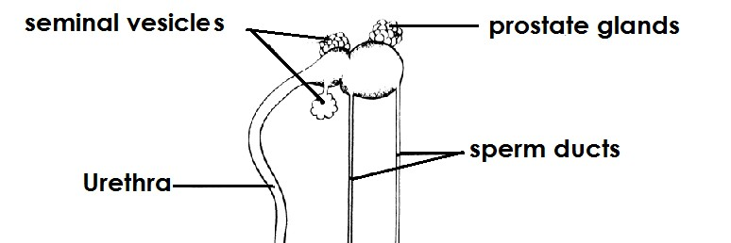-

-

-

-

**173 |** P a g e

-

-

-

-

-

##### Function of each part of the reproductive system of abull.

1. **Testes**
   * Produces sperm.
   * Produces testosterone hormone.
   * Note:
   * Sperms are the male reproductive cells.
   * Testosterone is responsible for increasing sexual desire and developing the physical and sexual features of male organisms.

##### Sperm duct

* + The sperm duct carries sperms from the testis to the urethra.

##### Penis

* + The penis directs sperms into the cow’s vagina.

##### Epididymis

* + It stores the sperms.

##### Sheath

* + Protects the penis from harm by covering it.

##### Scrotum

* + It protects the testes.
  + Regulates the temperature around testes.

##### Prostate glands and seminal vesicles.

* + They provide semen which helps sperms to move.
  + Fertilization in cattle

##### Qn. What is the fertilization?

* + Fertilization is the union of male and female gametes to form a **zygote**.

##### What name is given to the following in animals?

1. Male gametes? **Sperm**
2. Female gametes? **Ova**

##### Note:

* + The immediate result of fertilization in cattle is a zygote
  + After fertilization has take place, we say that the cow has conceived or conception has taken place.

##### What is a zygote?

- A zygote is a fertilized egg.

-

-

-

-

-

- A diagram showing a developingfoetus in the womb.

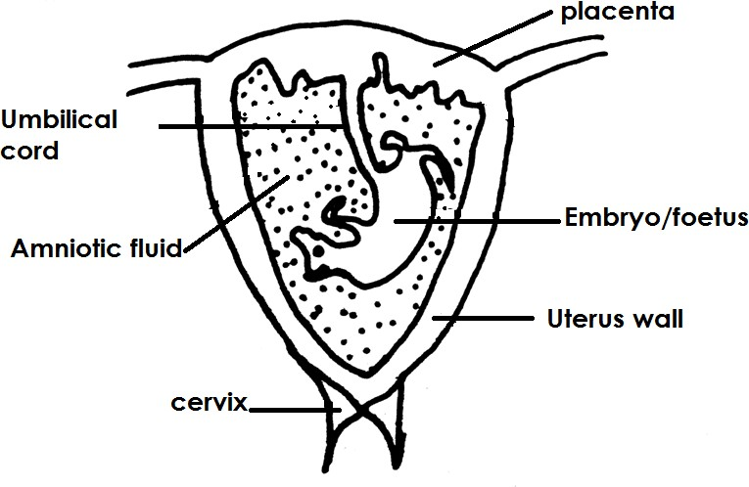-

-

-

-

-

-

-

-

-

-

-

-

##### Functions of each part

1. **Umbilical cord**
   * It connects the embryo to the placenta.
   * It acts as a passage of oxygen and food to the embryo.

##### Placenta

* + It attaches the embryo to the uterus.
  + It stores food and oxygen until they are taken by the embryo.
  + It stored waste materials from the embryo or foetus.

##### Amnion

* + It stores amniotic fluid.

##### Amniotic fluid

* + It protects the foetus from harm or injury.
  + Gestation period /pregnancy in cattle

##### Qn(a) what is gestation period?

* + Gestation period is the period from fertilization to birth.

##### State the gestation period of a cow.

- 9 months and 10 days (280 days)

-

##### Gestation period of some animals

|  |  |
| --- | --- |
| - Animal | - Gestation period |
| - Rabbits (doe) | - 1 month (30 days) |
| - Goat (nanny) | - 5 months (150 days) |
| - Sheep (ewe) | - 5 months |
| - Pig (sow) | - 3 months 3 weeks , 3 days (114 days) |
| - Dog (bitch) | - 2 months and 3 days ( 63 days) |

1. **What is an in calf cow?**

* An in calf cow is a cow that is pregnant.
* Signs of pregnancy
* Thecow does not go on heat after twenty one days of insemination.
* The cervix closes after pregnancy.
* Mucus discharge from the vagina.
* The udder enlarges.
* There is reduction in milk production in case of lactating cows.

##### Qn. Give the meaning of each of the following terms.

1. **A lactating period**
   * A lactating cow is a cow that produces milk after giving birth.

##### Lactation period

* + Lactation period is a period when the cow provides milk to the young ones.

##### Drying off

* + Drying off is when no milking is done in a cow.
  + Note:
  + During pregnancy (2months) before giving birth, the cows are subjected toa drying off period.
  + During drying off the cow is fed on protein rich foods and this is called steaming up.

##### Qn. What is steaming up?

* + Steaming up is the feeding of an in calfcow on foods rich in proteins.
  + Advantages of steaming up
  + Steaming up enables the embryo to grow healthy.
  + Steaming up controls low birth weight in cows.
  + Steaming up prevents still birth in cattle.
  + Steaming up builds up the calf body in preparation for calving.
  + Steaming up increases milk production in cows.
  + Steaming up increases the period of lactation.
  + Calving / parturition

##### Qn. What is calving?

* + Calving is the act of giving birth to a calf by a cow.
  + Signs of calving in cattle.
  + Mucus discharge from the vagina.
  + Loss of appetite.
  + The udder swells and is filled up with milk.
  + The in calf cow isolates itself from others.
  + The in calf cow is restless and keeps on changing positions.
  + The cow lies down most of the time.
  + The vulva becomes swollen and reddish.
  + Colostrum

##### Qn. What is colostrum?

* + Colostrum is the first milk produced by the cow after calving.
  + Advantages of colostrum
  + Colostrum boots the immunity of the calf.
  + Colostrum helps to open up the digestive system of the calf.
  + Colostrum improves on the calf’s eye sight because it is rich in vitamin A.
  + Colostrum contains proteins that build up the body of the calf.
  + Milking in cattle

##### Qn. What is milking?

- Milking is the removal of milk from the cow’s udder.

##### What is milk let down?

* + Milk let down is the flow of milk from cow’s udder.
  + Types of milking
  + Hand milking
  + Machine milking
  + Hand milking

##### Qn. What is hand milking?

* + Hand milking is the removal of milk from the cow’s udder by squeezing the teats by using hands.

##### The diagram to illustrate hand milking

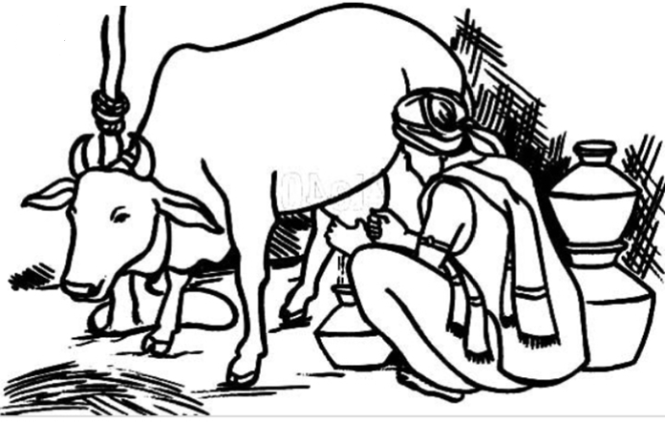

1. **Write down the advantages of hand milking**
   * Hand milking is cheap.
   * Hand milking requires less labour.

##### Qn. Write the disadvantages of hand milking

* + Hand milking is time consuming.
  + Hand milking is tiring.

##### Machine milking

* + Machine milking is the removal of milk from the teats using machines.

##### The diagram to illustrate machine milking

**177 |** P a g e

##### Qn. (a) Write down any advantages of machine milking.

* Machine milking saves time.

##### Qn. Write down the disadvantages of machine milking.

* It is expensive.
* Machine milking requires skilled labour.
* Machine milking damages the udder when one uses faulty machines.

##### Qn. Write down four steps of obtaining clean milk.

* Assemble the milking equipment and wash them with clean water and soap.
* Put the cow in a clean milking place and tie the hind legs.
* Wash the udder and the teats milk with warm water.
* Wash your hands with clean warm water and soap to remove dirt and germs.
* Questions

##### Why should the milking equipment be washed with clean water and soap?

* + To kill germs

##### Give a reason why the cow is given some feeds during milking?

* + To make the cow busy and relaxed.

##### Why are the treats and udder of a cow washed with warm water before milking?

* + To stimulate milk let down.
  + To remove dirt.

##### Why are the teats smeared with Vaseline or cream during milking?

* + To prevent the teats from cracking.

##### Equipment used milking

* + Strip cup
  + Lactometer

##### A strip cup

* + A strip cup is used to detect mastitis in milk.

##### Qn.a How can a farmer detect the presence of mastitis in milk?

* + Using a strip cup

##### Qn(b) How can a farmer detect the presence of mastitis in milk using a strip cup?

* + By seeing blood stains on the wire mesh or a strip cup.

-

* + 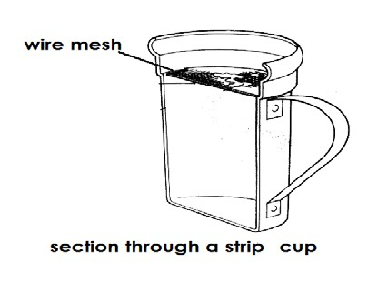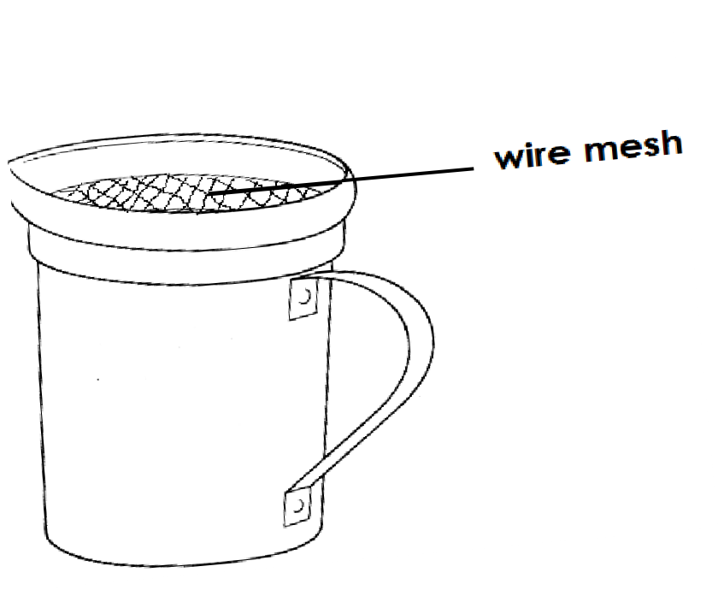The structure of a strip cup

##### Lactometer

- A lactometer is as instrument used to measure the amount of water in milk.

* + A lactometer is also used to detect whether fats have be removed from milk.
  + A lactometer measures the density of milk.

##### Qn. How does a lactometer work?

* + If a lactometer is dipped in milk where water has been added or fats have been removed, it will sink deeper in milk
  + A diagram showing a lactometer

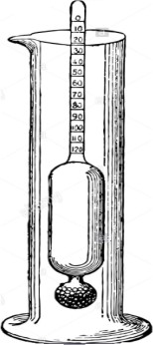

##### Preserving milk

**Qn**. **What is milk preservation**?

* + Milk preservation is the keeping of milk for a long time with going bad.

##### Qn. Why should milk be preserved?

* + For future use.
  + Methods of preserving milk
  + Refrigeration
  + Sterilization
  + Pasteurization
  + Boiling

##### Refrigeration

* + Refrigeration is the method of preserving milk by putting it in a refrigerator. Qn. **How does refrigeration prevent milk from going bad?**
  + Low temperature in a refrigerator prevents multiplication of bacteria.

##### Sterilization

* + Sterilization is the method of preserving milk where bacteria are killed by maximum boiling followed by covering milk on cooling.

##### Pasteurization

* + Pasteurization is a method of preserving milk that involves strong heating and sealing milk before bacteria enter.
  + Note:
  + Pasteurization was discovered by a French microbiological called **LouisPasteur**
  + Louis Pasteur discovered that milk goes bad because of bacteria.
  + Product of milk
  + Yoghurt
  + Cheese
  + Butter
  + Whey

- Ghee

* + Casein

##### Examples of processed milk

* + Fortified milk
  + Skimmed milk
  + Powdered milk (Dried milk)
  + Sterilized milk
  + Pasteurized milk

##### Fortified milk

* + Fortified milk is milk made more nutritious by adding proteins, vitamins A and D.

##### Pasteurized milk

* + Pasteurized milk is milk that has been maximumly heated and sealed before germs enter.

##### Skimmed milk

* + Skimmed milk is milk got after removing fats from milk.
  + Note:
  + The process of removing fats from milk is called skimming.

##### Powdered milk

* + Powdered milk is milk that has been processed into powder form.

##### Sterilized milk

* + Sterilized milk is milk got after being boiled to kill bacteria, cooled and covered.

##### Condensed milk

* + Condensed milk is milk that has been evaporated and sweetened with sugar.

-

* + Keeping milk records

##### Qn. What are milk records?

* + Milk records are written information about milk production on a farm.

##### Importance of keeping milk records

* + It enablesfarmers to know how muck milk is produced per cow.
  + Milk records enable a farmer to know profits and losses made.
  + Milk records enable the farmer to know the animals which need to be treated.
  + Milk records enable a farmer to select cows suffering from mastitis and treat them.
  + Others products from cattle
  + Hides
  + Bones
  + Horns
  + Blood
  + Dung and urine
  + Management practices in cattle
  + Dehorning
  + Cattle identification
  + Castration
  + Vaccination
  + Deworming
  + Deticking

- Hoof trimming

* + Spraying
  + Dipping
  + Dusting
  + Removal of extra teat

##### Castration

Qn. **What is castration**?

* + Castration is the removal testes from a male animal.

##### Methods of castration

* + Closed castration (Use of a burdizzo)
  + Open castration(surgical operation)
  + Use of a loop.

##### Closed castration

* + Closed castration is the crushing of testes and sperm ducts using a burdizzo.
  + Diagram of burdizzo

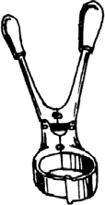-

-

-

-

-

-

-

##### Open castration

* + Open castration is the removal of testes from a male animal by cutting a slit on the scrotum using a shark knife.

##### Use of a loop

* + This is a method where an elastic rubber band (loop) is used to tie and squeeze the sperm duct.
  + Note:
  + In use of a loop, the sperms ducts and testes shrink and die.
  + Diagram showing a use of a loop

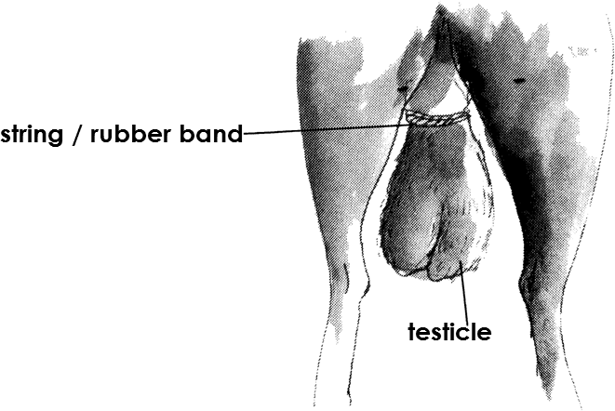

##### Advantages of castration

- Castration prevents unwanted pregnancies in cattle.

* + Castration prevents random mating in cattle.
  + Castration makes animals humble and easy to handle.
  + Castration prevents spread of venereal diseases in cattle.
  + Castration enables animals to grow faster and after.
  + Castration prevents poor breeds of cattle from breeding.
  + Disadvantages of castration
  + Animals are denied their natural feeling of having sex.
  + Animals may lose a lot of blood.
  + The wounds of the animal may become septic and cause more infections.
  + The animal feels pain.

##### Deworming

* + Deworming is the giving of animals medicine or drugs in order to kill internal parasites.
  + Methods of deworming
  + Dozing
  + Drenching Qn(a) **What is dozing**?
  + Dozing is the giving of animals solid medicine in order to kill internal parasites. (endo parasites)

##### What is drenching ?

* + Drenching is the giving of animals liquid medicine in order to kill internal parasites.
  + Note:
  + Drenching is done using a drenching gun or drenching bottle.
  + 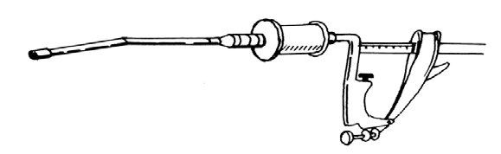Diagram showing a drenching gun

-

-

-

-

-

-

##### Dehorning

* + Dehorning is the removal of horns from an animals head.
  + Methods of dehorning
  + Use of chemical
  + Use of spoon dehorner
  + Use of dehorning iron

##### Qn. What is disbudding?

* + Disbudding is the removal of horn buds from the head of an animal.

##### Use of chemicals

* + In this method the horn bud is rubbed using caustic soda until it bleeds.

##### Use of spoon dehorners

* + In this method, a cylindrical tool (spoon dehorner) is used to scoop out the horn bud from the calf’s head.

##### Using a dehorning iron

* + In this method a hot iron is pressed on a horn bud until it bleeds.

- **A diagram a dehorning iron.**

-

-

-

-

-

-

-

-

##### Advantages of dehorning

* + Dehorning created space in the kraal.
  + Dehorning makes animals humble and easy to manage.
  + Dehorning reduced injuries among animals.
  + Many animals can be kept in small space.

##### Disadvantages of dehorning

* + The animal is denied a right to defend itself incase of danger.
  + The hot iron may enter deep and damage the animal brain.
  + The animal may feel a lot of pain.
  + The animal may lose a lot of blood if not done properly.

##### Dusting

* + Dusting is the smearing of chemicals on the animals body in order to remove extern al parasites.

##### Deticking

* + Deticking is the removal of ticks from the animal’s body using hands.

##### Vaccination

* + Vaccination is the introduction of vaccines into the animals body to prevent it from getting diseases.

##### Removal of extra teats

* + This practice is done in order to remove extra teats from the cow’s udder.

##### Hoof trimming

* + Hoof trimming is the cutting of animals’ hooves short. Qn. **Give one advantages of hoof trimming**
  + It helps to control foot rot disease.
  + It eases movement of animals.

##### Spraying

* + Spraying is the removal of ecto parasites from the body of the animals by sprinkling acaricides.
  + 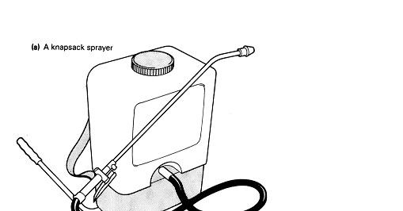A diagram showing a knap sprayer.

**183 |** P a g e

##### Qn. How is the above equipment useful on a cattle farm?

- It is used for spraying animals.

##### Identification of cattle

* + Cattle identification is the way of identifying cattle where labels or marks are used.
  + Identification methods used in cattle
  + Ear tagging
  + Ear notching
  + Use of number of laces
  + Ear tattooing
  + Branding
  + Tail bobbing

##### Ear tagging

* + This is a method of identifying cattle where tags having numbers are fixed in the ear of the animal using an application.

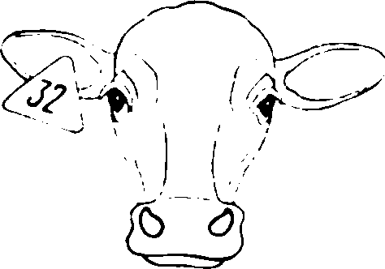

##### Ear notching

* + 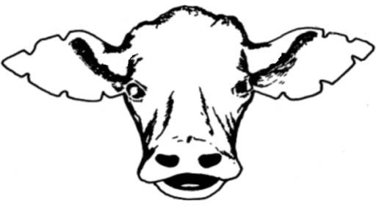This is when the animal’s ear is cut with marks at the edge.

##### Number laces

* + This is where a wooden or iron piece of plate is put on the animal’s head.

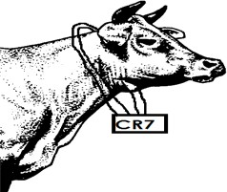

##### Ear tattooing

* + 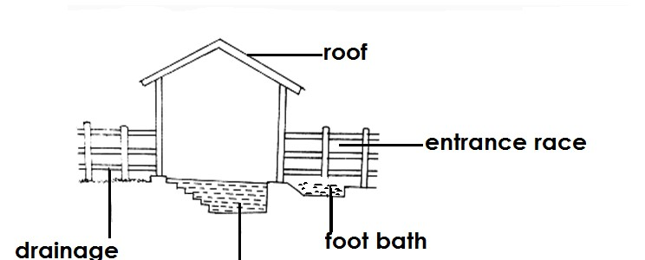This is done by making permanent marks up using pliers carrying a letter or number that will identify the animal.

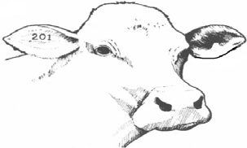

##### Branding

* + This is where a hot iron marked with a symbol for identification is used.

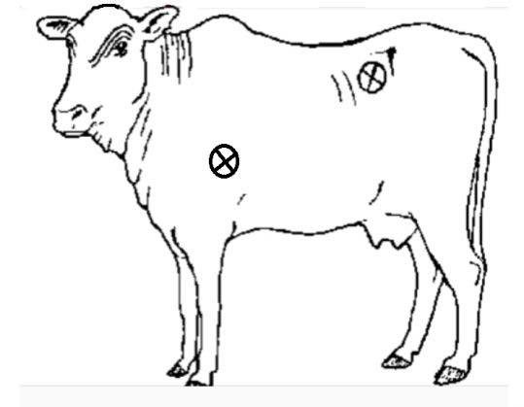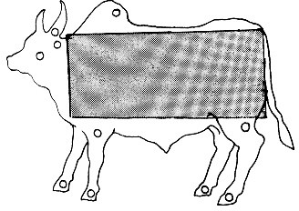-

-

-

-

-

-

-

-

-

* + Note:
  + Only certain parts of an animal should be branded.
  + This is because branding marks can spoil the quality of the hide after the animal is slaughtered.

##### Tail bobbing

* + Tail bobbing is the trimming of the animal switch.

##### (k) Dipping cattle

Qn(a) **What is cattle dipping**?

- Cattle dipping is the immersing of an animal in acaricides.

##### What are acaricides?

* + A caricides are chemicals used to kill external parasites.

##### Name the structure on a cattle farm where dipping is done from.

* + Dip tank
  + A diagram showing a structure of a dip tank.

-

-

-

-

-

-

-

a g e

-

-

* + Note:
  + A dip tank is a farm structure designed to immerse animals in order to kill external parasites.
  + Components of a dip tank and their functions

##### Roof

* + It is made of iron sheets to prevent evaporation of the dip wash.
  + The roof prevents dilution of acaricides by rain.

##### Collecting yard

* + It is where animals are put or collected before dipping.
  + Note:
  + The collecting yard should have a water trough from which animals drink water before being dipped.
  + The floor of the collecting yard should be built with quarry stones to remove mud from animals hooves.

(ii) **Foot bath**

- Clean animal feet not to make the dip wash dirty.

##### Entrance race

* + It is used to allow animals into the dip tank.

##### Dip tank

* + It is where animals are immersed.
  + It contains acaricides which kill ecto parasites.

(v) **Drainage race**

- Allow chemical flow back into the tank.

##### Qn. Give the meaning of each the following terms as used in cattle management.

1. **Hand dressing**
   * Hand dressing is a way of killing ticks where strong acaricides are used with a brush to treat areas not well treated in spraying.

##### Dip washing

* + Dip washing is a liquid containing chemicals that kill ticks in dip tank.
  + Factors to consider when constructing a cattle dip.
  + The cattle dip should be near a grazing area so that the animals do not walk long distances.
  + The cattle dip should be constructed on a strong firm ground.
  + The cattle dip should be constructed in a well drained place to control flooding.
  + Cattle management at the cattle dip
  + Provide animals with water before dipping them so that they are not tempted to drink acaricides.
  + Dip animals in the morning or evening.
  + First make 10 – 15 animals to run through the dip so that they can mix water with acaricides.
  + Animals should be arranged in the single file when entering the dip tank.

- Do not dip sick, injured, calves and pregnant animals.

* + Dip animals according to their ages.
  + Dip all animals in one day to prevent further spread of parasites.
  + Keep records of all animals dipped.

-

-

* + Different farm structures found on livestock farm.
  + Cattle dip
  + Spray race
  + Calf pen
  + Milking parlour /shed
  + Cattle crush

##### A cattle crush

* + A cattle crush is a structure used for restraining animals when carrying out certain cattle practices.
  + Examples of activities that can be carried out in a cattle crush.
  + Branding - Dosing
  + Ear tagging - Vaccination
  + Ear notching - Artificial insemination
  + Dehorning - Pregnancy diagnosis
  + Drenching - Castration

##### Structure of a cattle crush

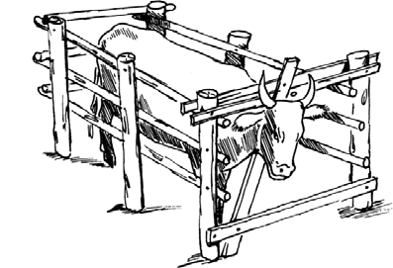

1. **A spray race**
   * Aspray race is a farm structure used for tick control. Qn. **How does a spray race work?**
   * A spray race works by showering acaricides on animals body.

##### Milking parlour

* + Milking parlour is place where milking is done.

##### Qn. Write down any three components of a milking parlour

* + Feeding trough
  + Water trough
  + Night trough

##### Calf pen

* + A calf pen is a structure for housing calves.

##### Qn. Identify the features of a good calf pen

* + A good calf pen should be clean.
  + A good calf pen should enable the calf to see the mother calf and other animals.
  + A good calf pen should be well ventilated.

##### Qn. State the different ways of caring for a calf pen.

* + Scrubbing the floor.
  + Repairing damaged parts of the calf pen.

##### Qn. Name the two different types of calf pen

* + Permanent calf pen
  + Movable calf pen

##### Permanent calf pen

**Qn. What is a permanent calf pen**?

* + A permanent calf pen is a pen that cannot be moved from one place to another.

##### Movable calf pen

* + A movable calf pen is a pen that can be moved from one place from another.
  + Note:
  + Movable calf pens are commonly used in paddock grazing.

-

-

-

-

* + Pastures

##### Qn. What is pasture?

* + Pasture is open grassland where animals graze.
  + Types of pasture
  + Natural pasture
  + Artificial pasture /prepared pasture

##### Natural pasture

**Qn. What is natural pasture?**

* + Natural pasture is grass that grow on its own and eaten by animals in its raw form.

##### Qn. Give the examples of natural pasture

* + Elephants
  + Couch grass
  + Alfa lfa
  + Rhodes grass
  + Spear grass
  + Nandi grass

##### Prepared / artificial pasture Qn. What is prepared pasture?

* + Prepared pasture is pasture made from fodder crops.

##### Qn. What are fodder crops?

* + Fodder crops are crops grown for feeding animals.

##### Qn. Write down examples of fodder crops

* + Sorghum
  + Millet

- Oats

* + Sweet potatoes
  + Maize
  + Barley

##### Qn. Write down the different examples of prepared pasture.

* + Hay
  + Silage
  + Note:
  + Hay is grass that has been dried for feeding farm animals.
  + -Silage is grass that has been stored without being dried and it used to feed animals.

##### Qn. State the importance of pasture.

* + Pasture is used as food for animals.
  + Some pasture is used as thatching material.
  + Some pasture like clovesand legumes are used to improve soil fertility.

##### Qn. Give the types of cattle of feeds.

* + Concentrates
  + Additives
  + Supplements / Roughages
  + Succulent feeds
  + Foliages
  + i)Concentrates

##### Qn. What are concentrates?

* + Concentrates are feeds with high value nutrients and they have less moisture.
  + Concentrates are given to animals to fatten.

##### Qn. Give examples of concentrates feeds.

* + Bone meal ( source of calcium)
  + Cotton seed cake (source of proteins and fats)
  + Maize bran (source of carbohydrates)
  + Rock salt ( source of sodium)
  + Blood meal ( source of iron)
  + Legumes

##### Roughages

* + Roughages are fibrous feeds with iron food value.
  + Roughages help in easing digestion of food.

##### Qn. Give examples of roughages / supplements.

* + Hay
  + Young grass
  + Dry maize stalks

##### Succulent feeds

* + Succulent feeds are feeds with high moisture content and low fibre.

##### Qn. Mention some examples of succulent feeds

* + Sweet potato vines
  + Banana peelings
  + Grass

##### Additives

- These are drugs, flavours, hormones added to animal feeds.

##### Foliages

* + These are feed that have been preserved and given to animals.

##### Qn. State the importance of feeding animals.

* + Feeding animals increases milk production.
  + Feeding animals boosts animals’ immunity.
  + Feeding enables animals to fatten.
  + Note:
  + Cows are given a block of salt to lick to stimulate milk production.
  + 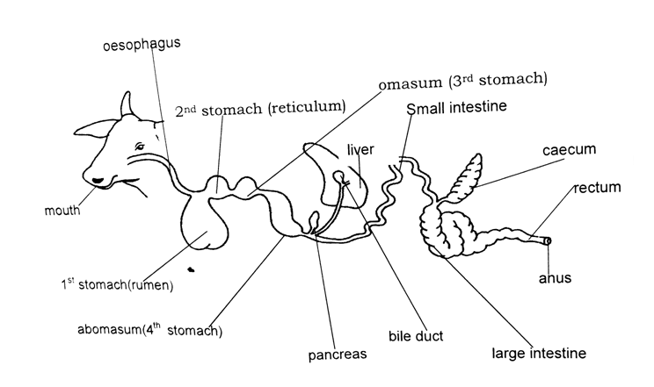Digestive system of cattle.

-

* + Functions of the parts of the digestive system of cattle

##### Mouth

* + It is where food is chewed and mixed with saliva.

##### Rumen

* + It is where food is stored temporarily before it is taken back to the mouth for rumination

/ further chewing.

* + Note:
  + The rumen is the first stomach of ruminants.

##### Reticulum

* + It is separates chewed food from unchewed food.
  + It retains and stores foreign material like stones.
  + Note:
  + Reticulum is the second stomach of ruminants.

##### Omasum

* + It grinds / crushes food into small soluble particles.
  + It is where absorption of water takes place.
  + Note:
  + Omasum is the third stomach of ruminants.

##### Abamasum

* + It is where digestion of food by enzymes starts from.

-

* + Note:
  + Abamasum is fourth stomach of ruminants and acts as the true stomach.

-

* + Grazing cattle

##### Qn. What is grazing?

* + Grazing is proper use of pasture by livestock.
  + Or
  + Grazing is getting animals to eat grass / pasture.
  + Note:
  + Pasture land is open grassland where animals can be freely grazed.
  + System / methods of grazing cattle

##### Qn. State the different systems /methods of grazing cattle.

* + Zero grazing
  + Tethering
  + Paddocking / paddock grazing
  + Strip grazing
  + Herding / free range grazing
  + Tethering grazing

##### Qn. What is tethering grazing?

* + Tethering is a method of grazing where animals are tied on a peg using a rope.

##### Qn. State the advantages of tethering grazing.

* + Tethering is cheap.
  + Animals get the best pasture.
  + Animals do not destroy farmers’ crops.

##### Qn. State the disadvantages of tethering grazing.

* + Few animals are kept.
  + Animals can be easily stolen.
  + Animals can be strangled by the ropes.
  + Animals can be killed by wild animals.
  + Animals many be restricted to only one type of pasture.
  + The rope can damage the animal’s hides.
  + Animals may not get enough pasture to eat if not monitored.

-

-

* + A diagram showing a tethered animal.

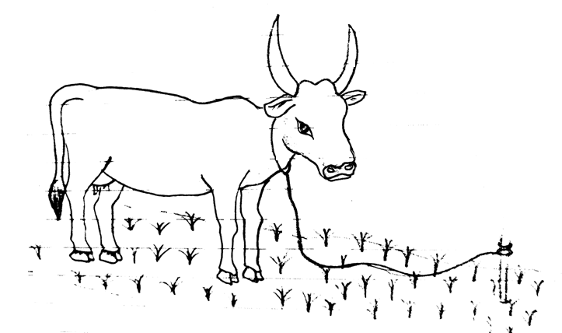-

-

-

-

-

-

-

-

-

**191 |** P a g e

-

* Paddocking / Paddock grazing

##### Qn. What is paddocking grazing ?

* Paddocking is a method of grazing where the grazing area is divided into small plots called paddocks.

##### Qn. Write down the advantages of poddocking.

* Paddocking control overgrazing.
* Paddocking allows proper use of pasture.
* Paddocking gives time for pasture to grow.
* Paddocking enables manure to be evenly distributed on the farm.
* Paddocking controls the spread of diseases on a farm.
* Paddocking restricts animals from destroying farmers’ crops.
* Paddocking controls the spread of pests.

##### Qn. State the disadvantaged of paddocking grazing

* Paddocking requires a large piece of land.
* Paddocking is expensive.
* Animals can be injured by barbed wires.
* 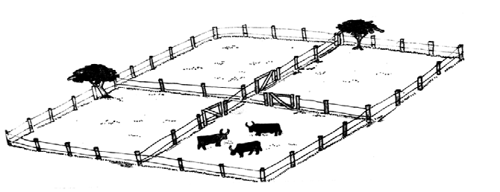A diagram showing paddocking grazing

-

-

-

-

-

-

-

* Note:
* Paddocking is commonly practiced in rural areas.

##### Qn. why is paddocking commonly practiced in rural areas?

* There is enough land in rural areas.

##### How does paddock grazing help to control tick borne diseases?

* + Paddocking breaks the life cycle of ticks.
  + Paddocking starves ticks to death.
  + Strip grazing

##### Qn. What is strip grazing?

* + Strip grazing is the method of grazing where the land is divided into strips using temporary wire carrying electricity.

##### Qn. State the advantages of strip grazing.

* + Strip grazing allows proper use of pasture.
  + Manure is evenly distributed.
  + Strip grazing helps in control of parasites.
  + Strip grazing helps in the control of diseases among animals.
  + Labour is reduced on farm.

**Qn. State the disadvantages of strip grazing.**

* + Few animals are kept.
  + It is expensive to maintain.
  + Animals may be shocked by electricity.

-

* + A diagram showing strip grazing.

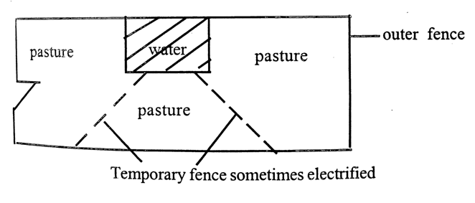-

-

-

-

-

-

-

-

-

* + Note:
  + Tethering , paddocking and strip grazing are all methods of rotational grazing.
  + Zero grazing

##### Qn. What is zero grazing?

* + Zero grazing is where cattle are feed indoors without going out to graze.

##### Qn. State the advantages of zero grazing

* + Animals are easy to control and monitor.
  + Animal dung can easily be collected.
  + Diseases can easily be controlled.
  + It requires a small piece of land.

##### Qn. State the disadvantages of zero grazing.

* + Animals lack enough exercises.
  + It is expensive to manage.
  + It is tiring to look for grass.
  + Few animals are kept.

##### Qn. Why are there less chances of animals contracting diseases in zero grazing?

* + Animals do not move out of the shed to mix up with other animals.

##### Why is zero grazing commonly practiced in urban areas?

* + There is limited land in urban areas.
  + A diagram showing zero grazing

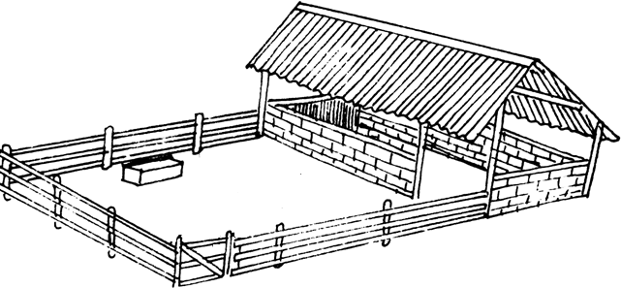-

-

-

-

-

-

-

* + Herding / free range grazing

##### Qn. What is herding?

* + Herding is a method of grazing where animals are left to move freely and graze on open

grassland.

* + Note:
  + In this method the animals are looked after by the herdsman.

##### Qn. State the advantages of herding

* + Animals get enough exercise.
  + Animals feed on a variety of pasture.
  + Herding is cheap.
  + Herds man guides animals to good pasture and water.

##### Qn. State the disadvantages of herding

* + Diseases can easily spread from one herd to another.
  + Animals may destroy farmers’ crops.
  + It may lead to overgrazing incase of limited land for grazing.
  + Pasture is wasted as animals may step on it while grazing.
  + Animals can get lost.
  + It requires a big piece of land.
  + Animals get tired due to walking long distances.
  + Parasites in cattle.

##### Qn. What is parasite?

* + A parasite is an organism that depends on other organisms for survival without killing them.
  + Note:
  + An organism on which a parasite depends is called **a host**.

##### Qn. Identify the different ways in which parasites depend on hosts.

* + By obtaining food from hosts.
  + By getting shelter from the host.
  + Types of parasites

##### Qn. Mention the two types of parasites

* + External parasites / ecto parasites
  + Internal parasites / endo parasites

##### External parasites / ecto parasites Qn. What are external parasites?

* + External parasites are parasites that live outside the animal’s body.

##### Qn. Give examples of external parasites.

* + Ticks
  + Mites
  + Tsetse flies
  + Fleas

##### Qn. State the effects ecto parasites on cattle.

* + Ecto parasites suck blood from animals’ body.
  + Ecto parasites damage the hides of cattle.
  + Ecto parasites spread diseases in cattle.
  + Ecto parasites make the animals uncomfortable.

##### Qn. Identify the ways of controlling external parasite in cattle.

- Spraying cattle using acaricides.

* + Dipping cattle in acaricides.
  + Deticking
  + Dusting
  + Practising rotational grazing
  + Trappingtsetse flies using tsetse fly traps.
  + Double fencing

##### Illustration of external parasites

**Tick A mite A tsetse fly**

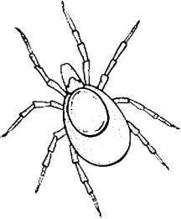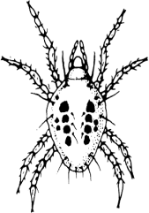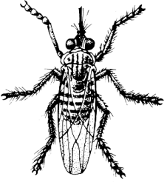

**Endo parasites / internal parasites Qn**. What are internal parasites?

* + Internal parasites are parasites that live inside animal’s body.
  + Note:
  + Internal parasites live in the intestines and liver of animals.

##### Qn. Give examples of internal parasites

* + Tape worms
  + Liver flukes
  + Hook worms
  + Thread worms

##### Qn. State the ways of controlling internal parasites.

* + By drenching
  + By dozing
  + Feeding animals on well drained pasture.
  + Treating liver flukes by killing water snail using molluscides.
  + Cattle diseases

##### Qn. Identify the causes of diseases in cattle.

* + Poor feeding
  + Eating contaminated feeds.
  + Poor sanitation in the animal houses.
  + Physical injuries.
  + Crowding of animals

##### Qn. State the signs of a sick animal.

* + Loss of body weight.
  + The animal has dull and rough fur.
  + The animal coughs and sneezes.
  + Difficulty in breathing.
  + Diarrhoea.

##### Qn. State the signs of a healthy animal

* + The animals muzzle is wet / moist.

- The animal gains weight.

* + The animal’s hair is smooth and shiny.
  + The animal’s ears are alert and warm.
  + The animal has good appetite.
  + Groups of cattle diseases
  + Cattle diseases are grouped according to the germs that cause them i.e

-Bacteria - causes bacterial diseases.

-Virus - causes viral diseases.

-Protozoa - cause protozoan diseases

##### Bacterial diseases

* + These are diseases caused by bacteria.
  + Examples of bacterial diseases that affect cattle.
  + Mastitis - Pneumonia
  + Foot rot - Tuberculosis
  + Anthrax
  + Black quarter
  + Calf scour
  + Brucellosis

##### Mastitis

* + Mastitis affects the udder of cattle. Qn. **How does mastitis spread**?
  + Mastitis spreads through body contact with an infected animal.

##### Note:

* + Humans get infected with mastitis when they drink milk with mastitis. Qn. **Mention the signs and symptoms of mastitis in cattle**.
  + Swollen and painful udder.
  + Blood stains in milk.
  + The cow refuses to be milked.
  + The affected teats my become dead and produce no milk. Qn. **Give the different ways of controlling mastitis in cattle**.
  + Treat the infected animal with antibiotics.
  + Use a strip cup to detect the presence of mastitis in milk.
  + Vaccinate animals regularly.
  + Ensure good hygiene for the animals.

##### Anthrax

Qn. **How does anthrax spread**?

* + Through contaminated feeds.
  + Through contact with an infected animal.
  + Note:
  + Anthrax is caused by a bacterium called **anthracis.**

##### Qn. Identify the signs and symptoms of anthracis

* + Sudden death
  + Blood stained dung
  + High temperature
  + Loss of appetite

- Dark watery blood from body openings

* + Reduction in milk production
  + Shivering

##### Qn. State the ways of controlling and preventing anthrax.

* + Vaccinate the animals regularly.
  + Burn or bury the dead animal.
  + Do not meat of dead animals.
  + Separate / isolate the infected animals.

##### Foot rot

* + Foot rot attacks hooves of animals.

##### Qn. Give the signs and symptoms of root rot.

* + Limping in animals.
  + Lameness in animals.
  + The animals hooves may rot ,swell and contain pus.

##### Qn. State the different ways of controlling and preventing foot rot.

* + Treat animals with antibiotics.
  + Carry out hoof trimming.
  + Observe proper sanitation in animal houses.

##### Pneumonia

* + It is an infectious disease that affects the lungs of animals.
  + It affects cattle, sheep , pig and rabbits.
  + Signs and symptoms of pneumonia
  + Difficulty in breathing
  + Coughing
  + Nasal discharge
  + Loss of appetite

##### Qn. How is pneumonia spread?

* + Through breathing in air contaminated with bacteria.
  + Prevention and control of pneumonia
  + Isolating infected animals from healthy ones.
  + Carry out proper ventilation.
  + Good hygiene.
  + Treat with antibiotics.

##### Black quarter

**Signs and symptoms of black quarter**

* + High fever
  + Shivering
  + Loss of appetite
  + Dullness
  + Swollen and painful muscles

##### Prevention/ control of black quarter

* + Treat early cases with antibiotics.
  + If the animal is dead , dispose off the carcasses by complete burning.

##### Tuberculosis

- It is an infectious disease caused by mycobacterium.

* + It affects respiratory system of a cattle,goats,and sheep. Qn. **How is tuberculosis spread**?
  + Through contaminated air.
  + Through milk from an infected cow.
  + Signs and symptoms of tuberculosis
  + Loss of appetite
  + Coughing
  + Loss of weighting
  + Decrease in milk production
  + Prevention and control of tuberculosis
  + Vaccination
  + Cull and slaughter the sick animals.
  + Treat early cases with antibiotics.
  + Kill infected animals.

##### Brucellosis (Contagious abortion)

* + It is a contagious bacterial disease.
  + It affects the reproductive system of a cow.
  + Humans get infected if they eat meat or drink milk from the infected cows.
  + It is a venereal disease that affects cattle. Qn. **How is brucellosis spread**?
  + Through mating and contact with infected animals.
  + Signs and symptoms of brucellosis
  + Abortion in pregnant cows.
  + Brownish vaginal discharge.
  + Infertility
  + Swollen testicles.

##### Prevention and control

* + Routine vaccination
  + Disposal of aborted dead foetus.
  + Use artificial insemination
  + Cull all infected animal.

##### Viral diseases

**Examples of diseases caused by virus in cattle**

* + Rinder pest

Qn. **How is rinderpest**?

##### Body contact with an infected animals. Sign and symptoms

* + High fever
  + Severe diarrhoea with blood stains
  + Sunken
  + Shedding tears
  + Sores on the mouth and vagina

##### Prevention and control of rinder pest

- Vaccinate the animals

* + Isolate animals
  + Slaughter all infected animals
  + Apply quarantine

##### Foot and mouth disease

* + It is a highly infectious disease
  + It is mainly attacks pigs , cattle , sheep
  + Note:
  + It attacks the mouth membrane and feet of an animal. Qn. **How is foot and mouth disease spread**?
  + Through contact with an infected animal.
  + Through sharing containers with an infected animal.

-

* + Signs and symptoms of foot and mouths disease
  + Blisters on the hooves and muzzle (mouth)
  + Wounds on the feet
  + Lameness
  + Loss of appetite
  + Reduction in milk production
  + High fever
  + Dullness
  + Prevention and control of foot and mouth disease
  + Vaccine regularly
  + Apply a quarantine
  + Isolate animals
  + Slaughter all infected animals Qn. **What is quarantine**?
  + Quarantine is the restriction of animal movement and their products from one place to another in case of a disease outbreak.

##### (b) How is quarantine an important practice in cattle management?

- Quarantine prevents the spreads of disease among cattle.

##### Protozoan diseases

* + These are diseases caused by protozoa to cattle.
  + Note
  + Most protozoan diseases are spread by ticks and tsetse flies.
  + Diseases spread by ticks are called **tick borne**. **Examples of cattle diseases caused by protozoa**
  + Nagana (trypanosomiasis)
  + Red water
  + Heart water
  + East Coast Fever
  + Anaplasmosis
  + Nagana (Trypanosomiasis)
  + Nagana is caused by a protozoan called **trypanosoma.**
  + Nagana is spread by a tsetse fly through bites.

**Note**:

* + Nagana is the only protozoan disease that is not spread by a tick.
  + Sign and symptoms of trypanasomiasis
  + Dullness
  + Loss of appetite
  + Loss of weight
  + High temperature
  + Prevention and control of Nagana
  + Isolate sick animals
  + Control tsetse flies
  + Use tsetse flies trap to kill tsetse flies.

##### Heart water

* + It is a protozoan disease spread by brown ticks.
  + Signs and symptoms of heart water
  + Loss of appetite
  + High fever
  + Animals move in circles
  + Restlessness

##### Prevention and control of heart water

* + Spraying using acaricides
  + Dipping animals in acaricides
  + Practicing rotational grazing

##### East Coast Fever

* + It is a protozoan disease spread by brown ticks.

##### Signs and symptoms of East Coast Fever

* + Loss if appetite
  + Loss of weight
  + High temperature
  + Weakness
  + Nasal discharge
  + Diarrhoea

##### Prevention and control of East Coast Fever

* + Dipping animals in acaricides.
  + Spraying animals with acaricides.

##### Red water

* + It is a protozoan disease spread by a red stick.

##### Signs and symptoms of red water

* + Reddish urine
  + High temperature
  + Loss of appetite
  + Dullness

##### Prevention and control of red water

* + Dipping animals in acaricides to kill ticks.
  + Spraying animals using acaricides.
  + Anaplasmosis (Gall sickness)

- It is spread through bites of ticks.

##### Signs and symptoms of anaplasmosis

* + Anaemia
  + Constipation
  + Blood in urine or faeces
  + Loss of weight

##### Prevention and control of anaplasmosis

* + Dipping cattle in acaricides.
  + Spraying cattle using acaricides.
  + Cattle products and their uses

##### Milk

* + Milk is sold by people to get money.
  + Milk is a source of food to people.

##### Beef

* + Beef is sold to get money.
  + Beef is a source of food.
  + Horns
  + Horns are used to make buttons, ear rings and handle for knives.
  + Horns are used to make shapes, for decoration.
  + Horns are used as musical instruments.

##### Hooves

* + They are used to make glue.
  + They are used to make buttons.

##### Blood

* + Blood is eaten as food.
  + Blood meal is a source of iron to animals.

##### Urine and dung

* + They are used to generate biogas.
  + They are used as farmyard manure.
  + Cow dung is mixed with sand and ash and used for plastering walls on buildings.
  + They promote good growth of pasture in paddocks.

1. Bones
   * Bones are used to make bones meal for farm animals(animal feeds)

##### Hides

* + Hides are used for making leather bags, shoes,wallets, belts and watch straps. Qn.**Identify the ways of preserving hides.**
  + Wet salting
  + Suspension drying Qn. **What is wet salting?**
  + Wet salting is the use of salt in order to dry hides. Qn. **How does salt preserve hides**?
  + Salt absorbs the moisture content in hides. Qn. **What suspension drying?**
  + Suspension drying is the use of heat from the sun to dry hides under the shade. Qn. **What is tanning**?
  + Tanning is the process of turning hides into leather.

##### A diagram showing suspension drying

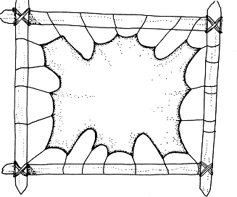-

-

-

-

-

-

-

-

* + Starting a live stock farm

##### Qn. Mention the requirements needed to start a livestock farm.

* + Land
  + Labour
  + Management
  + Market
  + Capital
  + Transport

##### Qn. How are the following factors important on a livestock farm?

1. **Land**
   * It is the place on which the farm is started.
   * It is where farm structures are constructed or built.
   * It is where feeds or pasture is grown.

##### Qn. State any four ways of acquiring land.

* + By buying
  + By inheriting
  + From donations
  + By hiring land

##### Capital

* + Capital is the money used to buy the things needed to start a farm.
  + Capital is used to buy land.
  + Capital is used to buy animals to be reared.
  + Capital is used to construct farm structures.
  + Capital is used to prepare pasture.
  + Capital is used to pay workers and experts on the farm.
  + Capital is used to buy acarcides and necessary equipment. Qn. **State any three ways of acquiring capital.**
  + Through donation
  + Through getting loans.
  + Through getting salaries.

1. **Labour** 
   * Labour are people who carryout activities on a farm. Qn. **Give two types of labour**
   * Skilled labour
   * Unskilled labour

##### Qn. State two ways of acquiring labour.

* By hiring people
* By employing people

##### Market

* + Market is the demand for cattle or their products.
  + Demand is the desire and ability of people to pay for the products.

##### Management

- Management involves people who help farmers to organize, plan and guide other workers.

##### Keeping farm records

Qn) **what are farm records?**

- Farm records are written information on various activities carried out on the farm.

##### Identify any six types of records kept on a cattle farm.

* + Health records
  + Feeding records
  + Production records
  + Marketing records/ sales records
  + Labour records
  + Breeding records
  + Milking records
  + Production of records
  + These show yields of various farm produce.
  + They involve how many animals have been produced and how many have died.
  + Health records
  + These show the type of disease and parasites affecting the cattle.
  + These also show treatment that has been given to cattle.
  + Field records
  + Show the number of animals kept on the farm.
  + Show different farm activities carried out on the farm.
  + Marketing records
  + Show the amount of money collected after selling the products.
  + Show the products sold on the farm.
  + Labour records
  + These show number of workers.
  + They also show their work.

##### Qn. Write down the importance of farm records.

* + Farm records help a farmer to plan for the farm.
  + Farm records help a farmer to be taxed fairly.
  + Farm records help a farmer to get loans from the bank.
  + Farm records help a farmer to know whether he or she is making profit or loss.
  + Farm records help a farmer to know income and expenditure.

- Farm records help a farmer to know birth and death rates.

* + Problems facing cattle farmers in Uganda
  + Animal diseases.
  + Lack of enough capital.
  + Shortage of labour.
  + Cattle parasites.
  + Lack of enough land.
  + Shortage of water and pasture.
  + Lack of ready market.
  + Prolonged drought.
  + Practices that harm cattle.

##### Qn.Mention any four practice that harm animals at home.

* + Castration
  + Dehorning
  + Ear tagging
  + Branding

##### Qn. State the practices that harm cattle in transit.

* + Poor posture
  + Overloading cattle
  + Making animals walk long distances

##### Qn. State the practices that harm cattle in the field.

* + Beating animals
  + Improper disposal of polythene bags.
  + Piercing animals to get blood from them.
  + Giving animals less food.

##### Qn. Mention any one practice that harms cattle in abattoirs.

* + Electrification

Qn. **What is an abattoir**?

* + An abattoir is a house in which animals are slaughtered.

##### FENCING IN CATTLE

Qn. **What is fencing**?

* + A fence is a barrier of line or dead material dividing land. Qn. **Mention the two types of fences**
  + Live fences
  + Dead fences
  + Examples of live fences
  + Cypress trees
  + Pine trees
  + Sisal
  + Bamboo trees

##### Qn. What is a live fence?

* + A live fence in a barrier made from growing plants that are planted along boarders of land.

##### Qn. What is a dead fence?

- A dead fence is a barrier made of non living materials.

##### Qn. List any four examples of dead fences.

* + Barbed wire fences.
  + Wall fences
  + Wood fences
  + Plain wire fences

##### Qn. Identify the examples of materials used to make dead fences.

-Cement - barbed wire

-Bricks -wire mesh

-Treated poles -blocks

##### Qn. State the importance of fencing in cattle.

* + Fencing prevents animals from going astray to destroy crops.
  + Fencing promotes proper use of pasture.
  + Fencing helps to isolate sick animals from health ones.
  + Live fences act as wind breaks.
  + Fencing makes farm management and planning easier.

##### Qn. Give two disadvantages of fencing.

* + Fencing is expensive.
  + Barbed wires can cause injury to cattle.
  + Caring for cattle

##### Qn. Mention any three ways of caring for cattle.

* + Feeding cattle
  + Watering cattle
  + Housing cattle
  + Housing cattle

##### Qn.What name is given to a house of cattle?

* + Byre

##### Qn. State the importance of a house to cattle.

* + It protects animals from bad weather.
  + It protects cattle from thieves.
  + It protects cattle from wild animals.

##### Qn. Mention the qualities of a good house or shed for cattle.

* + It should be well ventilated.
  + It should have a strong floor made of concrete.
  + It should have a slanting floor to enable urine to drain out easily.

##### Qn. State the importance of a roof ona cattle shed.

* + A roof protects the animals from rain and heat.

-

* + 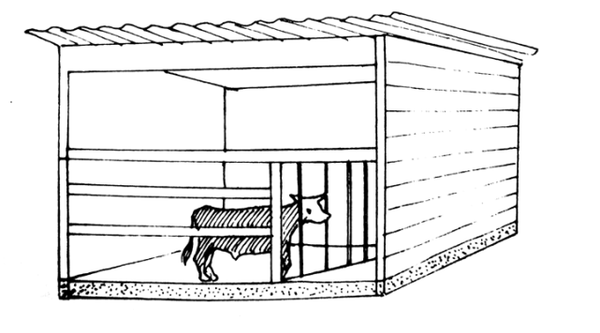A diagram showing a cattle shed.

**205 |** P a g e

##### Topic 7: RESOURCES IN OUR ENVIRONMENT

Qn. **What is a resource**?

* A resource is anything people use to meet their needs.
* Or
* A resource is a component of the environment people use to satisfy their needs.

##### Qn. What is an energy resource?

* An energy resource is anything that provides useful energy to people.

##### Qn. Write down the two types of resources.

1. Renewable resources
2. Non – renewable resources

##### RENEWABLE RESOURCES

Qn. **What are renewable resources**?

* + Renewable resources are resources that can be replaced naturally once used up.
  + Renewable resources are also referred to as inexhaustible resources. Qn. **Mention the examples of renewable resources.**
  + Plants
  + Animals
  + Air / wind
  + Water
  + Soil
  + Sun

##### Plant as resources

Qn. **Why are plants regarded as renewable resources**?

* + Plants can be replaced naturally once used up.

##### Qn. How can plants be replaced naturally once used up?

* + Through reproduction

##### Qn. How are plants used as resources in the environment?

* + Plants are used as food.
  + Plants provide wood for building, furniture and cooking.
  + Plants are used as herbal medicine.
  + Plants provide timber for construction.
  + Plants help in rain formation.
  + Plant remains can be used in the production of biogas.
  + Plants provide fibre to people.
  + Plants provide shade to animals and people.
  + Barks of some trees are used to make bark cloth.
  + Plants help to purify /clean air.

##### Qn. How do plants purify air?

* + By absorbing carbon gases from the atmosphere.
  + By releasing oxygen into the atmosphere.

##### Qn. How do plants help in rain formation?

* + Through transpiration

##### Qn. How are plants used as energy resources?

* + Plants help in rain formation.
  + Plants provide wood fuel to people
  + Plants remains can be used in the production of biogas.
  + Fibres

##### Qn. What is a fibre?

* + A fibre is a thread like material.

##### Qn. Write down the types of fibres.

* + Natural fibres
  + Artificialfibres

##### Qn. What are natural fibres?

* + Natural fibres are thread like materials got from plants and animals.

##### Qn. Mention the examples of natural fibres got from plants.

* + Banana fibres
  + Sisal
  + Cotton
  + Linen
  + Raffia

##### Qn. Write down the examples of natural fibres got from animals

* + Silk
  + Mohair
  + Wool
  + Fur

##### Qn. What are artificial fibres?

* + Artificial fibres are thread like material made by people.

##### Qn. Mention the examples of artificial fibres

* + Polyster
  + Rayon
  + Nylon
  + Plastic
  + Rubber
  + Jute

##### Qn. State the function of each of the following plant fibres.

1. **Cotton**

- For making clothes

- For making cotton wool.

##### Sisal

* + For making sacks
  + For making ropes

##### Jute

* + For making carpets
  + For making window blinds
  + For making gunny bags

##### Banana fibres

* + For making mats

- For making ropes.

* + For making dolls
  + For making balls

##### Linen

* + For making clothes
  + For making curtains
  + For making sewing threads

##### Raffia

* + For making huts
  + For making mats
  + For weaving baskets
  + For making rugs

##### Qn. State the function of each of the animal fibres

* + For making clothes
  + For making blankets
  + For making carpets
  + For making bed sheets
  + For making suits, sweaters, jackets etc
  + Note:
  + Wool is got from sheep.

##### Mohair

* + For making wigs worn by judges
  + For making gloves.
  + For making clothes.
  + For making sweaters.
  + For making carpets.
  + For making socks.
  + For making coats.
  + Note:
  + Mohair is got from Angora goats.

##### Silk

* + For making clothes.
  + For making sleeping bags.
  + For making comforters.
  + Note:
  + Silk is got from silk worms.

##### Fur

* + For making clothes.
  + For making hoods.
  + For making scarves.
  + For making hats.
  + Wood fuel

##### Qn. What is wood fuel?

* + Wood fuel is the fuel got from plants.

##### Qn. Mention the examples/ forms of wood fuel.

- Fire wood

* + Charcoal
  + Wood shavings
  + Saw dust
  + Briquettes

##### Qn. How is a charcoal obtained?

* + By burning wood under limited supply of oxygen.

##### Qn. What is formed when charcoal is burnt under excess supply of oxygen?

* + Ash

##### Qn. State the uses of charcoal

* + Charcoal is used for cooking.
  + Charcoal is used in iron boxes when iron clothes.
  + Charcoal is used in bakeries to provide heat.

##### Qn. State the dangers of charcoal burning to the environment.

* + Leads air pollution.
  + Leads to low rain formation.
  + Leads to deforestation.
  + Leads to global warming.

##### Qn. State the ways of harvesting plant resources.

* + By uprooting
  + By felling trees with axes
  + By digging out
  + By plucking
  + By hand picking
  + By coppicing
  + By pollarding
  + By lopping
  + Conservation of plant resources

##### Qn. What is plant conservation?

* + Plant conservation is the protection and preservation of plant resources.

##### Qn. How are plants conserved in the environment?

* + By practicing agro forestry.
  + By practicing afforestation.
  + By practicing re-afforestation.
  + By discovering deforestation.
  + By using energy saving stoves.
  + By using other alternative sources of energy for cooking and lighting.

##### Qn. Apart from wood fuel, mention any other alternative sources of energy used for cooking and lighting.

* + Solar energy / electricity.
  + Biogas
  + Natural gas

##### Qn. How does clay made charcoal stove conserve plants in the environment?

* + It reduces deforestation (cutting down of trees for charcoal)

##### Qn. How does the clay made charcoal stove help to conserve charcoal/ wood fuel?

- It uses less charcoal.

* + It retains heat for a long time.
  + Diagram showing clay made charcoal stove.

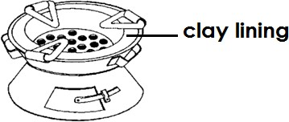

##### Qn. Name the fuel used in the above stove.

* + Charcoal

##### Qn. What is the importance of the clay lining on the above stove?

* + The clay lining retains / keeps heat for a long time.

##### Qn. Why should plants be conserved in the environment?

* + For future
  + To prevent extinction of some plant species.

##### Animals as resources.

Qn. **Why are animals regarded as renewable resources**?

* + Animals can be replaced naturally once used up.

##### Qn. How are animals replaced naturally in the environment?

* + Through reproduction

##### Qn. State the use of animals as resources.

* + Animals provide food to people.
  + Animals provide skins to people.
  + Animals provide hides to people.
  + Animals like dogs guard our homes.
  + Animals like camels,donkeys, horses are used for transport.
  + Animals like bees provide honey and bee wax.
  + Animal droppings and dung are used in the production of biogas.
  + Some animals are used to plough gardens.
  + Some animals provided fibre to people.
  + Animal droppings can be used as manure.
  + Some animals help in seed dispersal.

##### Qn. How are animals used as energy resources?

* + Animal droppings are used in the production of biogas.
  + Some animals are used for transport.
  + Some animals are used for ploughing.

##### Qn. State the different ways of harvesting animal resources.

* + By milking
  + By shearing
  + By slaughtering
  + By hunting
  + By fishing

##### Qn. State the ways of conserving animal resources.

- By keeping / gazetting animals in game parks and game reserves.

* + By proper feeding of animals.
  + By treating animals when they fall sick.
  + By deworming animals to control internal parasites.
  + By spraying animals using acaricides.
  + By protecting animals against poaching.
  + By cleaning animal shelters.
  + By cleaning animal feeding troughs.
  + By giving animals enough food and water.
  + By avoiding over fishing.
  + By vaccinating animals.

##### Qn. Why should animals be conserved?

* + To prevent extinction of some animal species.
  + For future use.

##### The sun as a resource

* + The sun is the main / major natural source of energy in the environment.

##### Qn. Why is the sun regarded as the main source of energy in the environment?

* + Most of the heat and light energy comes from the sun.

##### Qn. How is the sun used as a resource in the environment?

* + Heat from the sun helps in rain formation.
  + Heat from the sun helps to dry harvested crops.
  + Heat from the sun kills parasites in our beddings.
  + Heat from the sun enables the skin to make vitamin D.
  + Sun light help plants to make their own food.
  + Heat from the sun helps to preserve food.
  + Heat from the sun helps to dry people’s wet clothes.
  + The sun provides light to people for seeing.

##### Qn. How does heat from the sun help to dry people’s wet clothes?

* + Heat causes evaporation of water from the cloth.

##### Qn. How does heat from the sun help in rain formation?

* + It causes evaporation of water in the water bodies.
  + It causes transpiration in plants.

##### Qn. How does heat from the sun dries harvested crops?

* + Heat causes evaporation of water from the seeds.
  + Heat drains water from the harvested seeds. Qn. **How does heat from the sun preserve food?**
  + Heat kills germs in food.
  + Heat drains moisture from food.
  + Heat dehydrates moisture from food.

##### Devices that use heat and light from sun (solar energy)

* + Solar drier / grain drier
  + Solar water heater
  + Solar panel

- Solar cooker

##### Solar drier

Qn. **How is solar drier useful?**

* + For drying grains

Diagram showing a solar drier

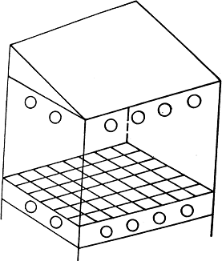

##### Qn. Why is the inside of the solar drier painted black?

* + To absorb heat from the sun

##### Qn. State the importance of the holes found at the bottom of a solar drier.

* + To let infresh air.

##### Qn. State the importance of the holes found on top of the solar drier.

* + To let out warm air

Qn. State the function of the transparent polythene sheet / paper placed on the top of the solar **drier.**

* + To allow light and heat from the sun to enter the drier.
  + To allow solar energy into the drier.

##### Solar water heater

Qn. **How is a solar water heater useful?**

* + For heating water

**Diagram showing a solar water heater**

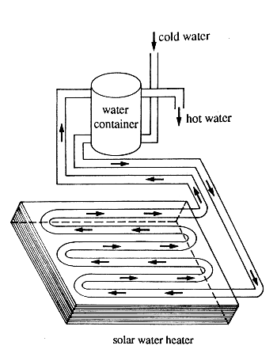

##### Qn. Why arethe boxes of a solar water heater painted black?

* + To absorb heat from the sun.

##### Solar cooker

Qn. **How is a solar cooker useful**?

* + For cooking food

**Diagramshowing a solar cooker**

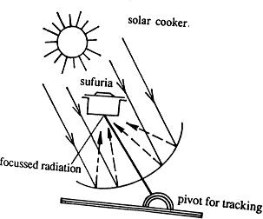

##### Solar panel

Qn. **How is a solar panel useful**?

* + For trapping solar energy from the sun.

##### Diagram showing a solar panel.

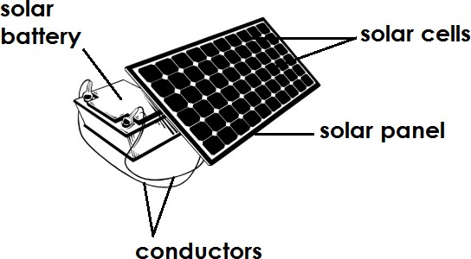

Qn. **State the function of each of the following components found on a solar panel.**

##### Solar cells

* + They covert / change solar energy into solar electricity.

##### Solar battery

- It stores solar electricity.

##### Solar panel

* + For trapping solar energy from the sun. Qn. **Why the solar panel is painted black**?
  + To absorb heat from the sun.

##### Qn. Why solar panels are always placed on roof of houses?

* + To enable them trap heat from the sun easily.

##### Soil as a resource

**Qn. Why is soil regarded as a renewable resource?**

* + Soil can be replaced naturally once used up.

##### Qn. How can soil be replaced naturally once used up?

* + Through decomposition of organic matter.
  + Through weathering of rocks.

##### Qn. State the uses of soil or a resource.

* + Loam soil is used for growing crops.
  + Sand soil is used for making glasses.
  + Sand soil is used to make blocks.
  + Clay soil is used to make bricks.
  + Clay soil is used for modeling.
  + Clay soil is used for making pots.
  + Soil is used for building houses.
  + Soil is a habitat for some animals. Qn. **How is soil harvested?**
  + By digging out

##### Qn. State the different ways of conserving soil as a resource.

* + By mulching.
  + By growing cover crops to control soil erosion.
  + By practicing crop rotation.
  + By bush fallowing
  + By applying manure.
  + By avoiding bush burning.
  + A void over cultivation.
  + A void deforestation.
  + Discouraging over stocking.
  + By planting trees to act as wind breaks.
  + A void dumping polythene bags on soil.
  + By using the 5R’s in waste management.

##### Qn. Write the 5R’s in full as used in waste management.

* + Recycle
  + Reuse
  + Reject/Refuse

- Reduce

* + Return

##### Water as a resource

**Qn. Why is water regarded as a renewable resource?**

* + Water can be replaced naturally once used up.

##### Qn. How is water replaced naturally once used up in the environment?

* + Through the water cycle / rain cycle .

##### Qn. How is water used as a resource?

* + Water is used for cooking food.
  + Water is used for washing clothes.
  + Water is used for irrigation.
  + Water is used for cooling car engines.
  + Water is used in making beverages.
  + Water is used in producing hydro electricity.
  + Water helps in seed dispersal.
  + Water tides are used to generate tidal electricity.
  + Water from hot springs is used to generate geothermal electricity. Qn. **How water is used as energy resources?**
  + Waterfalls are used to generate hydro electricity.
  + Water tides are used to generate tidal electricity.
  + Water from hot springs is used to generate geothermal electricity. Qn. **State the different ways of harvesting water as a resource**.
  + Rain water is harvested using water tanks, basins , buckets , big drums etc
  + Rain water is harvested using pits.
  + Ground water is harvested using bore holes/ water pumps.
  + Ground water is harvested using a wind lass / winch.
  + Underground water is fetched using jerry cans.

##### Qn. State the different ways of conserving water as a resource.

* + By protecting of wetlands( discouraging swamp drainage)
  + By planting trees
  + By protecting wells and springs.
  + By discouraging disposal of sewage in water sources.
  + A void disposing rubbish in water sources.

##### Qn. How does planting of trees conserve water?

* + Trees help in rain formation

##### Air as a resource

**Qn. Why is air regarded as renewable resource?**

* + Air can be replaced naturally once used up.

##### Qn. State the different ways of using air as a resources.

* + Carbon dioxide is used in preservation of soft drinks.
  + Carbon dioxide is used to preserve … food.
  + Carbon dioxide is used to put out fire using fire extinguishers.
  + Carbon dioxide helps plants to make their own food.

- Oxygen is used for respiration.

* + Oxygen is used in the process of food germination.
  + Nitrogen is used to preserve semen.
  + Nitrogen enables leguminous plants to make their proteins. Qn. **Give the uses of wind as resource.**
  + Wind helps to drive wind mills.
  + Wind helps to dry wet clothes.
  + Wind is used in winnowing.
  + Wind helps to sail boats and dhows.

##### Qn. How does carbon dioxide help to preserve soft drinks and canned / tinned food?

* + Carbon dioxide prevents the multiplication of bacteria.

**A wind mill**

* + This is a device used to turn turbines which drive generators and produce electricity.

##### Which type of electricity is produced by wind mills?

* + Mechanical electricity

##### Qn. State the importance of a wind mill.

* + It is used to pump water from underground.
  + It is used to generate electricity.
  + It is used to grind grains.

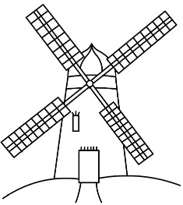**Structure of a wind mill**

##### Qn. How can air be conserved in the environment?

* + Discouraging bush burning.
  + Discouraging deforestation.
  + A void tobacco smoking.
  + By treating fumes from industries before releasing them in the atmosphere.
  + By planting trees.

##### Qn. What is conservation of resources?

* + Conservation is the protection and preservation of resources in the environment. Qn. **Why should resources be conserved**?
  + For future use.
  + To prevent extinction of some resources in the environment.

##### Qn. Mention the examples of living renewable resources in the environment.

* + Plants
  + Animals

##### Qn. Write the examples of non – living renewable resources in the environment

* + Water
  + Air / wind
  + Sun
  + Soil

**NON – RENEWABLE RESOURCES**

##### Qn. What are non- renewable resources?

* + Non renewable resources are resources that cannot be naturally replaced once used up.

**Note:**

* + Non- renewable resources are also referred to as exhaustible resources. Qn. **Mention the examples of non- renewable resources**.
  + Fossil fuels
  + Rocks
  + Minerals

##### Fossil fuels as non renewable resources.

Qn. **What are fossil fuels**?

* + Fossil fuels are fuels got from the remains of plants and animals that died a million years ago.

Qn. **What is a fuel**?

* + A fuel is anything burnt to produce heat. Qn. **Write the examples of fossil fuels**.
  + Petroleum
  + Coal

##### Qn. Why are fossils regarded of non- renewable resources?

* + Fossil fuel cannot be replaced naturally once used up. (i)Coal
  + Coal is a solid fossil fuel that was formed from plant remains that died a million years ago.

##### Qn. State the uses of coal as a resource.

* + Coal is burnt to produce thermal electricity.
  + Coal is used to make tar for surfacing roads.
  + Coal is burnt to produce heat for warming our houses.
  + Coal is used to make dyes, fertilizers and perfumes. Qn. **What is thermal electricity**?
  + Thermal electricity is the type of electricity got when coal is burnt.

##### Qn. How is the use of thermal electricity dangerous to the environment?

* + Burning of coal leads to air pollution.

##### Petroleum / crude oil

* + Petroleum is a dark thick mixture that was formed from remains of animals that got buried underground a million years ago.

Qn. **Mention the different products of petroleum**.

* + Kerosene / paraffin
  + Diesel
  + Petrol
  + Jet fuel / Aviation fuel
  + Petroleum jelly
  + Natural gas
  + Naphtha
  + Bitumen
  + Lubricating fluids

##### Qn. Write down the different uses of petroleum as a resource

* + Jet fuel is used to run engines of air crafts.
  + Petrol is used for running engines of vehicles.
  + Diesel is used for running car engines and other vehicles.
  + Natural gas is used for lighting, heating and cooking at home.
  + Kerosene is used for lighting and cooking at home.
  + Bitumen is used for surfacing roads.
  + Naphtha is used for making chemicals e.g. paints , drugs etc

##### Qn. How are products of petroleum separated from each other?

* + By fractional distillation

##### Rocks are non – renewable resources. Qn. What is rock?

* + A rocks is a hard solid material that is formed under the earth’s crust (ground) . Qn. **Why are rocks regarded as non – renewable resources**?
  + Rocks cannot be replaced naturally once used up. Qn. **State the different uses of rocks as resources**.
  + Rocks are used in constructing houses.
  + Rocks are used in construction of roads.
  + Rocks are used to decorate buildings.
  + Rocks act as habitats for some wild animals.
  + Rocks e.g. limestone is used to make cement.
  + Rocks help in soil formation through the process of weathering. Qn. **What is weathering of rocks**?
  + Weathering is the breaking down of rocks into small particles to form soil. Qn. **How is weathering important in the environment**?
  + Weather helps in soil formation. Qn. **Mention the types of weathering**.

1. Chemical weathering
2. Physical weathering

##### Qn. What is chemical weathering?

* + Chemical weathering is the process by which rocks are broken down as a result of chemical reactions.

##### Qn. What is physical weathering?

* + Physical weathering is the breaking down of rocks by use of force. Qn. **Write down the different agents of weathering**.

- Temperature

* + Burrowing of animals
  + Animal movements
  + Water
  + Expanding plant roots
  + Water

##### Minerals as resources

Qn. **What is a mineral**?

* + A mineral is a natural useful solid or liquid material obtained from the ground.
  + Note:
  + Minerals are extracted from **ores.**

Qn. **What is an ore**?

* + An ore a natural solid material from which a mineral is extracted.

**Examples of minerals**

* + Iron - Uranium
  + Gold - Salt
  + Copper - Steel
  + Aluminum - Lead
  + Wolfram - Cobalt
  + Diamond -zinc
  + Silver -Limestone
  + Tin

##### Qn. Write down the use of each of the following minerals as resources.

1. **Iron**
   * It is used for making axes.
   * It is used for making iron bars.
   * It is used for making nails.
   * It is used for making hoes.

##### Gold

* + It is used for making earrings.
  + It is used for making watches.
  + It is used for making trophies.
  + It is used for making necklaces.

##### Copper

* + - It is used for making electrical wires.
  + - It is used for making bullets.
  + - It is used for making coins.
  + - It is used in making freezers and refrigerators.

##### Aluminum

* + It is used for making tins.
  + It is used for making aeroplane bodies.
  + It is used for making roofing sheets.
  + It is used for making saucepans and kettles.

##### Wolfram

* + Tungsten metal is extracted from wolfram.
  + Tungsten is used to make filaments for electric bulbs.

##### Mercury

* + It is used in thermometers as a temperature indicator.
  + It is used to make some insecticides.
  + It is used to make materials used to fill dental caries (holes in teeth).

##### Lime stone

* + It is used for making cement.

##### Uranium

* + It is used to make nuclear electricity.
  + It is used to make atomic bombs.

##### Qn. State any one way of harvesting minerals as resources.

* + Using heavy machinery to extract them from the ground.
  + Alloys

##### Qn. What is an alloy?

* + An alloy is a mixture of two or more metals. Qn. **Identify any four examples of alloys**
  + Brass
  + Bronze
  + Dentist amalgam
  + Gold
  + Solder
  + Stainless steel
  + Manganese steel
  + Nickel steel
  + Cobalt steel

|  |  |  |
| --- | --- | --- |
| **Alloy** | **Combination** | **Uses** |
| - Brass | - Copper + Zinc | -For making ornaments  -For making bullets cases |
| - Solder | - Lead + tin | -For joining metals |
| - Bronze | - Copper + tin | -For making coins  -For making medals |
| - Stainless steel | - Steel + chromium | -For making cutlery |
| - Nickel steel | - Nickel + steel | -For making permanent magnets |
| - Dentist amalgam | - Mercury + copper | - Dental filling of the teeth |
| - Manganese steel | - Manganese + steel | - For making helmets |

##### Qn. Give any four reasons for making alloys.

* + To make metals harder.
  + To make the metal more resistant to friction.
  + To increase the electrical resistivity of a metal.
  + To lower melting point of metals.

##### Qn. State the different ways of conserving non renewable resources in the environment.

* + By recycling metal scraps.
  + By making alloys to make metals harder.
  + By painting metals to control rusting.
  + By using mineral resources sparingly.
  + By using other alternative sources of energy to produce heat and light.
  + Walking short distance instead of using cars.
  + By repairing vehicles in poor mechanical conditions. Qn. **What is environment**?
  + Environment is all things that surround people. Qn. **Mention the components of the environment**
  + Water
  + Air/Wind
  + Plants
  + Animals
  + Soil
  + Bacteria
  + Animal structures e.g. houses
  + Fungi
  + Rocks

##### Qn. Mention the types of environment.

* + Biological environment / Biotic environment
  + Physical environment / Abiotic environment

Biological environment / biotic environment

##### Qn. What is biotic environment?

* + Biotic environment is the type of environment that consists of living things. Qn. **Identify any four components of the biological environment**.
  + Plants
  + Animals
  + Fungi
  + Bacteria

**Physical environment /abiotic environment**

##### Qn. What is abiotic environment?

* Abiotic environment is the type of environment that consists of non living things. Qn. **Mention any four components of the abiotic environment**.
* Air/wind
* Water
* Soil
* Rocks
* Animal structures

**Environmental degradation**

* Environmental degradation is the lowering of the quality of the environment.

OR

* Environmental degradation is the lowering the quality of the environment making it less attractive and productive.

##### Qn. State the forms/types of environmental degradation.

* Soil degradation
* De-vegetation
* Wetland degradation/swamp drainage
* Pollution
* Deforestation
* Silting

##### Qn. State the different ways through which the environment can be degraded.

* By deforestation
* By over stocking
* Through bush burning
* By carrying out swamp drainage
* By over grazing
* By over cultivation
* By draining wetlands
* By industrialization
* By dumping wastes from industries into water.
* By urinating , defecating or bathing in water
* By pollution

Qn. **What is pollution**?

* Pollution is the release of harmful substances into the environment.
* OR
* Pollution is the addition of harmful substances into the environment. Qn. **State the four types of pollution**
* Air pollution
* Land or soil pollution
* Water pollution
* Sound pollution

##### Air pollution

Qn. **What is air pollution**?

* + Air pollution is the release/addition of harmful and dangerous gases into the air. Qn. **State any four ways through which air can be polluted**.
  + By fumes from factories and industries.
  + By exhaust fumes from cars, trains and other engines.
  + By tobacco smoke from smokers.
  + By heat and smoke from burning bushes and forests. Qn. **State the ways of controlling air pollution.**

- Discouraging bush burning.

* Carry out proper disposal of faeces and urine.
* Carry out proper disposal of rubbish.
* Avoid tobacco smoking
* Treat fumes from industries before releasing them into the environment.
* Use other alternative sources of energy which do not produce smoke.

##### Water pollution

Qn. **What is water pollution**?

* + Water pollution is the addition of harmful wastes into water.

##### Qn. What name is given to the harmful materials that pollute water?

* + Water pollutants.

##### Qn. State any four ways through water is polluted

* + Dumping wastes from farms and industries into water sources.
  + Urinating in water sources.
  + Bathing in water sources.
  + Defecating in water sources.
  + Washing in or near water sources.
  + Dumping house hold refuses into water sources. Qn. **State the ways of controlling water pollution**
  + Discourage dumping of polythene papers into water sources.
  + Avoid urinating in water sources.
  + Avoid defecating in water sources.
  + Avoid bathing in water sources.
  + Avoid washing clothes in water sources.
  + Discourage animals from drinking in water sources.

##### Soil pollution

Qn. **What is soil pollution**?

* + Soil pollution is the release of harmful substances into soil.

##### Qn. What name is given to harmful substances that pollute the soil?

* + Soil pollutants.

##### Qn. State any four examples of soil pollutants.

* + Polythene paper
  + Agro chemicals
  + Broken glasses
  + Plastics
  + Broken bottles
  + Metal scraps

##### Qn. State any four ways through which soil can be polluted.

* + Dumping polythene papers in the soil.
  + Dumping of metal scraps in the soil.
  + Dumping of broken bottles on soil.
  + Excessive use of agro chemicals.
  + Dumping plastics in the soil.
  + Poor disposal of wastes.

##### Qn. How do polythene papers and plastics affect the soil?

* + They prevent water from entering the soil.
  + They prevent air from entering into the soil. Qn. **State the ways of controlling soil pollution.**

- Avoid dumping polythene papers into the soil.

* + Avoid dumping plastics into the soil.
  + Avoid excessive use of agro chemicals.
  + Carryout proper disposal of wastes.
  + Avoid dumping broken glasses into soil.
  + Avoid dumping broken bottles into soil.
  + Avoid dumping metal scraps into soil.

##### Sound pollution

Qn. **What is sound pollution**?

* + Sound pollution is when there is too much sound or noise in the environment. Qn. **State any two ways through which sound is polluted.**
  + Noise from war weapons
  + Noise from birds e.g. weaver birds
  + Blaring music in markets and from people who sell tapes.
  + Noise from cinema halls.
  + Noise from churches.
  + Noise from factories.

##### Qn. State the ways of controlling sound pollution.

* + Minimizing noise from cinema halls.
  + Covering the inside walls of cinema halls with soft boards.
  + Covering the inside walls of cinema halls with thick curtains.

**Silting**

##### Qn. What is silting?

* + Silting is the deposition of silt into the water bodies. Qn. **State the causes of silting**
  + Soil erosion
  + Cultivating near river banks Qn. **State the effects of silting**
  + It leads to death of aquatic animals.
  + Silting makes water bodies shallow.
  + Silting causes contamination of water. Qn. **State the ways of controlling silting**
  + Avoid cultivating near river banks.
  + Planting trees near river banks to control soil erosion.
  + Swamp drainage

##### Qn. What is swamp drainage?

* + Swamp drainage is the act of removing or channeling water away from the wetland. Qn. **State the reasons why people drain wetlands**.
  + To get land for farming.
  + To construct roads.
  + To get land for industrialization.
  + To get land for constructing play grounds.

##### Qn. Give the uses of wetlands.

* + Wetlands help to filter water.
  + Wetlands control floods.
  + Wetlands act as fishing grounds.
  + Wetlands help in rain formation.

##### Bio degradable and non- bio degradable materials.

1. **Bio degradable materials**

##### Qn. What are biodegradable materials?

* + Biodegradable materials are materials that decompose/rot in the soil.
  + Examples of biodegradable materials
  + Plant remains
  + Animal remains
  + Paper
  + Wood

##### Non – biodegradable materials

Qn. **What are non- biodegradable materials?**

* + Non biodegradablematerials are materials that cannot decompose in the soil.

**Examples of non biodegradable materials**

* + Rubber
  + Polythene bags
  + Metal scraps
  + Plastics
  + Broken bottles
  + Old car tyres
  + Broken glasses

##### Qn. State the effects of non biodegradable materials to the soil.

* + They lead to soil exhaustion.
  + They lead to low crop yields.
  + They lead to death of organisms in the soil.
  + They prevent air and water from entering the soil.

##### Qn. Mention the natural causes of environmental degradation.

* + Volcanic eruption
  + Floods
  + Lightning
  + Landslides
  + Earth quakes
  + Elnino rains (heavy rains)
  + Strong winds

##### Qn. State the human causes of environmental degradation.

* + Deforestation
  + Uncontrolled mining
  + Bush burning
  + Over grazing
  + Over stocking
  + Over cultivating
  + Swamp drainage
  + Mon cropping
  + Charcoal burning

**TOPIC 8 : THE RESPIRATORY SYSTEM**

##### Qn. What is the respiratory system?

-The respiratory system is a group of organs which work together to carryout respiration.

##### Qn. What is respiration?

* + Respiration is the process by which the body uses digested food and oxygen to produce energy carbon dioxide and water vapour.

Or

* + Respiration is the oxidation of food in the body to provide energy, carbon dioxide and water vapour.

### Illustration

#### Oxygen + Food Energy + Carbondioxide + Water vapour

##### Qn. State the raw materials for respiration.

* + Oxygen
  + Digested food

##### Qn. State the three products of respiration

* + Energy
  + Carbondioxide
  + Water vapour

##### Qn. Mention the useful product of respiration

* + Energy

##### Qn. Mention the waste products or by products of respiration.

* + Carbondioxide
  + Water vapour

##### Qn. State the role of oxygen during respiration

* + Oxygen burns down food to release energy, carbondioxide and water vapour.

Or

* + Oxygen oxidizes food to release / produce energy Qn. **Where in the body does respiration take place?**
  + Body cells

##### Qn. State the importance of respiration to the body.

* + Respiration enables the body to get energy.
  + Respiration enables the body to get ridof / release carbondixoide and water vapour. Qn. **State the two types of respiration**
  + Aerobic respiration
  + Anaerobic respiration

##### Qn. What is aerobic respiration?

* + Aerobic respiration is the type of respiration that take place in the presence of oxygen. Qn. **What is anaerobic respiration**?
  + Anaerobic respiration is the type of respiration that takes place in the absence of oxygen.

### A diagram showing the respiratory system.

**Functions of each part of the respiratory systems.**

##### Lungs

* + Lungs are used for breathing (gaseous exchange)

##### Note:

* + - The lungs are located in the chest cavity.
    - The lungs are red coloured.

##### Qn. Why are the lungs red coloured?

* + - The lungs are red coloured because they contain a large number of blood capillaries. Qn. **Which part of the human skeleton protects the lungs**?
    - The ribcage

##### Qn. In which membrane are the lungs enclosed?

* + - Pleural membrane

##### Qn. State the function of the pleural membrane.

* + - It produces / secretes pleural fluid.

##### Qn. State the function of the pleural fluid to the respiratory system.

* + - The pleural fluid reduces friction between the ribs and the lungs. Qn. **Why are the lungs spongy**?
    - They have numerous air spaces within them.

##### Qn. Why the lungs are called respiratory organs?

* + - They carryout respiration
    - They allow oxygen in the body for the process of respiration.

##### Nose

* The nose acts as a passage of air into the lungs.

Note:

* The nose contains tiny hair called cilia.
* The nose contains mucus.

##### Qn. State the importance of mucus found in the nose.

* Mucus warms air found in the nose.
* Mucus traps dust and other foreign bodies.
* Mucus moistens air before it enters the nose.

##### Qn. State the importance of tiny hair found in the nose.

* Trap dust particles.
* To trap bacteria.

##### Qn. What happens to air when it passes through the nose?

* Air is warmed
* Air is filtered / cleaned / purified
* Air is moistened.

##### Qn. Why is it not advisable to breathe through the mouth?

* The air is the mouth is not warmed.
* The air in the mouth is not filtered.
* The air in the mouth is not moistened. Qn. **Why is air warmed in the nose**?
* To prevent it from chilling the lungs.

##### Epiglottis

* The epiglottis prevents food from entering the trachea during swallowing. Qn. **What happens when food enters the trachea**?
* It leads to choking

##### Qn. How does the epiglottis prevent food from entering the trachea?

* The epiglottis closes the trachea during swallowing of food.

##### Larynx / Voice box

- This contains vocal cords that vibrate to produce sound.

##### Trachea / wind pipe

* It acts as a passage of air to the lungs.
* It directs air to the lungs.

### Note

* The trachea is made up of rings of cartilage.

##### Qn. Why is the trachea made up of rings of cartilage?

* To prevent it from closing.
* To keep it open all the time.

##### Qn. Why should the trachea be kept open all the time?

* To prevent it from closing.
* To keep it open all the time.

##### Qn. Why should the trachea be kept open all the time?

* To prevent it from collapsing which can lead to suffocation. Qn. **State the importance cilia found in the trachea**.
* Trap dust in the trachea.

##### Bronchi

- These are two air passages into which air flows from the trachea.

##### Bronchioles

- They deliver air to the air sacs / alveoli

##### Air sacs / Alveoli

* These are tiny air spaces / bags found in the lungs. Qn. **How are alveoli useful in the lungs**?
* They help in gaseous exchange Qn. **What is gaseous exchange**?
* Gaseous exchange is the releasing of carbon dioxide from blood and the gaining of oxygen.

##### Qn. How are the air sacs adapted to gases exchanges?

* They are many in number.
* They are surrounded by a great net work of blood capillaries.
* They are thin walled.

### Qn. Why are the air sacs many in number?

* To increase the surface area for gaseous exchange to take place.
* To provide a wider surface area for gaseous exchange to take place. Qn. **Why the air sacs are thin walled**?
* To allow easy diffusion of gases.

##### Qn. Why are the air sacs surrounded by a net work of blood capillaries?

* To supply them with oxygen and digested food. Qn. **How does gaseous exchange occur?**
* When blood reaches the air sacs, carbondioxide diffuses out of the lungs and oxygen is diffused into the blood.

##### Qn. State the process by which gaseous exchange takes place in the air sacs.

* Diffusion

### A diagram showing gaseous exchange in the alveoli

-

-

-

##### Ribs

- Ribs protect lungs from damage.

##### Intercostal muscles

* These are muscles of the lungs.
* Intercostal muscles hold the ribs in position.

##### Diaphragm

* It separates the abdominal cavity from the chest cavity.
* It helps in breathing.

### Breathing

Qn. **what is breathing**?

* Breathing is the taking in and out of air. Qn. **Why do animals breathe in?**
* Animals breathe in to get enough oxygen for carrying out respiration. Qn. **State the two types of breathing**.
* Inhalation / inspiration / breathing in
* Exhalation / expiration / breathing out.

##### Qn. State the difference between air we breathe in and that we breathe out.

* The air we breathe in contains more oxygen while the air we breathe out contains more carbondioxide.
* The air we breathe in has more density while the air we breathe has less density.

##### Qn. State the importance of breathing to animals.

* Breathing in provides oxygen to body cells.
* Breathing out enables the body to expel carbondioxoide from the body. Qn. **Give the meaning of each of the following terms**.

##### Inspiration

* + Inspiration is the act of taking air into the lungs.

##### Expiration

* + Expiration is the act of taking air out of the lungs.

##### Qn. State what happens to the following during breathing in/ inspiration.

* + The lungs expand.
  + The lungs increase in volume.

##### Chest cavity

* + The volume of the chest cavity increases.

##### Ribs

* + The ribs more upward and outwards.

##### Intercostal muscles

* + They contract

##### Diaphragm

* + The diaphragm contracts and flattens.

##### Qn. Why do lungs expand during breathing in?

* + To create space for the incoming air.
  + In order to receive the incoming air.

### Diagram showing breathing in / inspiration

##### during exhalation / breathing out.

Qn. **State what happens to the following**

(i)

-

-

-

**Lungs**

The lungs return to their original size. The volume of the lungs decreases.

1. **Chest cavity**
   * The volume of the chest cavity decreases.

##### Ribs

* + Ribs move downwards and inwards.

##### Intercostal muscles

* + Intercostal muscles relax.

(vi) **Diaphragm**

- The diaphragm relaxes and forms a dome shape.

### Diagrams showing breathing out or expiration.

**231 |** P a g e

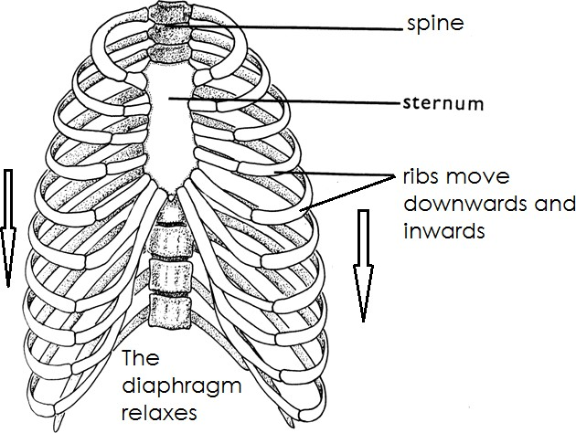

##### Qn. What is the importance of diaphragm during breathing?

* The diaphragm contracts and relaxes to allow air in and out of the lungs. Qn. **Why do we breathe out?**
* To take out or expel carbon dioxide from the body.

##### Qn. State the parts involved in breathing

* Nose
* Air sacs
* Trachea
* Diaphragm

### Rate of breathing

**-**The rate of breathing of a normal person is about 16 times per minute.

### Note:

* The rate of breathing can change due to various conditions i.e
  + When one is in the state of fear.
  + Too much excitement.
  + After performing a vigorous activity.

##### Qn. Why do we breathe faster after doing a vigorous activity like running?

* To allow more oxygen into the body for carrying out respiration.

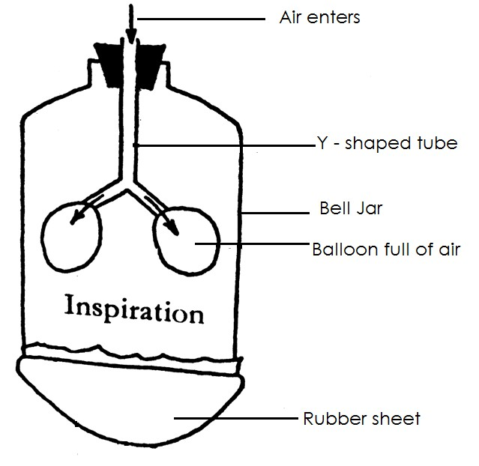

### Summary of air component inhaled andexhaled.

|  |  |  |
| --- | --- | --- |
| - **Gas** | - **Inspired** | - **Expired** |
| - Oxygen | - 21% | - 16% |
| - Carbon dioxide | - 0.03% | - 4% |
| - Nitrogen | - 78% | - 78% |
| - Water vapour | - less | - More |
| - Rare gases | - 0.97% | - 0.97% |

##### Qn. Why is the percentage of oxygen in the air we breathe in more than that we breathe out ?

* More oxygen is used in the process of respiration.

##### Qn. Why is the percentage of carbon dioxide inhaled less that that exhaled?

* More carbon dioxide is produced during the process of respiration.

Qn. **Why does the percentage of nitrogen in the air we breathe in and air we breathe out remain the same?**

-There is no body reaction that needs the presence of nitrogen.

##### Qn. Why is there less inspired water vapour than expired water vapour?

* More water vapour is produced during the process of respiration.

### An experiment to demonstrate breathing in human beings. Materials to be used.

* Y – Shaped tube.
* Bell jar.
* Two ballons
* Polythene bag/ rubber sheet
* A string

### Set up of the experiment during breathing in/ inspiration.

**Set up during breathing out/ expiration.**

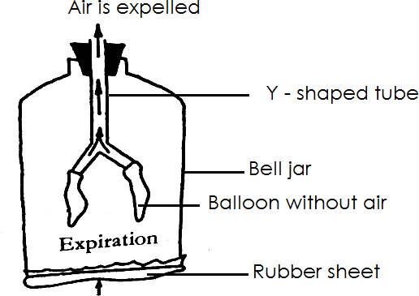

##### Qn. What do the following represent in the above model set up?

1. **Bell jar**?
   * It represents the ribcage.

##### Y – tube

* + It represents the trachea and bronchi.

##### Balloons

* + They represent the lungs.

##### Rubber sheet

* + It represents the diaphragm.

##### Qn. How can you allow air into the balloon?

* + By pulling the rubber sheet downwards.

##### Qn. What will happen to balloons when the rubber sheet is pulled downwards?

* + The volume of the balloons increase.

##### Qn. How can you remove air from the balloon?

* + Bu pushing the rubber sheet upwards.

##### Qn. What will happen to the balloons when the rubber sheet is pushed upwards?

* + The volume of the balloons will decrease.
  + Disorders and diseases of the respiratory system. Qn. **What is a disorder**?
  + A disorder is an illness that may affect the normal functioning of the body.

### Common disorders of the respiratory system.

* + Yawning
  + Sneezing
  + Choking
  + Hiccups
  + Nasal congestion

- Accumulation of mucus in the air sacs

* + Cough

### Note:

* + Hiccups are repeated sounds in the throat caused by the sudden movement of the diaphragm.

Qn. **What is choking**?

* + Choking is the blocking of the air passage to the lungs.

### Diseases of the respiratory system

* + Bronchitis - Whooping cough
  + Emphysema - Influenza
  + Lung cancer - Diphtheria
  + Asthma - Tuberculosis
  + Pneumonia

**The respiratory diseases are grouped as follows**

1. Communicable diseases (diseases caused by germs)
2. Non communicable diseases (diseases not caused by germs)

#### Inherited communicable diseases (diseases got from the parents to their off spring)

##### Examples of communicable diseases of the respiratory system

* + Tuberculosis - Whooping cough
  + Influenza - Diphtheria
  + Pneumonia - Bronchitis
  + Common colds

##### Tuberculosis

* + Tuberculosis is caused by bacteria called **mycobacterium. Qn. How does tuberculosis spread?**
  + Through air.
  + Through droplets of an infected person.

### Signs and symptoms of tuberculosis

* + Chronic cough
  + Loss of body weight
  + Fever
  + Difficulty in breathing
  + Coughing and spitting mucus with blood stains.
  + Prolonged back pain.
  + Prevention and control of tuberculosis
  + Immunizing children using BCG vaccine at birth.
  + Isolating food infected persons.
  + Drinking boiled milk.

##### Pneumonia

* + Pneumonia is caused by a bacterium called streptococcus pneumoniae.

##### Qn. How does pneumonia spread?

* + Through air
  + Note:
  + Pneumonia mainly affects air sacs (alveoli) in the lungs.

### Signs and symptoms of pneumonia

* + Difficulty in breathing.
  + Chest pain
  + Inflammation of the air sacs.
  + High fever
  + Coughing mucus with blood stains.

##### Qn. Why does a person suffering from pneumonia face difficulty in breathing?

* + Pneumonia causes inflammation of air sacs and fills them with pus.

##### Prevention and control of pneumonia

* + Immunization using PCV vaccine.
  + Isolate sick people from healthy ones.
  + A void living in places which are overcrowded.
  + Wear warm clothes during cold conditions.

##### Whooping cough / pertussis

* + It is caused by a bacterium.

##### Qn. How does whooping cough spread?

* + Through air

##### Signs and symptoms of whooping cough.

* + Runny nose
  + Gasp for breathe
  + Coughing spells that ends in vomiting

### Prevention and control of whooping cough

* + Immunization of children using DPT vaccine.
  + Isolate the infected persons from healthy ones.

##### Diphtheria

* + It is caused by a bacterium. Qn. **How does diphtheria spread?**
  + Through contaminated air.

### Signs and symptoms of Diphtheria

* + Difficulty in breathing.
  + Sore throat.
  + Swollen neck.
  + Prolonged fever.
  + Prevention and control of diphtheria
  + Immunization of children using DPT vaccine.
  + Isolate infected people from healthy ones.

##### Influenza

* + It is caused by a virus.

##### Qn. How does influenza spread?

* + Through air

##### Signs and symptoms of influenza

* + Runny nose
  + Difficulty in breathing
  + Fever

##### Qn. Prevention and control of influenza.

* + A void staying in cold places for long time.
  + A void living in crowded places.
  + A void staying in dusty places.

##### Bronchitis

* + It is caused by either a bacteria or virus.

### Signs and symptoms

* + Difficulty in breathing
  + Wheezing sound
  + Cough

### Prevention and control of Bronchitis

* + A void smoking.
  + A void staying in dusty places.
  + A void staying in poorly ventilated houses.

##### Note:

* + Bronchitis is worsened by smoking.

##### Common colds.

* + It is caused by viruses.

### Signs and symptoms of common colds

* + Runny nose
  + Sneezing
  + Congestion of the lungs
  + Headache
  + Cough

### Prevention and control of common colds

* + Isolate infected persons from healthy ones.
  + Living in well ventilated houses.
  + A void being near an infected person.

### Examples of non- communicable diseases of respiratory system.

* + Pleurisy
  + Emphysema
  + Larynitis

- Lung cancer

##### Pleurisy

This is the disease of the lungs caused due to inflammation of the pleural membrane.

##### Qn. How is pleurisy caused?

* + It is caused by tobacco smoking. Qn. **How can pleurisy be prevented**?
  + A void tobacco smoking

##### Lung cancer

* + It is caused by smoking

##### Qn. Write down any one sign of lung cancer.

* + Abnormal growth of the cells in the lungs. Qn. **How can lung cancer be prevented**?
  + A void tobacco smoking.

##### Emphysema

* + It is caused by smoking.

##### Qn. Write down any one sign of emphysema.

* + Difficult breathing
  + Cough

##### Qn. How can emphysema be prevented?

* + A void tobacco smoking

##### Larynitis

* + It is a disease for the respiratory system that affects the larynx.

### Hereditary / inherited diseases of the respiratory system.

##### Asthma

* + It is inherited from parents.

##### Qn. Write down any one sign of Asthma.

* + Difficulty in breathing.

##### Qn. How can Asthma be prevented / controlled?

* + A void living in dusty places.
  + A void using chemical .fumes and prays which may worsen the condition.

##### Qn. State the bad habits/ practices that cause damage (affects) the respiratory system.

* + Tobacco system
  + Poor feeding
  + Living in dusty places
  + Living in overcrowded places
  + Staying in poorly ventilated houses

##### Qn. Give the different ways / practices / habits that help the respiratory system in a good working condition.

* + Having regular physical exercises.
  + Feeding on food that makes up a balance diet.
  + A void tobacco smoking.
  + A void staying in dusty places.
  + A void living in poorly ventilated houses.
  + A void living in overcrowded places.
  + Isolate infected person form healthy ones.
  + Immunize children against the childhood immunisable diseases.
  + Always cover the mouth while coughing and sneezing.

##### TOPIC 9 : SCIENCE AT HOME AND IN OUR COMMUNITY

Science at home are various science activities used to solve common problems at home and in our community.

##### Qn. Identify examples of science activities common at home.

* + Boiling water
  + Washing clothes
  + Production of biogas
  + Preparing of local salt
  + Making electricity from wind
  + Promoting sanitation
  + Decantation of water
  + Distillation of water
  + Filtration of water

##### Qn. Mention any four uses of water to people.

* + Water is used for bathing.
  + Water is used for washing clothes.
  + Water is used for washing utensils.
  + Water is used for cooking food.
  + Water is used for mopping.
  + Water is used for flushing toilets.
  + Water is used for mixing agrochemicals.
  + For cooling machines in industries. Qn. **Give the uses of water in the body.**
  + Water helps to ease digestion.
  + Water helps to cool down body temperature.
  + Water helps information of plasma.
  + Water maintains the shape of body cells.
  + Water helps in transportation of waste materials. Qn. **State the uses water to crops**.
  + Water helps in process of germination.
  + Water acts as raw materials for photosynthesis
  + Water is agent of seed dispersal.
  + Water is an agent of pollination.

##### Qn. Identify the sources of water in environment.

|  |  |  |
| --- | --- | --- |
| - rivers | - swamps | - seas |
| - rain | - tanks | - springs |
| - lakes | - ponds | - dams |
| - wells | - oceans |  |

* + borehole - streams

##### Qn. Mention the properties of water.

* + Water exerts pressure.
  + Water finds its own level.
  + Water is a good solvent.

##### Water exerts pressure

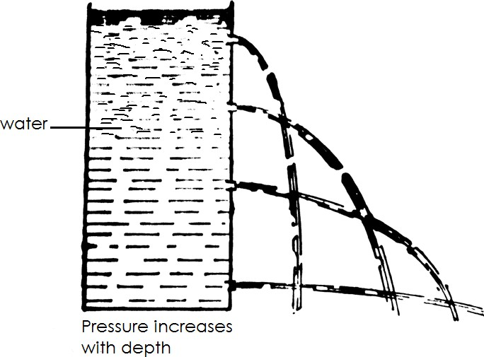

Qn. **Why does water pour at different levels?**

* + The pressure of water depends on it depth.

##### Qn. Why does the jet at bottom pour water the furthest?

* + The pressure at the bottom is greatest.

##### Water finds its own level.

* + When water is put in different containers having different shapes, it will have the same level.
  + Illustration

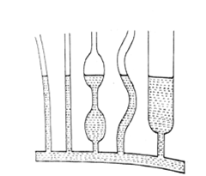 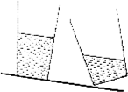

##### Water is a good solvent.

* + Water is a good solvent because it dissolves all solutes.

##### Qn. Identify some examples of solutes that can dissolve in water.

* + Salt - sugar - glucose
  + Powdered milk - baking powder

Qn. **What is pure water**?

* + Pure water is water which does not contain any impurities. Qn. **State the properties of pure water**
  + Pure water is colourless.
  + Pure water is tasteless.
  + Pure water is odourless (has no smell)
  + Pure water boils at 100 0c or 212 0 F
  + Pure water freezes at 0oc or 320F

##### Types of water

Qn. **Mention any two types of water**

* + Soft water
  + Hard water

##### Hard water

Qn. **What is hard water**?

* + Hard water is water that does not form lather easily with soap. Qn. **What makes water hard**?
  + Mineral salts

##### Qn. Why is hard water unable to form lather easily with soap?

* + Hard water contains a lot mineral salts Qn. **Mention the sources of hard water**
  + Seas - Wells - Lakes
  + Rivers - Boreholes

##### Qn. State the advantages of using hard water.

* + Hard water strengthens our bones and teeth.
  + Hard water is used to make beer.

##### Qn. State the disadvantages of using hard water.

* + Hard water wastes soap.
  + Hard water stains clothes.

##### Qn. How can hard water be made soft?

* + By boiling.
  + By treating with chemicals.

##### Soft water

Qn. **What is soft water**?

* + Soft water is water that forms lather with soap easily. Qn. **State the sources of soft water.**
  + Rain water

##### Qn. State the advantages of soft water.

* + It does not waste soap.

##### Qn. State the disadvantages of using soft water

* + It is not good for drinking.

##### Qn. How can soft water be made good for drinking?

* + By adding mineral salts.

##### Ways of making water clean.

Qn. **Identify the methods of making water clean**.

* + By decantation
  + By filtration
  + By distillation

##### Decantation / settling method

Qn. **What is decantation**?

* + Decantation is where solid particles in water are left to settle at the bottom of the container.

##### Steps to follow

1. Allow the mixture of water and dirt to settle for some hours.
2. Pour off the clean water on top of the container into another container carefully.

##### Illustration

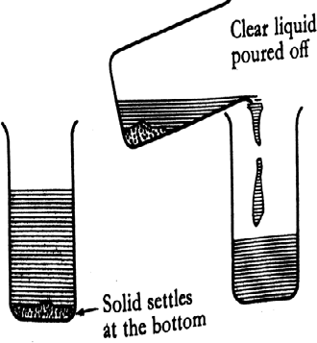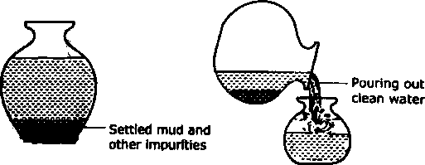

Qn. **How can water obtained by decantation be made safe for drinking**?

* + By boiling
  + By treating with chemicals.

##### Qn. Why is water obtained by decanting not recommended for drinking?

* + Decanting does not kill germs

##### Qn. State any two uses of water got after decantation.

* + It can be used for washing utensils.
  + It can be used for washing clothes.

##### Distillation

Qn. **What is distillation**?

* + Distillation is the method of making water clean by evaporating and condensing the water.

##### Qn. What scientific name is given to the pure water collected after distillation?

* + Distillate

##### A diagram is showing distillation method

Qn. **Why is distilled water not good for drinking**?

* + Distilled water does not contain mineral salts.

##### Qn. How can distilled water be made good for drinking?

* + By adding mineral salt.

##### Qn. State any two uses of distilled water.

* + It is used to mix drugs used in injections.
  + It is put in drips used in hospitals.

##### Filtration

Qn. **What is filtration**?

* + Filtration is where impurities in water are filtered.
  + Using a piece of cloth or sieve.
  + 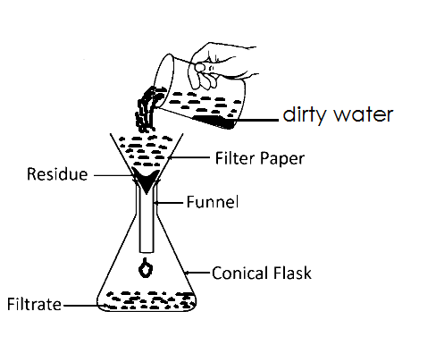A simple water purifier ( A water filter) Filtering using a filter paper

-

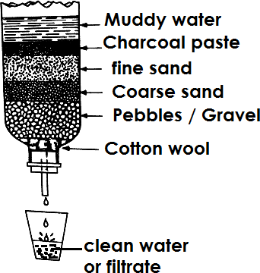-

-

-

-

-

-

-

-

-

##### Qn. What name is given to the solids particles trapped on the filter paper / sieve?

* + Residues

##### Qn. What science name is given to the clear liquid got after filtration?

* + Filtrate

##### Qn. Why is water got filtration not safe for drinking?

* + Filtration does not kill germs.

##### Qn. How can water obtained by filtration be made safe for drinking?

* + By treating with chemicals.
  + By boiling.

##### Qn. State any two activities at home in which filtered water can be used.

* + Cooking food
  + Washing clothes
  + Cleaning utensils

##### Qn. Besides making water clean, state any three activities at home that involve filtration at home.

* + Separating seeds from fruits juice.
  + Removing tea leaves from tea.
  + Removing solid particles such as husks an other particles from local brew.
  + Ways of making water safe for drinking

##### Qn. Mention any two ways of making water safe for drinking.

* + Boiling
  + Treating water using chemicals.

##### Qn. How does boiling water make it safe for drinking?

* + Boling kill germs in water.

##### Qn. How does treating water with chemicals make safe water for drinking?

* + Chemical kill germs in water.

##### Qn. Mention the example of chemicals used to treat water.

* + Chlorine - calcium chloride
  + Potassium paramagnet - lodine Qn. **What is chlorination**?
  + Chlorination is the addition of chlorine into water.

##### Stages in water treatment / purification.

* + Screening
  + Sedimentation
  + Filtration
  + Chlorination

##### Qn. Give the meaning of each of the following terms as used in water treatment.

1. **Screening**
   * Screening is the removal of solid floating materials from water by the help of metal grids where water enters the pipe.

##### Sedimentation

* + Sedimentation is the removal of large particles from water by allowing them to settle at the bottom of the tank.

##### Qn. What name is given to the solid particles that settle at the bottom of the tank?

* + Sediments

##### Qn. Mention any two examples of sedments

* + Sand - stones

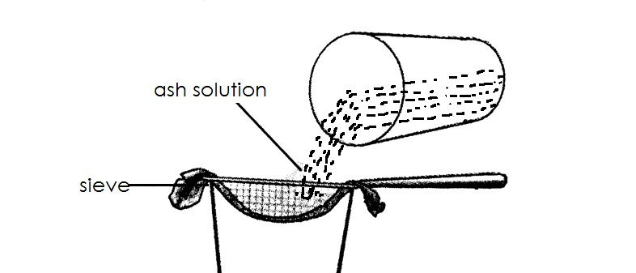

* Crystals of salt shall be seen on the saucepan.
* Illustration
  + Mud

##### Qn. State the different ways how purifies water can get contaminated.

* + Storing water in dirty places.
  + Storing water in dirty utensils.
  + Leaving water uncovered.
  + Drawing water using dirty containers.

##### Qn. State any the ways of preventing water contamination after boiling or treating.

* + By covering water.
  + By putting water in clean container.
  + By storing water in clean places.

-

* + Diagram showing stages of water purification

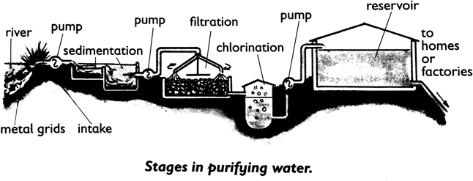

##### Qn. Mention any four disadvantage of using chemicals to treat water.

* + By chemicals is expensive.
  + Chemicals may make water to smell badly.
  + Chemicals may add taste to water.
  + Chemicals may add colour to water.

##### Making salt from plant materials

Qn. Mention any two local materials used to make salt.

* + Banana peeling.
  + Potato peeling.
  + Bean husks.

##### Qn. Write down the steps following in making local salt.

1. Get dry plant materials like banana peelings, sweet potato peelings , bean husks and burn them to obtain ash.
2. Get the ash from burnt plant materials and dissolve it into little water.
3. Filter off the ash from the mixture and obtain a salt solution.
4. Boil the salt solution to dryness.

##### Note

Qn. **Why is salt added to food?**

* + To make food tasty.
  + Salt is a source of mineral salts Qn. **State other uses of salt**.
  + It is used to preserve food.
  + Salt is added to animals feeds to supper proper growth of bones.
  + Salt is salt to get money.
  + Salt is used to make simple acids.
  + Salts is used to turn soft water into hard water. Qn. **State the disadvantages of using salt.**
  + Salt weakness metals by causing rusting.
  + It makes the food too salty to eat when poorly mixed with food.
  + Water impurities

##### Qn. What are water impurities?

* + Water impurities are material that make water dirty or impure. Qn. **Mention examples of water impurities**
  + Dust - faeces - poultry droppings
  + Cow dung - silt from erosion - industrial wastes
  + Chemicals e.g. herbicides , pesticides , insecticides
  + Germs
  + Cleaning clothes at home

##### Qn. Mention the steps involves in cleaning at home.

* + Sorting - Soaking
  + Washing - Rinsing
  + Wringing - Drying
  + Ironing

##### Sorting

Qn. **What is sorting**?

* + Sorting is the grouping of clothes according to their colours and degree of dirt. Qn. **State the reasons for sorting clothes before washing them**.
  + To separate very dirty clothes from other clothes.
  + To prevent clothes which have dye from spreading to others.
  + To make sure that those clothes that need special care are washed separately. Qn. **State the different factors to consider when sorting clothes**.
  + Colour of clothes.
  + Degree / intensity of dirty in clothes.
  + Note
  + Sorting is the first step involve in cleaning clothes at home.

##### Soaking

Qn. **What is soaking?**

* + Soaking is the sinking of clothes into water mixed with soap for sometimes. Qn. **State the importance of soaking clothes.**
  + To soften clothes for easy washing.
  + To dissolve dirt / loosening dirt in a cloth.
  + Note:
  + Soaking is done before washing.

##### Washing

* + What is washing?
  + Washing is the squeezing of clothes in water with soap. Qn. **Mention the types of washing**
  + Hand washing
  + Machine washing

##### Qn. State the different reasons for washing clothes.

* + To remove dirt / stains from clothes.
  + To remove germs.
  + To kill germs.

##### Rinsing

Qn. **What is rinsing** ?

* + Rinsing is the rewashing of soapy clothes in plenty of clean water. Qn. **State the reason of rinsing clothes**.
  + To remove all the lather from clothes.
  + To remove all the soap from clothes.

##### Wringing

Qn. **What is wringing?**

* + Wringing is the act of squeezing out water from the clothes after they have washed and rinsed.

##### Qn. State reason fro wringing clothes.

* + To remove excess water from clothes.

##### Drying

Qn. **What is drying**?

* + Drying is the putting of clothes somewhere to dry.
  + Note:
  + Drying can be done by hanging the clothes on a clothe line or clean surface. Qn. **State the reasons for drying clothes**.
  + To kill germs.
  + To remove water from the clothes.
  + Note:
  + Clothes should not be left to dry completely with moisture.

##### Qn. Why should some little moisture be left in clothes during drying?

* + To make ironing of clothes easy.
  + Ironing

Qn. **What is ironing**?

* + Ironing is the act of pressing clothes using a heated tool. Qn. **Mention any two tools that can be used to iron clothes.**

- Iron boxes.

* + Flat lrons

##### Qn. State the importance / purpose for ironing clothes.

* + To kill germs.
  + To remove wrinkles from a cloth.
  + To look smart.
  + Tailors lron clothes after sewing to give them the appropriate shape.
  + **Topic 10: ACCIDENTS AND FIRST AID**

##### Accident

**Qn. What is an accident?**

* + An accident is a sudden happening that causes harm to the body.
  + Note:
  + Accidents may lead to injuries on the body. Qn. **What is an injury?**
  + An injury is any damage to the body caused by an accident. Qn. **Write down the different places where accidents occur**.
  + schools - water bodies
  + homes - gardens
  + roads - churches
  + play grounds - hotels
  + construction sites - benches
  + bushes - forests

##### Qn. State the different causes of accidents in our community.

* + Careless running.
  + Playing on roads.
  + Playing with fire.
  + Playing with sharp piercing objects.
  + Playing rough games.
  + Falling from trees.
  + Playing with live electric wires.
  + Falling from tall buildings.
  + Body contact with hot metals.
  + Falling from stair cases.
  + Eating poisoned food.
  + Careless crossing of roads.

##### Qn. State different effects of accidents.

* + Accidents may lead to death.
  + Accidents may lead to loss of some body parts.
  + Accidents may lead to lameness.
  + Accidents may lead to wounds.
  + Accidents may lead to fractures.

- Accidents may lead to loss of blood due to breathing.

##### Qn. Mention the examples / forms of accidents

* + burns - electric shocks
  + scalds - snake bites
  + fractures - fainting
  + nose bleeding - dislocation
  + cuts - poisoning
  + wounds - fever
  + cramps - convulsion / fits
  + bruises - near drowning

##### First aid.

Qn. **What is first aid**?

* + First aid is the first help given to a casualty before being taken to a hospital.
  + Or
  + First aid is the immediate help / assistance given to a casualty before being taken to a health centres.

Qn. **Who is a casualty**?

* + A casualty is a person who has been involved in an accident.
  + Or
  + A casualty is a person who has been injured in an accident.
  + Or
  + A casualty is a person who has got an accident.

##### Qn. State the reasons / importance of giving first aid to a casualty.

* + To save life.
  + To stop bleeding.
  + To promote quick recovery.
  + To prevent further injuries.
  + To prevent the condition from becoming worse.
  + To reduce pain.

##### Qn. State the main reason for giving first aid.

* + To save life.

##### Qn. Who is a first aider?

* + A first aider is a person who give / administers first aid to a casualty. Qn. **State roles / responsibilities of a first aider**.
  + To assess the situation/ condition of the casualty.
  + To help in identifying the problem/ cause of the accident.
  + To assist the casualty as quickly as possible.
  + To remove the casualty from the accident scene.
  + To check for the ABC’s or 3 B’s.
  + To take the casualty to the hospital.

##### Qn. Write the following in full as used in first aid.

1. **ABC**
   1. Air way
   2. Breathing
   3. Circulation of blood

##### 3B’s

**B** Breathing

**B** Bleeding

**B** Breakages

##### Qn. State the qualities of a good first aider.

* Should be kind.
* Should be knowledgeable.
* Should be observant.
* Should be resourceful.
* Should be have common sense.
* Should be sympathetic.
* Should be gentle and tactful.
* First aid box and first aid kit Qn. **What is a first aid box**?
* A first aid box is a container where first aid tools / equipments are kept. Qn. **What is a first aid kit**?
* A first aid kit is a set of equipments / materials used for giving first aid.
* Diagram showing a first aid box

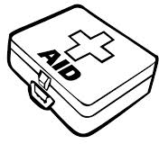

##### Qn. Mention the different places where first aid boxes are found.

* At home - in hotels
* At schools - In ships
* At petrol station - At the airports
* In vehicles - At banks
* In office

##### Qn. Why is a first aid box painted with bright colours?

* For easy identification

##### Qn. State the components of a first aid kit.

* plasters - safety pin
* cotton wool - lodine solution
* surgical spirit - black stone
* pair of scissors - surgical blade
* gloves - gauze
* razor blade - pair of tweezers
* bandage - pain killers
* needle and syringe

##### Qn. First aid kit and their uses.

|  |  |  |
| --- | --- | --- |
| No. | First aid kit | Uses |
| 1. | Bandage | * for covering wounds * for tying around the broken bones |

|  |  |  |
| --- | --- | --- |
|  |  |  |
| 2. | Razor blade | * for cutting bandages gauze and plasters. * for shaving around the affected area. * cutting fingers nails short to expose the wound. |
| 3. | Plasters  C:\Users\babra\AppData\Local\Microsoft\Windows\INetCache\Content.Word\Img-1597299436898.png | - for covering wounds and cuts |
| 4. | Safety pin | * for fastening bandages. * for stitching bandages. * for pinning bandages. |
| 5. | Surgical spirit | * for disinfecting wounds. * for killing germs around the injured part. |
| 6. | lodine solution | * cleaning wounds * to kill germs |
| 7. | Gloves | * for protection while dressing wounds. * for prevent contamination of the injured part by the first aider. |
| 8. | Pair of scissors | - for cutting plasters, bandages , gauze etc |



|  |  |  |
| --- | --- | --- |
|  |  | - for shaving hair around the injured part. |
| 9. | Cotton wool  C:\Users\babra\AppData\Local\Microsoft\Windows\INetCache\Content.Word\Img-1597300491899.png | - for cleaning wounds and cuts |
| 10. | Gauze | * for protecting wounds. * for absorbing pus and fluids from an injured part. |
| 11. | Pair of tweezers | * for picking up tiny objects from a wounds. * for removing beestings * for holding bandages , plasters etc |
| 12. | Needle and syringe | - for injecting |
| 13. | Black stones | - for sucking venom |
| 14. | Pain killer  e.gpanadollbrufenetc | - for reducing pain |

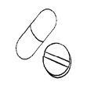

|  |  |  |
| --- | --- | --- |
|  |  |  |

Qn. **Mention the components of a first aid kit which are not found in a first aid box.**

* Stretcher
* Crutches
* Splints

##### Qn. Give the meaning of each of the following.

* Splints
* Splints are small pieces of wood or metal tied around a broken bone to keep it one position.

##### Qn. How are splints useful while giving first aid?

* Splints keep the broken bone in one position. Qn. **Why are splints not found in a first aid box**?
* Splints are big / splints are too big to fit in a first aid box.

##### Illustration showing application of a splint.

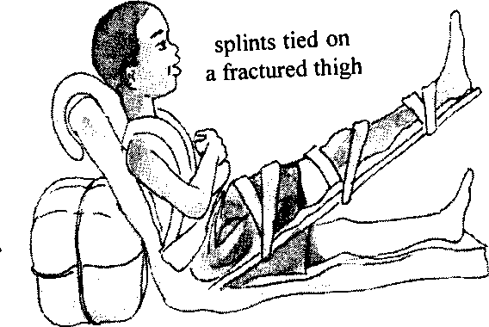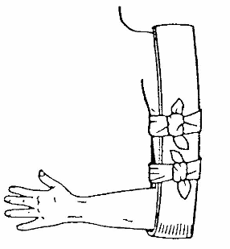

1. **Stretcher**
   * A stretcher is a simple emergency bed used for carrying casualties who unable to work. Qn. **How is a stretcher useful in giving first aid**?
   * A stretcher is used to carry causalities who can’t walk to he health centre/hospital. Qn. **Why is a stretcher not found in a first aid box?**
   * A stretcher is too big.

##### Qn. Mention the different local materials used for making a stretcher.

* + Pole / wood
  + Sacks
  + Ropes
  + Strings
  + Diagram showing a stretcher

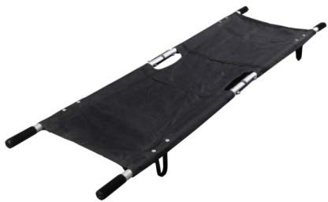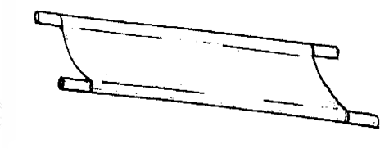

##### Crutches

* + A crutch is a piece of wood or metal used to assist casualty in walking. Qn. **Why is a crutch not found in a first aid box**?
  + A crutch is long and big.

##### Diagram showing a crutch

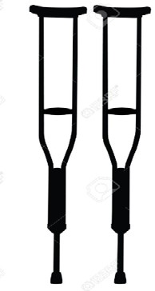

1. **Arm sling**
   * An arms sling is piece of clothe used to support a victim with a broken arm or hand. Qn. **How is an arm sling important in administering first aid**?
   * An arm sling helps to keep the broken / fractured arm in one position.
   * An arm sling gives support to the broken arm or hand.
   * Diagram showing an arm being supported by an arm sling.

-

-

-

-

-

-

-

-

* + FORMS OF ACCIDENTS

##### BURNS AND SCALD

1. **BURNS**

Qn. What is a burn?

* + A burn is an injury to the skin caused by heat. Qn. **Mention some examples of dry heat.**
  + Hot flat iron.
  + Fire
  + Hot charcoal
  + Hot charcoal stone
  + Cookers
  + Acids
  + Hot metal

##### Qn. State the different causes of burns.

* + Body contact with acids.
  + Body contact with hot saucepans.
  + Body contact with fire.
  + Body contact with hot kettles.
  + Body contact with frying pans.
  + Body contact with hot flat irons.
  + Body contact with burning charcoal.
  + Body contact with hot charcoal stoves.
  + Types of burns / degrees of burns.
  + First degree burn
  + Second degree burn
  + Third degree burn

1. First degree burn
   * First degree burn is the type of burn where a skin is burnt and does not form blisters.
   * Signs of a first aid a first degree burn.
   * Blisters are not formed.
   * The skin becomes tender for some few days. Qn. State the first aid for a first degree burn.
   * Put the burnt part in clean cold water.

##### Qn. Why do we put the burnt part in cold water.

* + To cool down the high temperature of the burnt part.

##### Second degree burn

* + Second degree burn is the type of burn which is severe and forms blisters on the skin.
  + Sign of a second degree burns
  + Blisters are formed on the skin.
  + First aid for second degree burn
  + Put the burnt part in clean cold water.
  + If the blister is not broken , wash the burnt area with a clean piece of bandage using cold water.

##### Third degree burn

* + Third degree burn is the type of burn where the skin is burnt deeply and causes complete damage on the skin.

##### Qn. State the signs of a third degree burn.

* + The skin appears shiny.
  + Blisters are formed on the skin and the skin is peeled off.
  + The victim loses a lot of body fluids. Qn. **What is ablister?**
  + A blister is raised skin with a liquid under it. Qn. **State the first aid for a third degree burn**.
  + Put the burnt part in clean cold water.

##### Qn. Why are victims of second and third degree burns encouraged to take plenty of fluids?

* + To replace the lost fluids in the body.

(b) **Scalds**

Qn. **What is a scald**?

- A scald is an injury on the skin caused by wet heat.

##### Qn. Identify some examples of wet heat.

* Hot water - porridge
* Steam - hot soup
* Hot milk - hot cooking oil Qn. **State four causes of scalds**
* Body contact with hot porridge.
* Body contact with hot cooking oil.
* Body contact with hot water.
* Body contact with hot milk.
* Body contact with hot tea.
* Body contact with steam.
* Body contact with hot soup.

##### Qn. What first aid can you give to a casualty with a scald?

* Put the injured part in clean cold water.

##### Qn. Why is it advisable to put the scalded part in clean cold water?

* To reduce on the high temperature of the scalded part. Qn. **State the ways of preventing burns and scalds**.
* Keep hot objects out of children’s reach.
* A void playing near fire places.
* Construct fire guards around cooking places.
* Carry hot objects using insulators of heat e.g. pieces of paper, leaves.
* Keep all flammable substances away from houses egg petrol .
* A void leaving candles or wick lamps burning in a house.
* A void cooking from open places.
* Keeping electrical equipments out of reach of children.

##### Qn. Give a reason why you should never apply cooking oil on the burn or scald.

* Cooking oil may cause more injections.
* The injury can become septic.

##### Qn. Why is it not advisable to pit rabbit for on a scald or burn.

* It can cause infections to the injury.

##### Qn. Why is it not advisable to apply sugar on a scald or burn?

* Sugar attracts bacteria.
* Sugar absorbs water from the skin.

##### Qn. Give a reason why it is not advisable to apply salt on burn or scald?

* Salt causes dehydration by absorbing water from the skin.

##### Qn. Give a reason why it is not advisable to burnt blisters incase of a second or third degree burn.

* Germs can enters the wounds and make it become septic. Qn. **Give the effects of burns and scalds.**
* They can lead to death.
* They can lead to damage to tendons, ligaments or muscles.
* They may lead to big scars on the body.
* They can lead to severe pain in the body.
* Change in the skin colour of affected area.

##### FEVER AND CONVULSIONS

1. **Fever**

Qn. **What is fever?**

* + Fever is condition in which a person’s body temperature rises beyond the normal.
  + OR
  + Fever is the abnormal rise of a person’s body temperature.
  + Note:
  + The normal human body temperature is about 370Oc or 98.4oF
  + Fever is not a disease but it may be as a result of illness such as malaria, typhoid , measles , meningitis etc

##### Qn. State the first aid for fever.

* + Apply tepid sponging.

##### Qn. Why is tepid sponging a good first aid for fever?

* + Tepid sponging cools down the high temperature of the victim’s body.

##### Qn. Why is it not advisable to use cold water when administering first aid for fever?

* + It can lead to vaso constriction which can lead to increase in blood pressure.

##### CONCULSIONS / FITS

Qn. **What are convulsions**?

* + Convulsions are sudden violent body movements which cannot be controlled.
  + OR
  + Convulsions are the uncontrolled jerky movement of the body.
  + OR
  + Convulsions are sudden shaking movement of the body that cannot be controlled. Qn. **State any one cause of convulsions**
  + High fever
  + Epilepsy

##### Qn. State the different signs and symptoms of convulsions.

* + High body temperature beyond normal.
  + Swearing excessively.
  + Urination frequently.
  + Violent shaking.
  + Shivering
  + A foaming mouth ( A lot of saliva bubbles in the mouth)

##### Qn. In four clear steps , state how you can administer first aid to convulsing person.

* + Clear the place where the person is convulsing from.
  + Remove or loosen the tight clothes from the victim’s body.
  + Put a hard object like a spoon in the mouth of the victim.
  + Take the victim to the nearest health centre.

##### Qn. In one sentence, state the first aid for convulsions.

* + Clear the place where a person is convulsing from and put a hard object in his / her mouth.

##### Qn. Why is advisable to put a hard object in the mouth of a person who is convulsing?

* + To prevent the victim from biting the tongue and lips.

##### Qn. Why is it not advisable to give a convulsing victim food or drinks?

- The liquid or food can choke the victim and cause death.

##### Qn. Why is it not advisable to force the jaws of a convulsing person to open?

* + Forcing jaws to open may cause them to break.
  + Note:
  + After the convulsions have stopped , put the patient in a recovery position to rest.
  + 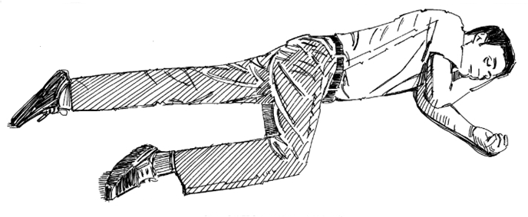Illustration (Recovery position)

##### Qn. State the ways of preventing and controlling of convulsions.

* + Control mosquitoes to prevent the spread of malaria.
  + Immunise children against measles.
  + Get early treatment incase of an infection from a health centre.

##### FAINTING

Qn. **What is fainting**?

* + Fainting is the loss of consciousness for a short time.
  + OR
  + Fainting is the brief loss of consciousness
  + OR
  + Fainting is the sudden or temporary loss of consciousness
  + OR
  + Fainting is a condition in which a person becomes unconscious for a short time. Qn. **State the main cause of fainting**
  + Limited supply of oxygen to the brain.
  + Limited supply of oxygenated blood to the brain.

-

##### Qn. Mention the conditions that can lead to fainting.

* + Prolonged hunger
  + Shocking hunger
  + Standing under sunshine for long time.
  + Too much excitement
  + Severe pain
  + Hear problems
  + Alcoholism
  + Dehydration
  + Doing a very heavy / strenuous exercises.
  + Staying in overcrowded places for along time.
  + Staying in a poorly ventilated place. Qn. **State the first aid for fainting**.
  + Raise the victim’s legs higher than the head.

##### Qn. Why are the legs of a convulsing person raised higher than the head?

- To allow oxygenated blood flow back to the brain.

##### Qn. In four steps, state how you can administer first aid to a person who has fainted?

* + Lie the victim on his or her back in an open place.
  + Remove or loosen the tight clothes from the victim’s body.
  + Chase away the by standers to provide fresh air to the victim.
  + Raise the victim’s legs higher that the head.

##### illustration

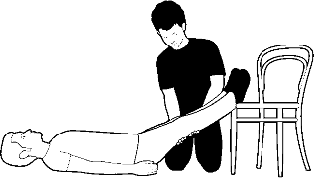-

-

-

-

-

-

-

-

* + Note:
  + Do not overcrowd around the victim because it can lead to shortage of fresh air.

##### DROWNING AND FEVER DROWNING

1. **Drowning**

Qn. **What is drowning**?

* + Drowning is the dying as a result of a person lungs being filled up with water.

##### Note:

* + A person who has drowned is not given first aid.

##### Qn. Why is a person who has drowned not given first aid?

* + The person is already dead.

1. Near drowning

##### Qn. What is near drowning?

* + Near drowning is a condition in which a person stops breathing due to having a lot of water in his / her lungs but is not jet dead.

##### Qn. Mention the various places where drowning and near drowning can occur / take place.

* + In bath rubs
  + In lakes
  + In wells
  + In rivers
  + In swamps
  + In ponds
  + In pits dug by builders to trap rain water
  + In streams
  + In swimming pools
  + Irrigation ditches
  + In hot springs
  + In seas

- In oceans

* + In dams
  + Water falls
  + Septic tanks
  + In a basin full of water
  + A vat of paint
  + A vat of oil

##### Qn. State the first aid for near drowning.

* + Apply mouth to mouth breathing. ( resuscitation)

##### Qn. In four steps , state how you can administer first aid to a person who has nearly drowned.

* + Shout for help from people around.
  + Remove the person from water as soon as possible.
  + Lie the victim on his / her back and tilt the head backwards.
  + Apply mouth to mouth breathing.

##### Qn. How to apply mouth to mouth breathing?

1. Lie the victim on his / her back and tilt the head backwards.
2. Remove any foreign body/ objects which may stuck in the mouth.
3. Press the victim’s nostrils with your fingers to close them.
4. Bring / put your mouth to that a victim and blow strongly into water mouth.

##### Qn. What is mouth to mouth breathing a good first aid for a person who has nearly drowned?

* + It enables a person to breather again (rebreathe)

-

-

* + Illustration

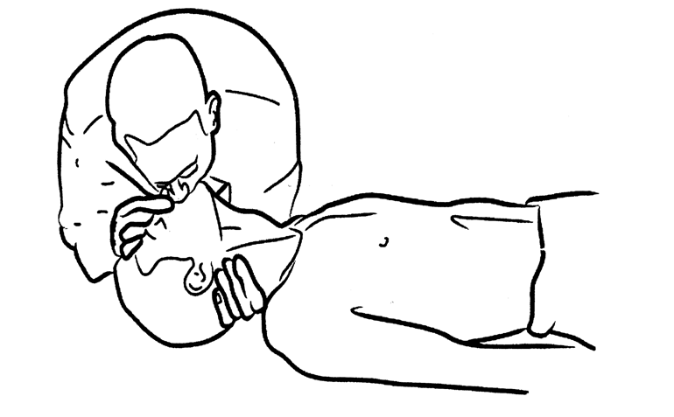

##### Qn. State the causes of near drowning.

* + Overturning of boats and their water vessel in water.
  + Lack of swimming skills.
  + Due to floods.
  + Leaving children unattended to while swimming, in both tubs.
  + Swimming or riding a boat while drunk.
  + Attempted suicide.

##### Qn. State the different ways of preventing drowning and near drowning.

- A void leaving basins, buckets and bath tubs full of water.

* + Fencing of swimming pools.
  + Acquiring swimming skills.
  + A void swimming or riding of boats while drunk.
  + Be careful while crossing flooded places.
  + Children should not be allowed to swim alone.
  + Provide life jackets to passengers on sailing boats.
  + Sailing boats.
  + Cover all septic tanks in an area.
  + Discourage children from playing near water sources.

##### NOSE BLEEDING

Qn. **What is nose bleeding**?

* + Nose bleeding is the flow of blood from a person’s body through the nose. Qn. **State the causes of nose bleeding**.
  + Over inhalation of dry air.
  + Over blowing of the nose.
  + Taking food one’s body in allergic to.
  + Taking medication for long time.
  + Severe blow on the nose.
  + Severe / high fever.

##### Qn. How does over inhalation of dry air lead to nose bleeding?

* + It leads to drying up of the nostrils and blood vessels which causes them to break. Qn. **How does a severe blow on the nose lead to nose bleeding**?
  + It overstrains the blood vessels and causes them to break. Qn. **State the first aid for nose bleeding**.
  + Blend the victim forward and pinch the soft part of the nose. Qn. **Why do we pinch the soft part of the nose**?
  + To prevent / reduce blood flow from the nose.

##### Qn. Why is not advisable to make a victim of nose bleeding to backwards?

* + It may allow blood to flow back to the brain and cause death.

##### Qn. In four steps, state how you cab administer first aid to a person with nose bleeding.

1. Let the casualty sit and bend forward and the pinch the upper / soft part of the nose.
2. Encourage the victim to breathe through the mouth.
3. Keep the head of the victim higher then level of the heart.
4. Put ice wrapped in a towel on the nose.

##### Illustration (first aid for nose bleeding)

Qn. **State the ways of preventing of nose bleeding**.

* + Keep the nostril moist.

- A void eating food one in allergic to.

* + A void playing rough games that may cause injury to the nose.
  + Taking citrus fruits.
  + Get early treatment incase of high fever.

##### FOREIGH BODIES

Qn. **What is a foreign body?**

* + A foreign is any external material or object that enters the body through a natural opening.

##### Qn. Mention the examples of natural openings on the body.

* + Eyes - Mouth/ throat
  + Ears - Vagina
  + Nose Anus

##### Qn. Mention the different examples of foreign bodied that may enter the body through a natural opening.

* + Seeds - coins
  + Small stones - small insects
  + Soil / dust - pins
  + Watch cells - Bottle lids
  + Dildos - Used condoms
  + Small sticks - Bullets
  + Beads - Broken glasses
  + Nails - Coffee berries
  + Thorns

##### Foreign bodies in the eye

Qn. **Write down the examples of foreign bodies that may enter the eye.**

* + Dust
  + Small stones
  + Small insects

##### Qn. State the first aid for foreign bodies in the eye.

* + Wash the victim’s eye with plenty of clean water.
  + Gently wipe away the foreign body from the eye using a corner of soft piece of cloth.
  + Note:
  + It the foreign body remains inside seek medical help.

##### Foreign bodies in the ear

Qn. **Mention the examples of foreign bodies that may enter the nose**.

* + Seeds
  + Beads
  + Small stones
  + Small insects
  + Coffee berries

##### Qn. State the first aid for foreign bodies in the nose.

* + Tell the victim to blow his / her nostrils fast and hard.
  + Encourage the victim to breathe through the mouth instead of the nose.
  + Note:
  + It the foreign body remains in the nose seek medical help.

1. Foreign bodies in the ear.

##### Qn. Mention the foreign bodies that may enter the ear.

* + Beads
  + Small stones
  + Small insects
  + Small seeds

##### Qn. State the first aid for a foreign body in the ear.

* + If the foreign body is an insect, pour clean cold water in the ear and make the victim lie / bend the head on the affected ear.
  + Note:
  + If the foreign body is not an insect, do not attempt to remove it because it may be pushed deeper and cause damage to the ear drum.

##### Foreign bodies in the mouth.

Qn. **Mention the examples of foreign bodies that may enter through the mouth.**

* + Coins - pencil rubbers
  + Small stone - sweets
  + Coffee berries - bottle lids
  + Seeds - small sticks
  + Buttons - big lumps of food
  + Fish bones

##### Note:

* + Foreign bodies in the mouth can lead to choking.

##### Qn. State the first aid for a foreign body in the mouth.

* + Open the person’s mouth and remove the foreign body.
  + Note:
  + If the foreign body cannot be removed, seek medical; help.

##### Foreign bodies in the vagina

Qn. **Mention the examples of foreign bodies in the vagina**.

* + Dildors
  + Small sticks
  + Small seeds
  + Watch cells
  + Used condoms
  + Small pieces of cloth
  + Forgotten tampons
  + Small stones
  + Coffee berries
  + Small pins etc

##### Qn. State the first aid for foreign bodies in the vagina.

* + Remove the foreign body incase it is safe to do so.
  + Note:
  + Seek medical help from the health worker if you are unable to remove the foreign body.

##### Foreign bodies in the anus.

Qn. **Mention the examples of foreign bodies in the anus.**

* + Small sticks - Small stones
  + Bullets - Grass
  + Swords - Seeds

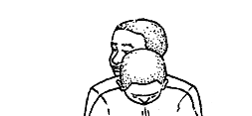

* + Sand - Leaves

##### Qn. State the first aid for a foreign body in the anus.

* + Remove the foreign body using fingers if it is safe it do so.
  + Note:
  + Do not attempt to remove any foreign body if you are unable to do so because it can cause damage to the anal canal.

##### Foreign bodies in the throat.

Qn. **Mention the foreign bodies that may enter the throat.**

* + Big lumps of food.
  + Fish bones.
  + Bottle lids.
  + Note:
  + Foreign bodiesin the throat can lead to choking.

##### Qn. State the first aid for a foreign body in the throat.

* + Give the victim a number of sharp blows on his / her back.
  + Illustration.

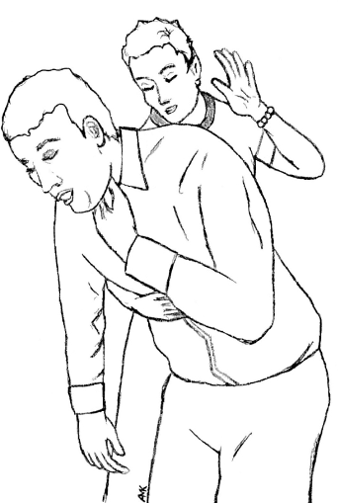-

-

-

-

-

-

-

-

-

-

-

* + CHOKING

Qn. **What is choking**?

* + Choking is a condition where a person’s air way is blocked.
  + OR
  + Chocking is the blockage of air passage to the lungs. Qn. **State the causes of choking**
  + Swallowing big lumps of food.
  + Eating while talking.
  + Eating food hurriedly.
  + Drinking hurriedly.
  + Talking with food in the mouth. Qn. **State the first aid for choking**
  + Give the victim a number of sharp blows at the back.
  + Stand behind the victim and push the belly with a sudden upward push.
  + Illustration.

##### Qn. State the affect of choking to an individual.

* + Choking can lead to death.

##### Qn. State the different ways of preventing choking.

* + A void swallowing big lumps of food.
  + A void eating while talking.
  + A void eating food hurriedly.
  + A void drinking hurriedly.
  + A void swallowing unchewed food.
  + A void running while eating food.
  + POISONING

Qn. **What is poisoning**?

* + Poisoning is the introduction of poisonous substances into body. Qn. **What is poison?**
  + Poison is a substance that causes death or harm if it swallowed or absorbed in the body.
  + Note:
  + A poison may be inform of solid , liquid or glasses.

##### Qn. State the different ways through which poison may be introduced in the body.

* + Through air
  + Through injections
  + Through swallowing
  + Through animal bites e.g mad dogs , snake bites Qn. **State the causes of poisoning**
  + Swallowing expired drugs.
  + Swallowing agrochemicals.
  + Eating expired foods.
  + Eating poisoned foods.
  + Eating poisonous fungi
  + Taking an overdose of a drug.
  + Injecting poisonous substance into the body
  + Mad dog bites
  + Snake bites

##### Qn. Identify the examples of poisonous substances.

|  |  |  |
| --- | --- | --- |
| - Insecticides | - jik | - rat poison |
| - Larvicides | - diesel | - wormicides |
| - Pesticides | - paraffin | - Acaricides |
| - Liquid soap | - herbicides | - expired drugs |

* + Fungicides - vim - petrol
  + Varnish

##### Qn. State the signs and symptoms of poisoning.

* + The victim feels thirsty.
  + Severe vomiting.
  + General body weakness
  + Rapid breathing
  + Loss of body balance
  + Abdominal pain
  + Headaches
  + Excessive sweating
  + Mental confusion
  + Nausea

##### Qn. State the first aid for poisoning

* + Give the victim plenty of milk juice to dilute the poison.

Qn. Why is the person who has take poison given plenty of fluids?

* + To dilute the poison in the body.
  + Note:
  + For a person who has taken paraffin , petrol don’t encouraged him or her to vomit because it can cause more damage to the throat.

##### Qn. Give a reason why it is not advisable to make a person who has taken paraffin or petrol to vomit?

* + Vomiting can cause more damage to the throat.

##### Qn. State the different ways of preventing poisoning at home.

* + Put poisonous substances out of children’s reach.
  + Dispose off all expired drugs.
  + A void taking overdose of a drug.
  + Slashing tall grass / brushes to prevent snake bites.
  + Carryout vaccination of dogs to prevent dog bites.
  + Dispose off all expired foods.
  + Label all dangerous chemicals at home.
  + Buy drugs from recommended places.
  + Inform children about the dangers of poison.
  + Read and follow instructions of medical containers and others.

##### FRACTURES

Qn. **What is fractures?**

* + A fracture is a broke or cracked bone in the body. Qn. How do fracture occur?
  + Fracture occur when there is too much pressure on the bone. Qn. **State the signs of a fracture**.
  + Swelling of the fractured part.
  + Limping
  + Bleeding of the fractured part incase of a compound fracture.

Qn. **State the symptoms of a fracture**.

* + Severe pain of the site of the fracture. Qn. **State the types of fractures.**
  + Simple fracture (closed fracture)
  + Compound fracture (open fracture)
  + Green stick fracture.
  + Fracture
  + Comminuted fracture

##### Simple fracture

Qn. **What is a simple fracture**?

* + A simple fracture is the type of fracture where the bone break end remains inside the skin.

##### Qn. State the different signs and symptoms of a simple fracture.

* + Swelling of the fractured part.
  + Limping.
  + Severe pain at the site of an injury.
  + A diagram showing a simple fracture.

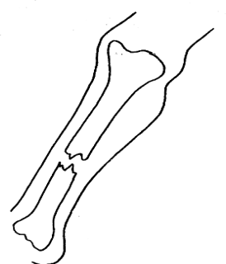-

-

##### Compound fracture

Qn. **What is a compound fracture?**

* + A compound fracture is the type of the fracture where the bone breaks and comes out of the skin.

Qn. State any signs of a compound fracture.

* + The broken bone comes out of the skin.
  + Bleeding of the fractured part.
  + A diagram showing a compound fracture

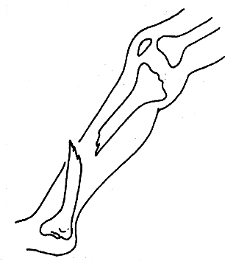

##### Green stick fracture

Qn. **What is a greenstick fracture?**

* + A green stick fracture is the type of fracture where the bone partly breaks or bends but remains attaches.
  + Note:
  + A green stick fracture mainly occurs in babies.
  + Illustration.

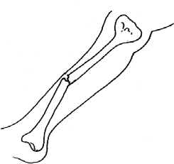-

-

-

-

-

-

-

-

-

##### Qn. Why does a green stick mainly occur in babies?

* + Babies have soft bones.

1. Comminuted fracture

##### Qn. What is a comminuted fracture?

* + A comminuted fracture is a type of fracture where the bone breaks into many pieces.
  + Note:
  + The broken bone may either come out or remain inside the skin.
  + 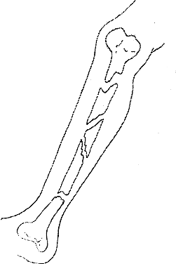A diagram showing a comminuted fracture.

##### Qn. State the first aid for a fracture.

* + Tie splints around the fractured part.

##### Qn. State the function of each of the following during giving first aid for a fracture.

1. Splints
   * Splints help to keep the broken bone in the same position.

##### Arm sling

* + It supports the broken arm in one position.
  + DISLOCATION

Qn. **What is dislocation**?

* + A dislocation is when a bone is displaced from its normal position at a joint. Qn. **What is a joint**?
  + A joint is a place where two or more bone meet in the body.
  + Strain

##### Qn. What is a strain?

* + A strain is a torn or overstretched muscle.( tendon) Qn. **What is a tendon**?
  + A tendon is a structure that joins a bone to a muscle in the body.
  + SPRAIN

Qn. **What is sprain**?

* + A sprain is a torn or overstretched ligament. Qn. **What is a ligament**?
  + A ligament is a structure the joins a bone to a bone in the body. Qn. **How do strains and sprains occur**?
  + They occur when a joint is force to move beyond its normal position. Qn. **State the signs and symptoms of sprains and strains**.
  + Pain around the injured part.
  + Swelling of the injured part.
  + The injured part may become hot.
  + Difficulty in moving the injured part.

##### Qn. State the first aid for strains and sprains.

* + Rest the injured part in comfortable position.
  + Apply ice or cold water on the injured part.
  + Tie the join with a bandage.
  + Note:
  + The major first aid for a sprain and a strain is to think R.I.C.E in first 24 hours.
  + **R** - Rest the injured part
  + **I** - lce pack
  + **C** - Compression
  + **E** - Elevation
  + **R.I.C.E** - Rest Ice Compression Elevation
  + CRAMP

Qn. **What is a cramp**?

* + A cramp is a sudden painful contraction of one or more muscles. Qn. **State the different causes of a cramp**.
  + Lack of body fluids and minerals salts.
  + When one gets involved in a vigorous activity. Qn. **State the first aid for a cramp**.
  + First stop the activity you are doing immediately.
  + Rest the injured part.
  + Massage the injured part.
  + CUTS

Qn. **What is a cut**?

* + A cut is an injury caused by a sharp piercing object on the body.

##### Qn. Write down the different examples of sharp objects that may lead or causecuts.

* + Knives - pins - needle
  + Nails - nail cutters - safety pin

|  |  |  |  |
| --- | --- | --- | --- |
| - Panga | - pair of scissors | - | barbed wires |
| - Razor blade | - broken glass - | axe |  |
| - Swords | - iron sheets | - | spears |

##### Qn. Write down the two types of cuts.

* + Minor cuts
  + Major cuts

Qn. **What are minor cuts**?

* + A minor cut is where the skin is simply broken and cut and less blood may come out. Qn. **State the first aid for minor cuts**.
  + Wash the injured part with clean cold water and tie a bandage around it to reduce on the swelling.

Qn. **What is major cut**?

* + A major cut is where the skin is cut deeply and cause a lot of bleeding. Qn. State the first aid for major cuts.
  + Apply direct pressure at the point of injury.
  + Raise and support the injured part high to reduce bleeding.
  + Place a pad of cotton wood for blood to sip through.
  + Tie a tourniquet around the sit of injury.
  + Note:
  + Deep cuts may result into wounds. Qn. **What is a tourniquet** ?
  + A tourniquet is a device which applies pressure to limb in order to limit the flow of blood.

##### WOUNDS

Qn. **What is a wound**?

* + A wounds is a break is the continuity of body tissues. Qn. **State the four types of wounds.**
  + Punctured wounds
  + Lacerated wounds
  + Incised wounds
  + Contused wounds

1. Punctured wounds

##### Qn. What are punctured wounds?

* + Punctured wounds are wounds which have a very small opening on the skin but very deep into the body.

##### Qn. Mention the example of materials / objects that may cause punctured wounds.

* + Nails
  + Needles
  + Spears

##### Lacerated wounds

Qn. **What are lacerated wounds**?

* + Lacerated wounds are wounds which are torn and have irregular edges.
  + Note:
  + Lacerated wounds are mainly caused by objects with rough edges.

##### Qn. Mention the examples of objects / materials that cause lacerated wounds.

- Barbed wires

* + Claws of birds

1. Incised wounds

##### Qn. What are incised wounds?

* + Incised wounds are wounds caused by sharp objects.

##### Qn. Mention atleast any two examples of objects that cause incised wounds.

* + Knife
  + Panga

##### Confused wounds

Qn. What are confused wounds?

* + Confused wounds are wounds caused by bruising on the body. Qn. **State causes of confused wounds**.
  + Severe blow on rough surfaces e.g. wall falling from a ladder, steps , building etc Qn. **State the first aid for wounds**.
  + Apply direct pressure at the point of injury using a clean piece of clothe , bandage or gauze.
  + 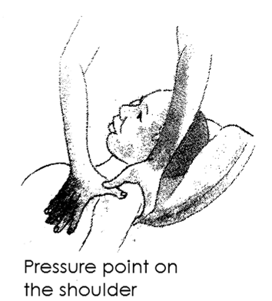Illustration

-

-

-

-

-

-

**ELECTRIC SHOCK**

Qn. **What is an electric shock**?

* + An electric shock is an accidents got when current passes through one’s body.
  + OR
  + An electric shock is an accident caused when one’s body gets into contact with the source of electricity.

##### Qn. State the different causes of electrics hock.

* + Touching naked electric wires with bare hands.
  + Touching naked electric wires with wet hands.
  + Pouring water in electric sockets.
  + Pushing metallic objects into electric sockets.
  + Over loading electric circuits.
  + Ignorance on how to use electricity. Qn. **State the first aid for electric shock.**
  + Switch off the source of current and remove the victim using an electric insulator e.g dry wood, clothes etc
  + Note:
  + Do not attempt to remove the victim from the source of current if it is not broken.
  + 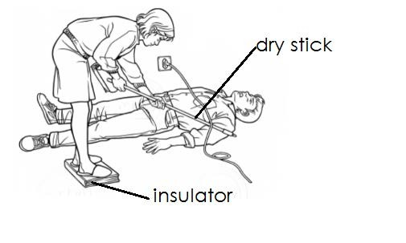Illustration

-

-

##### Qn. State the different ways of preventing electric shocks.

* + All electric wires should be properly insulated.
  + Switch off all electric appliances after use.
  + A void pouring water in electric sockets.
  + A void touching live electric wires with bare hands.
  + A void touching live electric with wet hands.
  + A void overloading electric circuits.
  + SNAKES BITES
  + Snake bites are caused when snake venom is introduced into body. Qn. **How is snake venom introduced into body**?
  + Through bites of a poisonous snake. Qn. **State the first aid for a snake bite**.
  + Tie a piece of clothe above the bitten part.
  + Apply a black stone at the site of injury.

##### Qn. Why is a piece of clothe tied above the bitten part?

* + To prevent the snake’s poison from reaching the heart.
  + TOPIC 11 : SANITATION Qn. **What is sanitation**?
  + Sanitation is the generation cleanliness of a place where we stay or live.

##### Qn. State the indicators of poor sanitation in an area(sanitation concerns)

* + Presence of rubbish in an area.
  + Presence of houseflies in an area.
  + Bad smell in an area.
  + Presence of stagnant water in an area.
  + Presence of bushes in an area.

##### Qn. Mention the different ways of promoting sanitation.

* + Proper disposal of rubbish.
  + Proper disposal of faeces and urine.
  + Slashing bushes in the compound.
  + Sweeping bushes in the compound.
  + Burning rubbish.
  + Dusting houses.
  + Smoking pit latrines.

- Removing con webs from houses.

* + Scrubbing the toilets and latrines.
  + Spraying vectors using insecticides. Qn. **State the danger of poor sanitation**.
  + Poor sanitation leads to easy spread of diarrhoeal diseases.
  + Poor sanitation leads to food contamination.
  + Poor sanitation leads to bad smell.
  + Poor sanitation leads to water contamination.
  + Poor sanitation encourages multiplication of vector.

##### Qn. State the importance of promoting proper sanitation.

* + Proper sanitation prevents easy spread of diarrhoeal diseases.
  + Proper sanitation prevents bad smell.
  + Proper sanitation prevents air pollution.
  + Proper sanitation prevents food contamination.
  + Proper sanitation controls vectors.

##### Qn. State the components of a clean home.

* + Plate stand /plate rack
  + Toilets / latrines
  + Bathroom
  + Kitchen
  + Rubbish pit / Dust bin

##### Qn. How does each of the following components useful in a home?

1. **Plate stand / plate rack**
   * It is where utensils are put to dry.
2. Kitchen
   * It is a place where food is cooked from.

##### Toilet / latrine

* + For disposal of feaces and urine.

##### Bathroom

* + It is a place where people bathe from.

1. Rubbish pit / dust pin
   * For proper disposal of rubbish.
   * LATRINES

Qn. **What is a latrine**?

* + A latrine is a place used for proper disposal of faces and urine.
  + OR
  + A latrine is a place for urination and defecation. Qn. **Mention the types of latrines.**

1. Ordinary pit latrine / conventional pit latrine
2. The ventilated improved pit latrine (VIP latrine)
3. The Ecosan latrine

##### Ordinary / conventional pit latrine.

* + This is the common pit latrine used in rural homes for disposing human faeces and urine. Qn. **State the components of an ordinary pit latrine.**
  + A deep pit

- A lid

* + A strong floor
  + A roof
  + A door
  + A hole
  + A wall

##### Qn. State the function of the above component on the ordinary pit latrine.

1. A deep pit
   * For holding faeces under the ground.

##### A strong floor

* + It is where the user stands while urinating and defecating.
  + Note:
  + The floor should be smooth for easy cleaning.
  + The floor should be strong enough to hold the weight of use in order to prevent him / her from falling into the pit.

##### Hole

* + Acts as a passage of faeces and urine into pit.

-

-

* + Note:
  + The hole should be big enough for faeces and urine to pass through and small enough to prevent the user from falling inside the pit.

##### A lid

* + It is used for covering the hole in order to keep houseflies away.

##### A wall and a door

* + For privacy

##### The roof

* + Prevents rain water from reaching the inside of the pit latrine.
  + Protects the floor and people from rain water.
  + Structure of an ordinary pit latrine (conventional pit latrine)

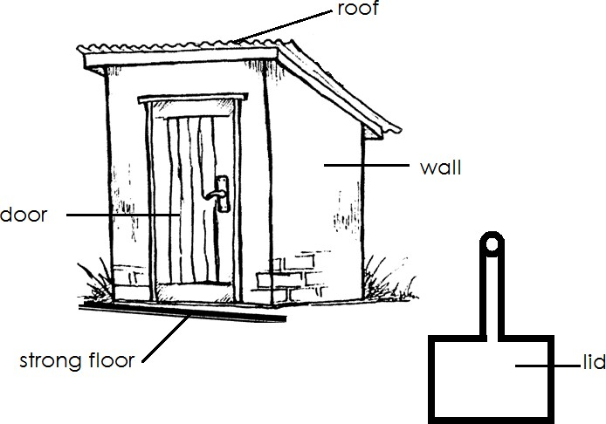-

##### Qn. State the different characteristics of an ordinary / conventional pit latrine.

* + An ordinary pit latrine has no vent pipe.
  + An ordinary pit latrine produce bad smell.
  + An ordinary pit latrine has a lid for covering the hole.

##### Qn. Mention the ways of keeping on ordinary pit latrine clean.

* + Sweeping the floor regularly.
  + Scrubbing the floor regularly.
  + Removing cobwebs.
  + By dumping faeces and urine properly in the pit.
  + By smoking it regularly.

##### Qn. Why should an ordinary pit latrine be smoked regularly?

* + To reduce on the bad smell.

##### The ventilated improve pit latrine (VIP latrine)

* + A VIP is a modern pit latrine.

##### Qn. State the characteristics of a VIP latrine.

* + It has a vent pipe.
  + It has a screen.
  + It does not have a lid.
  + It does not produce a lot of smell.

##### Qn. Why is a VIP latrine said to be ventilated?

* + It has a vent pipe

##### Qn. Why is a VIP latrine said to be improved?

* + It produced less smell.

##### Qn. Mention the component of a VIP latrine.

* + A vent pipe
  + A screen
  + A spiral wall

##### Structure of a VIP latrine Cross section

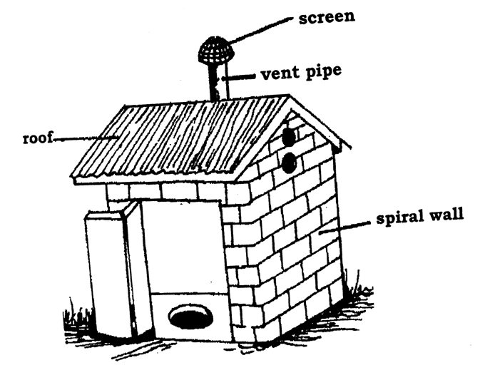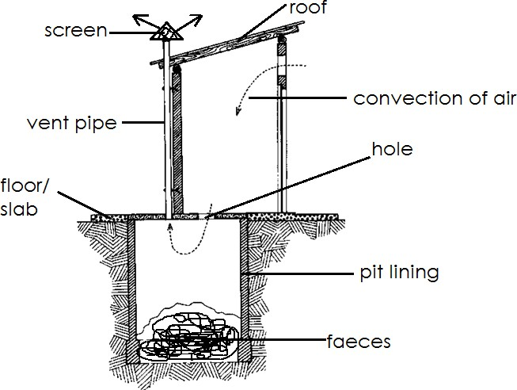

**Note**:

* + The arrows indicate convection currents.

##### Qn. State the function of the following structure on a VIP latrine.

1. Vent pipe
   * To let out bad smell.

##### Screen

* + For trapping houseflies

##### Spiral wall

* + For privacy
  + Note:
  + The spiral shapes should be left without a door to allow free air circulation.
  + The VIP latrine should be left with a lid to allow fresh air into the pit and drive away the bad smell.

##### Qn. How does a VIP latrine help to control the spread of diarrhoeal diseases?

* + It has a screen which traps and kill houseflies. Qn. **Why does a VIP latrine produce less smell**?
  + It has a vent pipe that lets out the bad smell.

-

##### Qn. State the differences between a VIP latrine and an ordinary pit latrine.

|  |  |  |
| --- | --- | --- |
| No. | VIP latrine | Ordinary /conventional pit latrine |
| (i) | Has a screen | Has no screen |
| (ii) | Has a vent pipe | Has no pipe |
| (iii) | Produce less smell | Produces a lot of bad smell |
| (iv) | Has no lis | Has a lid |

Qn. **State the ways of keeping a VIP latrine clean. ( maintenance of a VIP latrine**)

* + By sweeping the floor of the latrine.
  + By slashing bushes around the latrine.
  + By removing cob webs.
  + By scrubbing the floor regularly.
  + By disposing faeces and urine properly.
  + By emptying it incase it gets full.

##### Qn. Why shouldn’t a pit latrine be smoked?

* + It produce less smell.

##### The Ecosan latrines

* + The ecosan is an advanced pit latrine. Qn. Write Ecosan in full.
  + Ecological sanitation.

##### Qn. Mention the features / components of an Ecosan latrine.

* + A shallow pit
  + Two separate vaults /portions

##### Qn. How are the two separate vaults useful?

* + They are used for collecting faeces and urine separately. Qn. **Why should faeces be collected separately from urine?**
  + To allow faeces to dry
  + To keep the faeces dry

##### Qn. Why should the faeces in an ecosan latrine be kept dry?

* + Dry faeces can be used as fertilizers in the garden.
  + Dry faeces can be used as fuel.

##### Qn. Why should urine be collocted separately from faeces?

* + To reduce on the smell.
  + To promote / improve hygiene in an ecosan.
  + To make it easier to handle the solid faeces. Qn. **State the advantages of using Ecosan**.
  + They don’t produce any bad smell.
  + The faeces collected can be used as manure.
  + Urine collected can be used as pesticides.
  + Prevents pollution of surface and ground water.

##### Qn. State the ways of maintaining on Ecosan latrine clean.

* + Scrubbing the floor.
  + Sweeping the floor.
  + Removing cobwebs.
  + Covering the faeces with ash.
  + Site / location of pit latrines

1. The pit latrine should be constructed atleast 10 metres away from the kitchen, main house or school.
2. The pit latrine should be constructed at least 30 metres away from the water source.
3. A pit latrine should be constructed below / down hill the water table.

##### Qn. Why should a pit latrine be constructed 10 metres away from the main house, kitchen or school?

* + To prevent food contamination

##### Qn. Why should a pit latrine be constructed 30 metres away from water source?

* + To prevent waer contamination

##### Qn. Why should a pit latrine be constructed down hill / below the water hill?

* + To prevent water contamination.
  + Illustration showing the site of a pit latrine.

-

-

-

-

-

-

-

-

-

-

* + The potty
  + A potty is a small portable latrine for babies. Qn. **How is a potty useful to babies**?
  + For proper disposal of faeces and urine. Qn. How can a potty be kept clean?
  + By emptying it.
  + By washing it after use.
  + THE FLUSH TOILET / WATER CLOSET TOILETS
  + The flush is also used for proper disposal of faeces and urine.

- The toilets are mostly used in urban areas.

##### Qn. Why are flush toilets called so?

* + They use water to carry away faeces and urine.

##### Qn. Mention the components of a flush toilet / water closet toilet.

* + Water tank ( cistern)
  + A seat
  + A handle
  + A lid
  + A septic tank
  + A bowl
  + Pipe to the septic tank
  + 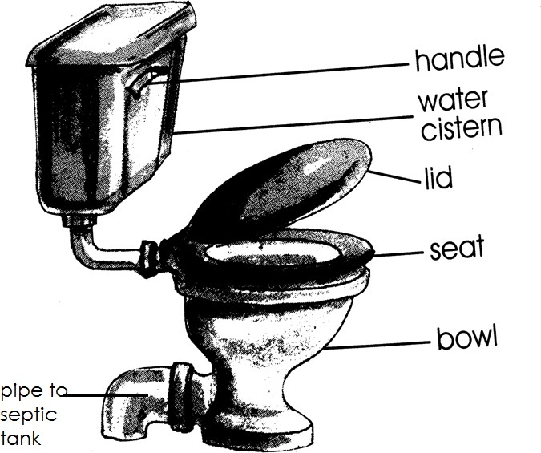STRUCTURE OF A FLUSH TOILET

##### Qn. Give the function of each component / part found on a flush toilet.

1. **Bowl**
   * This is a container where faeces and urine are deposited.
   * Note:
   * The bowl should be left with some water.

##### Qn. State the importance of water left inside the bowl?

* + To reduce on the bad smell from the toilet.

##### Seat

* + It is where the person sits while using the toilet.

##### Lid / cover

* + It is used for covering the bowl after use.

##### Handle

* + It is used for flushing water in the bowl.

##### Water tank / cistern

* + It is used for holding water used for flushing the toilet after use.

##### Pipe to septic tank

* + It directs faeces and urine to the septic tank.

##### Septic tank

* + It stores / keeps faeces and urine after flushing for some time.
  + Note:

- When the septic tank gets full , it should be emptied using a cesspool emptier.

##### Qn. How is a cesspool emptier useful?

* + For emptying toilets and latrines.

-

* + Structure of a cesspool emptier

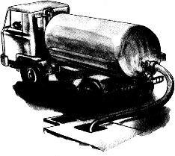-

-

-

-

-

-

-

-

-

* + Note:
  + Some toilets have a lid while others lack a lid.
  + The only toilet with a lid is the one for sitting on.
  + Proper use of a flush toilet / maintenance of a flush toilet.
  + Flush the toilet regularly after use.
  + Scrub the bowl after using the toilet.
  + Cover the bowl after using the toilet.
  + Do not stand the seat when using the toilet.
  + Do not use hard materials to clean yourself after use.
  + Use toilet papers or soft tissues to clean your self after use.
  + Wash your hands with water and soap after use.

##### Qn. State the disadvantages of using a flush toilet / water closet toilet.

* + Toilets may easily be blocked when one uses hard materials to clean oneself.
  + Toilets cannot be used where there is no piped water.
  + Toilets may lead to poor sanitation incase there is no water.
  + Toilets can not be used when water is not flowing.
  + Toilets with a seat may lead to spread of diseases.

##### Qn. Mention the common examples of materials used to keep our toilets / latrine clean.

* + Broom
  + Scrubbing brush
  + Gloves
  + Disinfectants e.gjik , vim etc
  + Toilet brush
  + Water
  + Rag

##### Qn. State the importance of using toilets / latrines in our community.

* + Proper use of toilets and latrines controls easy spread of diarrhoeal diseases.
  + Proper use of toilets and latrines prevents water contamination.
  + Proper use of toilets and latrines prevents food contamination.
  + Proper used of toilets and latrines prevents multiplication of houseflies.

- Proper use of toilets and latrines prevents bad smell.

* + Proper use of toilets and latrines promotes proper disposal of faeces and urine. Qn. **General precaution when using a latrine.**
  + Do not paraffin , oil , petrol , diesel etc in a latrine. Qn. **Why is it not advisable to put paraffin in a latrine**?
  + Paraffin may kill maggots and bacteria which help to reduce on the volume of faeces.
  + TOPIC 12 :THE REPRODUCTIVE SYSTEM

##### Qn. Explain the meaning of reproductive system.

* + Reproductive system is the system made up of organs involved in sexual reproduction. Qn. **What is reproduction?**
  + Reproduction is the process by which living things give rise to young ones.
  + OR
  + Reproduction is the process by which living things multiply in number by producing young ones.
  + Growth and development in human beings

##### Qn. Give the meaning of each of the following

1. **Growth**
   * Growth is the increase in size of a person.

##### Development

* + Development is increase in maturity.

##### Note :

* + Development appears more at puberty and adolescence.

##### Puberty and adolescence

Qn. **Give the meaning of each of the following terms.**

##### Puberty

* + Puberty is the period in which reproductive organs become sexually mature.

##### Adolescence

* + Adolescence is the transitional stage between childhood and adulthood.

##### Note:

* + A girl or boy who is in adolescence stage is called an **adolescent**. Qn. **Who is an adolescent?**
  + An adolescent is a boy or girl who is in the transitional stage between childhood and adulthood.
  + Note:
  + In boys adolescence begins at the age of 14 years to 20 years.
  + In girls adolescence begins at 11 years to 20 years.
  + Body changes that take place during puberty
  + Primary sex changes / characteristics.
  + Secondary sex changes / characteristics.
  + Emotional and social changes /characteristics.
  + Out of step sex changes / characteristics.

1. Primary sex changes / characteristics Qn. **What are primary sex changes?**
   * These are change that prepare the sexual organs for their function in reproduction.
   * Note:

- Primary sex characteristics are also called basic sex characteristics.

##### Qn. Mention the examples of primary sex characteristics in girls.

* + Ovulation begins (The ovary begins producing ova)
  + Menstruation begins.
  + Development of the uterus.

##### Qn. Mention the examples of primary sex characteristics in boys.

* + Boy start experiencing we dreams.
  + The testes start producing sperms.
  + The penis enlarges.

##### Secondary sex changes /characteristics

Qn. **What are secondary sex characteristics**?

* + These are changes which differentiate a grown up woman from a young girl and a grown up man from a young boy.

##### Qn. Mention the example of secondary sex characteristics in girls.

* + Growth of pubic hair.
  + Sweat glands become more active.
  + Enlargement of the hips.
  + Development of breasts.
  + Pimple appear on the face.
  + The voice become soft and attractive.
  + Note:
  + Secondary sex changes in girls are controlled by Oestrogen hormone. Qn. **Mention the examples of secondary sex changes in boys.**
  + Growth of public hair.
  + Sweat glands become more active.
  + Development of beards.
  + The voice of breaks and deepens.
  + The boys body becomes more muscular.
  + Pimples develop on the face.
  + Note:
  + Secondary sex change in boys are controlled by a hormone called **testosterone.**

##### Qn. State the examples of secondary sex characteristics that occur in both adolescent boys and girls.

* + Sweat glands become more active.
  + Growth of public hair.
  + Development of pimples.

##### Qn. State the secondary sex change that occur only in adolescent girls.

* + Enlargement of hips.
  + Development of breasts.
  + The voice become soft and attractive.
  + The face becomes smooth, good looking and attractive.

##### Qn. State the secondary sex changes that occur only in adolescentboys.

* + Development of breads.
  + The voice breaks and deepens.
  + The boys body becomes more muscular.

- Social and emotional / psychological changes in adolescent boys and girls.

##### Qn. What are social and emotional changes as used in adolescents?

* + These are changes that take place in the mind of an individual.

##### Qn. State the examples of social and emotional changes that occur in adolescents.

* + Adolescents become interested in members of the opposite sex.
  + Adolescents develop increased sexual desires.
  + Adolescent s become angry and disappointed easily.
  + Adolescents develop a great desire to be independent from parents
  + Adolescents want a lot of freedom and want to be recognized as adults.
  + Adolescents want to move in peer groups.
  + Adolescents may start rejecting / rebelling rules of their parents.
  + Some adolescents become interested in their bodies.

##### Out of step adolescent changes.

* + These are change that occur differently to every individual in the same age group. Qn. **Mention the examples of out of step adolescent changes during puberty.**
  + Growing taller than friends in the same age group.
  + Growing fatter that friends of the same age group.
  + Adolescents develop some anxieties and fantasies due to sexual maturation. Qn. **State the different problems associated or faced by adolescents.**
  + Adolescents are never satisfied with the demands made on them.
  + Adolescents gain different forms of wishes.
  + Adolescents have a lot desires , demands and expectations.
  + Adolescents may bring conflict between them and their elders.
  + Adolescents may develop anti – social behaviours e.g. Arson , Twang , Alcoholism etc
  + Adolescents may become delinquent.
  + Adolescents may want to experiment with the forbidden.

##### Qn. State the different ways of how adolescent can be helped.

* + By carrying out guidance and counselling.
  + By advising adolescents on how to manage their body changes.
  + By advising adolescents to share their problems with elders.
  + By sensitizing adolescents about the dangers of having early sex.
  + By sensiting adolescents about the dangers of bad peer groups.
  + The reproductive organs

##### Qn. What are reproductive organs?

* + Reproductive organs are organs / gonads that are involves in reproduction. Qn. **What is reproduction?**
  + Reproduction is the process through which living things multiply in number by giving rise to young ones.

##### Qn. How is reproduction important to living things?

* + Reproduction enables living things to remain in existence.
  + Reproduction enables living things to multiply in number. Qn. **Mention the two types of reproduction.**

1. A sexual reproduction
2. Sexual reproduction

##### Qn. Give the meaning of the following terms:-

1. **A sexual reproduction**

A sexual reproduction is the type of reproduction which does not involve the use of reproductive cells.

##### Sexual reproduction

Sexual reproduction is the type of reproduction that involves the use of reproductive cells (gametes)

##### Qn. Which type of reproduction do human beings undergo?

* + Sexual reproduction Qn. **What is a gamete**?

A gamete is a reproductive cell.

##### Qn. Identify the male gamete in human beings.

* + Sperms

##### Qn. Name the female gamete in human beings.

* + Ova
  + Note:
  + The sperms are produced by reproductive organs / gonads called **testis**or**testes.**
  + The ova are produced by reproductive organs / gonads called ovaries
  + Diagram showing the female reproductive system/organs

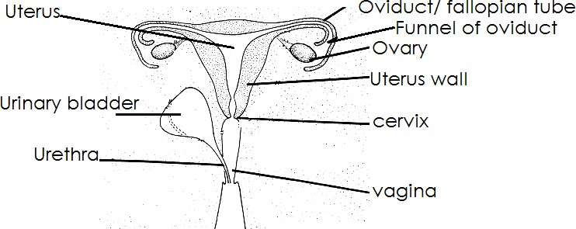

##### Qn. State the function of each of the following parts of the female reproductive system.

1. **Ovary**
   * They produce ova ( ovum)
   * They produce oestrogen hormones.
   * They produce progesterone hormones. Qn. **What is ovulation**?
   * Ovulation is the process by which the ovaries release ova.

##### Qn. How are the following hormones useful in the female reproductive system?

1. **Oestrogen hormones**
   * Controls the development of female sex organs.
   * Control secondary sex characteristics.

##### Progeterone hormones

* + Maintains the living of the uterus.

##### Note:

* + Lack of progesterone hormones may lead to miscarriages.

##### Fallopian tub /oviduct

- It is where fertilization take place.

* + It is where conception take place.

##### Uterus / womb

* + It is where implantation take place.
  + It is where development of the embryo take place.

##### Cervix

* + This is a ring of muscle found at the entrance o the uterus and separates it from the vagina.

##### Qn. How is cervix useful?

* + It closes the lower end of the uterus during pregnancy.

##### Vagina

* + It is where sperms are deposited during sexual intercourse.
  + It acts as a passage of the baby during birth.(acts as a birth canal)
  + It provides the vaginal fluid which lubricates the vagina during sexual intercourse.

##### Vulva

* + This is a fleshy structure which surrounds and protects the vaginal sperming.
  + 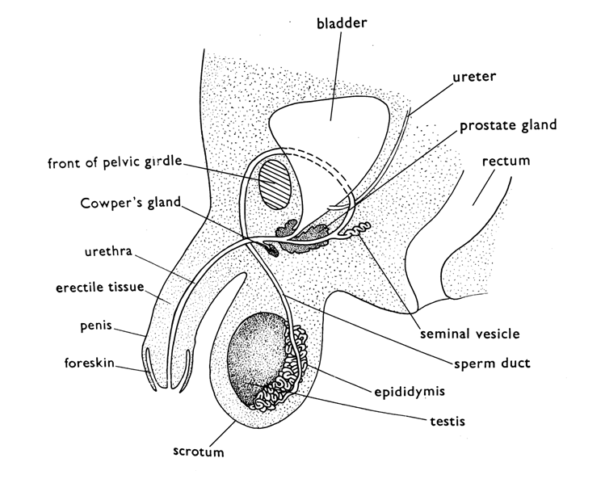Diagram showing the male reproductive system / organ

##### Qn. State the function of each part of the male reproductive system.

1. **Testes**
   * The testes produces sperms.
   * They produce testosterone hormone.

##### Qn. How are testosterone hormones useful in males?

* + Controls development of male sex organs.
  + Controls secondary sex characteristics.

##### Epididymis

* + It stores produced sperms.

##### Sperm duct

* + It acts as a passage of produced sperms to the vagina.

##### Scrotum

* + The scrotum regulates body temperature around the testes.
  + The scrotum protects the testes from harm.

##### Penis

* + The penis deposits sperms into the vagina during sexual intercourse. Qn. **What is copulation**?
  + Copulation is the inserting of the penis into vagina during sexual intercourse.

##### Erectile tissue

* + Erectile tissue is a tissue rich in blood vessels and sensory names.
  + It becomes stiff and erect when a man is sexually attracted causing the blood vessels to expand.

##### Prostate glands and seminal vesicle

* + They produce seminal fluids which form semen.
  + Semen enables the sperms to swim or move freely and also acts as food and energy to the sperms.

##### Fore skin

* + The foreskin covers or protects the penis glands.

##### Note:

* + The foreskin is always cut off (circumcision) to promote cleanliness. Qn. **How does circumcision prevent easy contraction of AIDS**?
  + Circumcision harden the penis glands making the entry of germs difficult.

##### Urethra

* + Urethra acts as a passage of urine from the body.
  + The urethra also act as a passage of sperm and semen to the vagina during sexual intercourse.

##### Urinary bladder

* + The urinary bladder stores urine for some time.
  + Reproductive health

##### Qn. What is reproductive health?

* + Reproductive health is the way of keeping the reproductive organs in good working condition.

##### Qn. State the ways of promoting reproductive health care for reproductive organs)

* + Cleaning the reproductive organs regularly.
  + Performing regular physical exercises.
  + Feeding on food that makes up a balances diet.
  + Going for regular medical checkups.
  + Shaving public hair around reproductive organs.
  + A void playing or getting involved in early sex.
  + A void weaving tight under wears.
  + Women should not use dildos for sexual satisfaction/
  + Women / adolescent girls should feed on green leafy vegetables.
  + Parents should take their male children for circumcision.
  + All under wears should be washed properly and worn dry.
  + Women / adolescent girls should be sanitary towel.
  + Fertilization

##### Qn. What is fertilization?

- Fertilization is the union of the male and female gametes to form a zygote.

##### Qn. Where in the body doe s fertilization take place?

* + In the oviduct
  + Types of fertilization

##### Qn. Mention the two types of fertilization

* + External fertilization
  + Internal fertilization

##### Qn. What is external fertilization?

* + External fertilization is the type of fertilization that take place outside the body of a female organism.

##### Qn. What is internal fertilization?

* + Internal fertilization is the type of fertilization that take place inside the body of a female organism.

##### Qn. How does external fertilization occur?

* + The female organism lay eggs and later the male sheds sperms on them.
  + Note:
  + External fertilization take place in fish and amphibians.
  + Internal fertilization mainly occur in birds , reptiles and mammals.
  + In order for fertilization to occur, there must be mating. Qn. **What is mating**?
  + Mating is sexual union of the male and female partners during sexual intercourse / copulation / coitus.

Qn. **What is copulation**?

* + Copulation is the inserting of an erect penis into the vagina.
  + Note:
  + The process of copulation is followed by rhythmical body movement of both sexual organs which may result in ejaculation.
  + After ejaculation, both male and female may experience organism.
  + Reproductive cells Qn. **What is gamete?**
  + A gamete is a reproductive cell.

##### Qn. What name is given to the following gamete in humans.

1. Male reproductive cells sperms / sperm
2. Female reproductive cells ova /ovum

##### A diagram show the sperm and ovum

1. 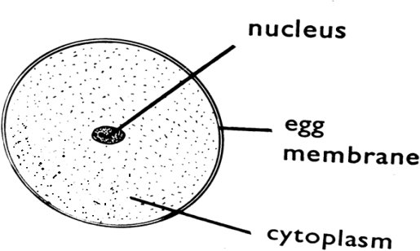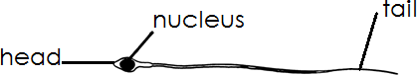**An ovum (ii) A sperm cell**

##### Qn. How does fertilization occur in human?

* + Fertilization occurs when the nucleus of the sperms unites with a nucleus of an ovum resulting into a zygote.

##### Qn. What is a zygote?

* + A zygote is fertilized ovum.
  + Note:
  + After fertilization has taken place, a zygote is formed and later develop, into an embryo and later into a foetus.
  + After implantation , the woman may start showing signs of pregnancy.

##### Qn. Give the meaning of each of the following

1. **Implantation**
   * Implantation is the process by which the zygote attaches itself to the wall of the uterus.

##### Pregnancy

* + Pregnancy is the time from conception to the time of giving birth.

##### Qn. Arrange the following in their order of occurrence pregnancy, fertilisation , ovulation , copulation , implantation , conception.

* + Ovulation
  + Copulation
  + Fertilization
  + Conception
  + Implantation
  + Pregnancy

##### Qn. Where do the following take place.

1. Ovulation - ovary
2. Copulation - vagina
3. Fertilisation - oviduct
4. Conception - oviduct
5. Implantation - womb
6. Pregnancy - uterus

##### Pregnancy / gestation period

* + Is the period from fertilization to birth. Qn. **State the gestation period in humans.**
  + 9 months and 10 days.

##### Qn. State the signs of pregnancy

* + Menstruation stops.
  + Ovulation stops
  + Frequent urination
  + Loss of appetite
  + The breasts grow bigger and are filled up with break milk.
  + The belly enlarges
  + The legs and hips enlarge and increase on weight.
  + The woman may experience morning sickness.

##### Qn. State the danger signs and symptoms of pregnancy (problems faced during pregnancy)

* + Severe vomiting

- Prolonged anaemia

* + Severe swelling of legs , face and hands
  + Bleeding / coloured discharge from the vagina
  + Itching of he breasts and abdomen
  + Backache
  + Heartburn
  + Constipation
  + Menstruation

##### Qn. What is menstruation?

* + Menstruation is the periodic monthly outflow of blood from the uterus through the vagina.

##### Qn. How does menstruation occur?

* + Menstruation occurs when fertilization of the ovum fails which makes the uterus wall thick and break leading to blood flow.
  + Note:
  + Menstruation occurs every after 28 day – 30 days incase fertilization has not take place.
  + Menstruation and ovulation help stop at about 45 years and this is called menopause.
  + Menstruation take place due to the hormone called progesterone.
  + Requirements of a pregnant woman

##### Qn. Identify the requirements of a pregnant woman.

* + Ante natal care
  + Good nutrition / balance diet
  + Regular physical exercises
  + Adequate rest and sleep
  + Good personal hygiene
  + Appropriate clothing

##### Qn. State the importance of each of the following food values to a pregnant woman.

1. **Carbohydrates**
   * Provide energy

##### Protein

* + To build body tissues and repair worn out cells.

##### Vitamins

* + To protect the mother’s body and that of the unborn baby.

##### Mineral salts

1. Iron to build haemoglobin in body of the mother and her baby child.
2. Calcium to build strong bones and teeth.
3. Phosphorus to build strong bones and teeth.
   * It helps in proper functioning of the body cells.
   * Antenatal care

##### Qn. What is Antenatal care?

* + Antenatal care is the treatment and education given to a pregnant woman in order to maintain good health for herself and the unborn baby.

##### Qn. State the importance of antenatal care to a pregnant mother.

* + Mothers are educated how to care for their babies.
  + Mother’s problems that are related to pregnancy are detected and controlled.

- Pregnant mother’s are educated on how to care for themselves.

* + Sexually transmitted diseases are treated and controlled when detected.
  + Pregnant mothers are given tetanus toxoid vaccine (T T) Qn. **Why is T T vaccine given to pregnant women?**
  + To protect herself and the unborn baby from contracting tetanus.
  + 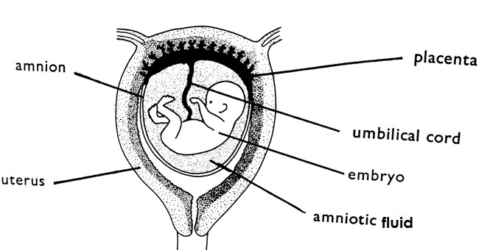The human foetus in the uterus

##### Qn. State the functions of the various parts

1. **Umbilical cord**
   * It transport food and oxygenated blood from the placenta to the embryo.
   * It transport waste material from the embryo the placenta.

##### Placenta

* + The placenta is an organ by which the embryo is attached to the uterus by the umbilical cord.
  + Function
  + It prevents the mixing of blood from the matter with that of the foetus.
  + It prevent toxic / dangerous chemicals from reaching foetus.
  + It stores waste materials from the foetus they diffuse through the mother’s food.
  + It stores food and oxygen used by the foetus.

##### Qn. By that process does food and oxygen from the mother’s blood enter the body the foetus?

* + By diffusion

##### Amnion

* + An amnion is a sac used for keeping the amniotic fluid.

##### Amniotic fluid

* + It protects and prevent the embryo from unequal pressure acting on it.
  + It protects and prevents the embryo from knocks.
  + Birth /parturition Qn. **What is birth**?
  + Birth is the act of producing a baby in human being.

##### Note:

* + When pregnant woman is about to give birth, she undergoes labour. Qn. **What is labour**?
  + Labour is a period of pain experienced when a pregnant woman is about to give birth.
  + Note:
  + At birth the umbilical cord should be cut and tied using sterilized instruments.
  + When the baby comes out of the vagina it cries.

##### Qn. Why is the umbilical cord cut using sterilized instruments?

* + To prevent the born from getting tetanus.
  + To prevent the baby from getting AIDS.

##### Qn. Why does the baby cry immediately after birth?

* + Due to change in temperature experiences by the baby. Qn. **How is crying useful to a newly born baby**?
  + Crying helps to open up the breathing system of a newly born baby. Qn. **What happens after some time when the umbilical cord is cut**?
  + It shrivel and falls away leaving a scar called navel.
  + Birth weight
  + Birth weight is the weight a baby is born with. Qn. **State the healthy / normal birth weight**.

- 2.5kg - 4kg

##### Qn. Define the following terms as used in birth.

1. **Caesarean birth**
   * Caesarean birth is the surgical removal of the baby from uterus.

##### breech birth

* + Breech birth is when the baby is borne with the bottom first.

##### Still birth

* + Still birth is the giving birth t dead foetus.

##### Premature birth

* + Premature birth is the giving birth to a baby before its right time.

##### Abortion

* + Abortion is the forceful removal of the foetus from the mothers uterus before its development.

##### Miscarriage

* + Miscarriage is when developing baby is expelled or rejected by the uterus in its easily stages of development.
  + Types of birth
  + Single child birth
  + Multiple birth Qn. **Define following**

##### Single child birth

* + This is when one child is born at a time to a mother.

##### Multiple birth

* + This is when two or more babies are born at the same time to a mother.
  + Groups of multiple births
  + Twins ( two babies)
  + Triplets ( three children)
  + Quadruplets (five babies)
  + Sextuplets ( six children)
  + Septuplets ( seven children)
  + Octuplets (eight children)
  + Nonuplets (Nine children)
  + Decaplets(ten children)
  + TWINS

Qn. **What are twins?**

* + Twins are two babies born at same time. Qn. **Identify the types of twins**
  + Identical twins / monozygotic twins
  + Siamese twins/conjoined twins
  + Fraternal twins
  + Identical twins / monozygotic twins
  + What are identical twins?
  + Identical twins are twins that develops from one fertilized ovum that divided and grows into two babies.
  + Note:
  + Identical twins always share the same sex and appearance.
  + Siamese twins / conjoined twins Qn. **What are Siamese twins**?
  + These are babies which develop from a fertilized ovum that divided itself into two but fails to separate fully.
  + Note:
  + Siamese twins may share the same body organs e.g. heart, liver, brain
  + Siamese twins can be separated by surgery.
  + Fraternal twins

##### Qn. What are fraternal twins?

* + Are two babied that develop from two ova and are fertilized by two different sperms.
  + Note:
  + Fraternal twins may have different sex and may not resemble.
  + Sex of the child

##### Qn. How is a sex of a child determined?

* + By the help of chromosomes found in the gametes. Qn. **What is a chromosome**?
  + A chromosome is along coil of DNA found in the nucleus of reproductive cells which carry gones.

Qn. Write **DNA** in full.

* + Deoxyribonucleic acid

##### Qn. Mention the two types of chromosomes.

* + X Chromosomes
  + Y Chromosomes

##### Note :

* + All female have two chromosomes ie XX
  + All males have two chromosomes ie XY Qn. **How is the sex determined**?
  + If is a perm with X chromosome joins with an ovum , the baby will be a girl.
  + Illustration

(i) X chromosome + X chromosome = Baby girl

+ = Baby girl

X chromosome + X chromosome

(b) If a sperm wit Y chromosome joins with an ovum , the baby will be a boy. Illustration

(i) Y chromosome + X chromosome = Baby boy

+ = Baby boy

= Baby boy

Y chromosome x chromosome

##### TEENAGE PREGNANCY

Qn. **What is teenage pregnancy**?

* Teenage pregnancy is the type of pregnancy acquired by a girl below 20 years of age.

##### OR

* Teenage pregnancy is the pregnancy acquired by a teenage girl. Qn. **What is teenager**?
* A teenage is a person between 13 years and 19 years of age. Qn. **State the causes teenage pregnancy**.
* Bad peer pressure
* Defilement
* Rape
* Desire for luxury or material things.
* Failure by parents to provide enough basic needs to children.
* Drug abuse
* Early marriage
* Lack of sex education teenagers
* Watching pornography
* Having unprotected sex

##### Qn. State the consequences / effects of teenage pregnancy.

* Leads to school drop outs.
* Leads to contraction of STD’s
* Leads to difficult delivery / obstructed labour
* Teenagers may attempt to have an abortion.
* The girl may be rejected by parents.
* The girl may lack financial support.
* Leads to early marriages.
* Leads to shame in the family.
* Leads to a number of street children.

##### Qn. Mention the different ways of controlling teenage pregnancy.

* Abstain from sex till marriage.
* A void gifts from stronger.
* A void bad peer groups.
* Young girls should be counseled and guided.
* Providing sexual education to teenage girls.
* Teenagers should be taught good life skills about sex e.g.” say No” to sex.
* DISORDERS AND DISEASES OF THE REPRODUCTIVE SYSTEM

##### Disorders of the reproductive system.

Qn. **What is a reproductive disorder**?

* + A reproductive disorder is an abnormality in the system that prevents reproduction. Qn. **Mention the common disorders of the female reproductive system.**
  + Ectopic pregnancy
  + Fibroids
  + Menstrual cycle disorders
  + Ovarian tumours
  + Sterility /barrenness in woman
  + Inflammation of the oviducts
  + Cancer of the cervix

##### Ectopic pregnancy

* + This is a condition in which a fertilized ovum gets implanted in the oviduct and starts developing from there.

##### Qn. Write down any one symptom of ectopic pregnancy.

* + Severe pain in the oviduct.
  + Illustration

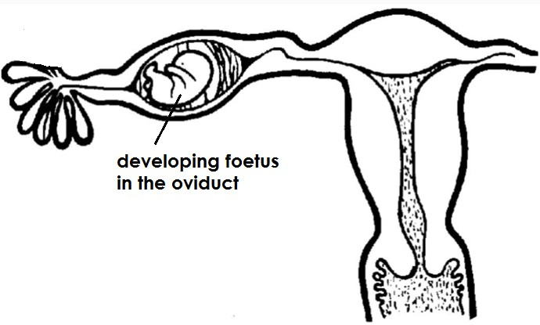-

-

-

-

-

-

-

-

-

-

* + Note:
  + Ectopic pregnancy can be corrected by surgery.

##### Fibroids

* + There are swellings that develop on the walls of the uterus. Qn. **Mention the signs and symptoms of fluids**.
  + Excessive bleeding
  + Severe pain menstruation
  + Severe pain during sexual intercourse

##### Menstrual cycle diseases

* + These are menstrual problems that occur just before and during menstruation.
  + Signs and symptoms of menstrual cycle
  + Failure to have periods
  + Delayed periods
  + Painful periods
  + Excessive bleeding

##### Ovarian tumours

* + These are masses of abnormal cells that form on the ovary.

##### Sterility / barrenness

* + This is the inability of a woman to conceive.

- Causes of sterility/barrenness in women

* + Untreated gonorrhoera which may block the oviduct.
  + Menstrual problem.
  + Weakness of the uterus.
  + Exposure to chemicals which may damage the ovaries.

##### Inflammation of the oviducts

* + These are swellings that lead to blockage of the oviducts/ fallopian tube.
  + Note:
  + Blockage of the oviducts prevents fertilization from taking place.

##### Cancer of the cervix

* + This is a condition in which the cervix develops tumours.
  + Note:
  + It is caused by viruses(Human papillomavirus) which spreads through having sexual intercourse.

##### Qn. Write down the common disorders of the male reproductive system.

* + Impotence
  + Hydrocele
  + Penile cancer
  + Enlargement of the prostate glands
  + Low sperm count
  + Sterility in men

1. Impotence
   * This the inability of a man’s penis to have an erection.

##### Qn. Mention the different causes of impotence in men.

* + - Excessive consumption of alcohol.
    - Drug abuse
    - Stress / worry
    - Old age

##### Hydrocele

- This is a condition in which a fluid accumulates in and around the testes.

##### Penile cancer

- This is the growth of abnormal cells that form on the penis.

##### Enlarged prostate

* This is a condition in which the prostate glands become swollen and enlarge.
* Note:
* The enlargement of the prostate glands squeeze the urethra and prevents easy flow of urine.

##### Low sperm count

* This is a condition in which the tested are unable to produce enough sperm.

##### Note:

* The condition may make a man fail to make a woman pregnant.

##### Sterility in men

* This is the inability of a man to make a woman pregnant.
* Causes of sterility in men
* Diseases such as diabetes.

- Heavy smoking

* Alcoholism
* Infections in the male reproductive system that may lower the sperm count.
* Abnormal sperms
* Untreated STD’s
* Injury or infection of the epididymis
* Diseases of the reproductive system.

##### Qn. Mention the examples of disease that attached reproductive system.

* Gonorrhoea
* Chancroid
* Syphilis
* Candidiasis
* Genital warts
* Trichomoniasis
* Genital herpe
* Lymphogranulma venereum
* Note:
* Most diseases of the reproductive system or STD’s or STIs. Qn. **Write the following abbreviation in full**.

##### STDs

Sexually Transmitted Diseases.

##### STIs

Sexually transmitted Infections

STDs /STIs are called venereal diseases; Qn. **How are STIs spread**?

* + Through having unprotected sexually intercourse with an infected person.

##### Qn. Mention some examples of Sexually Transmitted Diseases / Infections

* + AIDS
  + Gonorrhoea
  + Gentital herpes
  + Genital warts
  + Syphilis
  + Chancroid
  + Candidiasis
  + Trichomoniasis

1. Gonorrhoea

##### Qn. What causes gonorrhoea?

* + Gonorrhoea is caused by bacterial called neisseria gonorrhea. Qn. **State the signs and symptoms of gonorrhea in women**.
  + Discharge of pus from the vagina.
  + Pain in the lower abdomen.
  + Burning pain while urinating.
  + Painful menstruation period.

##### Qn. State the signs and symptoms of gonorrhoea in men.

* + Pus discharge from the penis.

- Difficulty in passing out urine.

##### Qn. State the effects of gonorrhea to an individual.

* + Gonorrhoea can cause sterility.
  + Gonorrhoea affects the urethra in men leading to painful urination.
  + Gonorrhoea affects the urethra and cervix leading to difficulty in urination.
  + Gonorrhoea can lead to blockage of the oviduct in women.
  + In pregnant women, Gonorrhoea can affect the eyes of a baby during birth leading to blindness.

##### Qn. How does gonorrhoea affects the eyes of a newly baby?

* + Gonorrhoea causes blindness to the newly born baby.

##### Qn. State the ways of controlling and preventing the spread of gonorrhea

* + A void unprotected sex with infected people.
  + Abstain from sex till marriage incase of adolescent.
  + Use of condoms when having sex with untrusted sexual partners.
  + Be faithful to your sexual partners.
  + Get early treatment incase of a disease.

(i) **Syphilis**

##### What cause syphilis?

* + Syphilis is caused by bacteria called treponema pallidum. Qn. **State the signs and symptoms of syphilis in women**.
  + Painless sore appears in the vagina.
  + Sore in the throat and mouth may appear.
  + Swollen body joints.
  + Swollen painful lymphnodes.

##### Qn. State the signs and symptoms of syphilis in men.

* + Painless sore appears on the penis.
  + Swollen body joints.
  + Sore in the throat and mouth may appear.
  + Swollen painful lymphnodes.
  + Mild fever.

##### Qn. State the effects of syphilis to an individual.

* + Syphilis can lead to madness if not treated.
  + Syphilis can lean to heart diseases if not treated.
  + Syphilis can lead to loss of teeth if not treated.
  + Syphilis can lead to blindness in the adults if not treated.

##### Qn. State the ways of preventing and controlling the spread of syphilis

* + Use of condoms when having sex with untrusted sexual partners.
  + Abstain from sex until marriage.
  + Be faithful to you sexual partner.
  + Getting early treatment.

##### Trichomoniasis

Qn. **What cause trichomoniasis**?

* + Trichomoniasis is caused by a protozoa called trichomonas vaginalis.
  + Note:
  + Trichomoniasis commonly affects women.
  + Frequent births can lead to high maternal mortality.
  + Frequent births can lead to low birth weight.

##### Qn. Give some reasons why parents have many children.

* + Ignorance of family planning methods.
  + High infant mortality rate.
  + The myth of male strengths.
  + The desire of a certain sex.

##### Qn. State the problems associated with a having too many children.

* + The family may lack enough food.
  + The parents may fail to dress the children properly.
  + Lack of proper health care.
  + The parents may not provide adequate care , love and attention to all children.
  + The children may lack a balanced diet.
  + Method of family planning
  + These are practices that people use to prevent unwanted pregnancies.
  + Note:
  + Family planning method are divided into two ie.
  + Natural family planning methods.
  + Artificial family planning methods

##### Natural family planning methods

Qn. **Identify any examples of natural family**.

* + Abstinence
  + Coitus interruptus (withdrawal method)
  + Prolonged breast feeding
  + The rhythm (safe period)
  + Cervical mucus method
  + Basal body temperature method

##### Abstinence

* + Abstinence is the method which involves abstaining from sex completely.
  + Abstinence is the best for school going children.

##### Qn. State the advantages of abstinence to a P.6 pupil.

* + Abstinence protects a P.6 pupils from getting sexually transmitted infections.
  + Abstinence prevents early pregnancies to P.6 pupil.
  + Abstinence prevents early marriages.

##### Coitus interruptus ( withdrawal method)

This is the withdrawing of the penis from the vagina just before ejaculation.

##### Note:

* + During withdrawal method, sperms and released outside the woman vagina.
  + Withdrawal is unreliable as the couple may fail to fulfill it.
  + Also sometime the sperms leak out ahead of ejaculation and can cause pregnancy.

1. Prolonged breast feeding

##### Qn. How does breastfeeding control pregnancy?

* + Prolonged breastfeeding delays ovulation hence controlling unwanted pregnancies.
  + Note:
  + Prolonged breastfeeding can only be effective to women who breastfeed their babies for long hours each day.
  + Women who leave their babies at home to go and work and return in the evening cannot benefit from prolonged method.

##### Rhythm (safe period)

* + This is a method that involves studying the menstrual cycle and sex is only limited for the unsafe days where fertilization will not take place.
  + Note:
  + Safe days are days in the menstrual cycle when fertilization cannot take place.

##### Basal body temperature method.

* + This is a method where a thermometer is used to measure a woman’s daily temperature when she is resting.
  + Note:
  + In most women the temperature rises about one degree on the day of ovulation and remains raised for several days.

##### The cervical mucus method

* + In this method, the women monitors her cervical mucus.
  + If the cervical mucus is clear, wet and sticky or elastic the woman is fertile and should abstain from sexual intercourse.

##### Qn. State the advantages of using natural family planning methods.

* + Natural family planning methods are easy to use.
  + Natural family planning methods are cheap.
  + Natural family planning methods do not have side effects.
  + Natural family planning methods do not present any complication to the user. Qn. **State the disadvantage of using natural family planning methods**.
  + They are not as effective as the artificial methods.
  + Natural family planning methods requires complete co-operation between the wife and husband.
  + Illiterate women may not be able to use the thermometer.
  + Natural family planning methods require a lot of teaching and supervision.
  + Artificial family planning methods

##### Qn. Identify the example of artificial family planning methods.

* + Use of condoms.
  + Use of foams and jellies ( spermicides)
  + Tubal ligation
  + Vasectomy
  + Norplant
  + Use of I.U.C.Ds
  + Use of birth control pills.
  + Use of diaphragm

##### Using condoms

* + A condom is a thin rubber material / sheath that is worn or a man’s penis before sexual intercourse.

##### Qn. How does a condom control unwanted pregnancies?

* + A condom hold semen and prevent it from getting into a woman’s body during sexual intercourse.

##### Qn. List down the advantages of using condoms.

* + They prevent fertilization from taking place.
  + They help prevent the spread of sexually transmitted diseases (STD s)
  + Condoms are effective if used properly.

##### Qn. List down the disadvantages of using condoms.

* + They are expensive to buy.
  + Some women do not use condoms because of fear that they can remain in the vagina.
  + Some faulty condoms can lead to easy spread of STDs and unwanted pregnancies.

-

* + Note:
  + Female condoms are called femidoms.
  + Like condoms femidoms hold sperms and prevent then from getting into her uterus.
  + Diagram of a male condom
  + Diagram of a femidom Diagram of a femidom

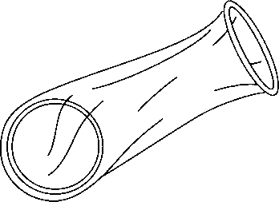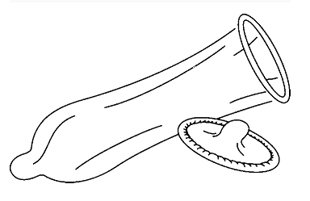-

-

-

-

-

-

-

-

-

##### Use of diaphragm

* + A diaphragm is a rubber cup that fits over the cervix and prevents semen from entering the uterus.

##### Qn. How does the diaphragm control unwanted pregnancies?

* + The diaphragm prevents semen from entering the uterus.

##### Qn. State the advantages of using the diaphragm as birth control method.

* + It is easy to use.
  + It is effective if used properly.

##### Qn. State the disadvantages of using a diaphragm as a mean of birth control method.

* + A diaphragm is expensive to buy.
  + A diaphragm must be fitted by a health worker.
  + A diagram of a diaphragm

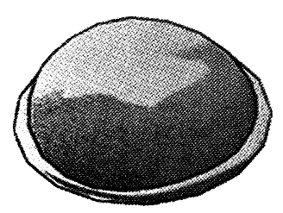

**301 |** P a g e

##### Using intra uterine device (IUD) or coil

* + An IUD is a coil or loop of plastic material which is placed inside a woman’s uterus.
  + An IUD prevents pregnancy from taking place. Qn. **State the advantage of using IUDs**.
  + IUDs are easy to be inserted by the health worker.
  + IUDs are highly effective in preventing pregnancy.
  + IUDs can prevent pregnancy for several years. Qn. **State the disadvantages of using IUDs.**
  + Increase the spread of sexually transmitted diseases.
  + IUDs may block the woman’s tube causing sterility.
  + IUDs may cause a lot of pain and bleeding of the uterus.
  + 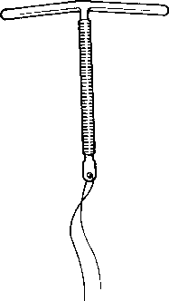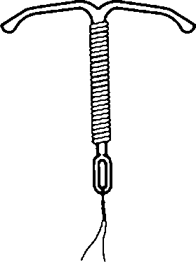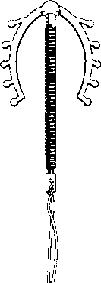A diagram showing different example s of IUDs.

##### Use of spermicides

* + Spermicides are jellies or creams which contain chemicals that kill sperms. Qn. **How do spermicides prevent unwanted pregnancies**?
  + Spermicides kill sperms.

##### Qn. State the advantage of using spermicides.

* + They are relatively easy to use.

##### Qn. State the disadvantage of using spermicides

* + They are not readily available in Uganda.
  + They may be hard to get due to lack of money.

##### Use of birth control pills (Oral contraceptives)

* + Birth control pills are tablets that contain chemical which prevent ovulation to take place. Qn. **How do birth control pills prevent unwanted pregnancies**?
  + Birth control pills prevent ovulation from taking place. Qn. **State the advantages of using birth control pills**.
  + Birth control pills are effective if used properly.
  + Birth control pills are readily available.

##### Qn. State the disadvantages of using birth control pills

* + Birth control pills do not prevent the spread of STDs.
  + They are difficult for some women since they must be taken everyday.
  + Women with medical problem are not advised to use them.
  + They worsen the risk of severe hearth attack, cancer and stroken.

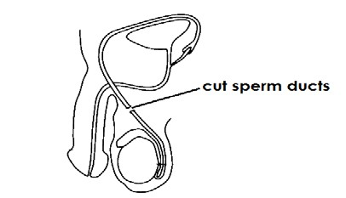

* + Diagram showing a strip of birth control pills

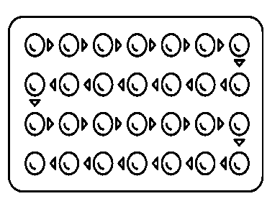-

-

-

##### Birth control injections

* + Birth control are chemicals inserted into a woman’s body in form of an injection to prevent ovulation from taking place.

Qn. State the advantage of birth control injection.

* + It is very effective and convenient for women.

##### Qn. State the disadvantage of using birth control injections.

* + It does not control the spread of STIs.
  + It may result into permanent sterility in some women.
  + It causes certain turmours among women.
  + It may result into a long delay to become pregnant again.

##### Qn. How do birth control injection control or prevent unwanted pregnancies?

* + Birth control injects prevent ovulation from taking place.

##### Implant / Nor plant

* + Norplant are capsules surgically inserted into the woman’s upper arm. Qn. **How do nor plants prevent unwanted pregnancy?**
  + Capsule contain chemical that prevent ovulation from taking place.
  + Permanent methods of family planning
  + Tuballigation
  + Vasectomy

##### Tubal ligation

* + Tubal ligation is the cutting of fallopian tubes through a simple surgical operation.
  + 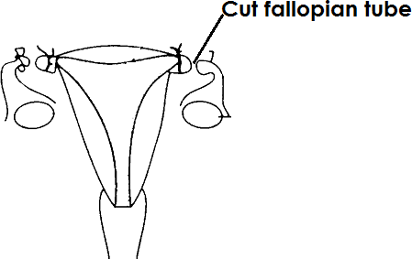Diagram showing tubal ligation

##### Qn. How do tubal ligation control unwanted pregnancy?

* + Tubal ligation prevents the ova from passing through the oviduct to be fertilized.

##### Vasectomy

* + Vasectomy is the cutting of the sperm ducts and trying them through a simple surgical operation.
  + A diagram showing vasectomy.

##### Qn. Mention any two advantages of sterilization.

* + It is done once and for all.
  + A man or woman is relaxed.
  + It is convenient and time saving.

##### Qn. State any two disadvantages of sterilization.

* + The method cannot be reversed.
  + The method is expensive.
  + The method cause permanent sterility.
  + The method is only used by people who have had enough children. Qn. **State the advantages of artificial family planning methods**.
  + The methods are effective if used properly.
  + The methods are available.
  + Some artificial family planning methods prevent the spread of STDs.

##### Qn. Identify any one artificial family planning method that help to control the spread of STDs.

* + Using condoms.

##### Qn. State the disadvantage of artificial family planning methods.

* + They are expensive.
  + Some have side effects.
  + Some may require the presence of health workers.
  + Some may result to complete sterility in one’s life.

Qn. Name the organization and body in Uganda that provide family planning services.

* + Family Planning Association of Uganda (FPAU)
  + Myths and misconceptions about family planning.
  + Using birth control pills or injects can cause cancer.
  + Family planning increase fornication or adultery among people.
  + European brought the methods of family planning to make Africans sterile.
  + If a woman uses birth control methods, she may produce little or no breast milk.
  + Vasectomy is castration of men.
  + The Whites want to reduce the population of Africans.
  + Some family planning methods can cause a woman to produce a child who is physically or mentally disabled.
  + Birth control methods should be used by women not men.
  + Africans believed that contraception make women to lose hair and grow beards.
  + Africans believed that use of contraceptives causes high blood pressure cause death while giving birth.
  + Child spacing

##### Qn. What is child spacing?

* + Child spacing is the time or duration left between the births of children in a family. Qn. **State the advantages of child spacing**.
  + It helps the mother to recover from the previous birth.
  + It helps the mother to keep healthy.

- Child spacing helps a child to have a healthy start to life.

* + PIASCY messages about adolescence and reproductive health. Qn. **What does PIASCY stand for**?
  + Presidential Initiative on AIDS strategy for communication to the Youth. Qn. **State the importance of PIASCY programme to adolescents.**
  + PIASCY helps adolescents learn how to keep their reproductive systems healthy.
  + PIASCY helps adolescents to learn about HIV/AIDS.
  + PIASCY prevents early pregnancies in adolescent girls.
  + PIASCY prevent the spread of STDs/STls in adolescents. Qn. **Write down some examples of PIASCY messages**.
  + Say not to sex
  + Do not accept gifts from strangers
  + Respect parents’ advice.
  + Virginity is health.
  + Avoid pregnancy as a child.
  + Do not trust any body for everybody is sick.
  + AIDS kills
  + AIDS has no cure.
  + Life has no spare parts.
  + Say no to bad touches.

-

-

-

-

-

-

-

-

-

-

-

-

-

-

-

-

-

-

-

-

-

-

-

-

-

-

-

-

-

-

-

-

-

-

-

-

-

-

-

-

-

-

-

-

-

-

-

-

-

-

-

-

-

-

-

-

-

-

-

-

-

-

-

-

-

-

-

-

-

-

-

-

-

-

-

-

-

-

-

-

-

-

-

-

-

-

-

-

-

-

-

-

-

-

-

-